
FPT ACADEMY INTERNATIONAL FPT – APTECH COMPUTER EDUCATION

PROJECT: Java Florist
Semester: 03 Batch No: T1-2406-E1

A.Hardware / Software Requirements
- Server Requirement
- Hardware
Component | Requirement
CPU | Processor type:  Pentium IV-compatible processor or faster  Processor speed:  Recommended: 2.0 GHz or faster
OS | Microsoft Windows Server 2012 with IIS
Memory (RAM) | RAM:  Minimum: 1 GB  Recommended: 2 GB or more
Hard Drive | Free space:  Minimum: 512 MB  Recommended: 50 GB or more  Maximum: Operating system maximum

- Software
Component | Requirement
Microsoft .NET Framework | Version 4.6 or higher
RDBMS | Microsoft SQL Server 2017

- Client Requirement
- Hardware
Component | Requirement
CPU | Processor type:  Pentium III-compatible processor or faster  Processor speed:  Recommended: 1.0 GHz or faster
OS | All OS (Window, Linux, Android, Mac OS …)
Memory (RAM) | RAM:  Minimum: 1 GB  Recommended: 2 GB or more  Maximum: Operating system maximum
Hard Drive | Free space:  Minimum: 10 MB

- Software
Component | Requirement
Web Browser | Chrome (up to date).

B. Installation Guide
Step 1: Extract file
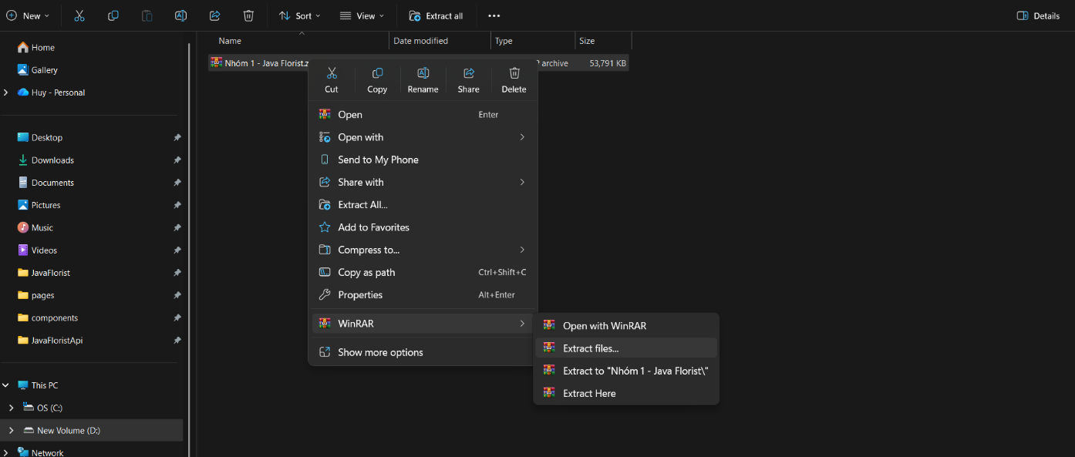

Step 2: Open Folder Group1-Java Florist.
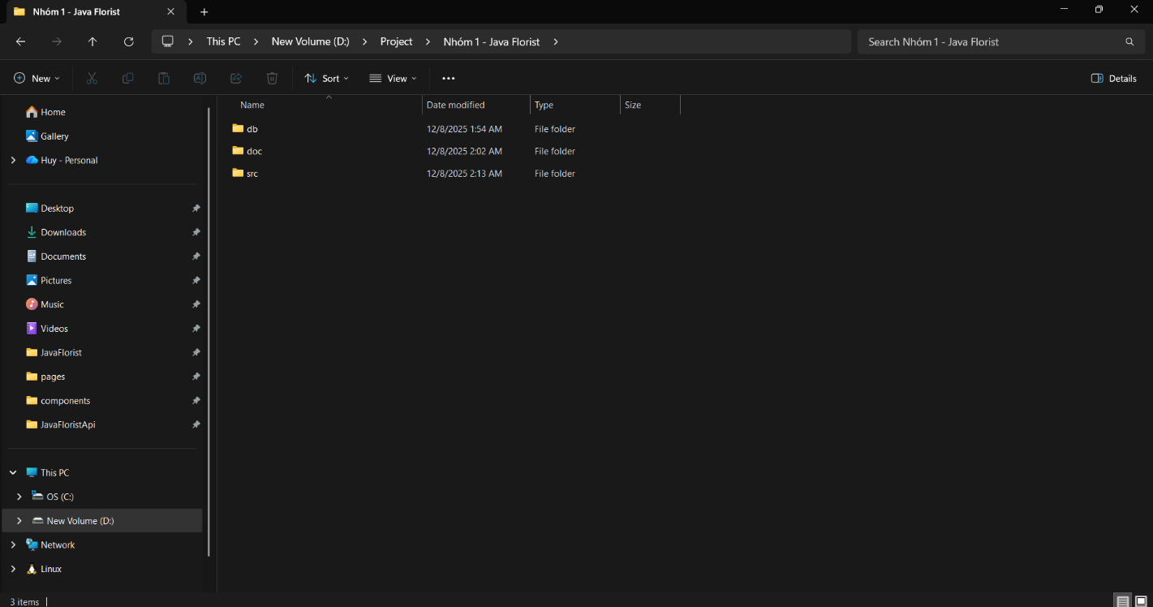

Step 3: Open Folder src/JavaFlorist
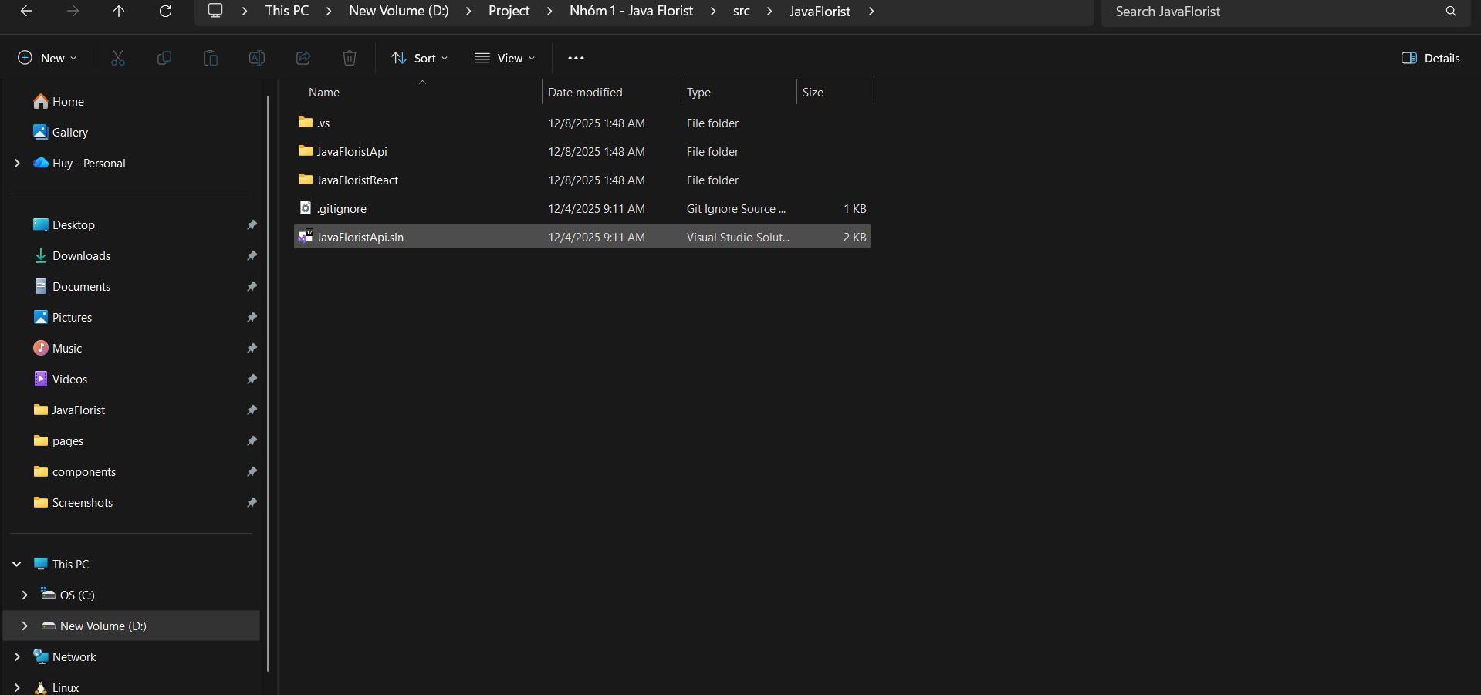

Step 4: Open File Visual JavaFloristApi.sln
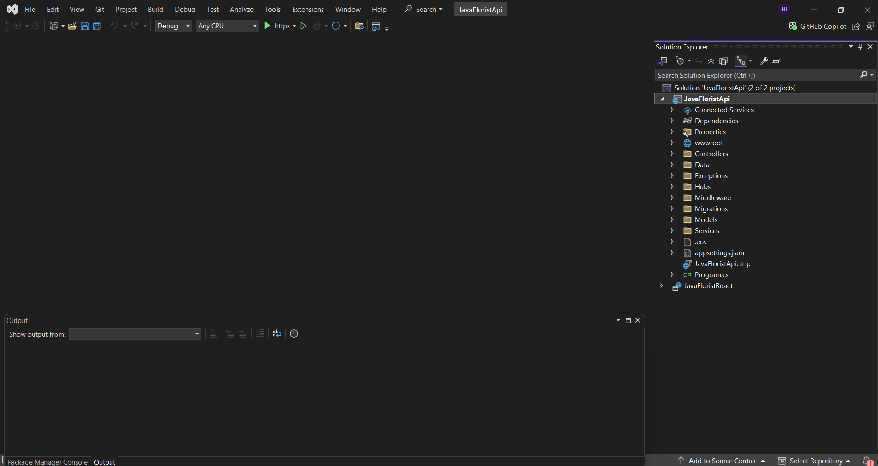

Step 5: Open SQL Server Management Studio and connect to your SQL Server instance
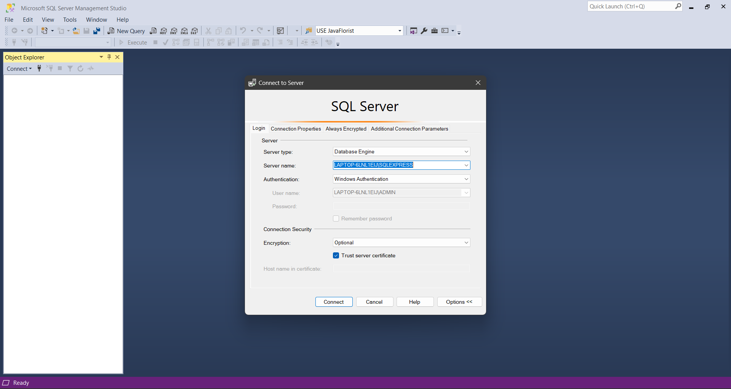

Step 6: Connect Database in project:
Click: File → Open → File...
Then choose the file database.sql

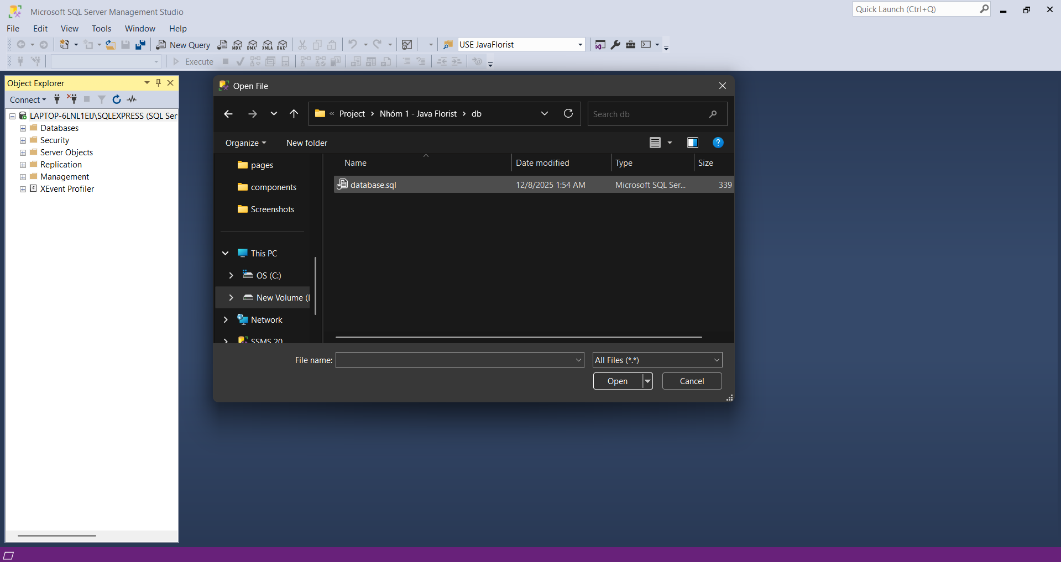

Step 7: Excute the Scripts
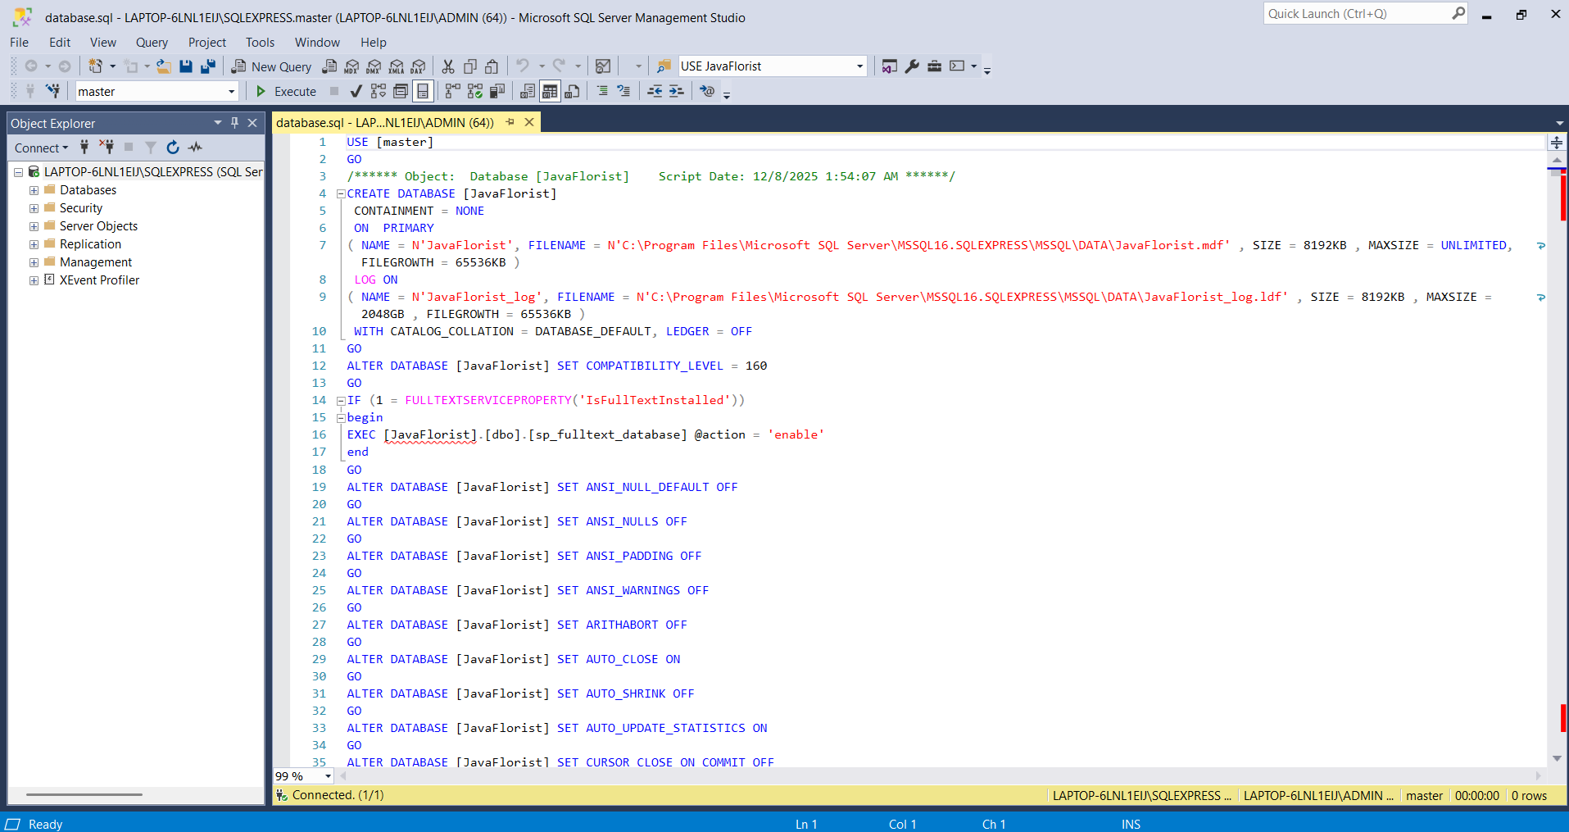

Step 8: Verify the Data
Refresh the database and check that the tables and data are imported successfully

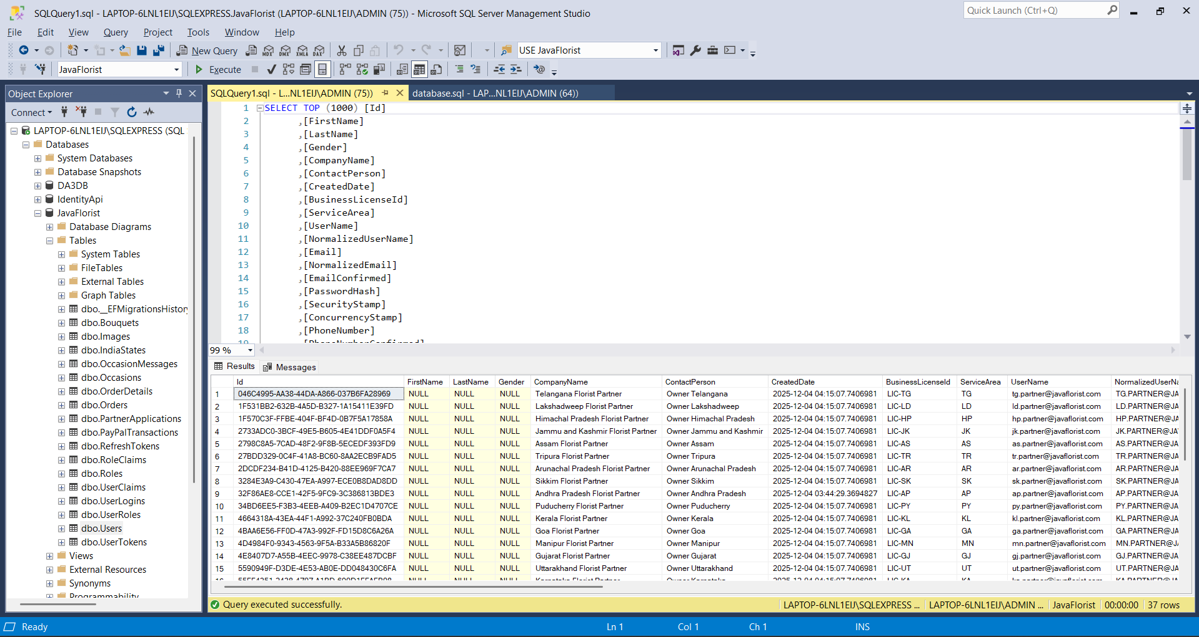

Step 9: Comeback to the project in Visual Studio
Open file: appsetting.json
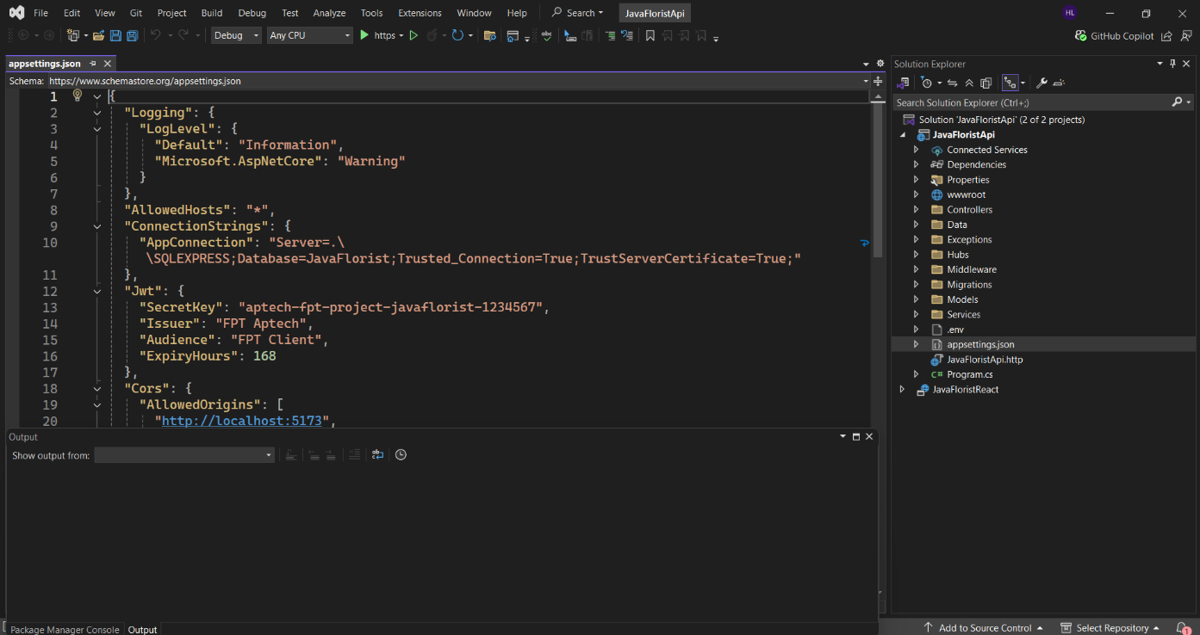

Step 10: Update the Connection String
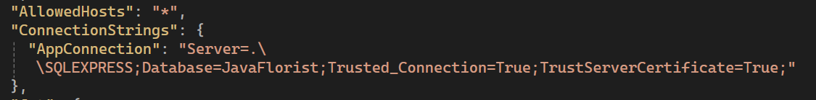

Step 11: Run the Application
Press F5 or click start to run the project
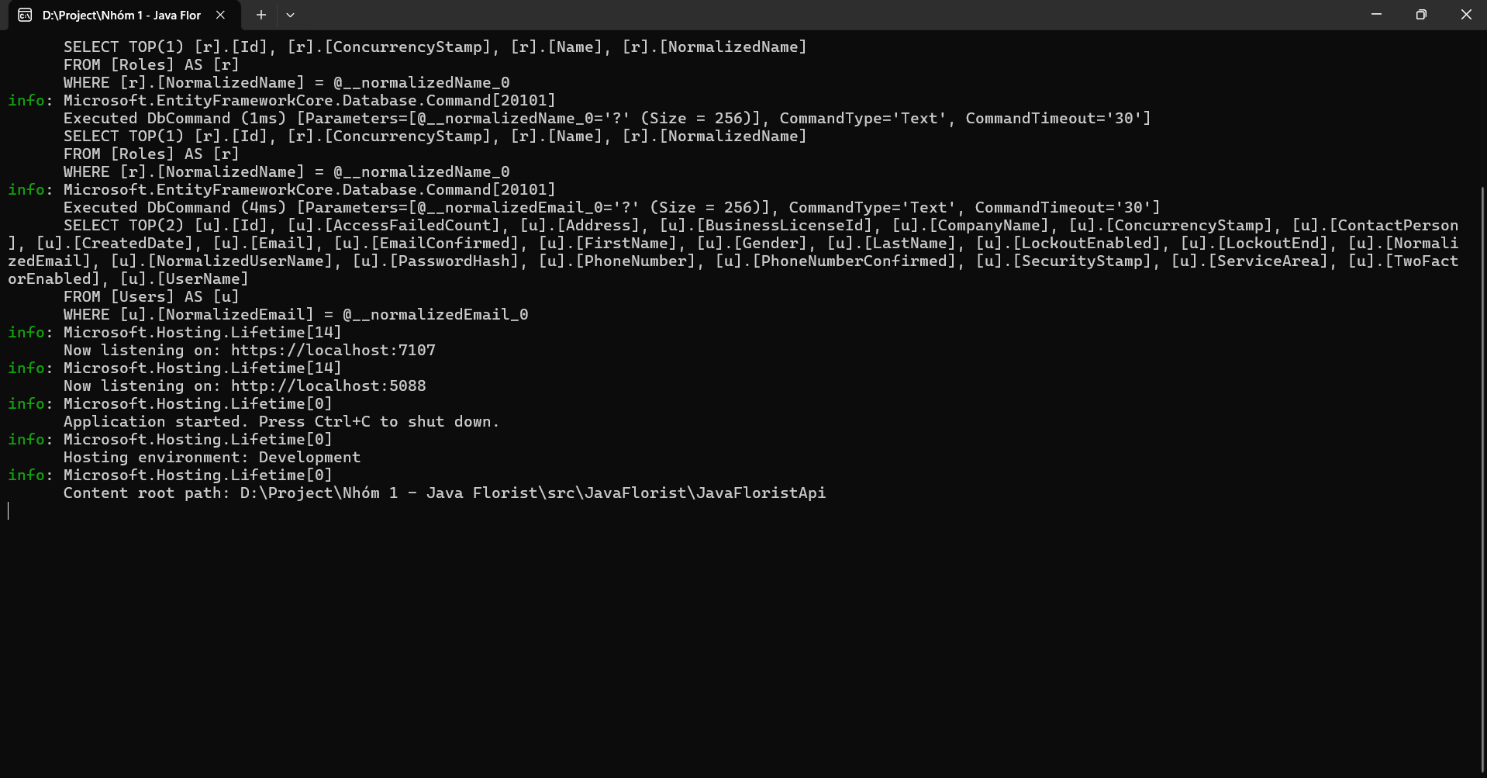

Step 12: Open JavaFloistReact
Open the frontend project folder in Visual Studio Code or any code editor
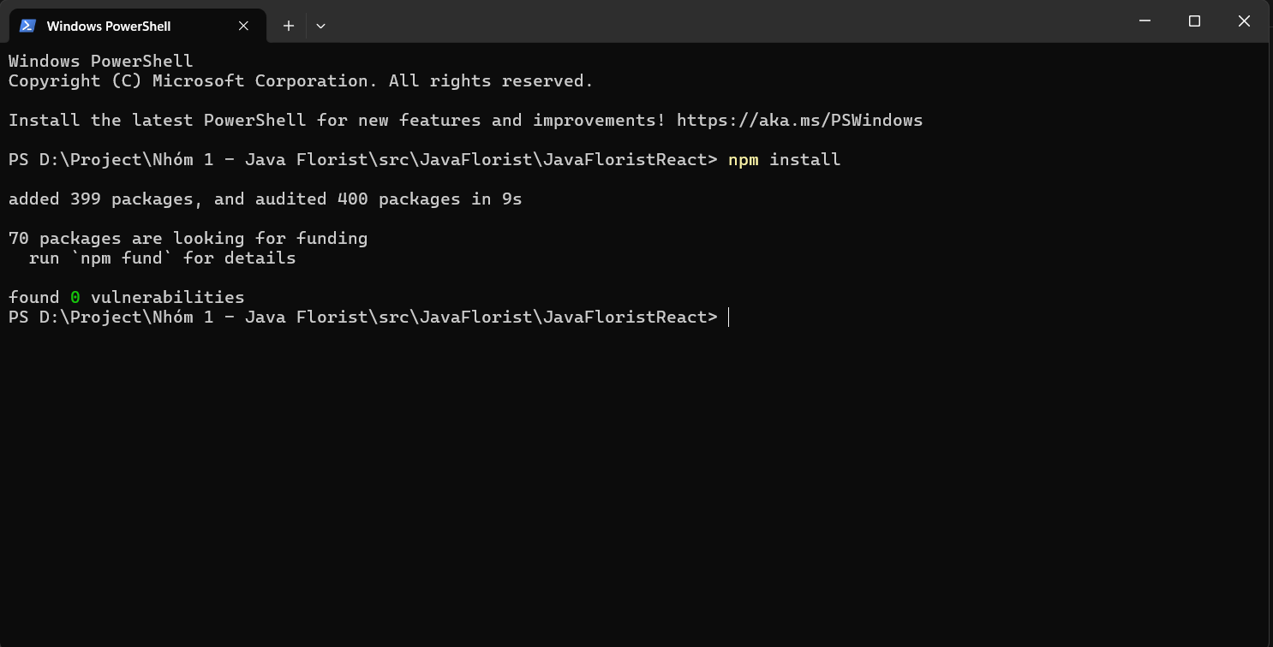

Step 13: Start the Development Server
Run command line: npm run dev
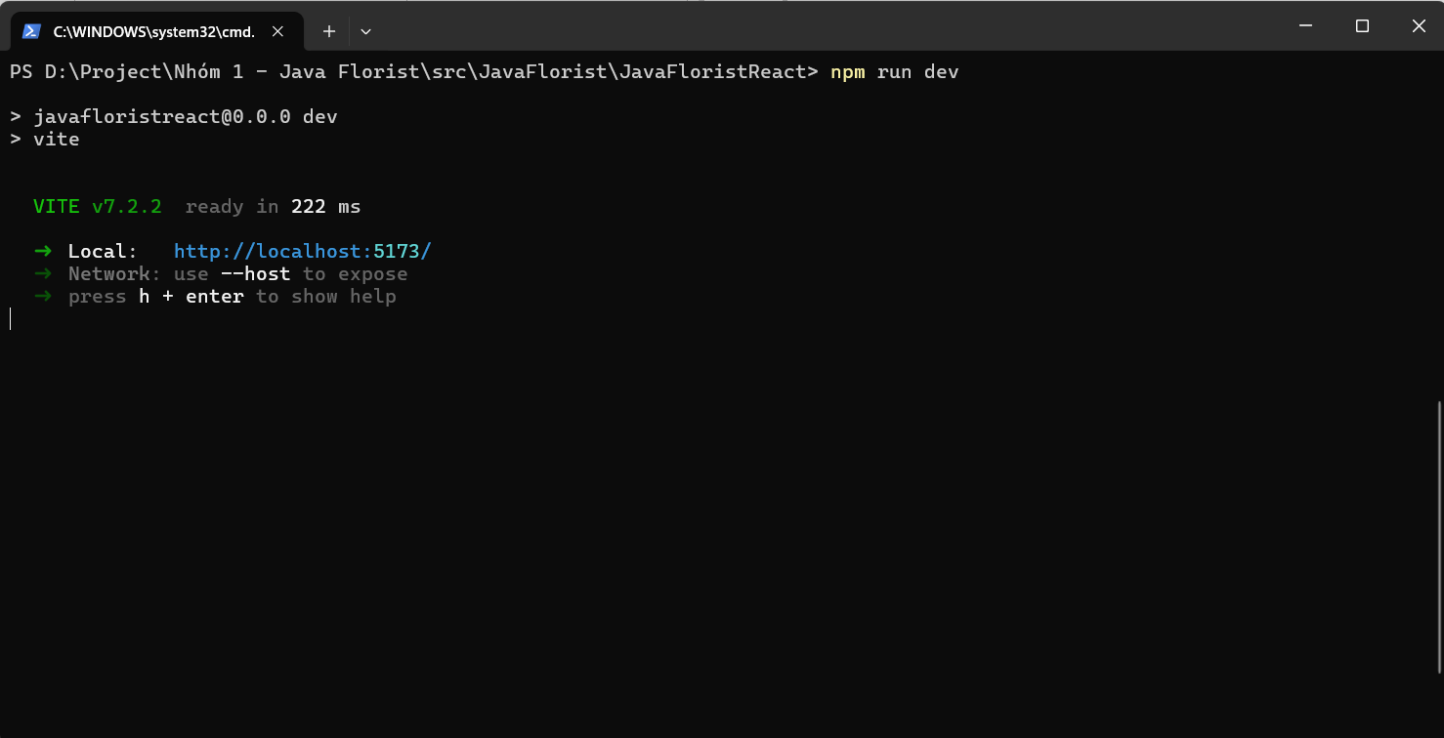

Step 14: Open your browser and to go:
http://localhost:5173
