#### Admin

#### View user list

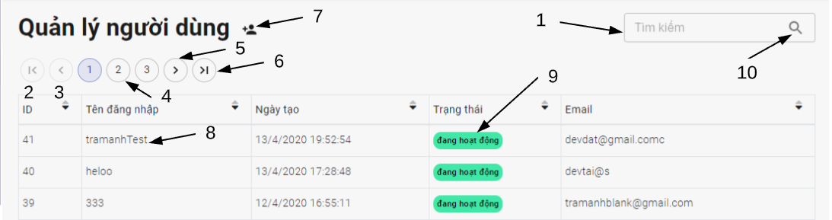

*Figure 109 - <Admin> View user account*

Fields

|  |  |  |  |  |  |  |
| --- | --- | --- | --- | --- | --- | --- |
| **No** | **Field Name** | **Description** | **Read only** | **Mandatory** | **Control Type** | **Data Type** |
| 1 | Username or email of user | Username or email of user to be search | No | No | TextBox | String |

*Table 121 - <Fields> View user list*

|  |  |  |  |  |
| --- | --- | --- | --- | --- |
| **No** | **Function** | **Description** | **Validation** | **Outcome** |
| 2 | Go to first user page | Go to first user page | Required | Show first user page |
| 3 | Select previous page | Back to previous page of user | Required | View previous page of user |
| 4 | Select page | Select page of user | Required | View specific page of user |
| 5 | Select next page | Back to next page of user | Required | View next page of user |
| 6 | Go to last user page | Go to last user page | Required | Show last user page |
| 7 | Add user |  | N/A | Open add user dialog |

Buttons/Hyperlinks

*Table 122 - <Buttons/Hyperlinks> View user list*

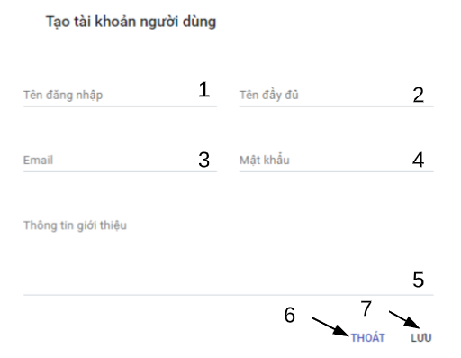

*Figure 109 - <Admin> Add user account*

Fields

|  |  |  |  |  |  |  |
| --- | --- | --- | --- | --- | --- | --- |
| **No** | **Field Name** | **Description** | **Read only** | **Mandatory** | **Control Type** | **Data Type** |
| 1 | Username | User name to register | No | Yes | TextBox | String |
| 2 | Name | Name of user | No | Yes | TextBox | String |
| 3 | Email | Email | No | Yes | TextBox | String |
| 4 | Password | Password of user | No | Yes | TextBox | String |
| 5 | Introduction | Introduction information of user | No | No | TextArea | String |

*Table 121 - <Fields> Add user*

|  |  |  |  |  |
| --- | --- | --- | --- | --- |
| **No** | **Function** | **Description** | **Validation** | **Outcome** |
| 6 | Exit |  | N/A | Close dialog |
| 7 | Save new user account |  | Required | Send create user account request and close dialog |

Buttons/Hyperlinks

*Table 122 - <Buttons/Hyperlinks> Add user*

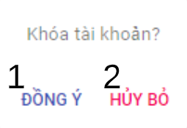

*Figure 109 - <Admin> Deactive/active user*

|  |  |  |  |  |
| --- | --- | --- | --- | --- |
| **No** | **Function** | **Description** | **Validation** | **Outcome** |
| 1 | Change status of user |  | Required | Send deactivated /activated user status request and close modal |
| 2 | Discard |  | N/A | Close modal |

Buttons/Hyperlinks

*Table 122 - <Buttons/Hyperlinks> Deactive/active user*

#### Admin menu bar



*Figure 109 - <Admin>Admin menu interface*

Buttons/Hyperlinks

|  |  |  |  |  |
| --- | --- | --- | --- | --- |
| **No** | **Function** | **Description** | **Validation** | **Outcome** |
| 1 | Show navigation | Show user navigation | Required | View admin navigation |
| 2 | Go to homepage |  | N/A | Transfer to homepage |
| 3 | Go to adminmagement |  |  | Transfer to admin management page |
| 4 | Go to profile | User profile detail | Required | Transfer to admin profile |

*Table 122 - <Buttons/Hyperlinks> User menu*

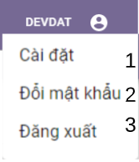

*Figure 92 - <Admin> Admin settings menu interface*

Buttons/Hyperlinks

|  |  |  |  |  |
| --- | --- | --- | --- | --- |
| **No** | **Function** | **Description** | **Validation** | **Outcome** |
| 1 | Settings | View edit profile page | Required | Transfer to edit profile page |
| 2 | Change password | View change password page | Required | Transfer to change password page |
| 3 | Logout |  | Required | Open logout modal |

*Table 96 - <Buttons/Hyperlinks> Admin settings menu bar*

#### Admin navigation

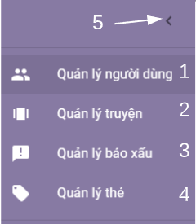

*Figure 109 - < Admin > Admin navigation interface*

Buttons/Hyperlinks

|  |  |  |  |  |
| --- | --- | --- | --- | --- |
| **No** | **Function** | **Description** | **Validation** | **Outcome** |
| 1 | User management |  | Required | Transfer to view user list page |
| 2 | Story management |  | Required | Transfer to view story list page |
| 3 | Report management | Report include story and comment reports | Required | Transfer to user history page |
| 4 | Tag management | Manage tag of story | Required | Transfer to user profile page |
| 5 | Hide admin navigation |  | N/A | Close admin navigation |

*Table 122 - <Buttons/Hyperlinks> Admin navigation*

#### View story list

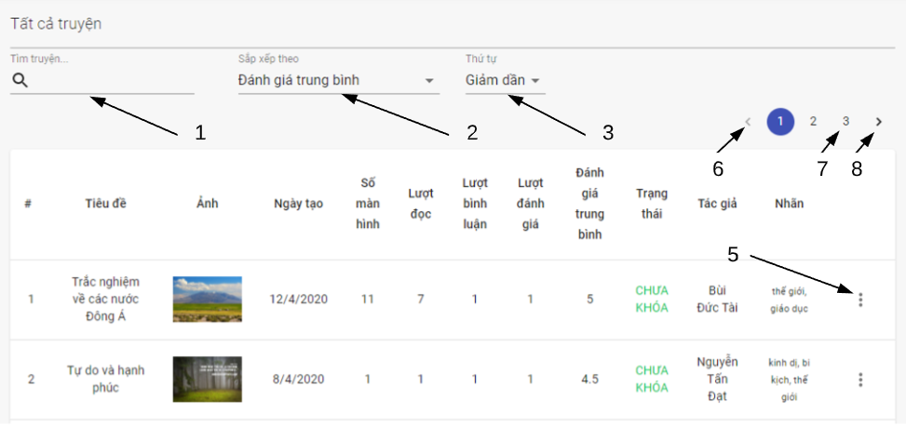

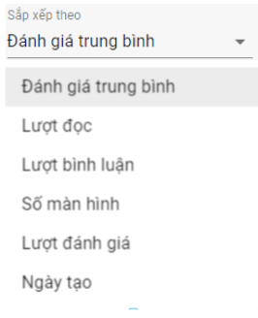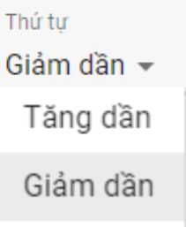

*Figure 109 - <Admin> View story list interface*

Fields

|  |  |  |  |  |  |  |
| --- | --- | --- | --- | --- | --- | --- |
| **No** | **Field Name** | **Description** | **Read only** | **Mandatory** | **Control Type** | **Data Type** |
| 1 | Story title | Title of searching story | No | No | TextBox | String |

*Table 122 - <Fields> View stories*

Buttons/Hyperlinks

|  |  |  |  |  |
| --- | --- | --- | --- | --- |
| **No** | **Function** | **Description** | **Validation** | **Outcome** |
| 2 | Choose criteria of story to order | Choose criteria of story like avg Rate, number of view,… | N/A |  |
| 3 | Choose order type | Choose order type to order list of story by criteria | N/A |  |
| 4 | Go to the story statistic |  | Required | Transfer to view story statistic |
| 5 | Open story settings |  | N/A |  |
| 6 | Select previous page | Back to previous page of searching stories | N/A | View previous page of searching stories |
| 7 | Select page | Select page of searching story | N/A | View specific page of searching stories |
| 8 | Select next page | Back to next page of searching stories | N/A | View next page of searching stories |

*Table 122 - <Buttons/Hyperlinks> View user’s stories*

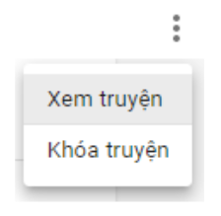

*Figure 109 - < User > Story settings interface*

Buttons/Hyperlinks

|  |  |  |  |  |
| --- | --- | --- | --- | --- |
| **No** | **Function** | **Description** | **Validation** | **Outcome** |
|  | View story details |  | N/A | Transfer to story detail page |
|  | Delete story |  | Required | Send delete story request |

*Table 122 - <Buttons/Hyperlinks> Story settings*

#### Admin report navigation



*Figure 109 - < Admin> Admin report navigation interface*

Buttons/Hyperlinks

|  |  |  |  |  |
| --- | --- | --- | --- | --- |
| **No** | **Function** | **Description** | **Validation** | **Outcome** |
| 1 | Show comment report |  | Required | Show comment report tab |
| 2 | Show story report |  | Required | Show story report tab |

*Table 122 - <Buttons/Hyperlinks> Admin report navigation*

#### View comment report tab

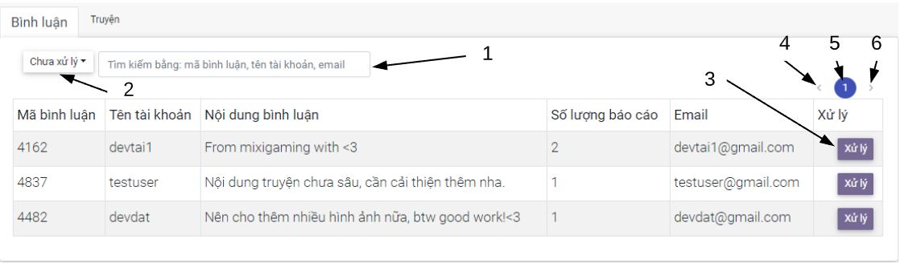

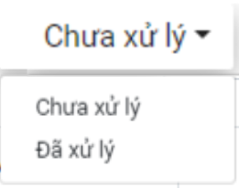

*Figure 109 - <Admin> View comment report tab interface*

Fields

|  |  |  |  |  |  |  |
| --- | --- | --- | --- | --- | --- | --- |
| **No** | **Field Name** | **Description** | **Read only** | **Mandatory** | **Control Type** | **Data Type** |
| 1 | Comment id , username or email | Comment id , username/ email of user belong to searching comment | No | No | TextBox | String |

*Table 122 - <Fields> View stories*

Buttons/Hyperlinks

|  |  |  |  |  |
| --- | --- | --- | --- | --- |
| **No** | **Function** | **Description** | **Validation** | **Outcome** |
| 2 | Choose report filter type | Filter report by type : handled or still not handle | N/A |  |
| 3 | Handle comment report | Choose order type to order list | N/A | Open report handle dialog |
| 4 | Select previous page | Back to previous page | N/A | View previous page |
| 5 | Select page | Select page | N/A | View specific page |
| 6 | Select next page | Back to next page | N/A | View next page |

*Table 122 - <Buttons/Hyperlinks> View user’s stories*

#### Admin Handle comment report dialog

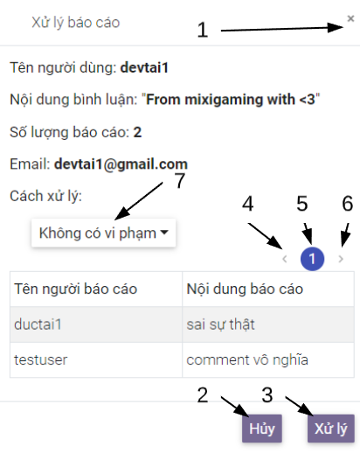

*Figure 109 - < Admin> Admin handle comment report dialog interface*

Buttons/Hyperlinks

|  |  |  |  |  |
| --- | --- | --- | --- | --- |
| **No** | **Function** | **Description** | **Validation** | **Outcome** |
| 1 | Close dialog |  | N/A | Close handle report dialog |
| 2 | Close dialog |  | N/A | Close handle report dialog |
| 3 | Handle report |  | Required | Send handle report request and close dialog |
| 4 | Select previous page | Back to previous page | N/A | View previous page |
| 5 | Select page | Select page | N/A | View specific page |
| 6 | Select next page | Back to next page | N/A | View next page |
| 7 | Choose handle options |  | No | Open handle options menu |

*Table 122 - <Buttons/Hyperlinks> Admin handle comment report dialog*

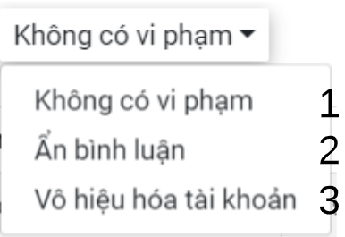

*Figure 109 - < Admin> Admin handle options menu interface*

Buttons/Hyperlinks

|  |  |  |  |  |
| --- | --- | --- | --- | --- |
| **No** | **Function** | **Description** | **Validation** | **Outcome** |
| 1 | Handle report | Change status of report to handled | Required |  |
| 2 | Hide comment | Hide comment | Required |  |
| 3 | Deactive user account | Ban user account | Required |  |

*Table 122 - <Buttons/Hyperlinks> Admin handle option menu*

#### View story report tab

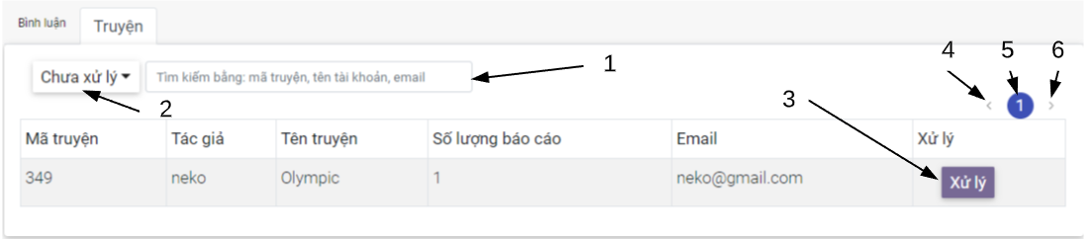



*Figure 109 - <Admin> View story report tab interface*

Fields

|  |  |  |  |  |  |  |
| --- | --- | --- | --- | --- | --- | --- |
| **No** | **Field Name** | **Description** | **Read only** | **Mandatory** | **Control Type** | **Data Type** |
| 1 | Story id , username or email | Story id , username/ email of user own story | No | No | TextBox | String |

*Table 122 - <Fields> View stories*

Buttons/Hyperlinks

|  |  |  |  |  |
| --- | --- | --- | --- | --- |
| **No** | **Function** | **Description** | **Validation** | **Outcome** |
| 2 | Choose report filter type | Filter report by type : handled or still not handle | N/A |  |
| 3 | Handle story report | Choose order type to order list | N/A | Open report handle dialog |
| 4 | Select previous page | Back to previous page | N/A | View previous page |
| 5 | Select page | Select page | N/A | View specific page |
| 6 | Select next page | Back to next page | N/A | View next page |

*Table 122 - <Buttons/Hyperlinks> View user’s stories*

#### Admin Handle story report dialog

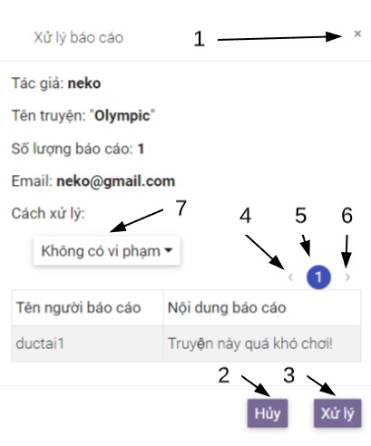

*Figure 109 - < Admin> Admin handle story report dialog interface*

Buttons/Hyperlinks

|  |  |  |  |  |
| --- | --- | --- | --- | --- |
| **No** | **Function** | **Description** | **Validation** | **Outcome** |
| 1 | Close dialog |  | N/A | Close handle report dialog |
| 2 | Close dialog |  | N/A | Close handle report dialog |
| 3 | Handle report | Handle report by selected option in handle options menu | Required | Send handle report request and close dialog |
| 4 | Select previous page | Back to previous page | N/A | View previous page |
| 5 | Select page | Select page | N/A | View specific page |
| 6 | Select next page | Back to next page | N/A | View next page |
| 7 | Choose handle option |  | N/A | Open handle options menu |

*Table 122 - <Buttons/Hyperlinks> Admin handle comment report dialog*

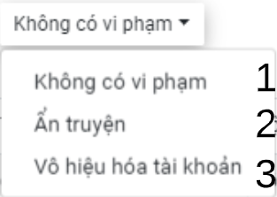

*Figure 109 - < Admin> Admin handle options menu interface*

Buttons/Hyperlinks

|  |  |  |  |  |
| --- | --- | --- | --- | --- |
| **No** | **Function** | **Description** | **Validation** | **Outcome** |
| 1 | Handle report | Change status of report to handled | Required |  |
| 2 | Hide story | Hide story from user | Required |  |
| 3 | Deactive user account | Ban user account | Required |  |

*Table 122 - <Buttons/Hyperlinks> Admin handle option menu*