#### Menu bar



*Figure 91 - <Guest> Menu bar interface*

Buttons/Hyperlinks

|  |  |  |  |  |
| --- | --- | --- | --- | --- |
| **No** | **Function** | **Description** | **Validation** | **Outcome** |
| 1 | Logo | Go to homepage | N/A | Transfer to homepage |
| 2 | Login | Login into the system | N/A | Transfer to login page |
| 3 | Register | Register to the system | N/A | Transfer to register page |

*Table 95 - <Buttons/Hyperlinks> Menu bar*

#### Login

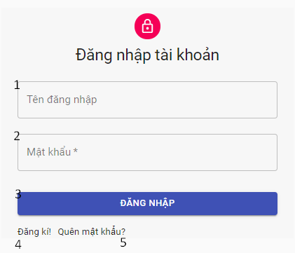

*Figure 91 - <Guest> Login interface*

Fields

|  |  |  |  |  |  |  |
| --- | --- | --- | --- | --- | --- | --- |
| **No** | **Field Name** | **Description** | **Read only** | **Mandatory** | **Control Type** | **Data Type** |
| 1 | Username | Username to login | No | Yes | TextBox | String |
| 2 | Password | Password to login | No | Yes | TextBox | String |

*Table 106 - <Fields> Log in*

Buttons/Hyperlinks

|  |  |  |  |  |
| --- | --- | --- | --- | --- |
| **No** | **Function** | **Description** | **Validation** | **Outcome** |
| 3 | Login | Login into the system | Require |  |
| 4 | Register | Register to the system | N/A | Transfer to register page |
| 5 | Forget password | Recovery user password | N/A | Transfer to email submit to recive reset password |

*Table 107 - <Buttons/Hyperlinks> Log in*

#### Register

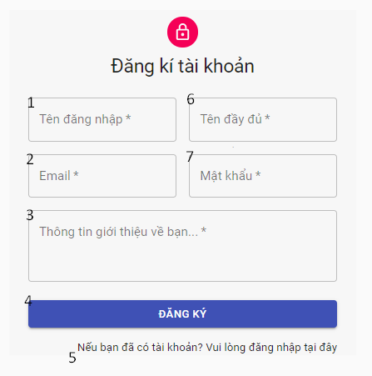

*Figure 103 - <Guest> Register interface*

Fields

|  |  |  |  |  |  |  |
| --- | --- | --- | --- | --- | --- | --- |
| **No** | **Field Name** | **Description** | **Read only** | **Mandatory** | **Control Type** | **Data Type** |
| 1 | Username | User name to register | No | Yes | TextBox | String |
| 2 | Email | Email | No | Yes | TextBox | String |
| 3 | Introduction | Introduction information of user | No | No | TextArea | String |
| 6 | Name | Name of user | No | Yes | TextBox | String |
| 7 | Password | Password of user | No | Yes | TextBox | String |

*Table 112 - <Fields> Register information*

Buttons/Hyperlinks

|  |  |  |  |  |
| --- | --- | --- | --- | --- |
| **No** | **Function** | **Description** | **Validation** | **Outcome** |
| 5 | Register | Register to the system | Required | Transfer to login page |
| 6 | [Go to login](http://localhost:3001/login) page | Go to login page | No | Transfer to login page |

*Table 113 - <Buttons/Hyperlinks> Register information*

#### Home page

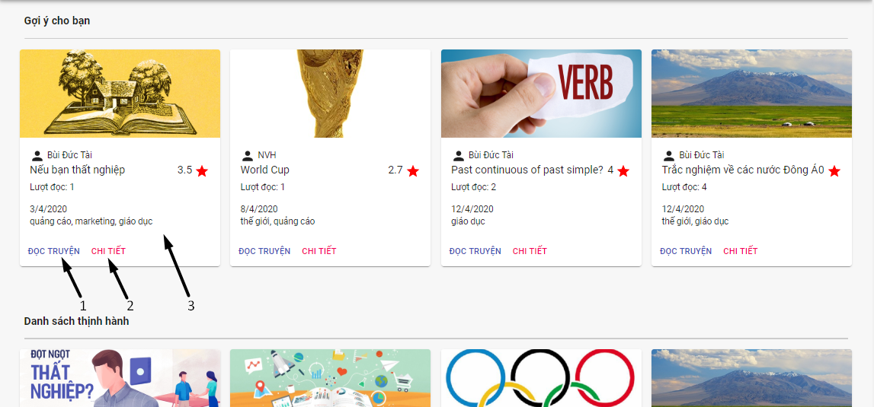

*Figure 99 - <Guest> Homepage interface*

Buttons/Hyperlinks

|  |  |  |  |  |
| --- | --- | --- | --- | --- |
| **No** | **Function** | **Description** | **Validation** | **Outcome** |
| 1 | Read story | Read story | N/A | Transfer to read story page |
| 2 | View detail of story | View detail of story | N/A | Tranfer to story detail page |
| 3 | View detail of story | View detail of story | N/A | Tranfer to story detail page |

*Table 105 - <Buttons/Hyperlinks> Homepage*

#### Submit email

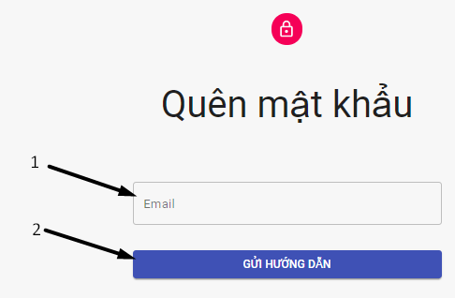

*Figure 99 - <Guest> Submit email interface*

Fields

|  |  |  |  |  |  |  |
| --- | --- | --- | --- | --- | --- | --- |
| **No** | **Field Name** | **Description** | **Read only** | **Mandatory** | **Control Type** | **Data Type** |
| 1 | Email | Email address to recieve reset password link | No | Yes | TextBox | String |

*Table 112 - <Fields> Submit email information*

Buttons/Hyperlinks

|  |  |  |  |  |
| --- | --- | --- | --- | --- |
| **No** | **Function** | **Description** | **Validation** | **Outcome** |
| 1 | Send intruction | Send reset password link to user submit email address | Required |  |

*Table 105 - <Buttons/Hyperlinks> Submit email*

#### Reset password

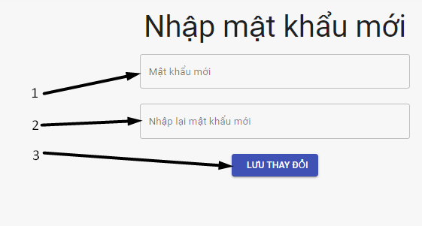

*Figure 99 - <Guest> Reset password interface*

Fields

|  |  |  |  |  |  |  |
| --- | --- | --- | --- | --- | --- | --- |
| **No** | **Field Name** | **Description** | **Read only** | **Mandatory** | **Control Type** | **Data Type** |
| 1 | New password | New password of user | No | Yes | TextBox | String |
| 2 | Re-password | Re-password of user | No | Yes | TextBox | String |

*Table 112 - <Fields> Reset password information*

Buttons/Hyperlinks

|  |  |  |  |  |
| --- | --- | --- | --- | --- |
| **No** | **Function** | **Description** | **Validation** | **Outcome** |
| 3 | Save password | Save new password | Required | Tranfer to homepage |

*Table 105 - <Buttons/Hyperlinks> Reset password*

#### Navigation



*Figure 99 - <Guest> Navigation interface*

Buttons/Hyperlinks

|  |  |  |  |  |
| --- | --- | --- | --- | --- |
| **No** | **Function** | **Description** | **Validation** | **Outcome** |
| 1 | Hide navigation |  | No |  |
| 2 | Go to homepage | Go to homepage | No | Tranfer to homepage |
| 3 | Go to search story page | Go to search story page | No | Tranfer to search storypage |

*Table 105 - <Buttons/Hyperlinks> Navigation*

#### Story Detail

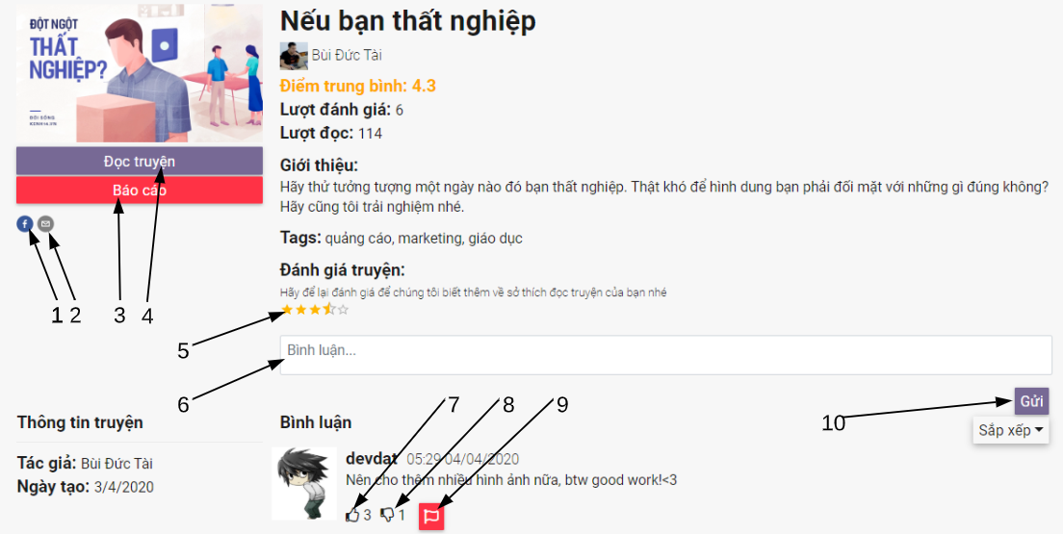

*Figure 109 - <Guest> Story detail interface*

Fields

|  |  |  |  |  |  |  |
| --- | --- | --- | --- | --- | --- | --- |
| **No** | **Field Name** | **Description** | **Read only** | **Mandatory** | **Control Type** | **Data Type** |
| 6 | Comment | Comment to the story | No | No | TextArea | String |

*Table 121 - <Fields> Comment*

Buttons/Hyperlinks

|  |  |  |  |  |
| --- | --- | --- | --- | --- |
| **No** | **Function** | **Description** | **Validation** | **Outcome** |
| 1 | Share to facebook | Share story to facebook | No | Open facebook share window |
| 2 | Send email | Send email | No | Open email compose window |
| 3 | Report | Report story to administrator | Required |  |
| 4 | Read story | Read story | No | Tranfer to read story page |
| 5 | Rating | Rate story | Required |  |
| 7 | Like comment |  | Required |  |
| 8 | Dislike comment |  | Required |  |
| 9 | Report comment | Report comment to administrator | Required |  |
| 10 | Send comment | Send comment to the story | Required |  |

*Table 122 - <Buttons/Hyperlinks> Story detail*

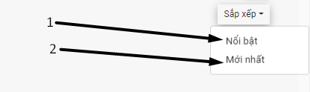

*Figure 92 - <Guest> Order comment interface*

Buttons/Hyperlinks

|  |  |  |  |  |
| --- | --- | --- | --- | --- |
| **No** | **Function** | **Description** | **Validation** | **Outcome** |
| 1 | View most outstanding comments |  | No | View list of most outstanding comments |
| 2 | View newest comments |  | No | View list of newest comments |

*Table 96 - <Buttons/Hyperlinks> Order comment*

#### Search story page

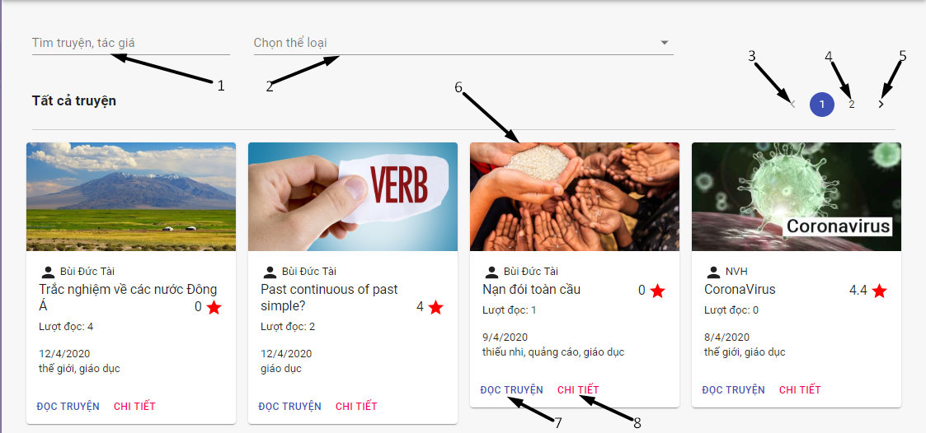

*Figure 109 - <Guest> Search story interface*

Fields

|  |  |  |  |  |  |  |
| --- | --- | --- | --- | --- | --- | --- |
| **No** | **Field Name** | **Description** | **Read only** | **Mandatory** | **Control Type** | **Data Type** |
| 1 | Story title / author | Title and author of story | No | No | TextBox | String |
| 2 | Tag | Tag of story | No | No | TextBox | String |

*Table 121 - <Fields> Search story*

Buttons/Hyperlinks

|  |  |  |  |  |
| --- | --- | --- | --- | --- |
| **No** | **Function** | **Description** | **Validation** | **Outcome** |
| 3 | Select previous page | Back to previous page of searching stories | No | View previous page of searching stories |
| 4 | Select page | Select page of searching story | No | View specific page of searching stories |
| 5 | Select next page | Back to next page of searching stories | No | View next page of searching stories |
| 6 | View detail of story | View detail of story | No | Tranfer to story detail page |
| 7 | Read story | Read story | No | Transfer to read story page |
| 8 | View detail of story | View detail of story | No | Tranfer to story detail page |

*Table 122 - <Buttons/Hyperlinks> Search story*

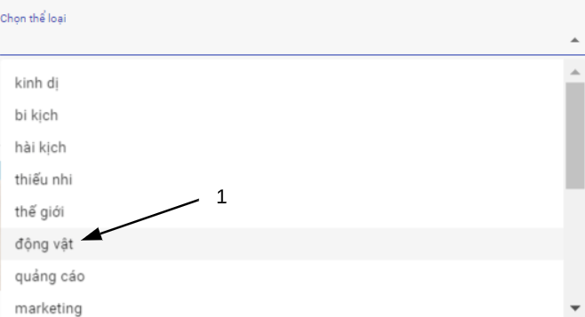

*Figure 121 - <Guest>Select tag interface*

Buttons/Hyperlinks

|  |  |  |  |  |
| --- | --- | --- | --- | --- |
| **No** | **Function** | **Description** | **Validation** | **Outcome** |
| 1 | Select tag | Select tag | No |  |

*Table 122 - <Buttons/Hyperlinks> Select tag*

#### Read story

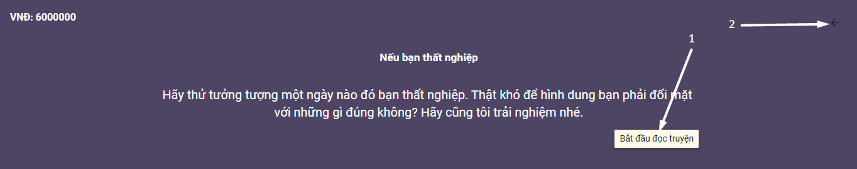

*Figure 92 - <Guest> Introduction screen interface*

Buttons/Hyperlinks

|  |  |  |  |  |
| --- | --- | --- | --- | --- |
| **No** | **Function** | **Description** | **Validation** | **Outcome** |
| 1 | Start reading | Go to start screen | No | View start screen |
| 2 | Back to story detail |  | No | Transfer to story detail page |

*Table 96 - <Buttons/Hyperlinks> Introduction screen*

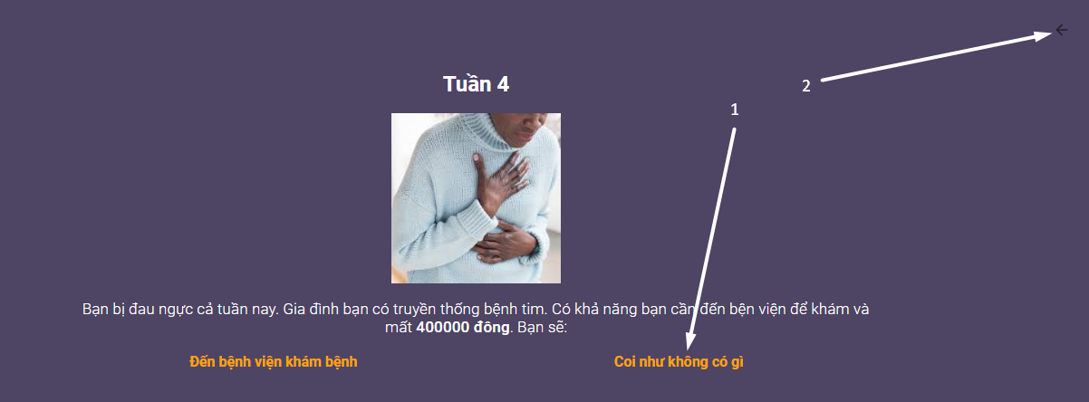

*Figure 92 - <Guest> Content screen interface*

Buttons/Hyperlinks

|  |  |  |  |  |
| --- | --- | --- | --- | --- |
| **No** | **Function** | **Description** | **Validation** | **Outcome** |
| 1 | Do screen action |  | No | View next screen, update information or open a url window |
| 2 | Back to story detail |  | No | Transfer to story detail page |

*Table 96 - <Buttons/Hyperlinks> Content screen*

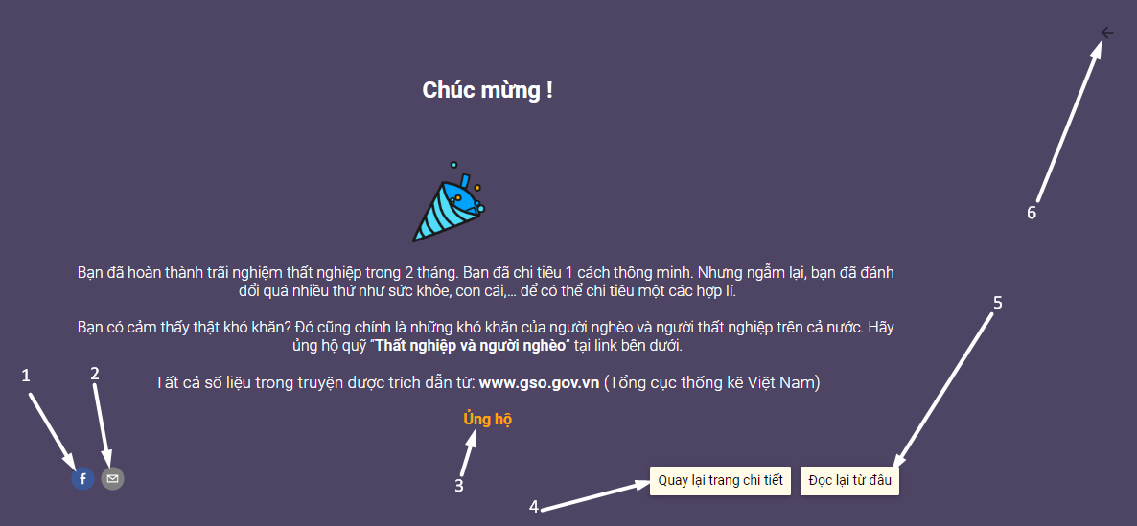

*Figure 92 - <Guest> End screen interface*

Buttons/Hyperlinks

|  |  |  |  |  |
| --- | --- | --- | --- | --- |
| **No** | **Function** | **Description** | **Validation** | **Outcome** |
| 1 | Share to facebook | Share story to facebook | No | Open facebook share window |
| 2 | Send email | Send email | No | Open email compose window |
| 3 | Do screen action |  | No | View next screen, update information or open a url window |
| 4 | Back to story detail |  | No | Transfer to story detail page |
| 5 | Back to start screen | Back to start screen | No | View start screen |
| 6 | Back to story detail |  | No | Transfer to story detail page |

*Table 96 - <Buttons/Hyperlinks> End screen*