#### User menu



*Figure 109 - <User> User menu interface*

Buttons/Hyperlinks

|  |  |  |  |  |
| --- | --- | --- | --- | --- |
| **No** | **Function** | **Description** | **Validation** | **Outcome** |
| 1 | Show navigation | Show user navigation | Required | View user navigation |
| 2 | Go to homepage |  | N/A | Transfer to homepage |
| 3 | Go to user profile | User profile detail | Required | Transfer to user profile |

*Table 122 - <Buttons/Hyperlinks> User menu*

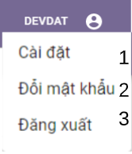

*Figure 92 - <User> User settings menu interface*

Buttons/Hyperlinks

|  |  |  |  |  |
| --- | --- | --- | --- | --- |
| **No** | **Function** | **Description** | **Validation** | **Outcome** |
| 1 | Settings | View edit user profile page | Required | Transfer to edit user profile page |
| 2 | Change password | View change password page | Required | Transfer to change password page |
| 3 | Logout |  | Required | Open logout modal |

*Table 96 - <Buttons/Hyperlinks> User settings menu bar*

#### User navigation

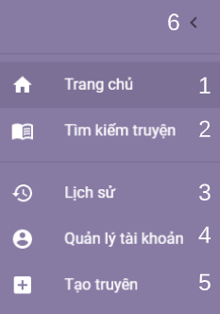

*Figure 109 - < User > User navigation interface*

Buttons/Hyperlinks

|  |  |  |  |  |
| --- | --- | --- | --- | --- |
| **No** | **Function** | **Description** | **Validation** | **Outcome** |
| 1 | Go to homepage | Show user navigation | Required | Transfer to home page |
| 2 | Go to search story | Show user search story page | N/A | Transfer to search story page |
| 3 | Go to history | Go to page of user history : story readings, reactions and comments | Required | Transfer to user history page |
| 4 | Go to user profile | Go to view user profile | Required | Transfer to user profile page |
| 5 | Go to create story | Go to create story page | Required | Transfer to create story page |
| 6 | Hide navigation | Close user navigation | N/A | Close user navigation |

*Table 122 - <Buttons/Hyperlinks> User navigation*

#### User history navigation



*Figure 109 - < User > User history navigation interface*

Buttons/Hyperlinks

|  |  |  |  |  |
| --- | --- | --- | --- | --- |
| **No** | **Function** | **Description** | **Validation** | **Outcome** |
| 1 | Show reading history | Show user navigation | Required | Show user reading history tab |
| 2 | Show comment history | Show user search story page | N/A | Show user comment history tab |
| 3 | Show reaction history | Go to page of user history : story readings, reactions and comments | Required | Show user reaction history tab |

*Table 122 - <Buttons/Hyperlinks> User history navigation*

#### User reading history tab

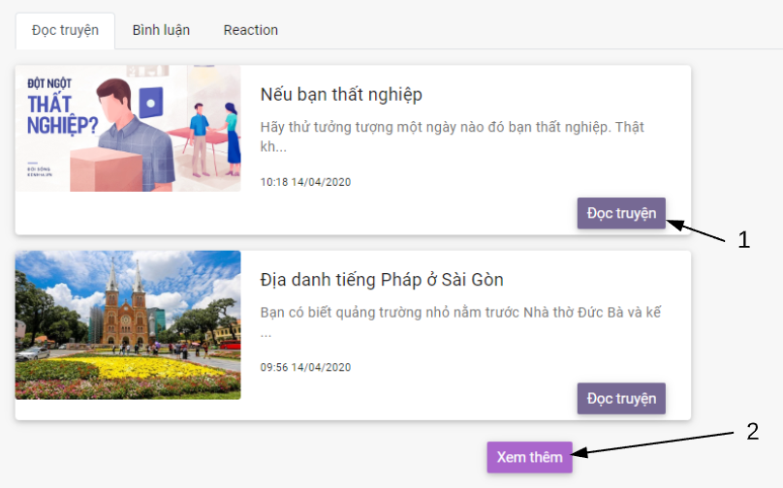

*Figure 109 - < User > User reading history tab interface*

Buttons/Hyperlinks

|  |  |  |  |  |
| --- | --- | --- | --- | --- |
| **No** | **Function** | **Description** | **Validation** | **Outcome** |
| 1 | Go to story detail | Go to story detail | N/A | Open new window of story detail page |
| 2 | Load more | Show more read stories in reading history | Required | Show more read stories in reading history |
| 3 | Show reaction history | Go to page of user history : story readings, reactions and comments | Required | Show user reaction history tab |

*Table 122 - <Buttons/Hyperlinks> User reading history tab*

#### User comment history tab

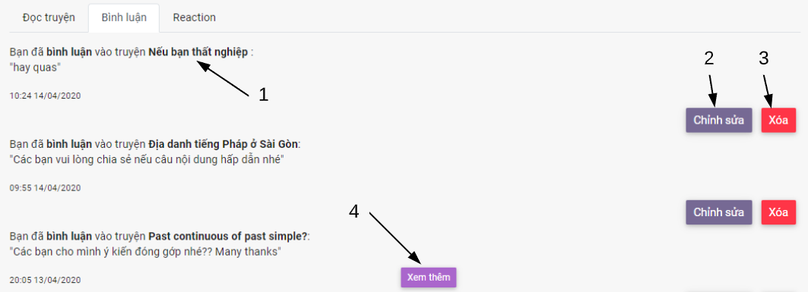

*Figure 109 - < User > User comment history tab interface*

Buttons/Hyperlinks

|  |  |  |  |  |
| --- | --- | --- | --- | --- |
| **No** | **Function** | **Description** | **Validation** | **Outcome** |
| 1 | Go to story detail | Go to story detail | N/A | Open new window of story detail page |
| 2 | Open edit comment dialog | Edit user comment of the story | Required | Open edit comment dialog |
| 3 | Delete comment | Delete user comment of the story | Required | Send delete comment request |
| 4 | Load more | Show more comment of user in comment history | Required | Show more comments in comment history |

*Table 122 - <Buttons/Hyperlinks> User comment history tab*

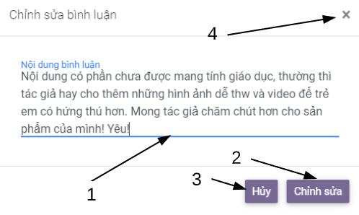

*Figure 109 - < User > User edit comment dialog interface*

Fields

|  |  |  |  |  |  |  |
| --- | --- | --- | --- | --- | --- | --- |
| **No** | **Field Name** | **Description** | **Read only** | **Mandatory** | **Control Type** | **Data Type** |
| 1 | User edit comment | Edit comment of user | N/A | N/A | TextArea | String |

*Table 121 - <Fields> Search story*

Buttons/Hyperlinks

|  |  |  |  |  |
| --- | --- | --- | --- | --- |
| **No** | **Function** | **Description** | **Validation** | **Outcome** |
| 2 | Save comment | Save changes of comment | Required | Save changes of comment and close dialog |
| 3 | Cancel | Cancel the changes of comment | N/A | Cancel changes of comment and close dialog |
| 4 | Cancel | Cancel the changes of comment | N/A | Cancel changes of comment and close dialog |

*Table 122 - <Buttons/Hyperlinks> User edit comment dialog*

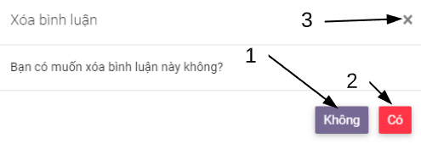

*Figure 109 - < User > User delete comment dialog interface*

Buttons/Hyperlinks

|  |  |  |  |  |
| --- | --- | --- | --- | --- |
| **No** | **Function** | **Description** | **Validation** | **Outcome** |
| 1 | Cancel |  | N/A | Close dialog |
| 2 | Delete comment | Delete user comment of the story | Required | Save changes of comment and close dialog |
| 3 | Cancel |  | N/A | Close dialog |

*Table 122 - <Buttons/Hyperlinks> User edit comment dialog*

#### User reaction history tab

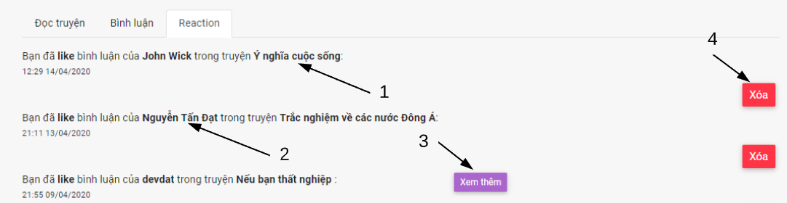

*Figure 109 - < User > User reaction history tab interface*

Buttons/Hyperlinks

|  |  |  |  |  |
| --- | --- | --- | --- | --- |
| **No** | **Function** | **Description** | **Validation** | **Outcome** |
| 1 | Go to story detail | Go to story detail | N/A | Open new window of story detail page |
| 2 | Go to user profile | Go to user profile | N/A | Go to user profile page |
| 3 | Load more | Show more reaction of user in reaction | Required | Show more comments in comment history |
| 4 | Delete reaction | Delete user reaction of the story | Required | Send delete reaction request |

*Table 122 - <Buttons/Hyperlinks> User comment history tab*

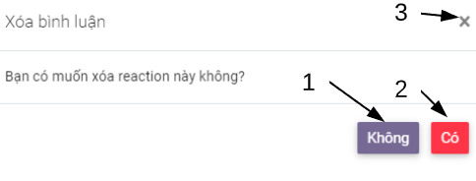

*Figure 109 - < User > User delete reaction dialog interface*

Buttons/Hyperlinks

|  |  |  |  |  |
| --- | --- | --- | --- | --- |
| **No** | **Function** | **Description** | **Validation** | **Outcome** |
| 1 | Cancel |  | N/A | Close dialog |
| 2 | Delete reaction | Delete user reaction of the comment | Required | Send reaction delete request and close dialog |
| 3 | Cancel |  | N/A | Close dialog |

*Table 122 - <Buttons/Hyperlinks> User delete reaction dialog*

#### View own profle

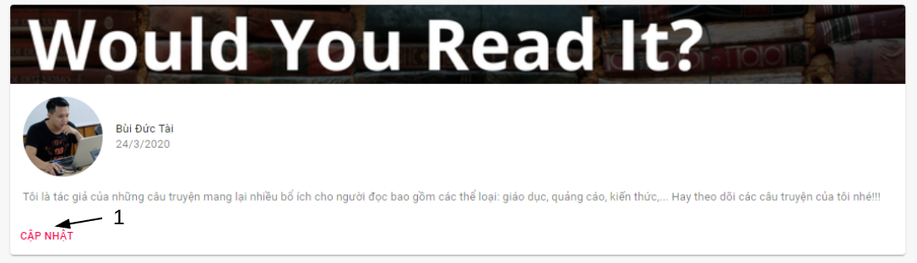

*Figure 109 - < User > User introduction interface*

Buttons/Hyperlinks

|  |  |  |  |  |
| --- | --- | --- | --- | --- |
| **No** | **Function** | **Description** | **Validation** | **Outcome** |
| 1 | Edit user profile | Edit user profile | N/A | Tranfer to edit user profile page |

*Table 122 - <Buttons/Hyperlinks> User introduction*

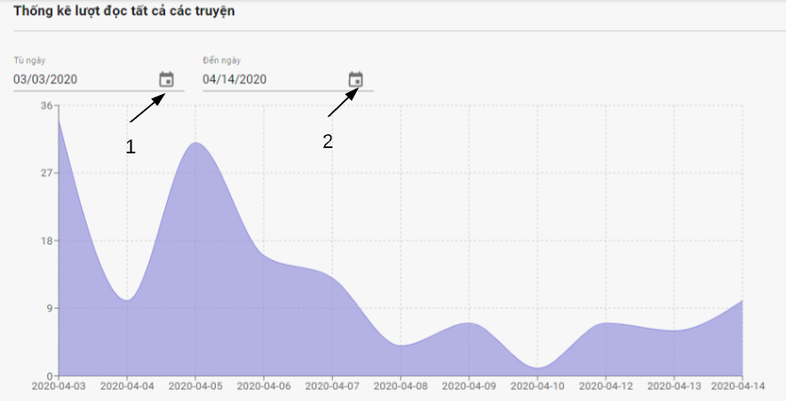

*Figure 109 - < User > User stories view statictic interface*

Fields

|  |  |  |  |  |  |  |
| --- | --- | --- | --- | --- | --- | --- |
| **No** | **Field Name** | **Description** | **Read only** | **Mandatory** | **Control Type** | **Data Type** |
| 1 | Start date | Start date of time range in statistics table of stories view number by day | N/A | Yes | DatetimePicker | String |
| 2 | End date | Start date of time range in statistics table of stories view number by day | N/A | Yes | DatetimePicker | String |

*Table 122 - <Buttons/Hyperlinks> User stories view statistic*

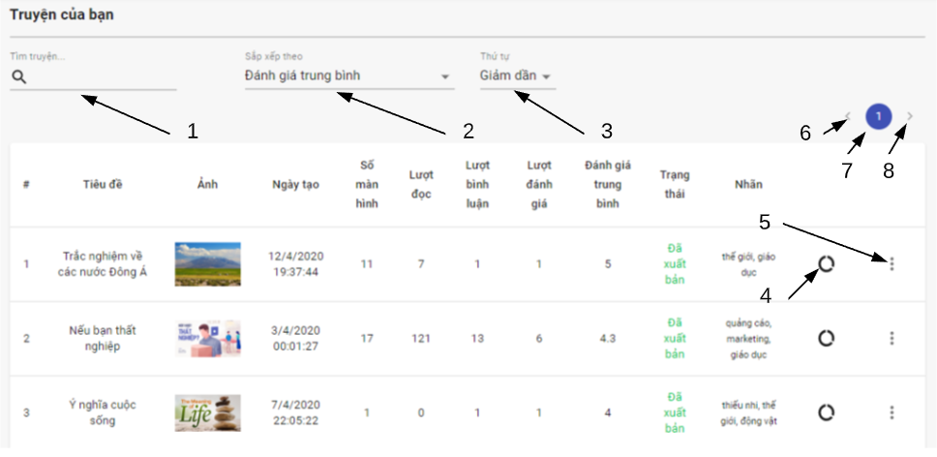

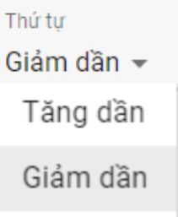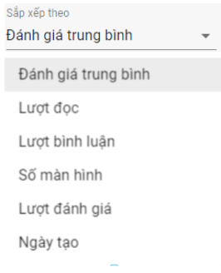

*Figure 109 - < User > User’s stories search interface*

Fields

|  |  |  |  |  |  |  |
| --- | --- | --- | --- | --- | --- | --- |
| **No** | **Field Name** | **Description** | **Read only** | **Mandatory** | **Control Type** | **Data Type** |
| 1 | Story title | Title of searching story | No | No | TextBox | String |

*Table 122 - <Fields> View user’s stories*

Buttons/Hyperlinks

|  |  |  |  |  |
| --- | --- | --- | --- | --- |
| **No** | **Function** | **Description** | **Validation** | **Outcome** |
| 2 | Choose criteria of story to order | Choose criteria of story like avg Rate, number of view,… | N/A |  |
| 3 | Choose order type | Choose order type to order list of story by criteria | N/A |  |
| 4 | Go to the story statistic |  | Required | Transfer to view story statistic |
| 5 | Open story settings |  | N/A |  |
| 6 | Select previous page | Back to previous page of searching stories | N/A | View previous page of searching stories |
| 7 | Select page | Select page of searching story | N/A | View specific page of searching stories |
| 8 | Select next page | Back to next page of searching stories | N/A | View next page of searching stories |

*Table 122 - <Buttons/Hyperlinks> View user’s stories*

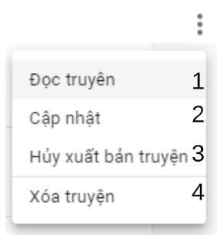

*Figure 109 - < User > User’s story settings interface*

Buttons/Hyperlinks

|  |  |  |  |  |
| --- | --- | --- | --- | --- |
| **No** | **Function** | **Description** | **Validation** | **Outcome** |
|  | Read story | Choose criteria of story like avg Rate, number of view,… | N/A | Transfer to read story page |
|  | Delete story |  | Required | Send delete story request |

*Table 122 - <Buttons/Hyperlinks> User’s story settings interface*

#### Edit profle

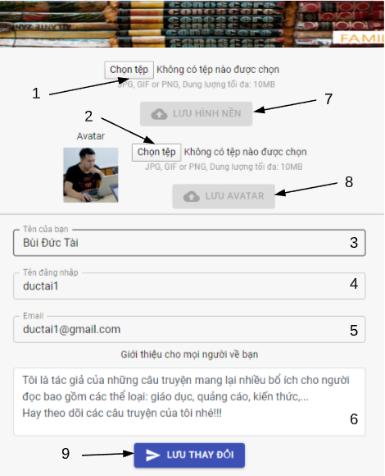

*Figure 109 - < User > User edit profile interface*

Fields

|  |  |  |  |  |  |  |
| --- | --- | --- | --- | --- | --- | --- |
| **No** | **Field Name** | **Description** | **Read only** | **Mandatory** | **Control Type** | **Data Type** |
| 1 | Background image |  | No | N/A | FileUpload | File |
| 2 | Avatar |  | No | N/A | FileUpload | File |
| 3 | Name |  | No | Yes | TextBox | String |
| 4 | Username |  | Yes | Yes | TextBox | String |
| 5 | Email |  | No | Yes | TextBox | String |
| 6 | Introduction |  | No | N/A | TextArea | String |

*Table 122 - <Fields> User edit profile*

Buttons/Hyperlinks

|  |  |  |  |  |
| --- | --- | --- | --- | --- |
| **No** | **Function** | **Description** | **Validation** | **Outcome** |
| 7 | Save background image | Save backgound image changes | Required | Upload backgound image |
| 8 | Save avatar | Save avatar changes | Required | Upload avatar |
| 9 | Save user information changes | Save user information changes include name, email, introduction | Required | Send profile update request |

*Table 122 - <Buttons/Hyperlinks> User edit profile*

#### Change password

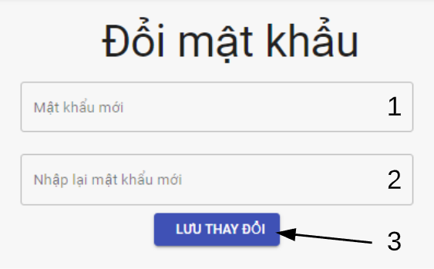

*Figure 109 - < User > User change password interface*

Fields

|  |  |  |  |  |  |  |
| --- | --- | --- | --- | --- | --- | --- |
| **No** | **Field Name** | **Description** | **Read only** | **Mandatory** | **Control Type** | **Data Type** |
| 1 | New password | New password to be updated | No | Yes | TextBox | String |
| 2 | Re-enter new password | Re enter new password that must be same with new password | No | Yes | TextBox | String |

*Table 122 - <Fields> User change password*

Buttons/Hyperlinks

|  |  |  |  |  |
| --- | --- | --- | --- | --- |
| **No** | **Function** | **Description** | **Validation** | **Outcome** |
| 3 | Save changes | Save new password | Required | Send update password request |

*Table 122 - <Buttons/Hyperlinks> User change password*