**Screenshot providing the extracted data from digital ID matches to the information on the ID**

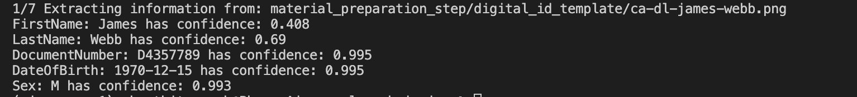

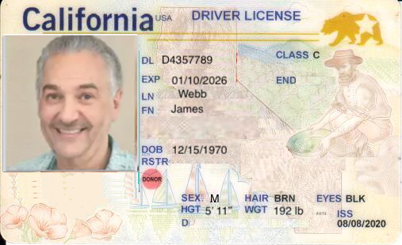

**Screenshot of label generation using label layout generation**

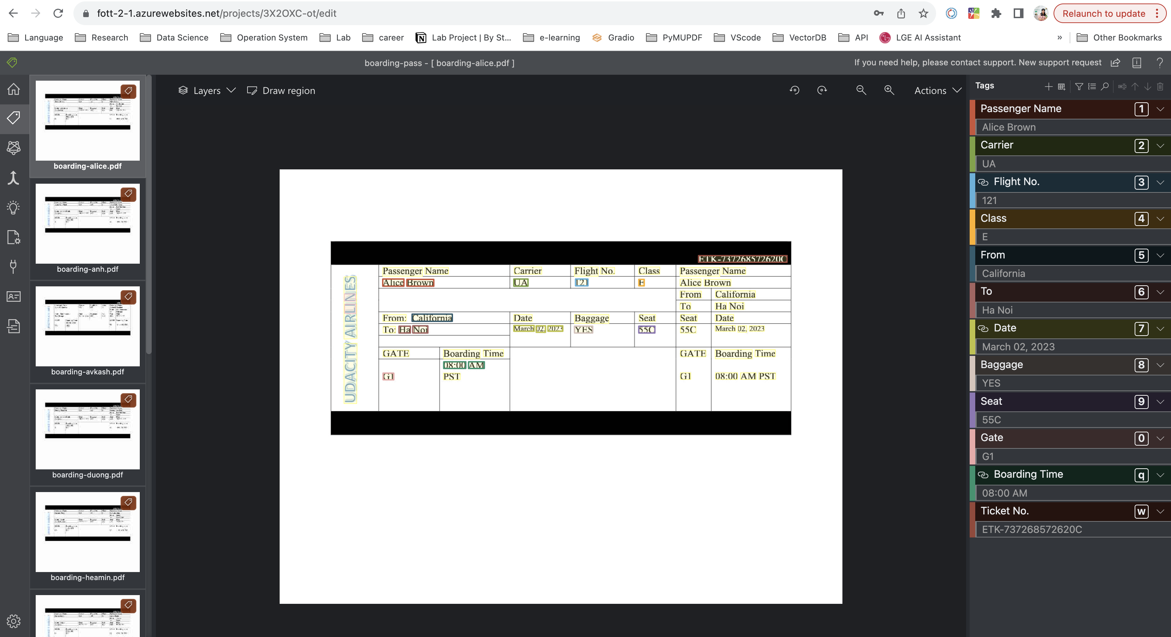

**Azure Storage Screenshot when boading pass and their training layout labels are stored**

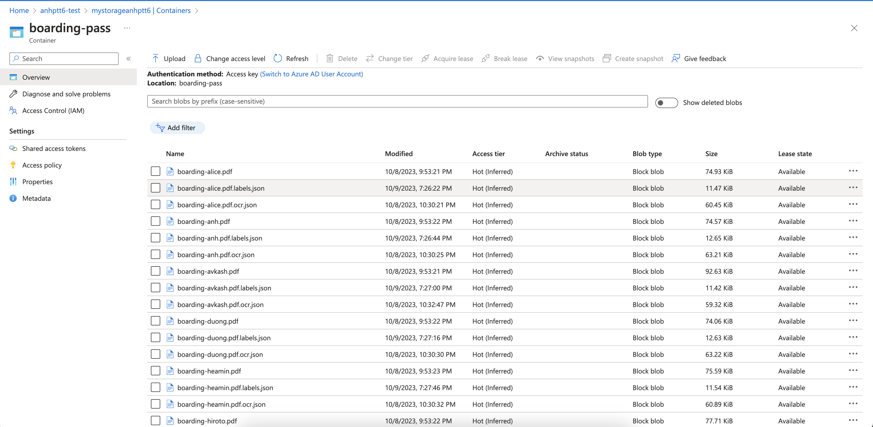

**Screenshot providing the extracted data match with the boarding pass**

