# List of Requirement

## Data source

Course data (995 row)

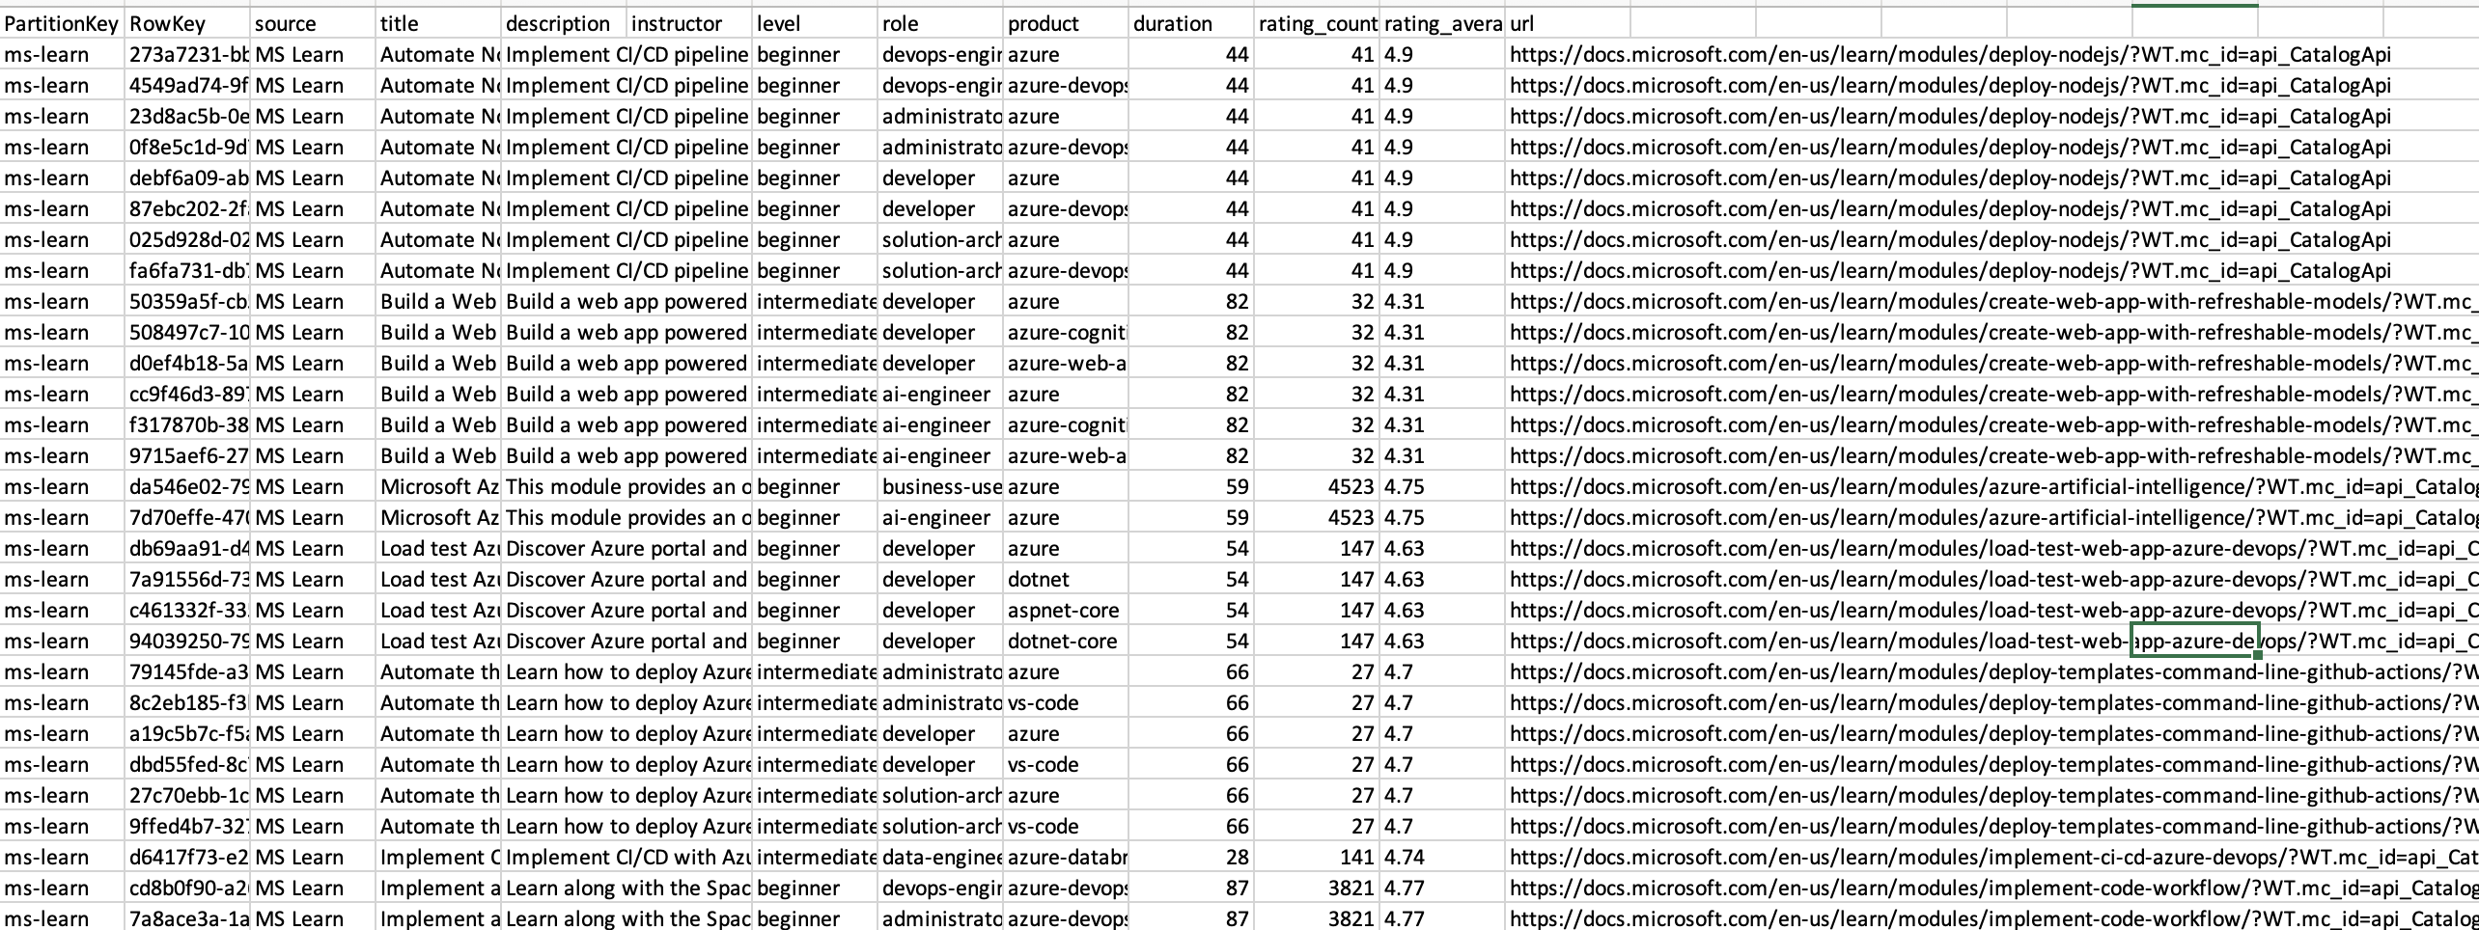

Curated Library (20 PDF files)

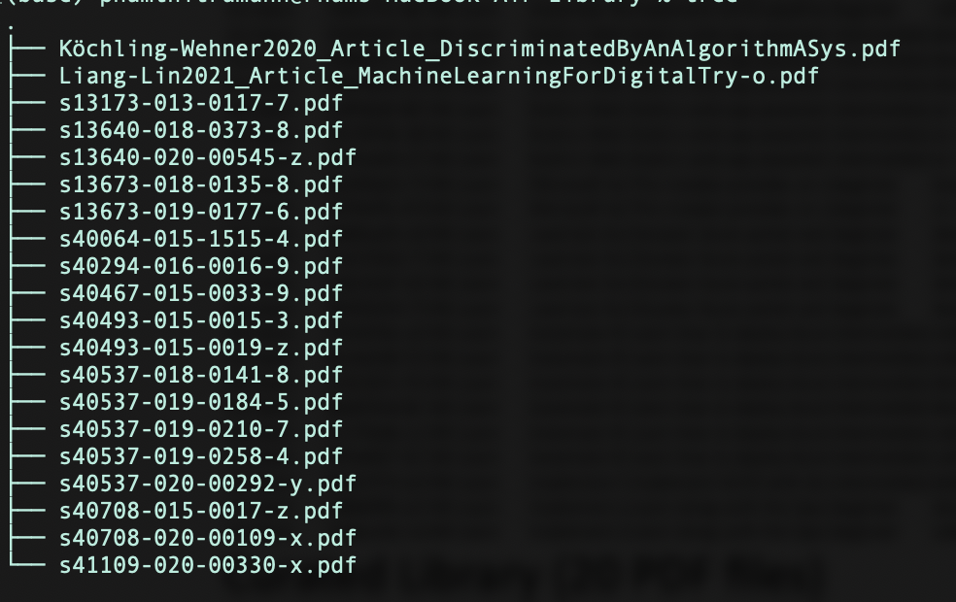

Instructor Profile (5 Instructors)

{

"inlineEntitiesDefinition": [

{

"name": "Mike Montoya",

"description": "Mike is our HR trainer responsible for helping employees be successful in their careers at our company. He has been with us for 3 years. Mike is an amateur chef and enjoys outdoor live music events."

},

{

"name": "Claudia Blackman",

"description": "Claudia is our senior DevOps engineer. She is charged with overseeing our DevOps operations and has been with the company for 2 years. Claudia enjoys downhill skiing and is a member of the local Search & Rescue Team."

},

{

"name": "Robert Gillis",

"description": "Robert is our GIS specialist in charge of making beautiful maps for our users. He has been with the company for 8 years and enjoys hiking, fishing, and any other outdoor activity."

},

{

"name": "Gerald Dominguez",

"description": "Gerald is a Junior IT Administrator and has been with the company for 1 year. Gerald played NCAA soccer and is a part-time soccer coach on weekends. "

},

{

"name": "Eileen Diaz",

"description": "Eileen is our Senior Security Engineer responsible for application and service security. She has been with the company for 9 years and enjoys writing Sci-Fi in her spare time."

}

]

}

## Enrichment

## Searching

* Users can search the Curated Library for papers by keywords and phrases, authors, publication name, publisher, and publication date, keywords and phrases, authors, and their associated institutions.
* Users can search Course Data by keywords and phrases from descriptions and other fields.

## Filtering

* Users can filter course data by course rating, rating count and duration

## Faceting

* Users can facet Course Data by role, product, and level
* User can facet course instructors by source, skill and role

## Sorting

* Users can sort course instructor by source, skill and role

## Retrievale

* Course data
* Instructors

# Diagram

