General Purpose Computer Tasks 3
1. Using Windows Explorer 3
2. Running a program 4
3. Browsing for a file 5
4. Creating a shortcut 6
5. Creating folders 7
6. Capturing a picture from the screen 8
7. Using the Task Manager 9
8. Taking files with you to other computers 10
9. Updating a page on our website 11
10. Using the Control Panel 12
11. Searching for Files 14
Printing Tasks 15
1. Printing from the manual feed tray 15
2. Using the Print Manager 16
3. Troubleshooting the printer 17
Personal Assistant – Application Explorer 18
1. Application Toolbar 19
2. Application List 21
3. Status Bar 24
4. SpellCheck & Thesaurus 25
5. Searching Applications 27
6. Browsing the Archive 30
7. Editing Applicant Data 31
Personal Assistant – Client Explorer 40
1. Client Toolbar 41
2. Client List 42
3. Editing Client Data 44
4. Billing Considerations 45
Personal Assistant – Information Resources 46
1. Landlord Contact Database 46
2. Criminal Information Sources 47
3. Employment Verification Channels 48
4. Document Library 49
Personal Assistant – Invoicing Manager 50
1. Searching Invoices 51
2. Searching Applications 52
3. Report Types 53
4. Monthly Billing 54
5. Billing Validation 55
6. Printing/Emailing Invoices 56
Personal Assistant – Miscellaneous 57
1. Automatic Documents and Reports 58
2. Editing your Timecard 59
3. User Manager 60
4. Program Settings 61
5. Common Datagrids 62
Quick Tips 65
Glossary 66

Chapter 1

General Purpose Computer Tasks

This chapter describes the most basic tasks that you must become familiar with in order to use your Windows computer effectively.

1. Using Windows Explorer

Windows Explorer is your gateway to all of the files and programs that are stored on your computer or the network. If you would like to develop proficiency with day-to-day activities, then this is a wise place to start. Unlike its close relative Internet Explorer, all of the information accessed using Windows Explorer has a place in a hierarchy.

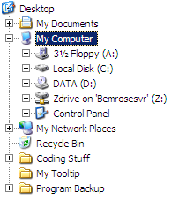
This is the hierarchy in which all files on your computer are stored. At the very top is the desktop. If you create folders on your desktop, they are listed at the end, as in the three folders at the bottom of this picture.

All of the items listed underneath ‘My Computer’ (except for ‘Control Panel’) are organized using the same folder/subfolder/file method as a normal hard drive. This means that you can learn one program, Explorer, to easily manage all of your files, regardless of where they are stored. Naturally, there are a few obvious differences for removable media such as a floppy disk or CD-ROM. For example, you can explore a floppy disk in almost exactly the same way as your hard drive, provided that a formatted disk is in the drive and it is not write-protected.

Explorer recognizes several ‘Special Folders’ on your hard drive. The ones which are most important to the average user are the My Documents Folder and the Desktop Folder. Even though they are displayed as separate from the Local Disk drive for easy visual access, they are in fact regular folders on your hard drive. On my machine, the path to the desktop is “C:\Documents and Settings\Luke\Desktop”, and to the My Documents folder is “C:\Documents and Settings\Luke\My Documents”. Most XP machines would have a similar path, with only the user name changed. This means that you can access the same files by exploring this directory, but is usually easier to use the shortcut at the top of the hierarchy for My Documents or the Desktop.
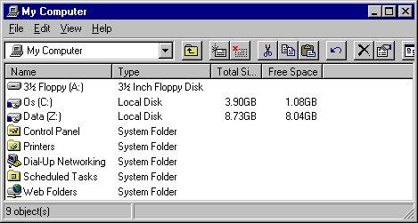
Usually the easiest way to start Explorer is to activate the ‘My Computer’ icon on the desktop. This can be done by double-clicking on it or by pressing the arrow keys or tab until it is highlighted and then pressing ENTER. From here you can access files on any of the disk drives, whether they are floppy disks, hard disks, or network drives. You can also access the control panel, which allows you to change many of the settings on your computer.

2. Running a program

Windows programs are started in two main ways. You can start the program all by itself, or you can activate a document that depends on the program. In the latter case, the program opens up by itself as before, but then immediately displays the document that was activated. For an example, think of Microsoft Word. You can start this program with no existing file open directly from the start menu, or you can open an MS Word document.

Most programs on your computer can be started by finding the appropriate item on the Start Menu. There can be many programs there so it may take a minute to find the correct one. Another more versatile way is to use the ‘Run’ item from the start menu.

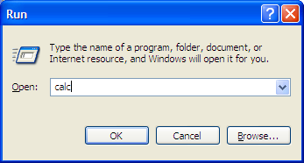
This is the dialog that is opened. You can use the ‘Browse’ button to find the file that you want (keep reading this chapter for information on browsing for a file), or you can type in the full path of the program that you want. For programs that are stored in the Windows system directories, you need only to type the name of the program; the path is optional.

For most programs, you must type the entire path to the program. Here are a few of the more useful programs that can be run by typing only the name:

Program name: Description:

calc A calculator that can be used for most any of the normal functions other than graphing.
iexplore Internet Explorer.
mspaint A picture editor.
notepad A simple text editor.
winword Microsoft Word.
explorer Windows Explorer.

All of these programs other than calc can be followed by the path to a file you would like it to open. For example, you could type ‘iexplore www.bemroseconsulting.com’ to view our website, or ‘notepad c:\temp.txt’ to edit a file. If there are spaces in the path, you will need to enclose it in double quotation marks, as in ‘mspaint "Z:\BPA\Program Graphics\Tools\1.bmp"’.

For commonly used programs, you will want to place a shortcut to the program on your desktop. Keep reading this chapter for information on how to do this.

Windows keeps a record of files that you have opened recently. If you wish to re-open any of those files, you can do this from the start menu, under ‘Recent Documents’.

3. Browsing for a file

Often when using any program, you will need to browse to a file. For example, a word processor will need you to find the file you wish for it to open. Note that in some situations, the file does not have to exist. This is the case when saving a file. If you choose a file that already exists, it will save over it; otherwise it will create a new one with the name that you specify.

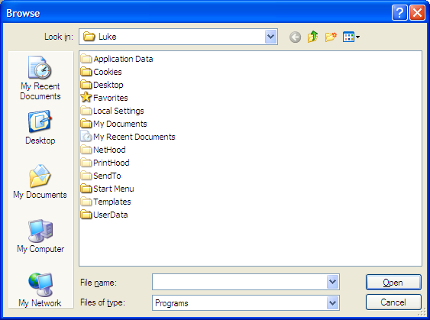
Most ‘Browse for file’ dialogs that you will come across will look similar to what you see here. In order to quickly find the file that you want, you will need to learn about each option available on this dialog. It is possible that some dialogs will be arranged differently, and some will not have all of the features, so it is best to learn what function goes with each picture so that you can recognize the same picture later.

The most important thing to know when browsing for a file is the layout of your hard drive. Almost always this will be the C:\ Drive. Here in the Bemrose Office, the network drive is designated as the Z:\ Drive. You can create as many folders and subfolders on these drives as you find useful. For an example, consider the following structure:

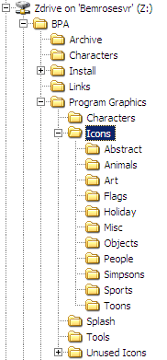
The ‘BPA’ Directory was created to contain all of the files used by the Bemrose Personal Assistant. The ‘Archive’ folder contains files that were used at one point, but are no longer necessary, but are worth keeping around. The ‘Program Graphics’ Folder contains folders for each type of graphics (pictures) that are used primarily for the icons, splash screens (when you log on), and the tool button pictures on the Application Explorer.

Using folders to create a logical storage structure greatly simplifies finding a file that you need. If all of these files were in the same directory, there would be over 3,000 files. Although it may seem confusing at first to have to know the folders that contain each of the files that you are using, it serves a very important purpose.

For another example, say that you have typed a Microsoft Word document, and you would like to save it so that you or another person can access it from any of the other computers on the network. You will have to save it on the network drive (Z:\), but to decide where on that drive you will have to consider a few things. If the document is for one-time use, you may elect to save it in the root directory (z:\somefile.doc), and delete it when you are done. If it is part of a category that you plan on using for several documents, you may create a new folder for it. For example, if you typed up the Rental Criterias for several clients, you could create the directory ‘Z:\Criteria’ to store all of them.

4. Creating a shortcut

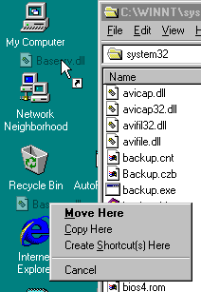
Shortcuts are basically a pointer to another program, document or internet site that you can place on your desktop or elsewhere to avoid having to navigate through several folders to get to the files that you use frequently. There are numerous ways to create them; here are some of the most useful.

1. If you would like a shortcut to an internet site, the easiest way is to go to the site in Internet Explorer, right click inside of the page, and choose ‘Create Shortcut’. It will prompt for confirmation before creating the shortcut on your desktop. You could then move it to another location.

2. If you would like a shortcut to a program, you can use Windows Explorer to find the file, then click and drag the file onto the desktop while holding both the Ctrl and Shift keys. Your cursor should show the shortcut icon as seen next to the top cursor in the example on the right. Often, you could also simply use the right button to drag instead of the left, which will show the context menu seen at the bottom of the example.

3. The more powerful, but slightly less intuitive method is to use the task automation that is provided by Explorer. Instead of navigating to both the destination and source folders(Desktop and ‘C:\WINNT\System32’ in the example above) for clicking and dragging, you can navigate only to the destination, right-click, and choose the ‘New’ Menu, then choose ‘Shortcut’ to activate the wizard seen below.

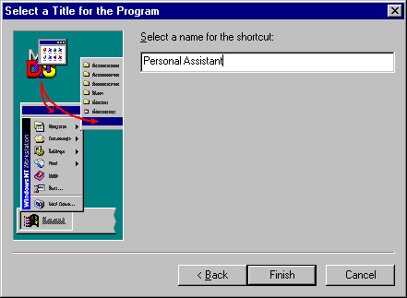
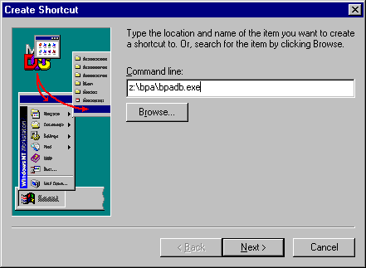

First you will be prompted for the path to the program that you would like to be the target of the shortcut. See ‘Browsing for Files’ later in this chapter for information on browsing to find the correct file. Then you will be asked for a name. You will want to enter a name that will always remind you of what Program or File is started by using the shortcut.

5. Creating folders

To create a folder, just right-click anywhere on the desktop or inside of Windows Explorer and choose ‘Folder’ from the ‘New’ menu. You can then add files to it by clicking and dragging. One thing to remember, though, is that all of the files that have an Icon in the corner are actually shortcuts. You can move these shortcuts to your new folder, but it will not change the location of the file targeted by that shortcut. (The file that is opened if you double-click on it.)

An alternative to using the right-click menu to create a folder is often available. If you see a button with a picture of a folder with a sparkle in its corner, then you can create a new folder by clicking on that button. The picture will usually look something like this:

Seen here is the right-click method for creating a new folder.

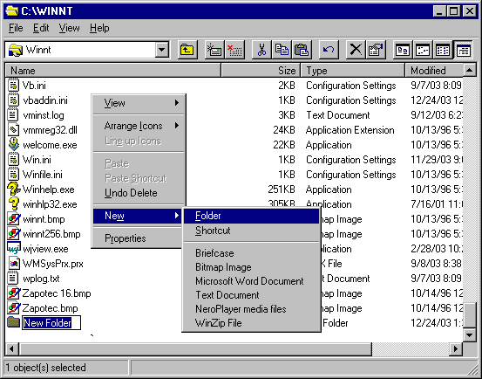

6. Capturing a picture from the screen

To capture part or all of the screen into a file, press the ‘Print Scrn’ button towards the top right of your keyboard. This will copy the screen to the clipboard, and you can paste it into any application. If you hold the Alt key while you press Print Scrn, then it will copy only the active window. Once you have pressed Print Scrn, just open Microsoft Paint. (It is often located on the start menu, under programs, then accessories. You can also go to Start, Run, and type ‘mspaint’, and then press ENTER.) Once you have the picture that you want to use, click on the ‘File’ menu and choose ‘Save As’ to save the file.

Here are the step-by-step instructions for the most simplistic way to capture a picture from the screen.

Let’s say that there is a picture on a web page that you would like to save to a file. Make sure that the picture is completely visible on the screen, and then press the ‘Print Scrn’ button. Click on the start menu, and choose ‘Run…’. Type ‘mspaint’, then press ENTER. When the program opens, press CTRL-V to paste the screenshot. You should now have a window that looks something like this:
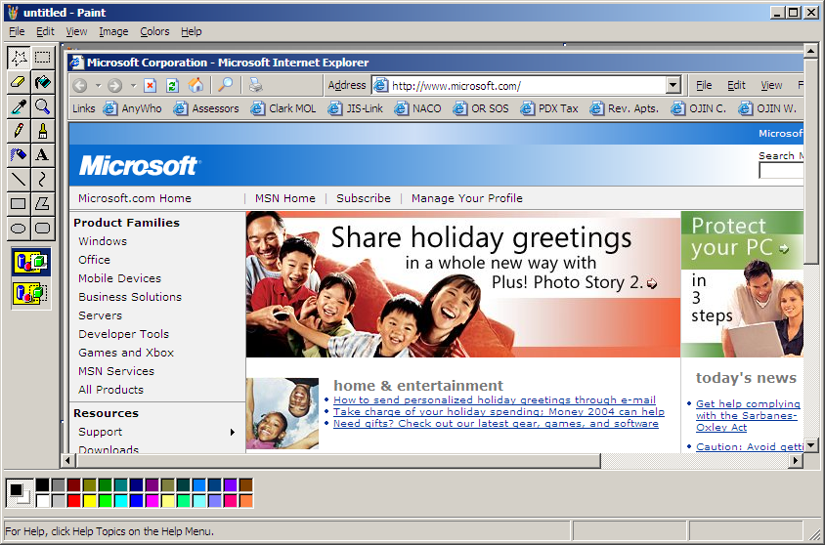
Choose one of the tools from the top left corner of the window that looks like a rectangle or star made out of a dotted line. Once you have selected the tool, you need to click and drag around the part of the picture that you wish to keep. The star-shaped tool will allow you to use free-form selection, in any shape that you can move the mouse while holding down the left button. The rectangle will only make rectangular shapes. You want to be as exact as possible, but be sure that no part of the picture that you want is excluded from the selection.

Once you have selected the part that you want, press CTRL-C to copy it. Then choose ‘New’ from the ‘File’ menu on the top of the window. It will ask if you want to save changes, choose ‘No’.

A blank picture will come up, and then press CTRL-V to paste in your picture. If you copied parts of other pictures behind the one you have intended, then you can erase them by choosing the eraser button below the dotted star. Once you have selected the eraser, you can change the shape that is erased as you move the mouse by choosing a shape from directly below the tools. Click and drag to erase, but if you need finer resolution you will want to use the pencil tool, choose a color, and change the view by clicking on the ‘View’ menu, and choosing ‘Zoom’, then ‘Large’. Remember that if you make a mistake, you can use the ‘Undo’ and ’Redo‘ items in the ‘Edit’ menu. Once you are satisfied with your picture, choose ‘Save As…’ from the ‘File’ Menu and decide where you would like to save it.

7. Using the Task Manager

The Task Manager has several useful functions but perhaps the most important is its ability to command any program to quit, even if it has stopped responding otherwise. To access the Task Manager, right-click on an open area in your task bar. If your computer has stopped responding, you can still access it by pressing CTRL-ALT-DELETE, then choosing ‘Task Manager’.

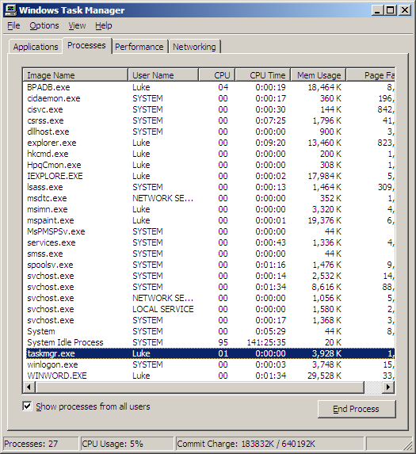
To end a program that has stopped responding, you need to find it in the list of running processes. The ‘Image Name’ column will have the name of the executable file. For example, Internet Explorer will be listed as ‘iexplore.exe’. If you do not know the name of the file, then you may be able to deduce which process it is with the CPU column. If the application has stopped responding, the chances are good that it has entered an endless loop, and will be using the processor far more than any normal program would. So if there is one item that has a very large value in the CPU column, it may be the offending program. Once you have located the process, simply click on it, and then choose ‘End Process’. You will be prompted for confirmation, and then you computer will begin shutting down the program. Depending on the size of the mess left by this program, Windows could take anywhere from a few seconds to a few minutes to return to normal functions.
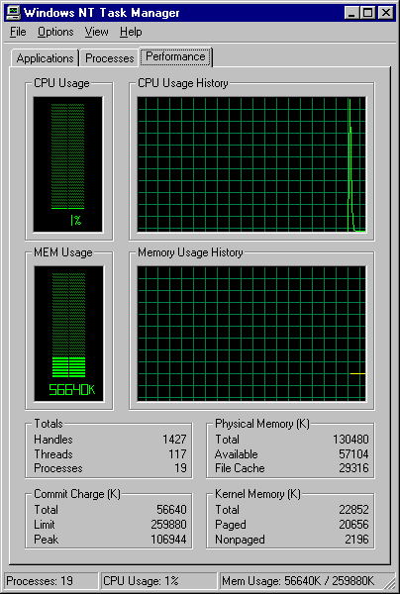

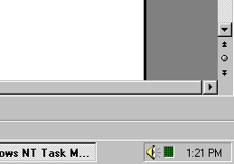
The Task Manager is also a source of information on the current state of your computer. It has current statistics, the most pertinent of which is memory usage. If programs seem to run well at first, but all seem to slow down after several hours(or when you open several programs at the same time), then it may help to try to keep few enough programs open so that the memory use is close to or below 50%. The meters can be seen either on the ‘Performance’ tab or the system tray, as pictured right and below respectively.

8. Taking files with you to other computers

To move a file from one computer to another, you have three options. If the computers share a network, then you can copy the file to a network drive and access the same network drive from the other machine. If both computers have internet capability you can send an email attachment or use a direct transfer protocol such as FTP. In other cases, you will have to save the file onto a removable storage device, whether that is a floppy disk, a CD-RW, or a Flash Drive.

To use any method listed above other than FTP, follow these instructions:

First the prerequisites:
- You will need to know the name and location of the file(s) that you need.
- If using removable media you will need sufficient space to hold all the files.
- If using a network drive you will need to be connected and to know the letter of the drive.
- If using email, you will need to know the email address that will receive the files, have a valid email account set up on your machine, and be connected to the internet.

Locate the file or files that you are interested in using Windows Explorer. See earlier in this chapter for specific information. Once you have found the files, make sure that they are all selected and that no unwanted files are also selected.

Then follow one set of instructions below depending on which method you will be using.

To use a network drive or removable media, you will need to know the name of the drive, and if it is removable, you will need to insert something with enough space to hold the files. First copy all of the files that you selected above using CTRL-C, the right-click menu, the toolbar, or the edit menu, and then navigate to the appropriate drive. Currently in our office the network drive letter is Z, and most floppy disk drives are A. Once you are at the drive, paste the files using CTRL-V, the right-click menu, the toolbar, or the edit menu. You may choose to paste them into the root directory, to place them into an existing folder, or to create a new folder for them. Then you move to the second machine, navigate to the network drive, and access the files. You may want to delete one of the copies when you are done, either from the first computer or from the network drive.

To attach the files to an email, you have two choices. You can right-click on them, then choose ‘Send To’, then ‘Mail Recipient’, or you can choose ‘Run’ from the Start menu, and type ‘mailto:email@address.com’ substituting the target email address, then press ENTER. When the email comes up, you can click and drag the files from Explorer onto the email message. After choosing one, fill out the email using the message body, subject, or anything else you want to include, and press ‘Send’. Note that it is possible to have your computer set up to send emails right away or to wait for a set amount of time, or to wait until you send and receive.

To get a file from an FTP site, follow these instructions:

To do this, you will need to know the name of the ftp site that you wish to download from. The easiest way is to use Internet Explorer. Type in the ftp address where you normally type in a web address. For example, type ftp.bemroseconsulting.com instead of www.bemroseconsulting.com. For many FTP servers, when you first navigate to the site you will have to enter a password. This can usually be accomplished by right-clicking inside the web page portion of internet explorer, and choosing ‘Login As..’. Once the file is in view, you can simply drag it to the desktop or to another folder.

9. Updating a page on our website

Over time, the links on our resources page may be broken, or you may want to update the client statements on the home page, or change other information. The first step is to navigate to the appropriate site, such as ftp.bemroseconsulting.com. This is done in the same way that you would go to www.bemroseconsulting.com, just type it into the location bar of your browser. When you first go to the site, it will likely give you a message saying that access is denied. This is because you must log in first. Once you have navigated to the FTP site, you can log on by right-clicking inside the white space where a web page would usually be, as seen below.

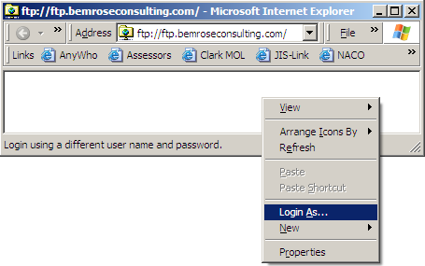
Once you are logged on, you will need to find the file you want to update. Currently on our website all of the web pages are stored in HTML Documents in the Web Directory. For example, if you are changing the Resources page, you will want the Resource.html file located in the Web directory. When you have found the file, click and drag it to your desktop or to another folder to store it temporarily. This will copy the file from the FTP site to your computer, and show an icon to represent it. First, create a backup copy to preserve the original in case you don’t want to keep your changes. This can be done by simply copying and pasting the file in the same folder. Then Right-click on the original icon, and choose ‘Edit’.
Once you choose to edit the HTML file that is stored on your computer, Microsoft Word should start up, and ask you to confirm that you want to open it as a HTML file. Choose OK. If any other program starts up instead of Word (as may happen if you have another default

HTML editor set up, probably will not be an issue on our network) then you will need to start Word and manually open the file. Once the file is open, you have the web page in front of you for editing, as seen below.

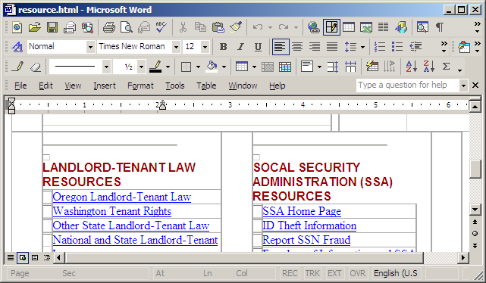
Do not be concerned if the pictures do not show, because you have only copied the file, and not it’s supporting pictures. It is possible to copy all of the pictures as well, but it is unneccesary when you just want to make a few changes.

From here you can click and type text to replace the text that is there and you can edit hyperlinks by right-clicking on one and choosing ‘Edit Hyperlink. Once you are satisfied with the changes, save the document and exit Word.

Once Word has closed, you need only to drag the file back to the web browser that you originally dragged it out of.

10. Using the Control Panel

Using the control panel, you can administer most of the software and hardware settings on your machine. There are upwards of twenty categories of settings available, so while you are greatly encouraged to explore and see what options are available, you must also exercise caution when making any changes. Outlined here are a few of the most useful items.

You can access the control panel from ‘My Computer’ on the desktop or using Explorer, or from the Start Menu under ‘Settings’.
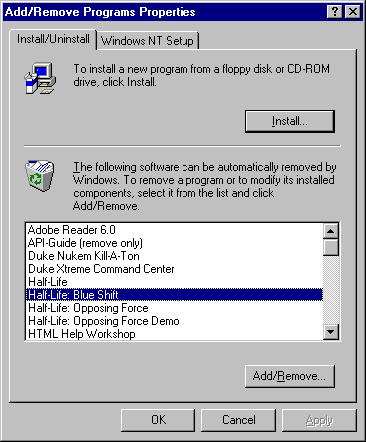
Add/Remove Programs
One of the most useful, here you can do just what the name implies, add or remove installed programs. For installation of a program, you will still need the installation CD or disks that came with it.

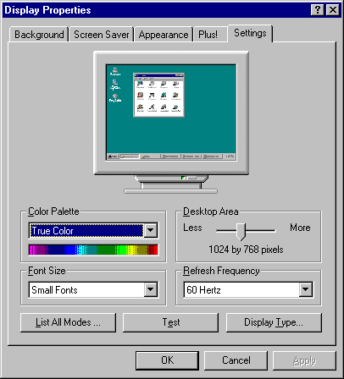
Display Settings
Here you can change the resolution and colors displayed by your monitor, as well as the appearance of various windows objects, your screensaver, and your desktop icons and background.

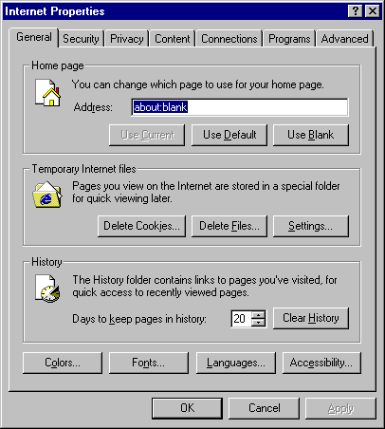
Internet Options
This will open the same dialog as is displayed from the Tools Menu of Internet explorer, allowing you to change your home page, security settings, temporary internet file settings, and may other internet-related options.

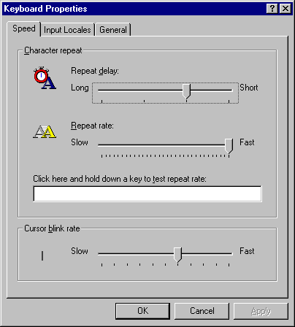
Keyboard Options
From here you can change the repeat rate and delay when you hold down a key, and the speed at which the cursor blinks.

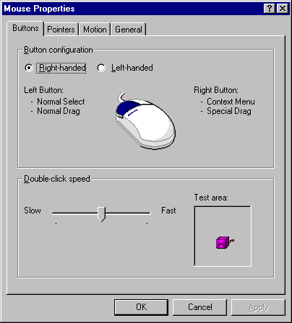
Mouse Options
This window allows you to change the double-click speed of the mouse, swap the left and right buttons, change the icons that are displayed instead of an arrow, hourglass, or other icon, and change the speed at which the mouse moves across your screen.

11. Searching for Files

To search for a file, open the start menu, and choose ‘Search’. Under XP, this will bring up the screen seen below.

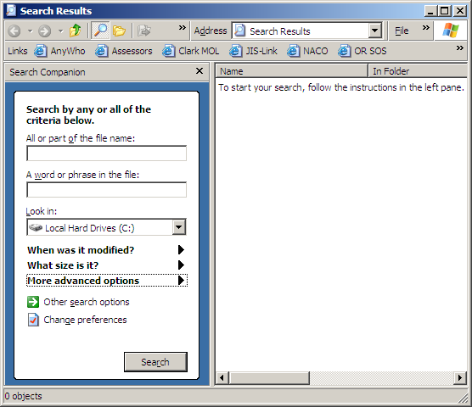

To use this window, you will take action based on what you know about the file. Hopefully you will know at least part of the filename. You can use wildcard characters the same as everywhere else, using * to match multiple characters and ? to match a single character. Unfortunately, the text search never works, so you cannot find a file based on a word or phrase in the file.

To speed up the search, you can choose the folder to begin the search. By default it will search the entire hard drive, but you may want it to search the network drive or a folder that is on the network drive.

You can also limit the search to files that were modified during certain dates, or files whose size are within a given range.
CHAPTER 2

Printing Tasks

This chapter describes some basic things that can be done when printing or experiencing problems printing.

1. Printing from the manual feed tray

In cases where you want to print a document onto a letterhead form, or a page that has already been printed on another side, it is very helpful to use the manual feed, because this can help ensure that the regular print jobs will not print on the paper first if they happened to be printing at the same time.

To print a form from the manual feed paper tray, you will need to inform the program that will be printing what you would like it to do. For Microsoft Word, this process is fairly simple, but there are two different ways.

If you would like the document that you are editing to always print from the manual feed tray, even if it is saved and then re-opened later, go to the ‘File’ menu and choose ‘Page Setup’. You will be presented with a tabbed dialog, and the middle tab should be ‘Paper’. Choose this tab, and then make sure that ‘Manual Paper Feed’ is selected in the list for the first page, and also the list for the other pages. Once you click ‘OK’, then anytime that you print the document it will default to the manual paper feed.

If you would like the document to print from the manual feed once, and then revert to the default print settings, start by choosing ‘Print’ from the ‘File’ menu. The standard print dialog will be shown, and you can click ‘Properties’ to edit the properties of the print job. You can change the paper source to ‘Manual Paper Feed’, and click ‘OK’ to close the printer properties. Click ‘OK’ again on the print dialog to print the document.
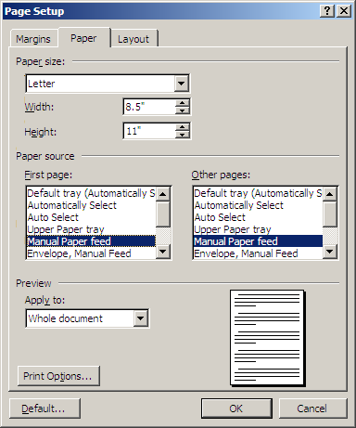
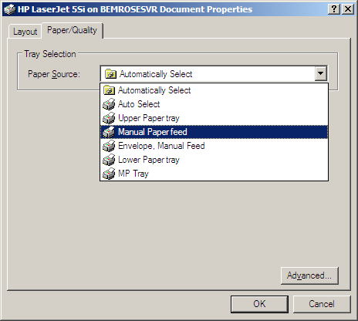

2. Using the Print Manager

The Print Manager is a great feature for Windows, because it allows you to control print jobs while they are still queued and waiting for their turn on the printer. There are two main functions for which it is used: canceling a document that was printed and cutting in line if there are numerous print jobs.

To open the print manager, click on the start menu, and choose ‘Settings’, then ‘Control Panel’. Find ‘Printers and Faxes’, and choose the printer that you are interested in. Currently the only printer on our network is entitled ‘HP LaserJet 5Si’. A simpler way, if you have print jobs in the queue, is to double-click on the small printer icon in the corner of the task bar.

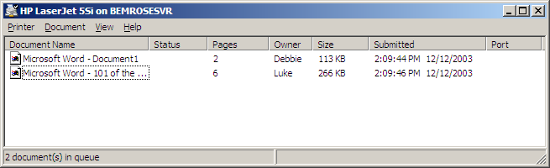

Sometimes it is difficult to determine which print job is the one you are looking for, but it usually can be deduced using the information that is shown. To cancel any print job, right-click on the list item and choose ‘Cancel’. This will cancel all the documents that are selected, so make sure that you only select the ones that you want canceled.

There are two ways to cut in the line and move your print job ahead to be printed sooner. There is an easy, less-than-reliable way, and a precise, forceful way. One thing to remember, though, is that if there is one very large print job, it cannot be split up, and thus if it is already printing, you will have to either cancel it or wait until it is finished. What this means is that if someone prints a 1000 page document (Or a 1 page document set to print 1000 copies) then once it has started printing, nothing else will be printed until it is either finished printing or canceled. You can only cut in line when there are separate print jobs. For example, when you use the Personal Assistant to print pads of applications, it will automatically separate the print jobs to print 50 copies at a time. If someone has printed 10 pads of applications, then you print a one-page cover sheet, you have your print job come out between pads of applications instead after they are all done.

The easy way is to right-click on your print job, and then choose ‘Properties’. There will be a slider for the priority of the print job, and it will probably be set to the lowest number, 1. Click and drag with your mouse to move this up to the highest priority. This way is fairly simple, but it does not seem to work in every situation.

The more precise method can be accomplished using these steps.
1. Click on the ‘Printer’ menu, and choose ‘Pause Printing’. This will give you more time to make the changes.
2. Select all of the print jobs, with the exceptions of the print job that you are wanting to print immediately and the current print job. The current print job will be the one at the very top of the queue. Once they are selected, right-click on one of them and choose ‘Pause’.
3. Click on the ‘Printer’ menu, and click on the ‘Pause Printing’ item again.
4. Once your document has printed, select all of the print jobs in the queue, right-click on one of them, and choose ‘Resume’.

3. Troubleshooting the printer

There have been times where the printer seems to ready, but when you print something, nothing happens. Usually I have seen this happen when a document is printed while the printer is powered off, and then the printer is turned on while the document is in the queue. Theoretically it could happen at other times as well. Here are some steps that you could try, arranged in the order that you would most often want to do them.

1. Open the Print Manager, by selecting ‘Settings’ from the start menu, and choosing ‘Control Panel’, then ‘Printers and Faxes’.
2. Be sure that the printer is not paused. Click on the ‘Printer’ menu, and if there is a check mark next to ‘Pause Printing’, then click on it to resume. If this does not work, continue with the next step.
3. Right-click on the first (top) job in the queue, and choose ‘Restart’. Give this a minute or two to see if it works, and if not then continue with the next step.
4. If none of the preceding was able to solve the problem, then it’s time to bring out the big guns. If you choose to use these steps, then you will have to re-print everything in the print queue, because it will be started all over.
a. In the print manager, click on the ‘Printer’ menu, and choose ‘Cancel All Documents’. This may have no visible effect, but that is alright.
b. Go to the print server. Currently this is the computer located at the front of screener’s row, directly next to the printer. You will need to log in if it is not logged in already.
c. From the start menu, choose ‘Settings’, then ‘Control Panel’. From the control panel, choose ‘Services’. This will bring up a window that looks much like this one:

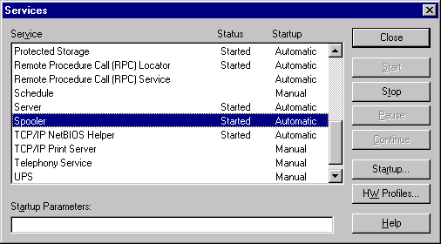

d. Find the service in the list that is called ‘Spooler’. Select this service, and then click the ‘Stop’ button. This will take a moment, and when it is done, click ‘Start’. This will restart the spooler, and you should then be able to print your documents.
CHAPTER 3

Personal Assistant – Application Explorer

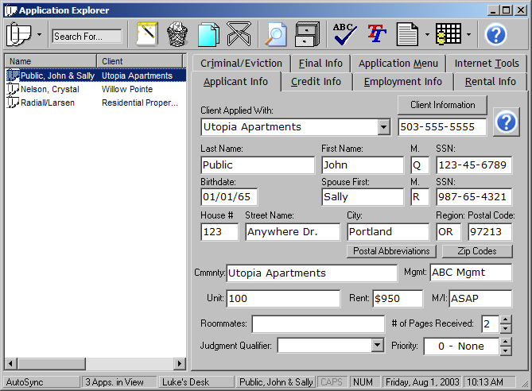

The Application Explorer is your gateway to all of the applicant information that is stored on our network. It allows you to view and edit the information, print reports and cover pages, create view and print lists of applications called datagrids, among other things.

1. Application Toolbar

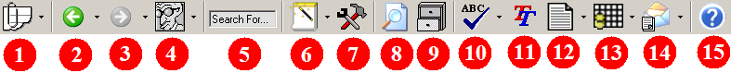

- This button controls the applications you are viewing by their current location. You can click on the drop-down arrow on the right side of this button to bring up this Menu:
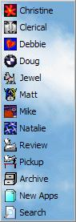
Use this menu to change the current location.
Select any screener to view their applications, or
select the Review, Pickup Table, or New Apps to
view other applications currently in-process.


- This button will move you to the applications that you were looking at previously. The drop-down list will allow you to choose from the last ten or so sets of applications that you were looking at, whether they were search results, a screener’s desk, or review.

- This button will also move you through the history list, but it will go forward instead. Both this button and the Back button are greyed out when there are no places in your history of viewed applications.


- This button will look different for each person. It will have the icon that is set up for the user who is logged in to the Personal Assistant. Clicking the button will send you to that person’s applications, and the drop-down list will allow you to choose between that person’s applications, Review, Pickup, New Apps, and Search or Archive.

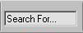
- You may use the ‘Search For…’ textbox to find any text inside of the applications that you are currently viewing. For example, you could type ‘Westland’ in this box and press ENTER to highlight all of the applications that contain that word, whether it is in the management company, employer, rental reference, or anywhere else. You can press ENTER repeatedly to cycle through each of the applications found so that you may find what you are looking for.


- This button creates a new application. You may also perform this function by pressing CTRL-N or by using the right-click menu from inside the application list. The drop-down list allow you to copy or delete the current application, or mark all of the selected applications as roommates.

- This button shows the Tools window, which will allow you to find zip codes, area codes, cities/counties and time zones.


- This button displays the ‘Search Apps’ Window. You can display this window by pressing CTRL-S, selecting ‘Search’ as the location, or selecting ‘Search Apps…’ from the right-click menu of the application list. See Section 5 for details.
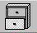
- This button displays the ‘Enter Archive’ Window. This window can also be displayed by pressing CTRL-A, by selecting ‘Archive’ from the location, or selecting ‘Enter Archive…’ from the right-click menu of the application list.


- This button will check the spelling of the currently selected application. If any errors are found, you will be prompted with suggestions to replace the word. You can run a mini-spellcheck on only the current textbox by pressing CTRL-D.


- This button will show the Thesaurus, allowing you to look up meanings, synonyms and antonyms. You can look up the currently selected textbox by pressing CTRL-T


- Using this button you can show a fax cover page for any applicant. By clicking on the button you can show a rental reference cover page, or use the drop-down list on the right for other options.


- This button will show the Common Datagrid Menu. You can also use the drop down list to create a datagrid from the applications that are currently shown, or the applications that are currently selected.


- This button will build all of the selected reports, including credit reports, and will then display the ‘Document Complete’ dialog which will allow you to email or print the reports.


- This button will show a character who is able to provide a limited amount of help.

2. Application List

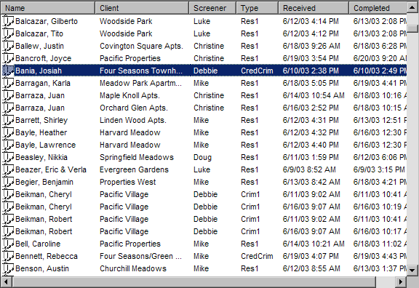

Here are a few tips on using this list effectively:
- Begin typing the name of an applicant to find it quickly.
- Hold CTRL while clicking on applications to select multiple applications individually.
- Hold SHIFT while clicking to select a range of applications.
- Press HOME or END to move to the beginning or end of the list. You can hold SHIFT while doing this to select all of the applications between the current application and the first or last one.
- Click on the column headers at the top of the list to sort the list by each column.
- Use the UP and DOWN keys to select adjacent applications.
- While editing application data, press CTRL-L to move the focus to this list to change the selected application, and press CTRL-L again to return to where you were editing.
- Right-Click on applications to display a menu of commonly used items. See the following pages for details.

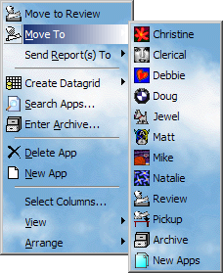

Selecting a location from the ‘Move To’ menu will move all of the selected applications to that location. A common location is displayed at the top of the menu, such as ‘Move to Review’ or ‘Move to Pickup’. Double-clicking on an application will always do the same thing as is shown in the top menu item.

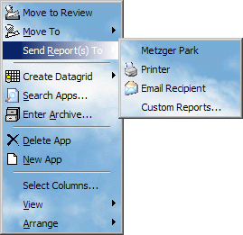
The ‘Send Reports To’ Menu will create the screening reports on the selected applications. You can then print or e-mail the report. If you select the client name from this menu, then the reports will be sent to a default delivery method that can be set from the Client Explorer. See Chapter 2 for details. Clicking on the ‘Custom Reports’ menu displays a window that is detailed in Chapter 7.

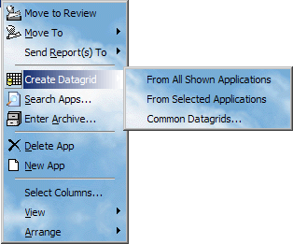

The ‘Create Datagrid’ Menu will allow you to create a datagrid on the applications that are currently shown.

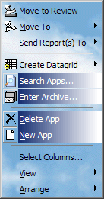

The ‘Search Apps…’ and ‘Enter Archive…’ items will display windows prompting for additional information. See Sections 5 and 6 for details.

You can select ‘Delete App’ to delete the current application, or ‘New App’ to create a new one.

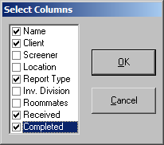
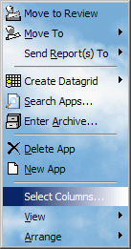
Clicking on this item, ‘Select Columns…’ will allow you to change the columns that are shown in the application list. The Screener and Location columns are always shown if the current location is Search Results, and the Screener column is always shown if the current location is the Archive.

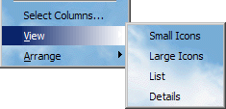

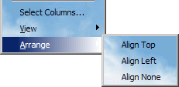
You can use the ‘View’ menu to change the way that the applications are displayed. ‘Details’ is the only view that allows you to see multiple columns. ‘Small Icons’ and ‘Large Icons’ allow you to organize the applications on-screen, and ‘List’ allows you to view many applications at once.

The ‘Arrange’ menu will affect how the applications are displayed in all views other than ‘Details’. Select ‘Align None’ to allow the applications to be organized on-screen.

3. Status Bar

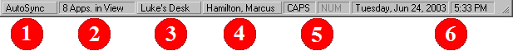

- There are two states for this panel, ‘AutoSync’ and ‘Static’. You can double-click this panel to toggle between the two. When ‘Autosync’ is selected, the application list will be refreshed to show applications which have been added or removed to the current location. By selecting ‘Static’, you can continue editing an application even if someone else moves it to a different location. For example, if you change this panel to ‘Static’ while you are editing an application, you can move the application to the Review, and then continue editing it without changing the location. It is a good idea to have the ‘Location’ Column visible in the application list if you choose to have a static view, so that you can keep track of the location of an application. See the preceding page for details on the ‘Select Columns…’ menu item on the right-click menu of the application list.

- This panel shows you how many applications are currently being shown.

- This panel shows you the current location. Click on this panel to bring up a menu of locations to choose from.

- These two panels show you the current state of CAPS LOCK and NUM LOCK. If they are grey, then the lock is off. If they are black, then the lock is on.

- These two panels show you the current date and time.

4. SpellCheck & Thesaurus
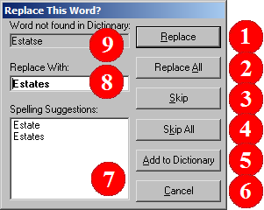

The Spellcheck can be started by pressing the button on the toolbar, (See Section 1) or by pressing CTRL-D. Pressing the Toolbar button will check all of the current application. Pressing CTRL-D will check only the textbox with the cursor.

- Pressing the ‘Replace’ button will replace the misspelled word with the word that is typed by number 8, under ‘Replace With’.

- Pressing the ‘Replace All’ button will replace this misspelled word and all occurrences of this word that are found during the spellcheck.

- Pressing the ‘Skip’ button will skip this word, but show the dialog if it is found again.

- Pressing the ‘Skip All’ button will skip all occurrences of the misspelled word that are found during the spellcheck.

- Pressing the ‘Add to Dictionary’ button will skip the word, and all future spellchecks will treat it as a correctly spelled word.

- Pressing the ‘Cancel’ button will skip the word and halt the spellcheck.

- Clicking on any word in the suggestion listbox will place the word into the ‘Replace With’ textbox.

- The word from this box will be used to replace the misspelled word if you choose ‘Replace’ or ‘Replace All’.

- The word shown on this label is the misspelled word that was found.

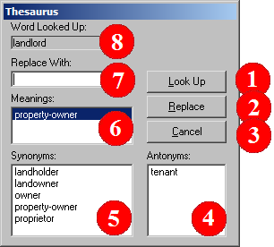
The Thesaurus can be displayed by pressing the button on the Toolbar, or by pressing CTRL-Q. If the Toolbar button is pressed, then you cannot insert a word into the application, and the replace button is not available. If the cursor is inside a textbox when the Thesaurus is shown, then it will look up the word that the cursor is on, and you can select another word to replace it.

- Pressing the ‘Look Up’ button will look up the word in the textbox by #7, and fill the meanings, synonyms, and antonyms listboxes.

- If you have shown the Thesaurus while the cursor was inside of a textbox, then you can press the ‘Replace’ button to replace the selected word with the word from the ‘Replace With’ textbox.

- Press the ‘Cancel’ button to close the Thesaurus.

- This listbox shows the antonyms that have been found for the word that was looked up. Clicking on any word will place it into the textbox by #7.

- This listbox shows the synonyms that have been found for the word. Clicking on any word will place it into the textbox by #7.

- This listbox shows any of multiple meanings that were found for the word that was looked up. Clicking on a meaning will fill the synonym and antonym boxes with the appropriate words.

- In this textbox, you can type any word to look up in the Thesaurus.

- This label shows the word that was looked up. You can double-click on the word to place it back into the textbox by #7.

5. Searching Applications

You can show the ‘Search Apps’ window by pressing the Toolbar button, changing the location of the Application Explorer to ‘Search’, or by pressing CTRL-S. There are three kinds of searches that you run, ‘Common Search’, ‘Simple Search’ or ‘Custom Search’.

Common Search

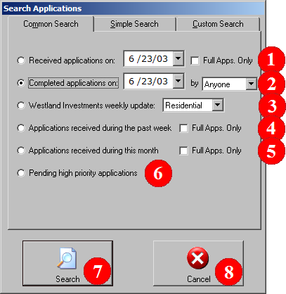
- Searches for a daily list for any selected day. Will include all applications unless ‘Full Apps. Only’ is checked.

- Searches for a completed list for any employee or for all employees.

- Searches for the Westland Update for Residential or Employment applications.

- Searches for all applications that have been received during the current week. Will include all applications unless ‘Full Apps. Only’ is checked.

- Searches for all applications that have been received during the current month. Will include all applications unless ‘Full Apps. Only’ is checked.

- Searches for applications with medium or high priority that are currently in process.

- This button runs the selected search, and displays the results in the Application List.

- This button cancels the search, and hides the ‘Search Apps’ window.

Simple Search

For a simple search, you can select to search back one week or one month, you can specify how many months back to search, or you can specify the dates you would like to search between.

You can also select to include In-Process Applications and/or Archived Applications, and provide a word or words to search for.

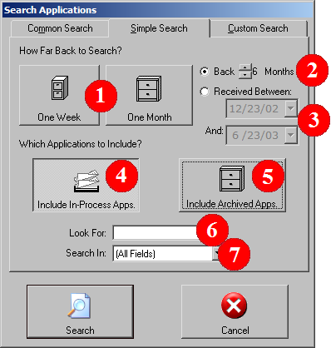
- Click these buttons to search back one week or one month.

- Click the up/down arrows to search back any number of months, or back as far as 1/02.

- When you select ‘Received Between’, you can select two dates to limit the search.

- When this button is pressed, In-Process applications are included in the search.

- When this button is pressed, Archived applications are included in the search.

- Type the word or words that you would like to find in this box. You may use * as a wildcard to match one or more characters if you are unsure of the correct spelling. For example, you could type ‘Jo*son’ here to find Johnson or Johanson. For birthdates or social security numbers, you can use wildcards, but you must match the format of the numbers as they appear in the ‘Applicant Info’ tab of the Application explorer. For example, 3/2*/65 will match all birthdates from 3/20/65 to 3/29/65, but 3/2*/1965 will match nothing. Also, for social security numbers 544-44* will match all numbers beginning with 544-44, but 54444* will match nothing.

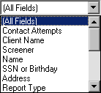
- You can use this listbox to limit the search to a specific field. For example, if you are looking for applications from a client named Mrs. Johnson, then you should select ‘Client Name’ from this list to avoid finding all of the applicants who are also named Johnson.

Custom Search

By using a custom search, you can run the most precise searches. You can find applications from certain clients, of specific report types, and between any dates that you provide.
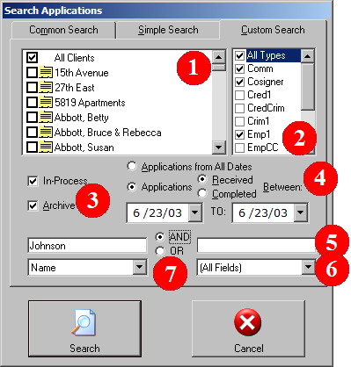
- Inside this list you can choose specific clients to find their applications, or check ‘All Clients’ to find any application.

- You can check one or more report types. Check ‘All Types’ to find any application.

- You can search In-Process applications and/or Archived applications using these checkboxes.

- You can select ‘Applications from All Dates’ for an exhaustive search of all past and current applicants. You can also choose to search through only the applications received or completed during specific dates.

- In this field and the corresponding field on the left you can enter a string of text to find in your search. You can use a * to match one or more characters. For birthdates or social security numbers, you can use wildcards, but you must match the format of the numbers as they appear in the ‘Applicant Info’ tab of the Application explorer. For example, 3/2*/65 will match all birthdates from 3/20/65 to 3/29/65, but 3/2*/1965 will match nothing. Also, for social security numbers 544-44* will match all numbers beginning with 544-44, but 54444* will match nothing.

- This listbox can limit your search to a specific field. This can improve efficiency if you know what you are searching for, whether it is in the Client Name, Applicant Name, etc.

- If you are searching for two strings of text, you can change the boolean operation to AND/OR. For example, if you had ‘Johnson’ in the first textbox, and ‘Westland’ in the second, then by choosing ‘OR’ you could find all the applicants who were named Johnson or also all of the applicants who applied through a Westland property, regardless of their name. By choosing AND, you would find only the applicants with the name Johnson who had also applied at a Westland property.

6. Browsing the Archive

To Browse the Archive, you just select the dates that you would like, and press ‘Enter Archive’. This will find all of the applications which were received or completed during those dates which are currently in the Archive.
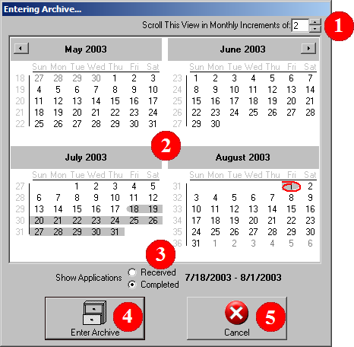

- The Months which are displayed can be scrolled using the right and left arrows near the top. By default, it will scroll two months at a time, but if you would like it to scroll by more or fewer months, you may change this number. For example, change this number to 12 to scroll a year at a time.

- This is where you select the dates that you are looking for. You simply click on the first day, hold the mouse button down, and drag to the last day.

- You can toggle between using the Receive Date or Complete Date to find the applications that are in the Archive.

- Press ‘Enter Archive’ to accept the dates that are selected and to view applications.

- Press ‘Cancel’ to hide this window and return to the Application Explorer.

7. Editing Applicant Data

Applicant data is done through the tab-style interface below. You can select each tab to view or edit the corresponding information. Often you will see a blue and white question mark button, and you may use this button to activate the Personal Assistant character, which will provide some helpful information.

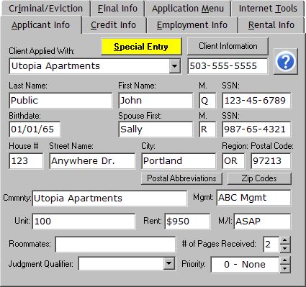
The yellow button marked ‘Special Entry’ appears whenever there are some client-specific circumstances that require your attention.

The client’s phone number appears next to the client name. You can press the ‘Client Information’ button to view or edit other client information.

You need to only type as much of the client name as is needed to recognize the client. The name will be filled in automatically, and the ‘Community’ and ‘Management’ Fields will be changed to reflect the new client.

To enter information into a new application, it is usually easiest to press ‘Tab’ to move to the next textbox without having to use the mouse. You can also press ENTER for the same effect, but using ENTER will move through all of the items that need to be entered on an application, including the report type and invoice division on the ‘Application Menu’ page.

In the ‘Roommates’ field, you can enter the roommate, as in ‘W/ Smith’, and it will be printed on the report under the name. You could also enter anything else that you wanted printed there, such as ‘COSIGNER’.

The ‘Judgment Qualifier’ still appears on this page so that you can see what was typed into it on old applications, but it is no longer used, so you cannot type new text into it.

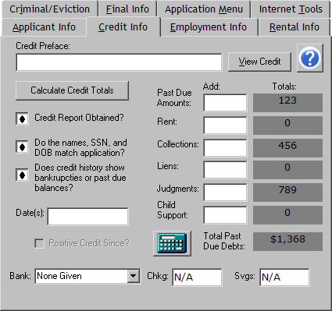
This is what the ‘Credit Info’ page will look like for Residential Reports. For Employment Reports, it will look the same, except it will not have the bank information.

You can use the ‘Calculate Credit Totals’ button to show outstanding debt automatically, or you may enter the balances yourself. To add negative credit you can type in the amount into the column marked ‘Add:’, and press ‘Enter’. This will add that amount to the total, and you can continue to add in the other accounts. If you already know the total, then you can just add the total in once. To delete the negative credit that has been entered, you can type a negative number into the ‘Add:’ column and press ENTER. You can subtract just the amount that was added in mistakenly or the entire amount.

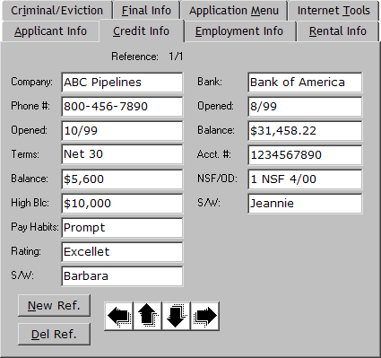
This is what the ‘Credit Info’ page will look like for commercial applications. You enter the bank information on the right side of the screen, and enter the credit references on the left.

You can use the ‘New Ref.’ button to add a new reference, and the ‘Del Ref.’ button to remove one. The left and right arrows are used to browse through multiple references and the up and down arrows are used to change their order. For example, if you are looking at the second reference as in the picture above, you can press the down arrow to move the second reference to the first position. The first reference will then become the second reference.

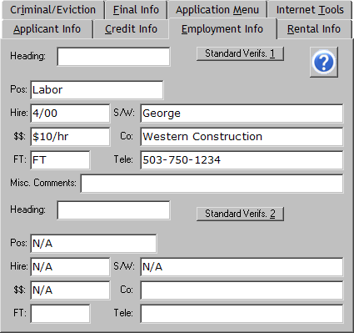
This is the ‘Employment Info’ page for Residential Reports. You can enter current and previous verifications for an applicant, or one verification each for an applicant and spouse. The ‘Heading’ textbox is used to describe the reference. If no text is typed into the box, ‘Applicant’ and ‘Previous’ will be printed, unless there is a spouse, and in that case, ‘Applicant’ and ‘Spouse’ will be printed on the report.

By pressing the ‘Standard Verifs.’ button, you will be given the menu of common verifications that you see below:

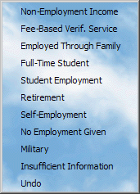
When you choose any of these menu options, one of the verifications will be filled with appropriate information. If you choose a menu item mistakenly, you can bring up the menu again and choose ‘Undo’ to restore the verification that was shown previously.

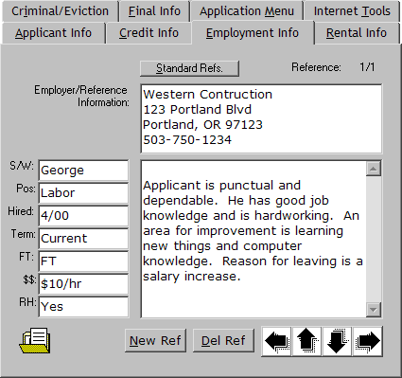
This is what the ‘Employment Info’ page will look like for Employment Reports. You can enter as many references as you need. Inside the ‘Employer/Reference Information’ box you typically want to enter the name, address, and phone number of the employer. In the case of a personal reference, you can describe who you spoke to and their relationship to the applicant.

You may press the ‘New Ref’ button to add a new reference, and the ‘Del Ref’ button to delete the current one. The left and right arrows are used to browse through the references and the up and down arrows are used to change the order. For example, when looking at the second reference as in the above picture, you can press the down arrow to move it to the first position. The first reference then is pushed to the second position.

The icon of a folder in the bottom right corner is used to copy a reference to another application. For example, if you are screening a married couple who share an employer, you can click on this icon and drag to the spouse that is shown in the Application List. When you release the button on the spouse, the reference is copied over into the same position that is shown.

You can press the ‘Standard Refs.’ button to bring up the menu of commonly used references as seen below:

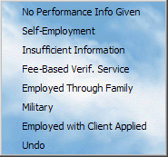

You can choose any of these references to fill the reference with appropriate information. If you mistakenly choose one of these items, you can choose ‘Undo’ to restore the reference that was shown previously.

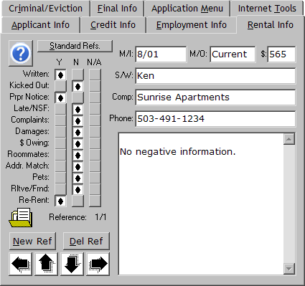
This is the ‘Rental Info’ page, where you can enter as many rental references as you need. If you need to enter a reference but have not spoken to anyone, you can fill in only the largest textbox on the bottom. If you speak to a landlord, input the name, the company that they work for and the phone number. In the case of a private landlord, then you can input just the name and put the phone number in either of the other two boxes.

While inputting a reference, there are several shortcuts that you can use. At the top of each column of checkboxes on the left side of the screen are the labels ‘Y’, ‘N’, and “N/A’. You can double-click on any of those labels to move all of the checkmarks to that column or right-click to move the checkmarks to show a standard, positive reference. You can also click on the words to the left of the checkmarks to toggle that row through the options. For example, as you are asking each question you could click one to three times on each label to enter the reference.

The folder icon in the bottom right corner is used to copy a reference. If you are screening roommates who share a landlord, you can click and drag from this icon to the roommate instead of entering it again.

By pressing the ‘Standard ‘Refs’ button, you can see these menus:

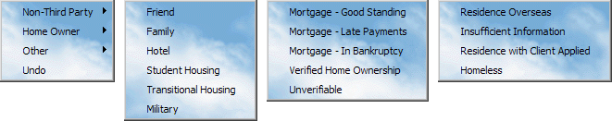

You can choose any of these menu items to fill the current reference with appropriate information. If you mistakenly choose any of these items, you can select ‘Undo’ to restore the reference that was previously shown.
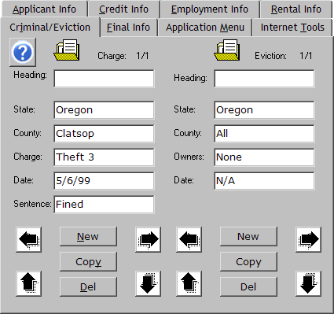
This is the ‘Criminal/Eviction’ Page. This page is unavailable on Commercial applications. You can enter as many charges and eviction filings as you need. The ‘Heading’ field is used to describe each charge or eviction. You typically need to use this field if you are screening a married couple. By typing a name into this field you can indicate which person that the charge or eviction was filed against.

You can drag from the folder icons to copy charges or evictions to another applicant. When dragging from the criminal charges, all charges will be copied. This is useful when an applicant has applied again with another client. When dragging evictions, one eviction is copied at a time.

You can use the ‘Copy’ button to create a copy of the currently shown criminal charge or eviction, if there were are filings that are nearly identical.

You can use the ‘New’ and ‘Del’ buttons to add or delete charges and evictions. The left and right arrows are used for browsing through the filings and the up and down arrows are used for changing their order. For example, if you are looking at the second charge, you can press the down arrow to move the charge to the first position, pushing the first charge to the second position.

While you are entering charges, you can press ALT-N to create a new charge, or ALT-D to delete the current one. You may do the same for evictions while the cursor is in the eviction textboxes.

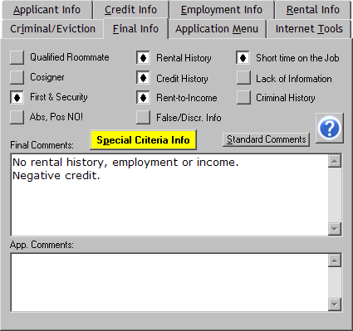
This is what the ‘Final Info’ page looks like for Residential Reports. For Employment, Commercial, and Credit/Criminal Reports, the recommendation boxes are unavailable. You can click on the box itself or on the words adjacent to it to toggle the checkmark.

The ‘Special Criteria Info’ button will display any client-specific information that has been inputted to help you in making an appropriate recommendation.

You can use the ‘App Comments’ box to store any information about the application screening. This field is never printed on any report, and is solely for administrative records.

By clicking on the ‘Standard Comments’ button you can view this list of options.

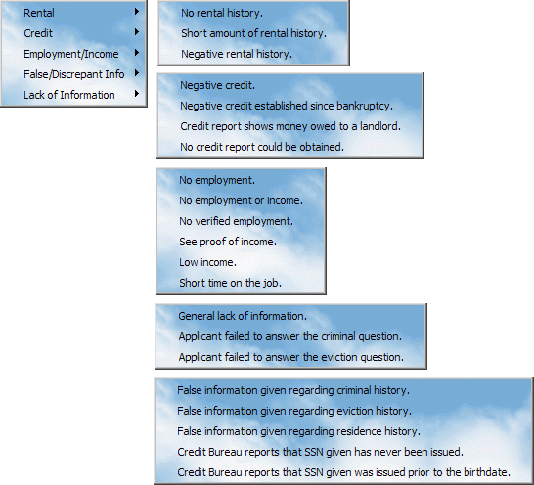
When you choose any of these menu items, the text is inserted into the final comments.

You can choose as many as apply to the applicant, and you can then type in other comments or make changes to the standard comments.

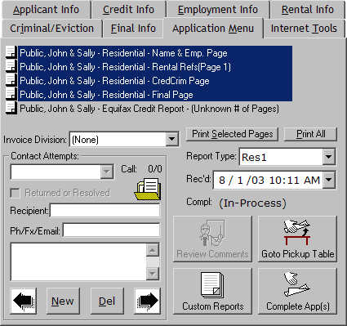
This is the ‘Application Menu’ page. From this page you can change the report type, received or completed date, invoice division and contact attempts. You can also print any of the pages in the report and perform various tasks with the four buttons in the bottom right corner.

The invoice division is only available for certain clients who require separate invoices. If it is available, the appropriate invoice division must be selected to ensure accurate billing.

If an application is In-Process, you can double-click on the label marked ‘Compl:’ to mark the application as completed. If it is completed, you can double-click on the same label to mark the application as In-Process.

The ‘Review Comments’ button is available only while the application is in the review, unless the reviewer has added comments that you can view.

The ‘Custom Reports’ button brings up a window prompting for more information. See Chapter 7 for details.

The two buttons on the bottom right of the screen change depending on your location. For example, if you are in the review, the top button will return the application to the screener, and the bottom button will send the application to the Archive.

The ‘Print Selected Pages’ and ‘Print All’ buttons will build and print the appropriate pages from the list above. You can right-click on these buttons to bring up a confirmation when the report is completed, which will allow you to print or email the report.

You can add or remove contact attempts with the ‘New’ and ‘Del’ buttons. A menu of common contact information is available by right-clicking on the folder icon above and on top of the ‘Contact Attempts’ frame.
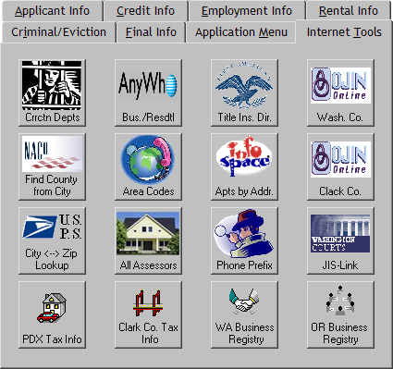
This is the ‘Internet Tools’ page. No applicant information is displayed here, but each of these buttons will open up the default internet browser and navigate to a website that can assist your investigation.

If it becomes necessary to change these tools you may do so by right-clicking on the button that you want to change to display this menu:

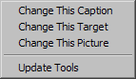
If you press ‘Change This Caption’, you will be prompted for the caption that you wish to appear below the picture on the button.

Choose ‘Change this Target’ to change the Web address that is activated when you click the button.

Choose ‘Change this Picture’ to change the picture that is displayed. You will need a small bitmap, with the largest size of 68 x 48. See Chapter 1 for details.

You can choose ‘Update Tools’ if someone else has changed these tools and you would like to use the updated version. These tools are updated automatically every time you log on to the program, but you could need to update them if you want to use changes that were made while you are using the program.

CHAPTER 3

Personal Assistant – Client Explorer

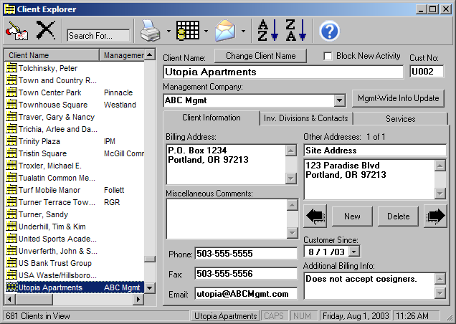

The Client explorer allows for editing of all the client information stored on our network.

1. Client Toolbar

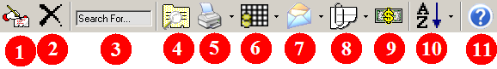

- This button will show you the window below, which will allow you to create a new client.

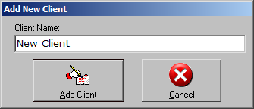
To use this window, just type the name of the client you would like to create, and then either press ENTER or click on ‘Add Client’. Or you may press ‘Cancel’ to return to the Client Explorer.

- This button will delete the selected client. You will be prompted for confirmation before the client is deleted.

- This textbox will allow you to search through the Clients. For example, you could type ‘Burnside’ into this box, when you press ENTER, the first match will be displayed and all other matches will be presented in bold type. You can press ENTER again to cycle through all of the matches.

- This button will allow you to search for clients. For example, you could search for all of the clients managed by Westland to shorten the list while you look through it.

- Use the drop-down list on this button to print Labels, Contracts, or Information Sheets.

- This button will show the Common Datagrid Menu. Use the drop-down list to create a datagrid from all shown Clients or the selected Clients.

- This button will send an email to the selected clients. Use the drop-down list to send email to all of the clients that are shown.

- This button will show the Application Explorer with the specified applications: For all shown clients, for all selected clients, or applicants which are not for any of the shown clients. For example, before you perform billing you could show all of the applications that are not for any of the clients, which will show you all of the applications that cannot be billed because they do not match a client name. (If there are any.)

- This button will allow you to change prices for the selected client.

- This button will sort the client list.

2. Client List

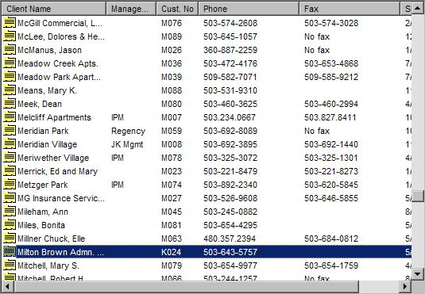

Here are a few tips on using this list effectively:
- Begin typing the name of a client to find it quickly.
- Hold CTRL while clicking on clients to select multiple clients individually.
- Hold SHIFT while clicking to select a range of clients.
- Press HOME or END to move to the beginning or end of the list. You can hold SHIFT while doing this to select all of the clients between the current application and the first or last one.
- Click on the column headers at the top of the list to sort the list by each column.
- Use the UP and DOWN keys to select adjacent clients.
- While editing client data, press CTRL-L to move the focus to this list to change the selected application, and press CTRL-L again to return to where you were editing.
- Right-Click on clients to display a menu of commonly used items. See the following page for details.

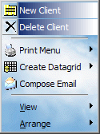
The ‘New Client’ and ‘Delete Client’ menu items add or remove clients. See the Section 1 of this chapter for information on the toolbar buttons that perform the same function.

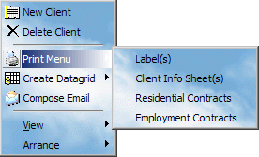
The ‘Print Menu’ item displays a list of functions. See Chapter 7 for details on creating Labels. Selecting ‘Client Info Sheet(s)’ will print the file cover pages for each of the selected clients. Selecting either of the Contracts will print two contracts for all of the selected clients.

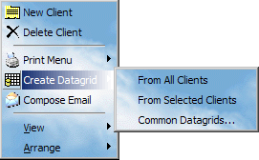

The ‘Create Datagrid’ menu allows you to create a datagrid from any or all of the clients. See Chapter 7 for details.

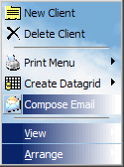
The ‘Compose Email’ menu item will open a new email message that is addressed to all of the clients that are selected. To send a broadcast message to all clients, select all clients and choose this item.

You can use the ‘View’ menu to change the way that the clients are displayed. ‘Details’ is the only view that allows you to see multiple columns. ‘Small Icons’ and ‘Large Icons’ allow you to organize the clients on-screen, and ‘List’ allows you to view many clients at once. The ‘Arrange’ menu will affect how the clients are displayed in all views other than ‘Details’. Select ‘Align None’ to allow the applications to be organized on-screen.

3. Editing Client Data

Client Data is divided into three sections: General Client Information, Invoice Divisions and Contacts, and Client Services. Click on each tab to edit the information.

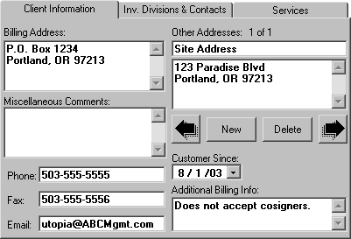

On this page you can enter the basic client information. You can add as many addresses as needed for a client, with the smaller field on top describing each one so that it can be chosen from the rest.

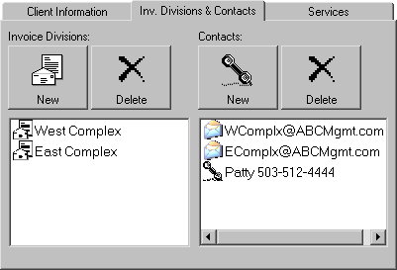
Invoice Divisions can be created to have separate invoices under the same client. In this example, when processing each applicant you would choose either West Complex or East Complex, and when billing is done two invoices will be created.

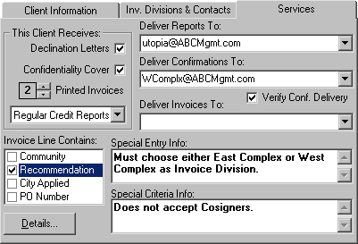
You can select the email addresses to send reports, confirmations, or invoices. If this field is blank, they are printed. You can change the number of invoices that are printed during billing, and the type of credit reports that are pulled. By checking the boxes under ‘Invoice Line Contains:’, you can add or remove the items that are on each invoice line item. If the ‘Special Entry Info’ box is not blank, then the button on the ‘Applicant Info’ Page of the Application Explorer will display that information. The text in ‘Special Criteria Info’ is displayed with the button on the ‘Final Info’ Page of the Application Explorer.

4. Billing Considerations

Invoice Divisions:

To automatically create multiple invoices for one client, you must use Invoice Divisions. For example, if you have a client who needs separate invoices for different complexes, you can create Invoice Divisions for each complex, and when processing each application, you need only choose the appropriate complex from the list. If you need separate billing addresses as well, you must enter a new client for each billing address.

Invoice Line:

By selecting items to include in the invoice line, you can provide more detailed information to the client. All line items will include the applicant name and date, such as ‘Public, John Q.: 8/1/03’. To include another item such as the recommendation, you need only to check the box under the services tab to instead show ‘Public, John Q.: 8/1/03 Recmd: Approval’

Invoice Delivery & Printed Invoices:

Underneath the boxes for report and confirmation delivery on the services tab is a box for invoice delivery. Most often this will be blank, which will result in the monthly invoice being printed only. You can enter an email address here or select one from the drop-down list ( if an address has been entered either in the email section or the contacts) to als o email a copy of the invoice. If you enter an email address, you will most likely want to change the number of printed invoices down to one, unless the client would like a regular mailed copy of the invoice as well.
CHAPTER 4

Personal Assistant – Information Resources

1. Landlord Contact Database
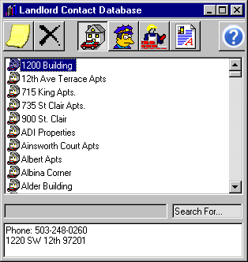

The landlord contact database stores any information that you need to contact landlords for a reference. To add a new landlord, click on the button that looks like a post-it note, and to delete one, click on the one that looks like an x. When you add a landlord, you want to enter at a minimum a phone number and address. Preferably you will enter a fax number as well. If you fail to enter an address, then the screener will have to know the name of the landlord in order to find it in the list, and may as well look it up in the phone book or online. Also, if the applicant has not provided the name of the landlord, then the screener will have to verify ownership and go through that whole process even though we already have the contact information for the landlord, which obviously defeats the purpose of even having the database in the first place. It is much better not to enter anything at all than to enter no more than a name and phone number. Another pitfall is to enter just a name and fax number. While this can be helpful for a while, if the fax number changes or the landlord does not respond, then the entry will again be entirely useless as anything but clutter.

There are two main ways to use this database, depending on whether you know the exact name of the landlord that you are looking for. If you do, then you can click inside of the list, and begin typing the name to highlight it. Once it is shown, you can either call the phone number, or if there is a fax number entered, you can double-click on the landlord name or press ENTER to bring up a rental reference fax. If you do not know the name of the landlord, type a partial address or phone number into the ‘Search For’ Textbox, and press ENTER repeatedly to cycle through the matches.

2. Criminal Information Sources

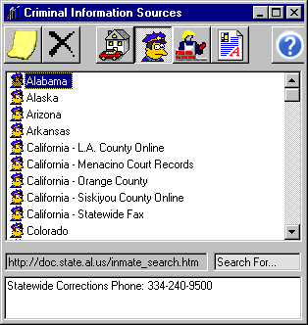

To add a criminal information source, click on the button that looks like a post-it note. To delete one, click on the button that looks like an x. To rename an item, make sure that it is highlighted, and then click once on it.

You will usually want to enter either a fax number or a website address into the grey textbox next to the ‘Search For’ textbox. If you do this, then when you double-click on an item or press ENTER while it is highlighted, then either the website or a criminal records request fax will be shown.

3. Employment Verification Channels

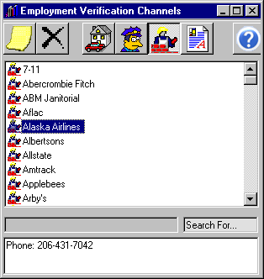

To add an employer, click on the button that looks like a post-it note. To delete one, click on the button that looks like an x. To rename an item, make sure that it is highlighted, and then click once on it.

You will usually want to enter either a fax number or a website address into the grey textbox next to the ‘Search For’ textbox. If you do this, then when you double-click on an item or press ENTER while it is highlighted, then either the website or an employment verification request fax will be shown.

For some employers, particularly franchises, it is important to note whether the verification channel is a corporate office or a local branch. If it is a local branch, you will want to indicate which one that it is, preferably with an address.

4. Document Library

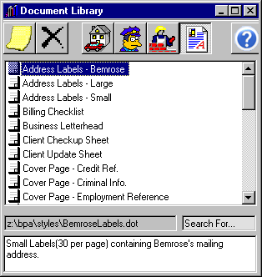

To add a document, you will first have to create it and save it onto the network drive. Most of the documents are Microsoft Word Documents, although you could just as easily place any other kind of document into the library, such as a picture or a WordPro document. Once you have created the document, click on the button that looks like a post-it note, type in the name you want to identify the document, and then type it’s path into the grey textbox next to the ‘Search For..’ textbox.. To delete a document, click on the button that looks like an x. Note that this will delete the document from being listed in the database, and will not delete the document from the network drive. To rename an item, make sure that it is highlighted, and then click once on it.

If the name itself does not sufficiently describe the document, then you can type a description into the white textbox on the bottom.
CHAPTER 5

Personal Assistant – Invoicing Manager

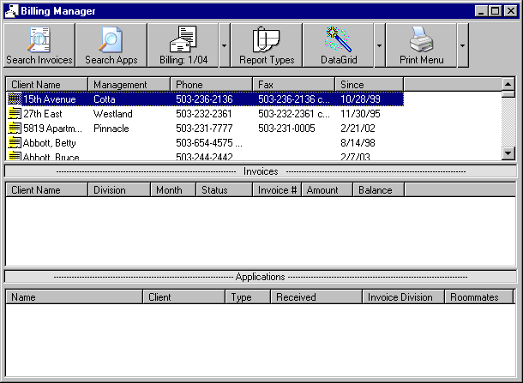

The Invoicing Manager allow you to view and edit invoices, bill applications, edit report types, print invoices, and create data grids with information about the invoices. The third toolbar button always shows you the current billing cycle. You can double-click on a client in the list shown above to be prompted to either create a new invoice for that client or look at their existing invoices for the current billing cycle.

1. Searching Invoices

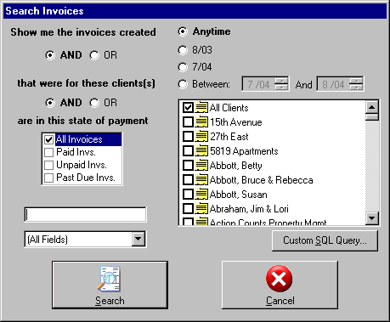

You show this window by clicking the first button on the toolbar, “Search Invoices’. The basic steps to finding the invoice that you are looking for are as follows.

- Choose the month that the invoice was billed. If you want several consecutive months you can choose ‘Between’, and enter the months. Otherwise choose ‘Anytime’.
- Choose the client(s) whose invoices you would like to see. You can check as many as you like, but be sure to uncheck ‘All Clients’ if you are searching for one or more specific clients.
- Choose whether you want to look at paid/unpaid/past due invoices, or at all of them.
- If you want to further refine your search, you can enter some text that you want to find into the one textbox on this window. To speed up your search and help eliminate unwanted matches, you can change the drop-down list to something other than ‘(All Fields)’, for example you could type in 3834 in the textbox and change the drop-down list to ‘Check No.’ to find any invoices that that have payments with that check number on them.
- When you are ready, click ‘Search’

2. Searching Applications

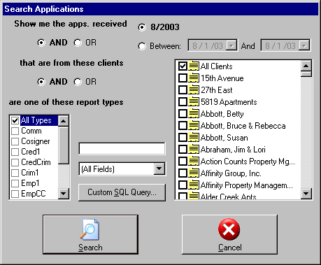

This is similar to searching applications as described in the Application Explorer chapter, except that the results will be shown in the Invoicing Manager. This is simply a shortcut to help during billing so that you do not have to switch back and forth if you want to look at the applications that need to be billed. Also, you can only select dates within the current billing cycle; that way there will not accidentally be looking at another month’s applications.

3. Report Types

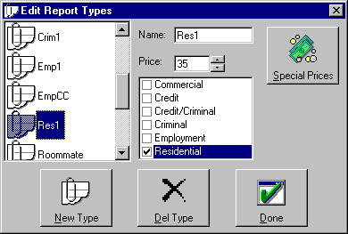

This window will allow you to add and remove report types, as well as change prices for the existing types. If you change the price on the windows shown above, you will be changing the default price for all clients. If you want to enter a special price for a client, click on the ‘Special Prices’ button near the top right corner of the window.

It is important that you enter the correct category for all of the types, such as Commercial, Employment or residential. For example, say that you create a new type called ZFreebieEmp1. If the ‘Residential’ box is marked, then when someone enters an application with that type and goes to edit the employment references, they will have two employment verifications instead. This is because the computer will not realize that a mistake has been made and will think that Residential is the correct type and that it should have employment verifications instead of employment references.

It is also important that you do not delete types that are in use for applications. If you do so, the result will be very confusing to screeners as the applications will appear to have no type. Also, in some cases you will be unable to print because the program cannot determine which pages belong in the document without knowing what type of application it is.

4. Monthly Billing

To begin the monthly billing, click on the button that has the word ‘Billing:‘ followed by the current billing month. This will show the window seen below.

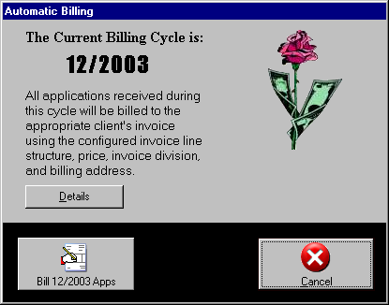

If you have already created invoices for the month, or if the month is not yet over, then you will be prompted for confirmation before you are allowed to click on ‘Bill Apps’. When you do click on the button, all of the applications that can be billed will be placed onto invoices. An application can be billed if it has a valid cli ent name. If the client has invoice divisions, then the application must also have an invoice division in order for it to be billed. After you click on ‘Bill Apps’, you will see a progress bar that shows the progress of the billing, and after a minute or so when it has finished, the program will show the billing validation window. See the next section for details.

5. Billing Validation

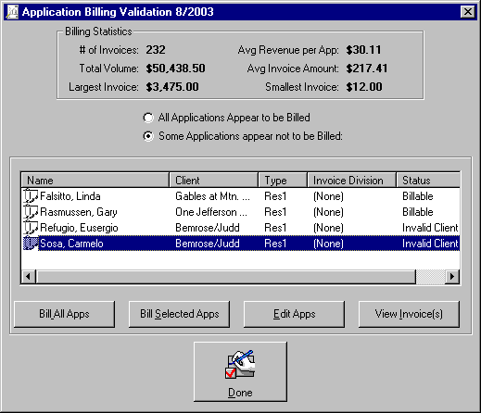

This window is shown automatically after the invoices have been created, and can be shown anytime by right-clicking inside of the application list on the Invoicing Manager and choosing ‘Billing Validation’. It will list all of the applications for the current month that do not appear on the invoice, and a possible reason why, which will be either an invalid client name or no invoice division. If any applications are found, you will need fix the mistake and put the applications onto the invoices by clicking either ‘Bill All Apps’ or ‘Bill Selected Apps’. When all applications have been billed, you can print and email them as described in the next section.

6. Printing/Emailing Invoices

To complete the monthly billing, click on the ‘Print’ button on the Invoicing Manager. This will show the window seen below.

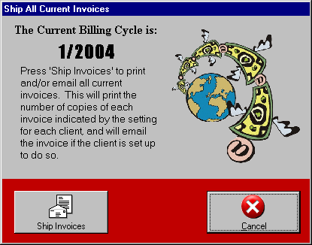

When you click ‘Ship Invoices’, each of the invoices will be printed based on the number of printed invoices set up in the client information. Clients that have an email address set up for invoice delivery will also receive a copy of the invoice at the email address. Once this is completed, this window will close, and you will need only to wait for the printer to finish its job before the invoices can be mailed.

CHAPTER 6

Personal Assistant – Miscellaneous

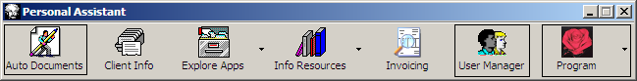

This chapter covers the remainder of the features available from the toolbar seen above.

1. Automatic Documents and Reports

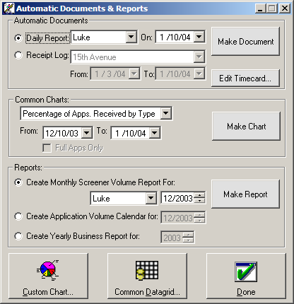

Each of the outlined frames represents a category of business information reports that can be compiled from the applicant and invoice information that is stored by the Personal Assistant. All options have been boiled down to only those which are absolutely necessary for creating each report. Custom charts and datagrids offer power and versatility with relative ease compared to any other program, while the Automatic Documents and Reports window seen above generates a useful subset of the available reports with a bare minimum of thought and interaction from the user.

To create a daily report for a screener, first make sure that the option button marked ‘Daily Report:’ is chosen, and then select the screener’s name and the date you are interested in from the drop-down list and the date picker to the right of that option button. When you have chosen the correct screener and date, click on ‘Make Document’ to build the daily report.

Common charts can be created simply by choosing the desired chart from the drop down list, choosing your dates, and clicking ‘Make Chart’. For some charts, you also have the option to limit it to full applications only. This o ption is unavailable for some charts, because it makes no sense. For example, when your chart is showing you the number of full applications compared to the number of credit-criminal applications, to limit the data to only full applications would render the chart useless.

2. Editing your Timecard

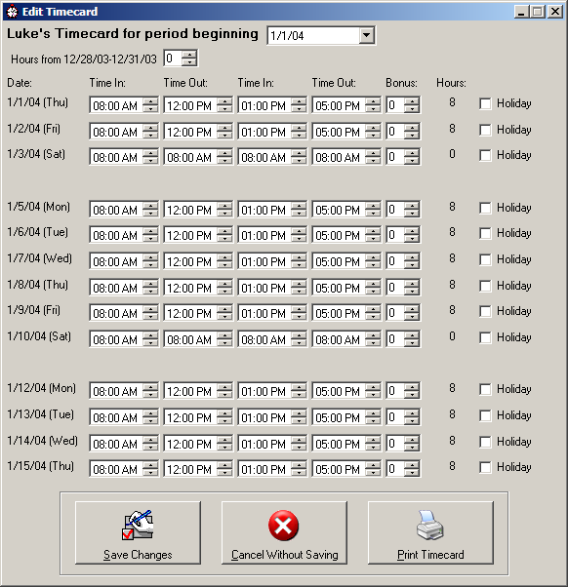

If you choose, you can use this window to create a timecard rather than writing it out by hand. You can store timecard information for only one time period at a time. This means that if you change the time period using the drop-down list at the top of the screen and then save the changes, you will have to re-enter the information if you then return to the original time period.

To create a timecard, follow these steps.

1. Select the correct time period from the drop-down list at the top. Note that you can only create a timecard for the current pay period and either the next pay period or the previous pay period, whichever is closer.

2. If the pay period begins later than a Monday, you may want to enter the number of hours that you worked on the weekdays from the last pay period. This is only used to calculate overtime pay, so if you have no overtime from the first week this is unnecessary.

3. Enter the start times, out/in times, and Finish time for your workday. To speed up this process, you can enter your regular times on the first line, and then double-click on each ‘Time In’ and ‘Time Out’ label to change all of following weekdays to match the same time.

4. Enter any bonuses from the period, and check the ‘Holiday’ box on the right if there are any paid holidays. To have the computer use the completed application dates to obtain bonus information, double-click on the ‘Bonus’ label near the top.

5. Click on ‘Print Timecard’.

3. User Manager

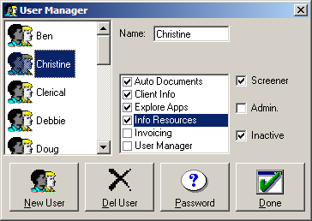

This window allows you to add and remove employees as users of the program. The only reason you should ever remove a user from the program is if they cease employment prior to screening applications. Once they have screened an application, the user should be marked as Inactive by using the checkbox on the right side of the window.

When you select a user, you can change the buttons that will appear on their Personal Assistant toolbar by using the checked list in the middle. You can also change whether that user is considered to be a screener or whether the user is granted administrative privileges. Administrative Privileges will allow the user to perform actions that will directly affect the billing, such as retrieving applications from the archive, deleting completed applications, and so forth. Note that a user can of course be both a screener and have administrative privileges.

You can change the password of the user by clicking on the ‘Password’ button. Note that you cannot view the current password; you may only change it to a new one.

4. Program Settings
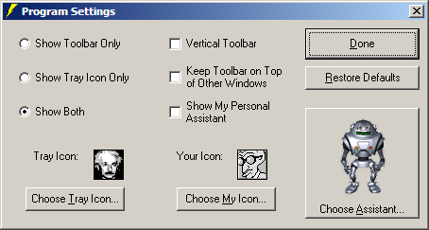

This window allows you to customize the display of your Personal Assistant. All of the settings will change immediately so that you can see what they do with the exception of the ‘Choose My Icon’ button. Each of the options has been boiled down to require an absolute minimum of knowledge.

The options that you can set from this window are:

1. Whether the Personal Assistant shows the toolbar, the tray icon, or both.

2. Whether the toolbar is shown as horizontal or vertical.

3. Whether the toolbar floats on top of other windows that you may be working with.

4. Whether the Personal Assistant Character is visible.

5. Change the icons that are shown in the system tray and next to your name in menus.

6. The appearance of the Personal Assistant Character.

You may restore the defaults by clicking on the button that says ‘Restore Defaults’.

5. Common Datagrids

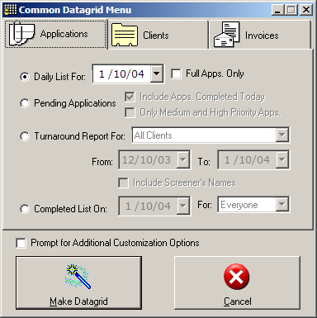

Using the common datagrids, you can quickly create useful lists of information on applications, clients, or invoices. From the first tab, you may create the following:

1. A list of all the applications received on a particular day, optionally including only full applications.

2. A list of pending applications, optionally also including applications that were pending until they were completed earlier in the day, and you may also choose to limit the list to applications marked as medium or high priority.

3. A turnaround report for a client or for all clients during a specified time period. The report will show the number of applications screened and how many business days that they were in process. If the list is not going to be given to a client, you may choose to include the screener’s names to give you a better understanding of who creating the biggest bottlenecks.

4. A completed list for a screener or for all screeners, showing the applications that were completed on a particular day.

For any of these lists you may also check the box marked ‘Prompt for Additional Customization Options’. This will allow you to change the options that are normally available when you create a datagrid directly from applications, clients or invoices, such as appending to the existing datagrid or selecting different columns of data to be displayed.

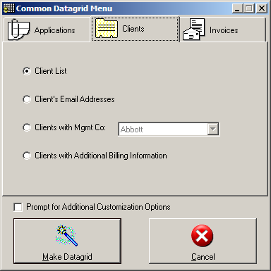

From the client information, you can create the following reports:

1. A list of all clients, including phone and fax numbers.

2. A list of client names and email addresses.

3. A list of clients belonging to a specific management company.

4. A list of clients who have special billing information that has been entered. This can be useful to show the clients who require special attention during billing.

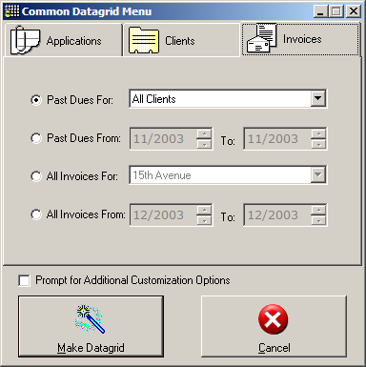

From the invoice information, you can create the following reports:

1. A list of all past dues, including client name, invoice number, date and amount.

2. A list of past dues from a certain time period.

3. A list of all invoices for a specific client.

4. A list of all invoices from a certain time period.

Quick Tips

1. Use the Clipboard
You can copy just about anything, including files, folders, pictures or text, and then paste it into another program. This can be done using the following keyboard shortcuts: CTRL-C for copy, CTRL-V for paste, and CTRL-X for cut. Cutting an object works the same way as copying it and then deleting it, so that the pasted copy becomes the only copy. You can also usually right-click on the file, picture, or text to access the same commands, or access them from the edit menus and toolbars of most programs, such as Microsoft Word or Explorer.

2. Use Keyboard Shortcuts.
There are a few system-wide keyboard shortcuts, including the ones listed above, CTRL-F4 to close the active window, ALT-Tab to switch between programs, and the Windows key to access the start menu. Many others are unique to each program. The TAB and Shift-TAB key combinations will often take the cursor to the next or previous item in the window or web page. If you see a button with an underlined letter in its caption, such as OK, then you can press ALT with that letter to trigger the button. If the button is outlined in a heavy dark border, then it can be activated by pressing the ENTER key. Pressing the ESC key can often close a dialog or cancel what you were doing. When you are editing text, you can use the arrow keys to move the cursor one step in each direction. You can hold CTRL with the arrow key to move one word to the left or right and one paragraph up or down. You can press HOME and END to move the beginning or ending of the line, and you can hold CTRL while pressing either button to move to the beginning or end of all the text. You can hold SHIFT while using any of the preceding keyboard combinations to select the text as the cursor moves. Many other keyboard shortcuts can be found by looking at the menus, tooltips and help documentation of each program.

3. Use Shortcut Links.
Place shortcuts to your most frequently used programs and documents onto your desktop. See the section in the first chapter for specific information

4. Take advantage of multi-tasking.
Computer scientists worked for decades to create a computer that was capable of switching between tasks quickly enough so as to appear to you that it is doing many things at once. The result of this is that you can do work simultaneously on many different programs. But if you close each window when you are switching to another instead of minimizing it just letting it sit there behind the window you’re now working with, you lose all of the benefits, and you force your computer to reload everything each time that you use it. On a good day, the only result will be a slowing down of every program on your computer. Instead, close each window only when you are done with it for a little while.

5. Use the system tray
The system tray is located on the task bar, next to the system time or the date and time. You can double-click and right-click on the icons to quickly access features of that program. For example, when you print a document, a printer icon appears, and you may double-click on it to open the Print Manager. The Personal Assistant has an icon that can be used to access any of the features found on the main toolbar even if you have the Internet or another window maximized so that you cannot see the toolbar.

6. Right-click, Right-click, Right-Click!
If you see an object on your screen, and you would like to do something with it but don’t know how, start by right-clicking on it. This is the easiest way to do most common tasks. You can also learn more about an object and what sort of things can be done with it by looking at it’s right-click menu.

Glossary

Desktop
This is the graphical representation of the desktop folder on your hard drive. It is the first thing that you see after the log on, and the last thing you see as you’re logging off. It contains icons for using different programs, and is the starting point for all computer work.

Dialog
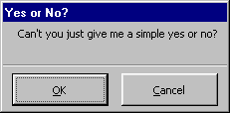
This word refers to any sort of window that pops up wanting you to answer a simple question, such as the one here:

Document
A file, typically a word processing document, although it could be a picture, plain text, or any file that is used by a program to display information.

File
A set of information stored on your computer that is given a single filename. A file can usually be read by multiple programs. This can be pictures, text, binary data, or a combination.

Folder
A logical grouping of files. This will allow you to place files that have pertinence to each other in the same folder or folder tree.

Manual feed paper tray
This is a special tray on your printer that will wait for you to insert paper for printing to continue. This allows you to use special types of paper without having to worry about normal print jobs being printed on them.

Path
A character string that identifies the drive and folders that contain a specific folder or file. For example, the current path to the Personal Assistant is Z:\bpa\bpa.exe. The path to the slash screens shown by the program is Z:\bpa\program graphics\splash.

Program
Executable code that is contained in a file. Some programs will have a user interface, window(s) that it will show that will allow you to use the program, although many do not.

Shortcut
A pointer to a file or folder. You can place a shortcut in a completely different folder, such as the desktop, and activate it as if it were that folder or file.

Task Bar
The bar, usually at the bottom of the screen, that contains the start menu, buttons for each of the windows that are currently open, the date/time, and any system tray icons.
Tooltip
A very small window containing helpful text that appears next to the mouse as it hovers over an object.

