**Guide**

1. Download zip file from Github
2. Extract Zip file
3. Download and install add-on Selenium IDE for Firefox (<http://www.seleniumhq.org/download/>)

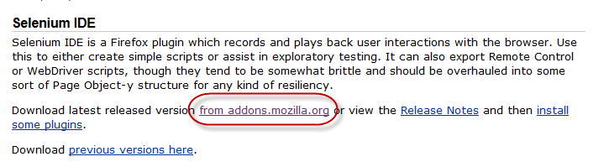

1. Restart Firefox browser
2. Open Selenium IDE (make sure a window of Firefox browser is opening)



1. On Selenium IDE window, select File > Open Test Suite then select “TS” file from folder at step #2
2. Select “Play entire test suite”