

Quantum Analytics co.

PYTHON PROJECT CENSUS DATA ANALYSIS

Academic Year 2023 : May Cohort

Full Name : **Tseliso Ramoeletsi**

Program Director : **Samuel Josiah**

Due Date : 5th of November 2023

**Which state has the most counties in it?**

State with the most counties is Texas with 255 counties.

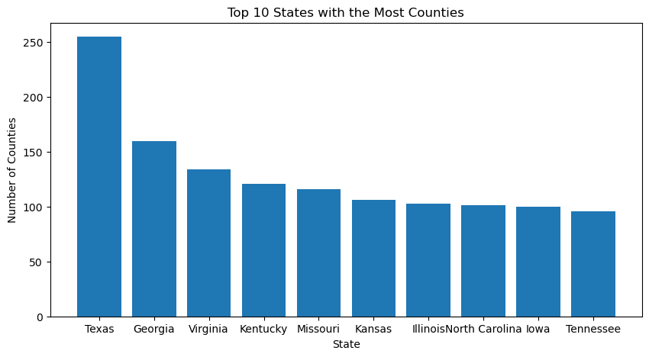

**What are the three most populous states?**

The Top 3 most populous states are: California (74,507,912), Texas (50,291,122), and New York (38,756,204).

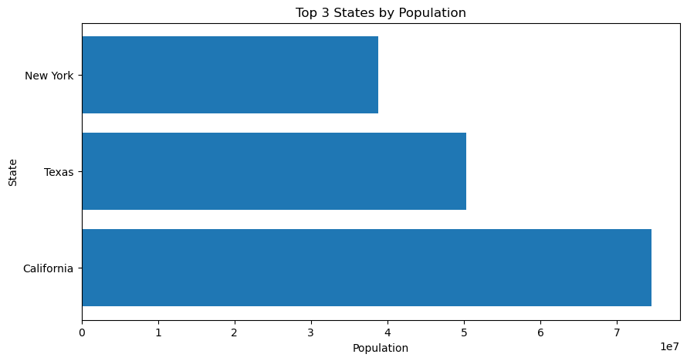

**Which County has the most Cities in it?**

The County with the most City is Washington County with 30 counties.

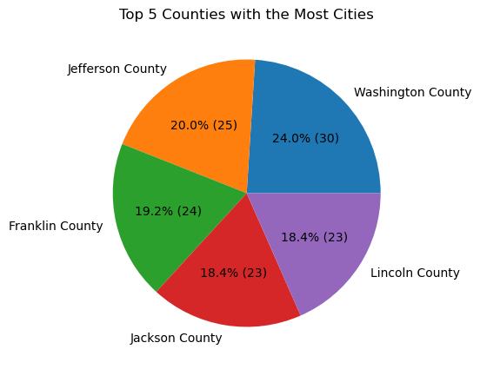

**Which region has the most divisions in it?**

The region with the most divisions is Region 3 with 1439 divisions.

