**REPORT PROBLEMS IN OUR MODEL**

**Link GitHub**: <https://github.com/tramtran2/prlab_image_colorization>

# Our Problems:

* **Accuracy is not convergence**
* **Red noise in colorized image**

# Our Models

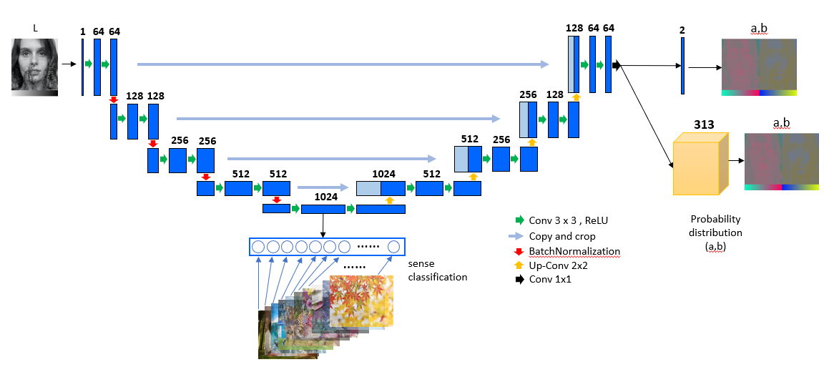

* Input: grayscale image
* Output:
  + Colorization image using regression
  + Colorization image using category cross-entropy with soft encoding with 313 quantization bins
  + Classification branch with scene classification for regularization

# Training History

* Using RMSProp, Adam with Step Decay, or Constant or Cycle Learning Rate
* Training and validating on Coco-Stuff

|  |  |
| --- | --- |
|  |  |
| **Ground-truth** | ***Results (with Red Noise and some regions are not colorized)*** |

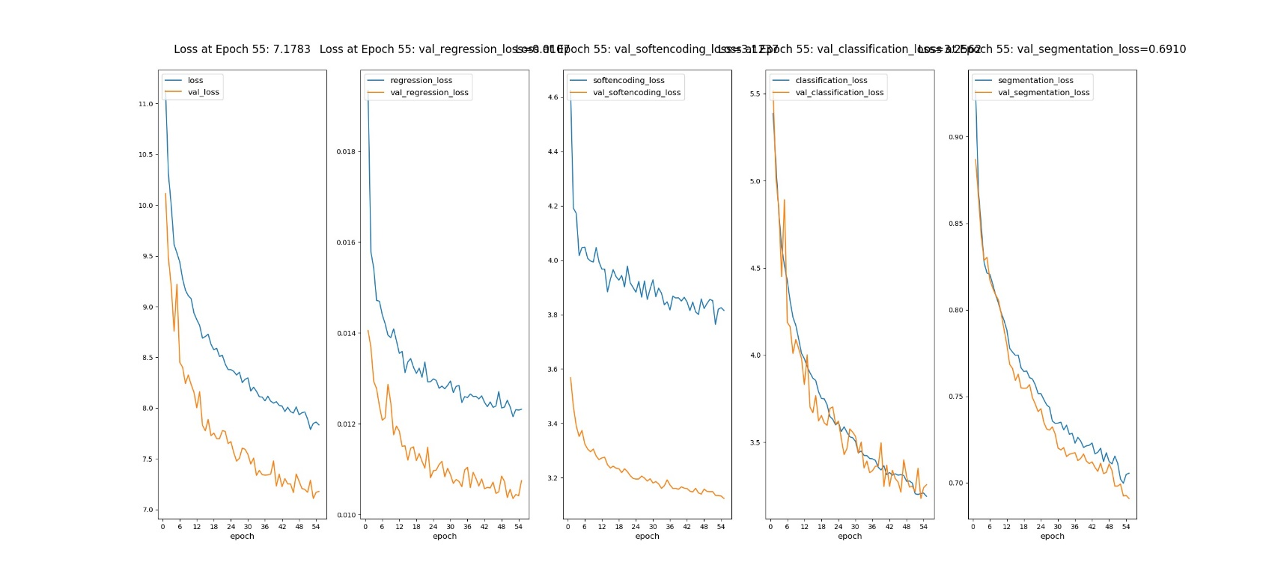

* ***Loss of soft-encoding is good for convergence (image above – column 3) but the accuracy is noise with around 0.32.***

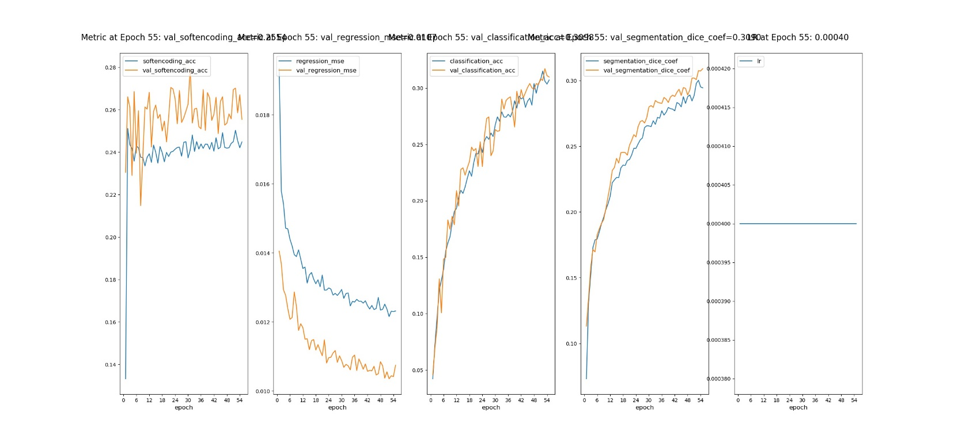

**Testing with collecting images:**

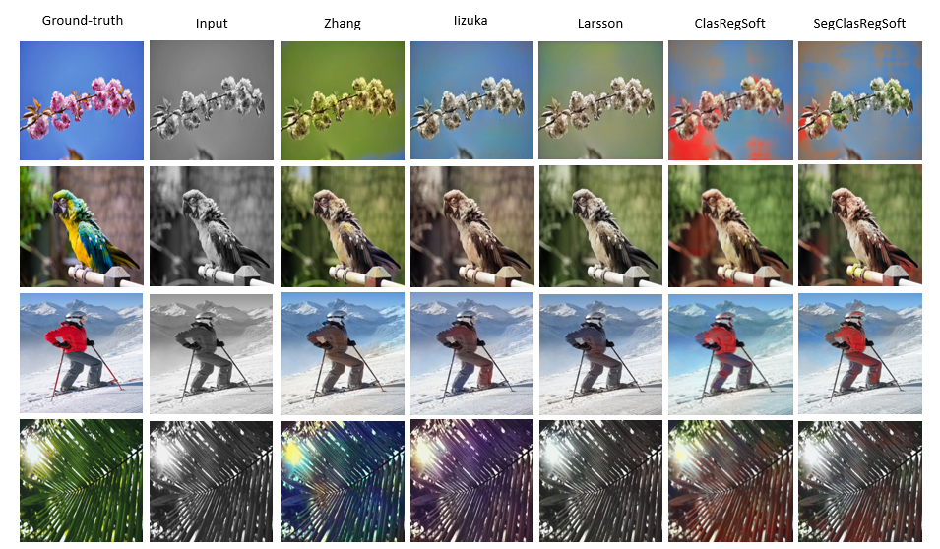

***Red Noise in our method (last two columns)***

# Soft-Encoding

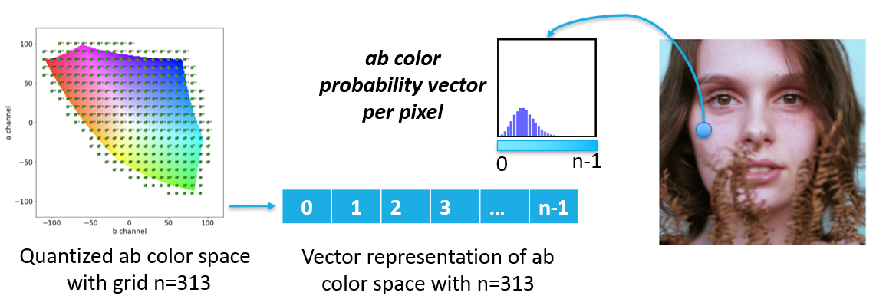

**Implementations:**

For **pts_in_hull**: getting from Richard Zhang works (<https://richzhang.github.io/colorization/>)

**Soft-Encoding:**

def load_nn_finder(pts_in_hull_path, nb_neighbors = 5):

    # Load the array of quantized ab value

    q_ab = np.load(pts_in_hull_path)

    nn_finder = nn.NearestNeighbors(n_neighbors=nb_neighbors, algorithm='ball_tree').fit(q_ab)

    return q_ab, nn_finder

# load_nn_finder

def get_soft_encoding(image_Lab, nn_finder, nb_q, sigma_neighbor = 5):

    """

    image_Lab = read_image("...")["res_image_Lab"]

    q_ab, nn_finder = load_nn_finder("pts_in_hull.npy", nb_neighbors = 5)

    y = get_soft_encoding(image_Lab, nn_finder, nb_q = q_ab.shape[0], sigma_neighbor = 5)

    """

    # get and normalize image_ab

    # due to preprocessing weighted with minus 128

    image_ab = image_Lab[:, :, 1:].astype(np.int32) - 128

    h, w = image_ab.shape[:2]

    a = np.ravel(image_ab[:, :, 0])

    b = np.ravel(image_ab[:, :, 1])

    ab = np.vstack((a, b)).T

    # Get the distance to and the idx of the nearest neighbors

    dist_neighb, idx_neigh = nn_finder.kneighbors(ab)

    # Smooth the weights with a gaussian kernel

    wts = np.exp(-dist_neighb ** 2 / (2 * sigma_neighbor ** 2))

    wts = wts / np.sum(wts, axis=1)[:, np.newaxis]

    # format the target

    y = np.zeros((ab.shape[0], nb_q))

    idx_pts = np.arange(ab.shape[0])[:, np.newaxis]

    y[idx_pts, idx_neigh] = wts

    y = y.reshape(h, w, nb_q)

    return y

# get_soft_encoding

**Decode with annealing:**

def decode_soft_encoding_image_v1(x_image, y_image, q_ab, epsilon = 1e-8, T = 0.38, x_post_fn = None, usegpu = False, **kwargs):

    """

    q_ab = np.load(os.path.join(module_dir, "data", "pts_in_hull.npy").replace("\\", "/"))

    x_image: L channel (batchsize, height, width, 1) --> gray

    y_image: softencoding of ab channel (height, width, nb_q)

    """

    if len(x_image.shape) == 2:

        x_batch_image = x_image.reshape((1,) + x_image.shape[0:2] + (1,))

    elif len(x_image.shape) == 3 and x_image.shape[2]==1:

        x_batch_image = x_image.reshape((1,) + x_image.shape[0:3])

    else:

        assert("Invalid Gray Image with shape (w, h) or (w, h, 1)")

    # if

    y_batch_image = y_image.reshape((1,) + y_image.shape[0:3])

    y_batch_RGB = decode_soft_encoding_batch_image_v1(x_batch_image, y_batch_image, q_ab, epsilon, T, x_post_fn, usegpu = usegpu)

    return y_batch_RGB.reshape(y_batch_RGB.shape[1:])

# decode_image_v1

**Decode without annealing:**

def decode_soft_encoding_image_v0(x_image, y_image, q_ab, x_post_fn = None, **kwargs):

    """

    q_ab = np.load(os.path.join(module_dir, "data", "pts_in_hull.npy").replace("\\", "/"))

    x_image: L channel (batchsize, height, width, 1) --> gray

    y_image: softencoding of ab channel (height, width, nb_q)

    """

    if len(x_image.shape) == 2:

        x_batch_image = x_image.reshape((1,) + x_image.shape[0:2] + (1,))

    elif len(x_image.shape) == 3 and x_image.shape[2]==1:

        x_batch_image = x_image.reshape((1,) + x_image.shape[0:3])

    else:

        assert("Invalid Gray Image with shape (w, h) or (w, h, 1)")

    # if

    y_batch_image = y_image.reshape((1,) + y_image.shape[0:3])

    y_batch_RGB = decode_soft_encoding_batch_image_v0(x_batch_image, y_batch_image, q_ab, x_post_fn)

    return y_batch_RGB.reshape(y_batch_RGB.shape[1:])

# decode_image_v0

# Loss

* **Scene-context classification:** Category Cross-Entropy (CCE) loss:

Where C is the number of scene, yi/ is the ground-truth/predicted scene probability.

* **Pixel Classification of ab color distribution**: Weighted Category Cross-Entropy Loss:

Where h, w is the height and width of image, N is the number of quantized colors of ab color distribution,  **is the weighted of color-class at pixel (h,w) to encourage the rare-color**, / is the ground-truth/prediction probability of the soft-encoding color i at pixel (h,w).

* **Regression ab channel**: Using Mean Square Error (MSE) Loss:

Where / is the ground-truth/prediction of ab values at pixel (h,w)

**Implementations**:

def build_categorical_crossentropy_color_loss(prior_factor_path = "prior_factor.npy", nb_q = 313, train_session = None):

    # Load the color prior factor that encourages rare colors

    prior_factor = None

    if prior_factor_path is None:

        prior_factor = np.ones(nb_q).astype(np.float32)

    elif os.path.exists(prior_factor_path) == False:

        assert(f'prior_factor_path: {prior_factor_path} is not exists!')

    else:

        prior_factor = np.load(prior_factor_path).astype(np.float32)

    # if

    q = len(prior_factor) # number of bins

    def categorical_crossentropy_color(y_true, y_pred):

        y_true = K.reshape(y_true, (-1, q))

        y_pred = K.reshape(y_pred, (-1, q))

        idx_max = K.argmax(y_true, axis=1)

        weights = K.gather(prior_factor, idx_max)

        weights = K.reshape(weights, (-1, 1))

        # multiply y_true by weights

        y_true = y_true * weights

        # cross_ent = K.categorical_crossentropy(y_pred, y_true)

        cross_ent = K.categorical_crossentropy(y_true, y_pred)

        cross_ent = K.mean(cross_ent, axis=-1)

        return cross_ent

    # wrapper

    return categorical_crossentropy_color

# build_categorical_crossentropy_color_loss