FACTORS AFFECTING BITCOIN PRICE IN THE

CRYPTOCURRENCY MARKET: AN EMPIRICAL STUDY

**Tram Nguyen**

**Christopher de Bodisco**

**Ranjini Thaver**

Stetson University

**Abstract**

*This study examines the relationships between Bitcoin and some major cryptocurrencies to better understand different market factors’ effects on their price formation. Our results show evidence of Bitcoin’s price is driven by both transactional demand, such as supply of Bitcoin or the size of Bitcoin economy, and speculative demand, namely media attention or price of another cryptocurrency. Bitcoin’s dominant player role may be jeopardized in the decentralized payment system market. In addition, since late December 2017, speculation for Bitcoin has been decreasing for several reasons, which can potential open opportunity for Bitcoin’s transactional demand to grow faster.*

*Keywords: behavioral cryptocurrency market, Bitcoin’s dominance, speculative demand, transactional demand, Bitcoin economy*

**Introduction**

Bitcoin was introduced in 2009, with the idea that transactions can be made anonymously and decentralized. Bitcoin and other digital currencies can be compared to cash because they share attributes, such as medium of exchange and store of value. However, these digital currencies are purely digital, used primarily online and extremely volatile as shown in Figure 1, which make many of their critics deny their ability to be a “currency”.

The emerging market of cryptocurrencies is full of ambiguities, particularly the competition between different cryptocurrencies, which motivates this analysis. By understanding the competition between different cryptocurrencies and how they interact with one another in this market, we hope to see if Bitcoin collapses, despite its recent rapid increase in price and demand, whether other cryptocurrencies will be able to replace it and maintain the market, or will the collapse of Bitcoin mark the end of this nascent market?

*Network effect*, the value of a product or service increases as the number of users increases, is one of the main characteristics of this market. According to Katz and Shapiro (1994) from the network effects literature, such environment is likely to create a winner-take-all dynamic, and only one dominant player remains in the market. One prime example of the network effect is the competition between Facebook and Google+. At the time, while Google+ was designed with much better functions compared to Facebook, it could not gain significant market share, and as a result, lost the “social media battle”, because of the network effect created by Facebook users.

The currency market also exhibits a network effect. The more popular a currency is, the more useful it becomes to own, and as a result, its demand increases proportionally with its popularity. In terms of cryptocurrency, Bitcoin is the first ever cryptocurrency and the most well-known in the market. However, it has many shortcomings that were addressed by newer and improved cryptocurrencies. Given improved substitutes, can Bitcoin’s first-mover advantage create a network effect large enough for it to maintain its status as the dominant player in this market?

Previous literature contradicted each other in whether Bitcoin will maintain its dominant role in this nascent market. Gandal and Halaburda (2016) suggest that during the 2014 period, strong network effect favoring Bitcoin became more apparent as Bitcoin gained its popularity. However, El Bahrawy et al (2017) argues that though Bitcoin’s price is increasing at an exponential rate, the currency is losing ground to its alternatives.

This study investigates the behavior of the cryptocurrency market. While the previous studies provide significant insights, we suspect that the uncertainty in the drivers of Bitcoin’s demand is causing the mismatch in these researchers’ findings, since these studies consider only Bitcoin’s price when they calculate the network effect. Therefore, we want to better understand the different forces that drive demand for Bitcoin, namely two main forces: transactional demand and speculative demand to find out if the network effect exists at all.

**Figure 1**

**Price of Bitcoin (blue line), Ethereum (yellow line), and Litecoin (green line)**

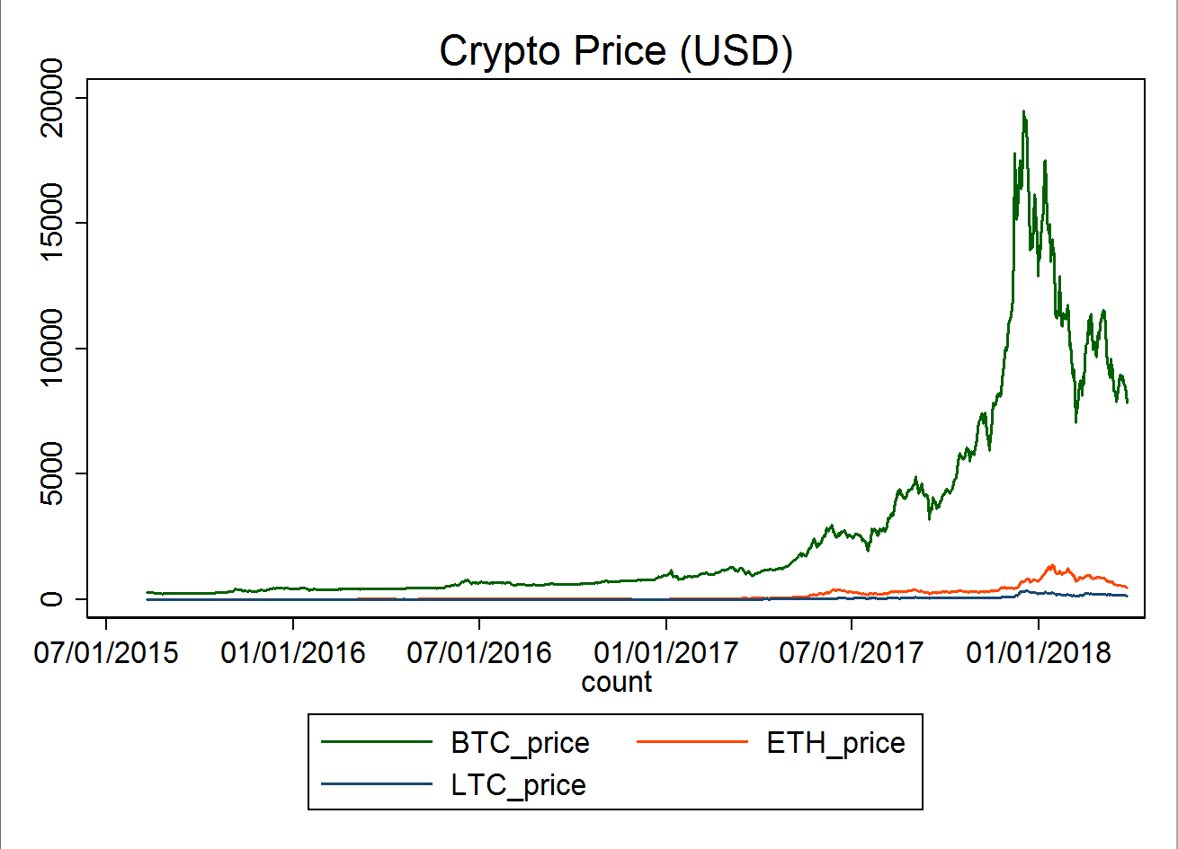

**Literature Review**

***Brief Background on Cryptocurrencies and Blockchain***

Bitcoin, the first cryptocurrency, was introduced in 2009, and was followed by many cryptocurrencies. Cryptocurrencies have no central authorities over transactions, or in other words, they are decentralized. They use cryptography techniques for secure communication in the presence of third parties, to control transactions, and to manage supply and detect fraud. Once confirmed, all transactions are stored digitally and recorded in a “block” (Nakamoto, 2009).

When each block is closed, miners have the opportunity to solve a mathematical problem to provide the key to unlock it. Whoever solves it first will get a reward of a certain amount of Bitcoin, which serves as an incentive for people to mine, maintain the secure system, and generate new coins. After each block is locked, it then gets placed in a chain of pre-existing blocks, which is why this system is called “blockchain”. As the blockchain continues to grow, the math problems get harder and the coin rewards get smaller.

The supply of most cryptocurrencies increases at a predetermined rate and cannot be changed by any central authority. This creates concerns about the deflationary aspect of the currency due to its limited supply (R, A., 2014). However, there is a constant debate among economists whether deflation is good for the economy. Keynesian economists argue that deflation is bad for the economy because it incentivizes individuals to save money instead of spending it. On the other hand, the Austrian economists claim that as deflation occurs, prices as well as the cost for production decrease, but profits will not change. Therefore, this will increase incentive for entrepreneurs to invest in long-term projects.

Bitcoin’s algorithm provides an effective safeguard against “counterfeit” by assuming that the majority of users are honest. If a record of someone is different from anyone else, it is likely that this person cheated, and their record will become invalidated. So far, this algorithm is effective in maintaining the integrity of the whole system, but many critics worry about what will happen if 51% of the users’ cheat (Berkman, 2014).

On the other hand, cryptocurrency become vulnerable while trading. Bitcoin can be stolen through wallets or exchange, and by February 2014, it was revealed that $450 million worth of Bitcoins were stolen from Mt. Gox which shut down the exchange. Recently, there has also been a hack that stole $31 million worth of Bitcoin. However, according to Lee, J. (2017), these attacks did not prevent more consumers from entering this market. First, the price of Bitcoin experienced a small shock, which dropped from $8300 to $7800, but it soon went back up.

***Current Cryptocurrency Market***

Bitcoin was initially popular in part because its anonymity enabled trade in illegal goods. In October 2013, the US government shut down the largest website facilitating such trades. After that, though Bitcoin’s price continued to climb, its price fluctuated more due to speculation, security problems, and general uncertainty about the technology.

Meanwhile, more cryptocurrencies are being introduced in the ecosystem. Almost all other cryptocurrencies were based on the Bitcoin protocol. They fix Bitcoin’s shortcomings, while providing alternatives for consumers, which is why they are called *altcoins*, cryptocurrencies that are alternatives to Bitcoin. While some altcoins are better versions of Bitcoin, some do not provide any improvement over Bitcoin. This is because there is virtually no barrier to entry in the market, since Bitcoin is an open-source protocol, and new comers can still capture significant profits from their short-lived period (Gandal et al, 2016).

Many critics express concerns that Bitcoin will deflate heavily due to its limited supply. To be specific, Bitcoin’s system only allows miners to mine Bitcoin at a decreasing rate, and eventually capped at 21 million coins, which is similar to the rate at which gold is mined. This intensifies worries that as Bitcoin’s price gets so high, it will lose its transactional value and network gains. In the case of gold when the US was a colony, gold was replaced by silver coins, an inferior commodity. If we apply this to the current state of Bitcoin, Bitcoin’s alternatives are superior, since they are improvements on the Bitcoin’s protocol and come with lower cost to own. Therefore, this analogy suggests that as Bitcoin deflate significantly, it is likely that Bitcoin will be replaced by its alternatives (Gandal & Halaburda, 2016).

However, current literature disagrees on this issue. Gandal & Halaburda (2016) argued that Bitcoin will eventually loses its dominant role due to its limited structure and other superior coins will take over. Meanwhile, other researchers believed that Bitcoin will remain the dominant player in this market because its first mover advantage is really significant.

Therefore, we want to learn more about how these coins are behaving in regard to one another. Cheah et al, as well as almost all Bitcoin researchers, confirmed that Bitcoin exhibits extremely speculative nature and has no fundamental value. However, if we treat these cryptocurrencies as “money or currency”, then money’s intrinsic value is calculated on its transactional demand. The Macro Note section elaborates more on demand for money.

***Macro Note: Money Demand***

In the discussion *The Transaction Demand for Money: A Close Look*, Kari (2015) summarizes the two main reasons why people would hold money, which can be translated into why people would hold Bitcoin if we treat Bitcoin as “money”.

People want to hold money because they need it to purchase goods and services, with the cost that they must compromise the potential interest they would have gained if they were to put that money in a saving account. Transactional demand for money depends on *interest rate* (if interest rates are low, it is not worth it to move out of money into other assets and then back to money, and vice versa), *aggregate income* (if the volume of income and output produced in the goods markets increase, then the number of transactions and exchanges increase, and consequently, people would want to hold more money to perform their transactions promptly), and *price level* (if price increases, people will need to hold more money to support their given level of transactions) (Kari, 2015).

In addition to transactional demand, speculative demand encourages consumers to hold money. This goes back to the asset market concept in macroeconomics. Suppose that interest rate fluctuates. At two percent a person can get $1020 in a year’s time in exchange for $1000 in cash now. However, they expect the interest rate to rise to ten percent, and as a result instead of $1020, they will make up to $1100 if they make the investment. So if interest rate is unusually low, and it is expected to rise, rational consumers would keep their wealth, instead of holding on to cash, to profit.

***Bitcoin as “money”***

Though cryptocurrencies are distributed through a decentralized system and have slightly different attributes than money, they still share some similarities in terms of why people want to hold on to them: purchase power and speculation. According to Schuh and Shy (2015), while many consumers who own cryptocurrencies use them to either make payments for goods and services (evidence for transaction demand), they also expect the currency to appreciate (speculative demand). As a result, we modeled demand for Bitcoin as “money” to learn more about how they are interacting with one another. Ciaian et al (2016) attempted to model Bitcoin using the traditional market forces and Bitcoin’s attractiveness for investors, and these factors appeared to have a significant impact on Bitcoin price with variation over time.

First, to model Bitcoin as a currency, the authors tried to look at Bitcoin’s traditional determinants such as supply and demand. Ciaian et al. (2016) modeled Bitcoin price formation similarly to gold. They denominate the stock of money base of Bitcoin in dollars for their research assuming that users have to convert everything to dollars when they pay for goods and services. According to them, the Bitcoin money supply is the product of the total stock of Bitcoin in circulation and its price (dollar per unit of Bitcoin), and demand for Bitcoin is assumed to depend on the general price level, the size of Bitcoin economy, and the velocity of Bitcoin is circulation. They found that in perfect markets, the equilibrium price is negatively correlated with the velocity and the stock of Bitcoin, while positively correlated with the size of Bitcoin economy and general price level.

Speculative demand for Bitcoin, or in Ciaian’s words, attractiveness to investors and users is proved to be a significant driver of Bitcoin demand. Research conducted by Lee (2014) finds that news reports affect the price of Bitcoin depending on the type of news (positive news increases price, while negative news decreases it). Therefore, we hypothesize that using Google search term for Bitcoin, one can capture the public attention to this currency. We might not be able to distinguish good vs bad news, but we believe this variable will be able to capture the speculative nature of Bitcoin’s users. As Bitcoin gets more popular, more people will buy into it, hoping they can get a small profit out of the hype.

In addition to the Google trend, the Volatility Index (VIX), may be able to explain price of Bitcoin in some ways. Qadan and Yagil (2012) found a connection between gold and the VIX between 1995 and 2010. The relationship between VIX and price of gold was negative. A higher VIX reflect a bearish condition in the exchange or the market as a whole, while a lower VIX reflects neutral to bullish condition in the exchange. Therefore, when VIX is low, we expect investors to invest more into assets like gold to hedge their investment. Similarly, since Bitcoin is not tied to any central fiat currency, investing in Bitcoin when the market is dull can be a decent strategy to diversify risk.

**Figure 2**

**Bitcoin (USD) Price’s turning point (coindesk.com)**

***Bitcoin Futures***

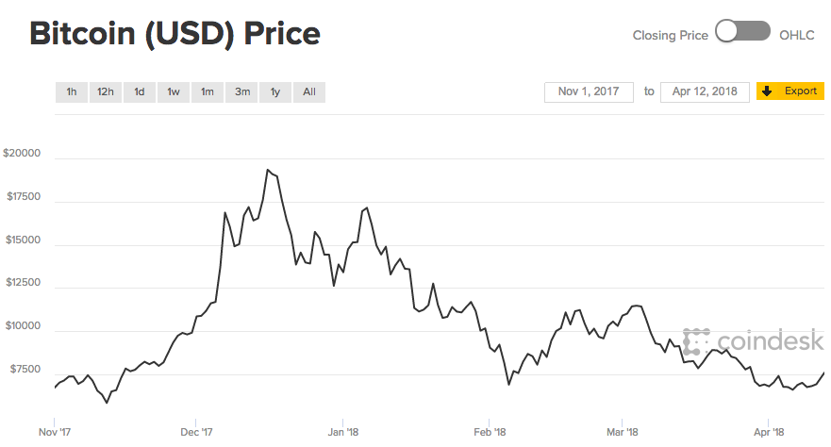

In late December 2017, the Bitcoin Futures Exchange was open, giving BTC speculators another platform to speculate. Ever since, along with tightened regulation and manipulation from the BTC whales (a group of people that hold the largest shares of BTC), the price of BTC has been falling sharply (Figure 2). Despite some small increase in BTC price, its price, in general, decreased significantly ever since. Therefore, we want to further understand of how the factors explaining BTC price will change their “role” along with this event.

Many critics argued that since BTC futures open, a lot of the speculations transitioned from the “real” exchange to the futures exchange, and therefore, we do not see as much speculative demand for BTC as we used to do before. According to Pylypczak-Wasylyszyn (2015), the Commodity Futures Trading Commission (CFTC), the government body responsible for futures market, classifies market participants as “commercial traders” to lock in pricing, or “non-commercial traders” or speculators in other words. While in agriculture and banking, it is popular to trade on futures market to ensure a stable price, speculation on futures is more for the purpose of directional betting.

As traders always look for new ways to capitalize on the price movements of assets, they are more interested in the price appreciation, than owning the commodity. Goods like gold and oil are extremely widely traded on these market. One example is that one investor may feel that gold offers better risk-to-reward profile during an economic downturn, so they would purchase gold futures to capitalize on that downturn. Therefore, as speculation for Bitcoin continues to grow, investors can capture more profits from trading on Bitcoin futures exchange, so we may not see as much speculation on Bitcoin as we did before.

As Bitcoin price dropped tremendously, some economists argued that this is the “growing pain” of this currency. Optimists also believe that as the price decreases and speculation wears off, we will be able to see more clearly the currency transactional demand.

**Economic Model**

***Transaction Demand in the Cryptocurrency Market***

According to the “Macro Note about Money demand”, one of the reasons why people would want to hold on to money is its purchasing power, or liquidity. Cash gives them the flexibility to make almost any transaction. Similarly, previous literature demonstrated that there is evidence that people are holding cryptocurrencies in order to make payments and purchase goods and services.

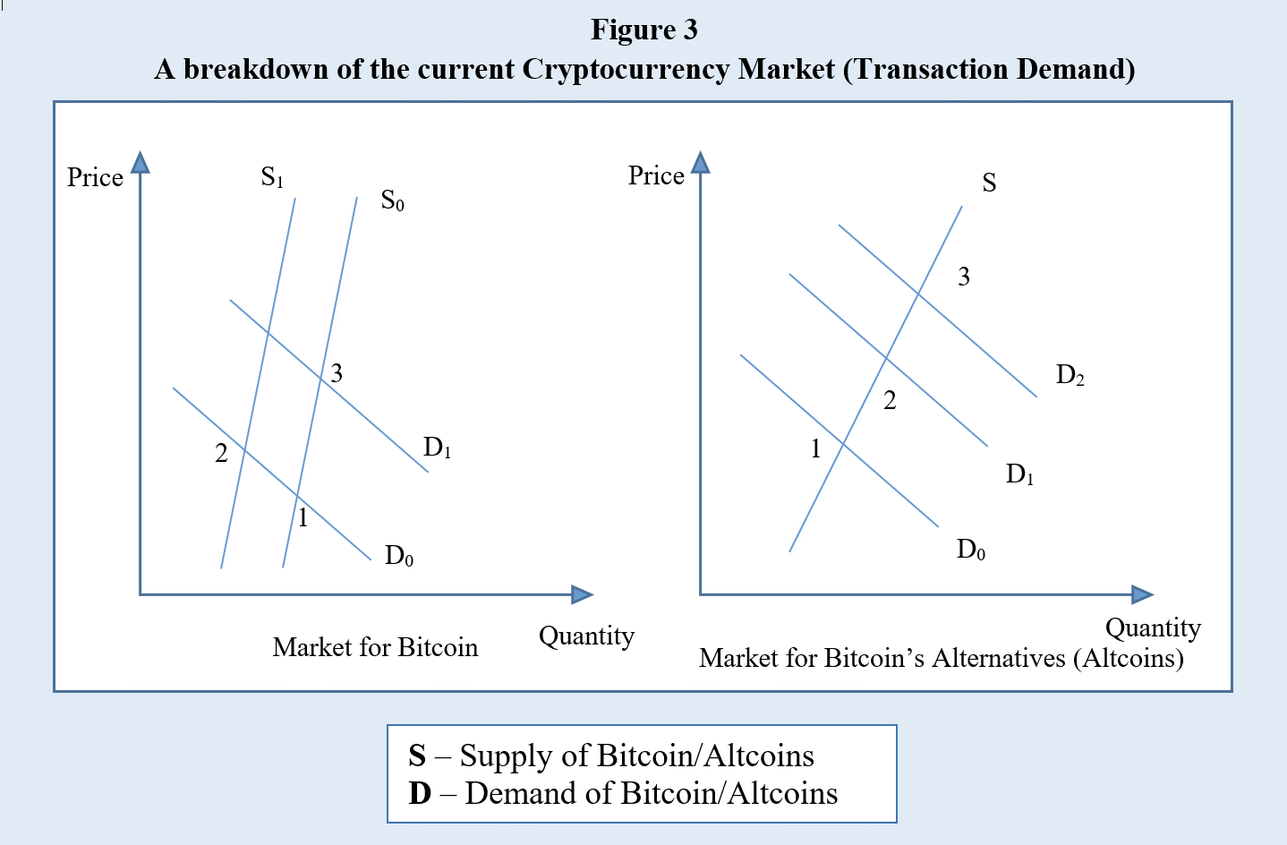

Fundamentally, we think this is one of the most important aspect of cryptocurrencies, introducing a new system of money and transaction that is not subject to any centralized authority. Considering this type of demand for cryptocurrencies, how does the market behave if we assume that people only want to buy cryptocurrencies to pay for goods.

If the price of Bitcoin increases (caused by a supply shock or something unexpected happening), BTC Supply S0 shifts to S1, and market equilibrium shifts from point 1 to 2 in the market for Bitcoin. The higher price in Bitcoin increases the demand for its alternatives.

However, if demand of Bitcoin increases because there are more people flooding into the market (Demand for Bitcoin D0 shifts to D1, and as a result, equilibrium shifts from point 1 to point 3), this will prompt the consumers who already considered altcoins as Bitcoin alternatives to switch over to buy altcoins. In the market for Altcoins, demand for them, D0 shifts to D2, shifting equilibrium from point 1 to point 3). So overall, the price of Altcoins would also increase as well as their quantity.

***Speculative Demand***

Speculative demand is put into effect when people are interested in buying more Bitcoin because they think the returns will exceed other (financial) assets’ returns on their money. This is a part of money demand, and helps explain why people want to hold money. Due to the increase in Bitcoin price, this demand has been growing exponentially. In this model, we attempt to capture the relationship between Bitcoin and Altcoins assuming there is only speculative demand for them. (Most people who own Bitcoin expect it to appreciate in price, and existing literature up until 2015 suggested that Bitcoin has an extremely speculative nature).

Figure 4 shows a breakdown of the current Cryptocurrency Market (Speculative Demand). Suppose people expect the price of Bitcoin to rise. In this case, they would be interested in holding Bitcoin to get some profit. As a result, demand for Bitcoin increases (D0 shifts to D1, shifting equilibrium from point 1 to point 2). As the supply of Bitcoin is increasing at a set rate by the algorithm, we assume supply does not change significantly in the short run. Therefore, the increase in price of Bitcoin would signal other consumers that price of Bitcoin will continue to grow, which creates a feeding system for price and demand to grow in tandem to each other (demand from D1 to D2, and market equilibrium from point 2 to point 3…)

In the market of Altcoins, if the assumption is that people only hold on to cryptocurrencies for speculative purposes, and there are no new consumers in this market, the demand for altcoins would decrease because their buyers are putting their bets on Bitcoin. However, if there are more people entering the market to buy cryptocurrencies, since the price of Bitcoin is too high, and they expect Altcoins to appreciate as well, demand for Altcoins also increases. Therefore, the overall impact on the Altcoins’ market is ambiguous in this argument.

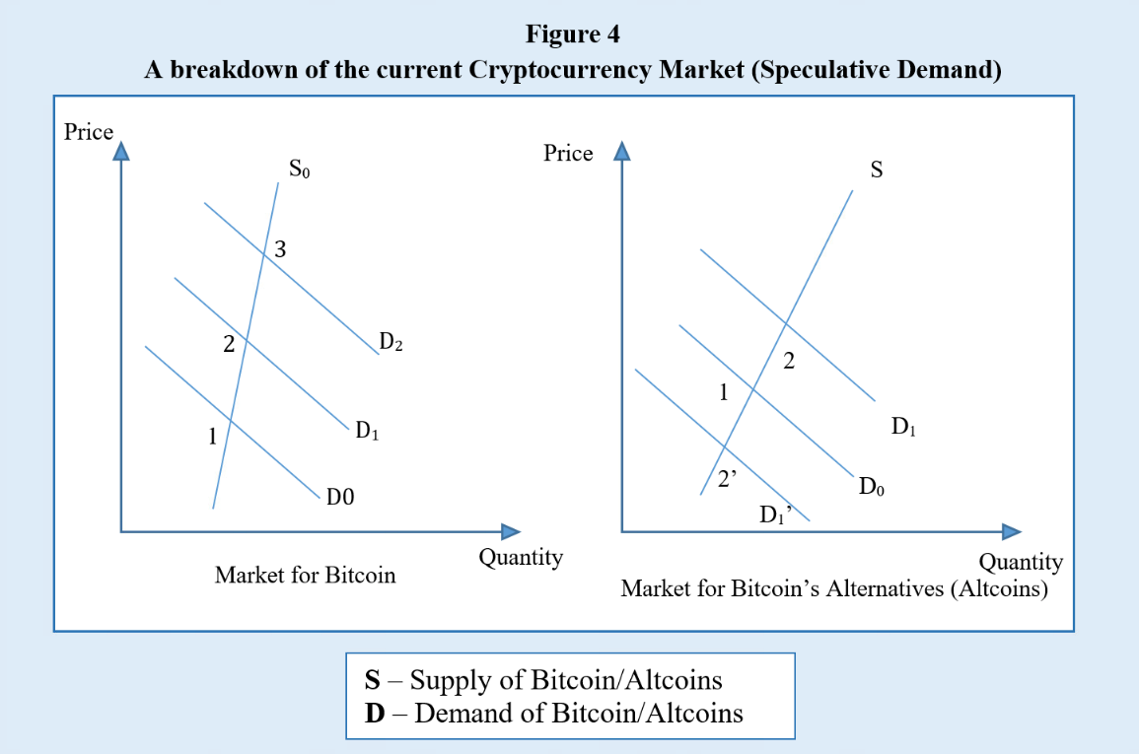

***Network effect***

The network effect suggests that as the number of users of a network increases, its value increases. We use the analogy of Facebook and Google+, where Bitcoin is the existing player and alternative coins are Google+. What would happen, clearly, is that as the Bitcoin gets more popular, its demand will increase because of the network effect. As a result, its alternatives will likely be neglected, since consumers do not see the value of holding other cryptocurrencies. Below are graphs with the assumption that the Bitcoin’s network effect gives Bitcoin an advantage in the market.

Figure 5 shows a breakdown of the current Cryptocurrency Market with the Network Effect. As Bitcoin gets more popular, its demand increases (since more people are joining the market), which shifts its demand curve from D0 to D1 (equilibrium moves from point 1 to point 2). As a result, its price increases, which caused more people wanting to own it. Again, its demand increases to D2 (equilibrium shifts from point 2 to point 3). This cycle keeps feeding itself until people lose interest in Bitcoin, or they do not expect Bitcoin to appreciate anymore

Meanwhile, the market for Bitcoin’s substitute behaves in the opposite direction. As more people invest in Bitcoin, they do not see the point in buying other cryptocurrencies, since they do not expect them to appreciate as much as Bitcoin. Therefore, the demand for them decreases, which results in a drop in price for other cryptocurrencies.

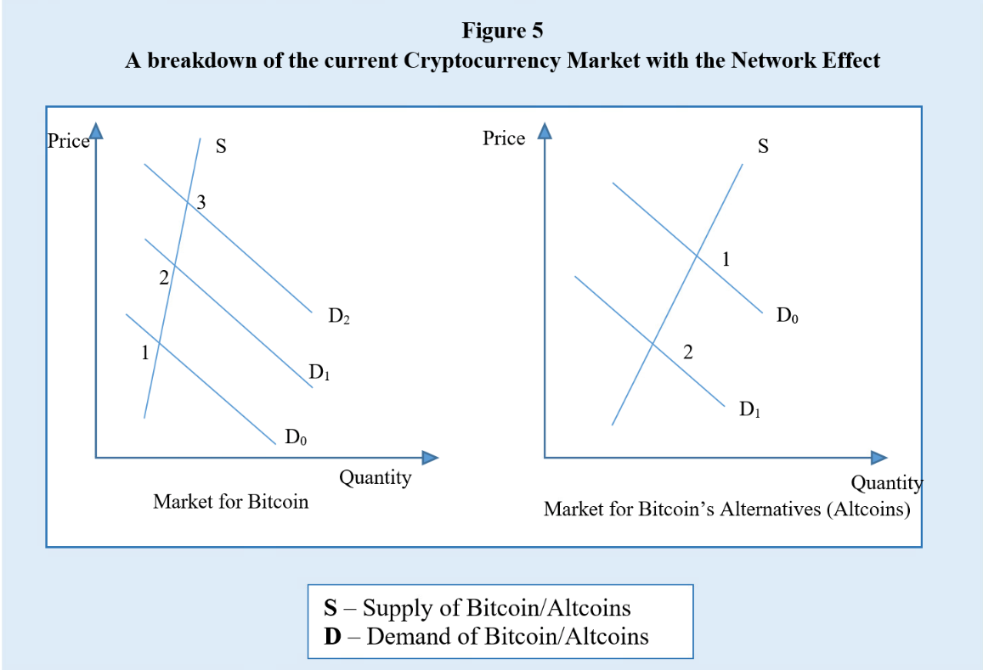

However, when it comes to the network effect, what matters the most is the transaction ability of Bitcoin. Going back to the purpose of Bitcoin, it introduces a new decentralized system of payment that does not require any central authority to approve payment or control money supply, but rather its cryptography technology. The previous literatures that examine the network effect of this market (Gandal et al, 2016 & El Bahrawy et al, 2017) did not address the different forces that drive demand, so we want to answer the question if the network effect of Bitcoin is large enough to give it the competitive edge compared to Altcoins, and if so, what demand is driving this network effect.

Gandal & Halaburda (2016). indicate that instead of the network effect, the fact that newer currencies are improvements on Bitcoin’s system can lead to a substitution effect in this market. Specifically, as price of Bitcoin goes up, consumers do not see the purpose of buying Bitcoin, so they decide to invest in other currencies with similar functionalities for cheaper price

More recent literature confirm that consumers are using Bitcoin and other cryptocurrencies to pay for goods and services and show evidence that cryptocurrencies can be useful for economic reasons such as trade transaction. Lewis (2017) suggested that while the rapid increase in Bitcoin’s price is driven by speculative demand, the demand for Bitcoin as a transaction tool is growing in tandem with it, and eventually, as the speculative demand wears off, we will be able to see more clearly how the transaction demand is determining Bitcoin’s price.

**Methodology**

The model incorporates economic variables like supply and the price of substitutes of Bitcoin, as well as speculative variables that capture Bitcoin’s attractiveness to investors like Google queries for Bitcoin. This model is specified as follows:

*PBTC = f (PATC, ECO, SBTC, SEARCH, ATTACK, VIX, VEN, DFUT) (1)*

Where:

*PBTC =* the price of Bitcoin at time t

*PATC =* the price of Bitcoin’s alternatives like Ethereum, Litecoin… at time t

*ECO =* the size of Bitcoin’s economy (number of transactions/addresses) at time t

*SBTC* = the supply of Bitcoin (number of coins in circulation) at time t

*SEARCH =* the number of BTC queries on Google at time t

*ATTACK* = the number of Cyber-attack queries on Google at time t

*VIX =* the volatility index of the S&P 500 at time t

*VEN =* the number of vendors that accept Bitcoin as payment at time t

*DFUT* = a dummy on when the future exchange of Bitcoin is introduced at time t

The signs are hypothesized below

(+/-) (+) (-) (+/-) (-) (+/-) (-)

$$PBTC= 0+ 1PATC+ 2 ECO+3SBTC+4SEARCH+5ATTACK+6VIX+7VEN+$$

(-)

$8DFUT$ (2)

***Data Sources and Specifications***

Data on the price of Bitcoin, as well as other cryptocurrencies that we are using in the model including Litecoin and Ethereum, can be found on Coinmetrics.io. The economy of Bitcoin, or number of transactions in Bitcoin, can be retrieved from Coinmetrics.io. Coinmetrics claimed that this measure can be underestimated. For example, in case when one sender sends BTC to many receivers that should be translated to multiple transactions, but is only recorded as one transaction.

The data on supply of Bitcoin are also from this website. Coinmetrics defined it as “the number of new coins that have been brought into existence on that day”, and they claimed this is not an estimate number, but rather the actual amount of Bitcoin in circulation. In addition, to capture attractiveness to investors, we use Google search queries for Bitcoin term. Since Google indexed their data after 90-day period, we need to convert it to real term.

VIX is the proxy we use to measure Bitcoin’s speculative demand. In 2017, the price of Bitcoin skyrocketed despite critics and comparisons to the Tulip bubble… However, when the price dropped recently, with the introduction of Bitcoin future exchange, investors were more cautious toward this cryptocurrency, so we want to test if the launch of Bitcoin future affect the way investors spend their money on this currency. The authors suspect rather than “blind” speculation from the crowd, the professional investors will establish their systematic way of thinking, and make the VIX significantly explain the volatility of Bitcoin’s price.

As an effort to capture transactional demand for Bitcoin, we are interested in seeing how the increases of vendors accepting Bitcoin affect Bitcoin’s demand, and number of vendors accepting Bitcoin might help in explaining it. The data were obtained from coinmap.org. The only problem is that we cannot see how many vendors stop accepting Bitcoin, but we will use this data until we can find a better dataset.

***Model Specification***

The authors of the current study want to incorporate the traditional supply and demand model to model Bitcoin. To simplify the model, we assume that users convert Bitcoin into dollars for transactional purposes (when in fact, they do not have to unless they trade Bitcoin with Dollar).

Since this is a time-series analysis, the authors need to consider the serial correlation. After running the Durbin-Watson test on the variables, we can see that these measures are highly non-stationary, especially price series.

Ssekuma (2011) suggested that co-integration regression is one of the most robust models for time-series data, so we employed the Pesaran co-integration to better understand Bitcoin’s price movement in the short and long run. The short-run Bitcoin co-integration model is specified as follows:

$${∆P}_{BTC}= α_{0}+ λ_{1}{ΔETH}_{t}+λ_{2}{ΔLTC}_{t}+λ_{3}{ΔECO}_{t}+λ_{4}{ΔSBTC}_{t}+λ_{5}{ΔSEARCH}_{t}+λ_{6}{ΔATTACK}_{t}+λ_{7}{ΔVIX}_{t}+λ_{8}{ΔVEN}_{t}+\sum_{i=1}^{n}{β_{i}}{ΔPETH}_{t-i}+\sum_{i=1}^{n}{γ_{i}}{ΔPLTC}_{t-i}+\sum_{i=1}^{n}{δ_{i}}{ΔECO}_{t-i}+\sum_{i=1}^{n}{η_{i}}{ΔSBTC}_{t-i}+ \sum_{i=1}^{n}{ϑ_{i}}{ΔSEARCH}_{t-i}+\sum_{i=1}^{n}{κ_{i}}{ΔATTACK}_{t-i}+\sum_{i=1}^{n}{{}_{i}}{ΔVIX}_{t-i}+ +\sum_{i=1}^{n}{{}_{i}}{ΔVEN}_{t-i}+ α_{1}D_{FUT}+ϖ$$

Where:

${∆P}_{BTC}$ = the first difference of the logged Price of BTC at time *t*

${ΔETH}_{t}$ = the first difference of the logged Price of ETH at time *t*

${ΔLTC}_{t}=$ the first difference of the logged Price of LTC at time *t*

${ΔECO}_{t}$ = the first difference of BTC Economy at time *t*

${ΔSBTC}_{t}$ = the first difference of the logged BTC Supply at time *t*

${ΔSEARCH}_{t}$ = the first difference of the number of BTC queries on Google at time *t*

${ΔATTACK}_{t}$ = the first difference of Cyber-attack at time *t*

${ΔVIX}_{t}$ = the first difference of the VIX index at time *t*

${ΔVEN}_{t}$ = the first difference of the number of vendors that accept BTC at time *t*

$\sum_{i=1}^{n}{β_{i}}{ΔPETH}_{t-i}$ = first difference of logged price of ETH at time *t-i*

$\sum_{i=1}^{n}{γ_{i}}{ΔPLTC}_{t-i}$ = first difference of logged price of LTC at time *t-i*

$\sum_{i=1}^{n}{δ_{i}}{ΔECO}_{t-i}$ = first difference of BTC Economy at time *t-i*

$\sum_{i=1}^{n}{η_{i}}{ΔSBTC}_{t-i}$ = first difference of BTC Supply at time *t-i*

$\sum_{i=1}^{n}{ϑ_{i}}{ΔSEARCH}_{t-i}$ = first difference of the number of BTC queries on Google at time *t-i*

$\sum_{i=1}^{n}{κ_{i}}{ΔATTACK}_{t-i}$ = first difference of Cyber-attack at time *t-i*

$\sum_{i=1}^{n}{{}_{i}}{ΔVIX}_{t-i}$ = first difference of the VIX Index at time *t-i*

$\sum_{i=1}^{n}{{}_{i}}{ΔVEN}_{t-i}$ = first difference of the number of vendors at time *t-i*

$D_{FUT}$ = A dummy on when the Future Exchange opened (0 – when the Future Exchange not yet opened, and 1- when it opened)

The short-run model transformed the independent variables into differenced natural logs and includes the error correction variable. The long-run model is determined using the logs of the variables, allowing for the interpretation of the determinants’ elasticities.

$$\ln{PBTC= {}_{0}+} {}_{1}{ΔETH}_{t}+{}_{2}{ΔLTC}_{t}+{}_{3}{ΔECO}_{t}+{}_{4}{ΔSBTC}_{t}+{}_{5}{ΔSEARCH}_{t}+{}_{6}{ΔATTACK}_{t}+{}_{7}{ΔVIX}_{t}+{}_{8}{ΔVEN}_{t}+{}_{9}D_{FUT}+$$

Since BTC prices, similarly to gold prices or interest rates, are non-stationary (more information in the Appendix), a co-integration model has been shown to account for the non-stationarity of the variables compared to others such as linear or dynamic regression.

**Results**

***Co-integration Model***

The Dickey-Fuller test on price series confirms that BTC, ETH, and LTC prices are all non-stationary. To account for the non-stationary, a co-integration regression is conducted to better model the data as well as further understand the underlying relationship between dependent and independent variables. In addition, we also use the log of BTC, ETH and LTC prices, since the Dickey-Fuller test confirms that these logged variables are stationary.

Table 1 shows the authors’ estimation of the long-run partial elasticities of the logged price of Bitcoin with respect to each independent variable. Other than the Cyber-attack and DFUT variable, all the coefficients have the expected signs. LTC, ECO, SEARCH, VEN are significant at 0.1% level. However, logged price of ETH, which is positive and not significant, or inelastic,

**Table 1**

**Long-run Elasticities, 2015-Present**

|  |  |  |
| --- | --- | --- |
| **Variable** | **Coefficient** | **p-value** |
| lETH | 0.01338124 | 0.6356 |
| lLTC | 0.2464411*** | 0.0003 |
| lECO | 0.4402868** | -0.0016 |
| lSBTC | -0.0337608 | -0.6977 |
| lSEARCH | 0.1504677*** | 0.0000 |
| lATTACK | 0.01933748 | -0.1129 |
| lVEN | 3.396127*** | -0.0001 |
| lVIX | -0.0850465 | -0.3592 |
| DFUT | 0.2039283* | -0.0497 |
| (Intercept) | -30.09134*** | 0.0001 |
|  |  |  |
| R^2 = 0.429 |  |  |
| Adjusted R^2 = 0.406 |  |  |
| Df = 915 |  |  |
| Significance Codes: ***0, **0,001, *0.05, . 0.1  Coefficient > 1: elastic, < 1: inelastic | | |

can be understandable. This may be because the purpose of the two blockchain systems are different. Bitcoin was created to serve as a currency, while Ethereum is more for the building application on the blockchain system purpose.

On the other hand, LTC price is significant and inelastic, which can be interpreted as LTC price increases by one unit, the price of BTC increases by 0.246 of a unit, holding all others equal. LTC coefficient is also highly significant, which implies a long-run relationship with BTC. Researching more into LTC, we also found that LTC has existed almost as long as BTC has, and its developers tend to replicate the peer-to-peer payment system of BTC. This similarity may explain why LTC price is so significant in explaining BTC price in the long-run.

ECO, or transactions in BTC is also positive and inelastic, yielding as number of BTC transactions increases by one unit, the price of BTC also increases by 0.44 of a unit. SBTC returns negative and inelastic, which suggests that as the supply of BTC increases by one unit, the price of BTC decreases by 0.034 of a unit. Number of vendors accepting BTC, VEN, is elastic and positive, implying that for every unit increase of vendor accepting BTC, its price increases by 3.396 units. This large coefficient is likely to be caused by the small number of vendors accepting BTC as a mean of payment.

Though all these variable capturing BTC transactional demand are significant, we are most skeptical of the VEN variable. While ECO and SBTC measure the traditional element of the BTC market, VEN may also capture some of the speculative demand. This can be because some of the vendors want to speculate BTC to earn profit from the price appreciation rather than wanting to keep BTC as their assets.

Number of BTC Google search queries is positive and inelastic. To be specific, for every unit increase in Google Trend Index of Bitcoin, the price of BTC increases by 0.15 of a unit. However, number of search queries for Cyber-attack variable is not significant, and in fact, positive and inelastic. This implies that overall, people do not really care about cyber-attack, but rather BTC’s popularity when investing in BTC. As BTC gets more popular, its price also appreciates tremendously, which is why investors decide to spend their money to capture future profit.

Lastly is the VIX variable, though it is not significant, it is negative and inelastic. Recall BTC’s price increase from 2015 to late 2017 despite any economic condition or political scrutiny. Does this variable tell us that BTC speculators pour money into it, because they believe this decentralized payment system is not subject to any economic down/upturn?

Table 2 presents the authors’ estimation of the short-run in using the Error Correction Model (ECM). In ECM, the movement of any one determinant in time t, is related to the gap in time t-1 from its long-run equilibrium. In this model, only the most significant variable in each category is kept, and they are the 4th lag of the price of BTC, the price of ETH and LTC, the 5th lag of ECO, the 3th lag of SBTC, the 6th lag of SEARCH, the 2nd lag of VIX, and the VEN.

The result shows that with the introduction of the error-correction term, other than ATTACK, all the other variables are still significant, which is consistent with other models. The coefficient of SBTC is also unexpected, implying a positive relationship between BTC supply and BTC price. The fact that we are including both supply and demand for BTC in one equation may be the cause of the unexpected sign. However, for the short-run period, price of BTC may not have enough time to settle at an equilibrium point yet, so the relationship is positive.

The error-correction coefficient indicates a 1.097% adjustment in one day. To diagnose this model, we conducted several tests as following (more details in Appendix). The Wald test determines the true value of parameters in the data based on the sample estimate. If the parameter is 0, there is no relationship between them (Fears, Benichou, & Gail 1996). The Wald test rejected the null hypothesis that the relationship parameters are zero, implying that co-integration exists in the model.

**Table 2**

**Error-Correction Model and Short-run Elasticities, 2015-Present**

|  |  |  |
| --- | --- | --- |
| **Variable** | **Coefficient** | **p-value** |
| Δln BTCt-4 | -0.0641177 | 0.0439 |
| Δln ETHt | 0.0989996*** | 0.0000 |
| Δln LTCt | 0.3382258*** | 0.0000 |
| Δln ECOt-5 | 0.0265963** | 0.0034 |
| Δln SBTCt-3 | 0.023515* | 0.0112 |
| Δln SEARCHt-6 | 0.0181151*** | 0.0011 |
| Δln ATTACKt-4 | 0.0005099 | 0.7493 |
| Δln VIX t-2 | -0.0309688 | 0.0363 |
| Δln VENt | 4.7006253** | 0.0023 |
| DFUT | -0.0103911** | 0.0048 |
| ecm1 | -0.010972 | 0.2344 |
| (Intercept) | 0.0009281 | 0.58643 |
|  |  |  |
| R^2 = 0.3971 |  |  |
| Adjusted R^2 = 0.3782 |  |  |
| Df = 923 |  |  |
| Significance Codes: ***0, **0,001, *0.05, . 0.1 | | |

The Breush-Godfrey test checks for serial correlation in the residuals. This test is similar to Durbin-Watson, but it is more robust, since it is not limited to nonstochastic regressors. Unfortunately, both of the tests failed to reject the null hypothesis that serial correlation exists. Jarque-Bera test for normality, kurtosis, and skewness of the model’s fit (Jarque and Bera 1987). This test rejected the null that skewness and kurtosis are zero. Augmented Dickey-Fuller test to determine the unit root. If the null hypothesis of unit root is rejected, then the series is determined to be integrated. The test returns marginally significant results. We can reject the null at 5% level of significance, but not 1%. Therefore, the model is stationary to some extent. The Ramsey RESET test is also carried out to test for misspecification error, and the test result rejects the null that there is no misspecification error. The implication of these tests is that despite our efforts to eliminate serial correlation, there are still indications of misspecification in our model, which warns us that we may be over interpreting the statistical significance of some of our coefficients.

**CONCLUSION**

Ever since the introduction of Bitcoin, the first ever decentralized payment system, it has attracted attention from the media and investors, especially when it comes to what is driving Bitcoin price. As we are trying to better understand the underlying relationship between Bitcoin and two of its runners-up, we can learn more about the different drivers of Bitcoin’s demand including transactional and speculative demand.

Consistent with many critics, our results suggest that demand for Bitcoin is driven mostly from unconventional indicators like media attention or price of another cryptocurrency. In the analysis, the price of Ethereum proved to be significant in explaining the variance in Bitcoin’s price in the short-run error-correction model, but insignificant in the long-run elasticities model. This may happen because the original purpose of the two blockchain systems are different. While Bitcoin’s developers envision a decentralized payment system, Ethereum’s developers are looking toward a blockchain system that software engineers can build more applications upon.

While Ethereum’s investors may not have the same interest as Bitcoin’s investors, Litecoin’s investors may. Through the three models, price of Litecoin consistently positively correlated with price of Bitcoin. Going back to the developers’ intention, both of these cryptocurrencies are expected to serve the main purpose of a decentralized payment system. In another word, according to the economics model, Litecoin may be a substitute for Bitcoin. Therefore, this market does not really exhibit a strong network effect, and with more runners-up like Litecoin, Bitcoin is facing some serious competitions from newer cryptocurrencies for its dominant player role.

The Dummy of Bitcoin futures exchange is also significant in all the models, implying that there is, in fact, a structural break in late December 2017. This dummy accounts for a lot of events happening around this time. Not only the introduction of Bitcoin futures, but also the tightened regulations, the shut-down of some well-known cryptocurrencies exchange, the ban of cryptocurrency in China, and the manipulation of Bitcoin whales, slowly eliminate speculation for Bitcoin. The sign of this coefficient is consistent with the current news.

One of the main factors why Bitcoin speculation decreases significantly can be caused by the Bitcoin whales, and regulations. Bitcoin whales are the largest Bitcoin holders in the community. They form a close-knit community and have access to all the whales’ activities. Some cryptocurrencies traders commented that these whales are selling off their shares to avoid regulations from the government.

In addition, this massive sell-off will prompt “outside” people to think that Bitcoin speculation is gone, so that eventually they will start to trade with one another again to create another Bitcoin mania to profit from, or maybe allow Bitcoin’s demand to revert to be more transactional. Our result is consistent with this theory, but suggests that Bitcoin price will would be constrained in the future by viable substitutes such as Litecoin. As advanced functionalities are introduced, Bitcoin’s network effect may not be sufficient to maintain its place for a long time.

**APPENDIX**

1. Dickey-Fuller results of logged variables

|  |  |  |
| --- | --- | --- |
| **Dickey-Fuller** |  |  |
| **Variable** | **Test statistic** | **p-value** |
| ln (BTC) | -0.108 | 0.9486 |
| ln (ETH) | -0.933 | 0.7768 |
| ln (LTC) | 0.337 | 0.979 |
| ln (ECO) | -7.586* | 0 |
| ln (SBTC) | -5.757* | 0 |
| ln (GG search) | -2.937* | 0.0412 |
| ln (ATTACK) | -7.402* | 0 |
| ln(VIX) | -3.65* | 0.0049 |
| ln(VEN) | 15.81 | 1 |

(*) indicates that the variable is nonstationary

1. Short-run Error Correction Diagnostics

|  |  |  |
| --- | --- | --- |
| **Test** | **Test Statistic** | **p-value** |
| Wald | 6.575 | 0 |
| Durbin-Watson | 1.919 | 0.103 |
| Breush-Godfrey | 1.0514 | 0.3796 |
| RESET | 66.071 | 0 |
| Jarque-Bera | 62.859 | 0 |
| Augmented Dickey-Fuller | -5.1869 | 0 |

***Acknowledgement:***

The authors would like to Dr. Plante (Professor of Math and Computer Science at Stetson University) for sharing his previous work as a guideline for the Co-integration model in this paper.

**REFERENCES**

2017 List of Big Companies that Accept Bitcoin & Cryptocurrencies - <https://steemit.com/bitcoin/@steemitguide/2017-top-list-of-big-companies-that-accept-bitcoin-and-cryptocurrencies>

Berkman, F (2014). What is a 51 percent attack, and why are Bitcoin users freaking out about it now? - <https://www.dailydot.com/business/bitcoin-51-percent-attack/>

Bouoiyour, J., Selmi, R., & Tiwari, A. (2014). Is Bitcoin business income or speculative bubble? Unconditional vs. conditional frequency domain analysis - <https://mpra.ub.uni-muenchen.de/59595/>

Cheah, E, Fry, J. (2015). Speculative bubbles in Bitcoin markets? An empirical investigation into the fundamental value of Bitcoin - <http://www.sciencedirect.com/science/article/pii/S0165176515000890>

Ciaian, P., Rajcaniova, & Kancs, A. (2016) The economics of Bitcoin price formation – https://arxiv.org/pdf/1405.4498.pdf (data: <https://www.quandl.com/>)

CoinDesk (2016). State of Bitcoin and Blockchain -https://www.slideshare.net/CoinDesk/state-of-bitcoin-and-blockchain-2016-57577869/69-150k_Merchants_Accepting_Bitcoin_Forecasted Controlled supply - <https://en.bitcoin.it/wiki/Controlled_supply>

ElBahrawy, A., Alessandretti, L, Kandler, A., Pastor-Satorras, R., & Baronchelli, A. (2017) Evolutionary dynamics of the cryptocurrency market

Fears, T.R., Benichou, J., & Gail, M.H. (1996). A reminder of the fallibility of the Wald statistic. The American Statistician

Gandal, N. & Halaburda, H. (2016). Can We Predict the Winner in a Market with Network Effects? Competition in Cryptocurrency Market

Iwamura, M., Kitamura, Y. & Matsumoto, T. (2014). Is Bitcoin the only Cryptocurrency in the Town? Economics of Cryptocurrency and Friedrick A. Hayek - <https://papers.ssrn.com/sol3/papers.cfm?abstract_id=2405790>

Jarque, C.M., & Bera, A.K. (1987). A test for normality of observations and regression residuals. International Statistical Review

Kari, D. (2015) The Transaction Demand for Money: A Close Look - <http://www.economicsdiscussion.net/money/demand-for-money/the-transactions-demand-for-money-a-close-look/16115>

Katz, M. & Shapiro, C. (1994). Network externalities competition and compatibility. American Economics Review

Kristoufek, L. (2015). What are the main drivers of the Bitcoin price? Evidence from wavelet coherence analysis - <https://arxiv.org/pdf/1406.0268.pdf>

Lee, J. (2017). Even a $31 Million Hack Couldn’t Keep Bitcoin Down - <https://www.bloomberg.com/news/articles/2017-11-21/bitcoin-falls-after-31-million-theft-of-cryptocurrency-tether>

Lewis, N. (2017). What is the Fundamental Value of Bitcoin? - [https://www.forbes.com/sites/nathanlewis/2017/12/07/what-is-the-fundamental-value-of-bitcoin/2/#123d85343c08](https://www.forbes.com/sites/nathanlewis/2017/12/07/what-is-the-fundamental-value-of-bitcoin/2/)

Marco, S. (2017). Silk Road Goes Dark: Bitcoin Survives Its Biggest Market’s Demise - https://www.coindesk.com/bitcoin-milestones-silk-road-goes-dark-bitcoin-survives-its-biggest-markets-demise/

Nakamoto, S. (2009). Bitcoin: A Peer-to-Peer Electronic Cash System -

<https://bitcoin.org/bitcoin.pdf>

O’Neill, P.H. (2017). The curious case of the missing Mt. Gox bitcoin fortune - <https://www.cyberscoop.com/bitcoin-mt-gox-chainalysis-elliptic/>

Pesaran, M.H., Shin, Y. & Smith, R.J. (2001) Bounds testing approaches to the analysis of level relationships. Journal of applied econometrics

Pylypczak-Wasylyszyn, D. (2015). Hedging vs. Speculation with Futures - <http://commodityhq.com/trading-strategies/speculating-vs-hedging-with-futures-explained/>

R, A (2014). Bitcoin's deflation problem - <https://www.economist.com/free-exchange/2014/04/03/bitcoins-deflation-problem>

Reiff, N. (2017). What Happens to Bitcoin After All 21 Million are Mined? - <https://www.investopedia.com/news/what-happens-bitcoin-after-all-21-million-are-mined/>

Schuh, S & Shy, O. (2015). U.S. Consumers’ Adoption and Use of Bitcoin and other Virtual Currencies

Studenmund, A.H. (2010). Using Econometrics: A Practical Guide

Thaver, R. & Lopez, J. Unemployment as a determinant of Gold Prices: Empirical Evidence

Vergara, M. (2014). From Beanie babies to Bitcoin: Speculation in the Digital Economy?

Yang and Doong (2004). Price and Volatility Spillovers between Stock Prices and Exchange Rates: Empirical Evidence from the G-7 Countries

Yermack, D (2013). Is Bitcoin a Real Currency? An Economic Appraisal – <http://www.nber.org/papers/w19747>

Data: <https://www.quandl.com/data/BCHAIN-Blockchain?page=4>

<https://coinmetrics.io/on-data-and-certainty/>

[http://coinmap.org/#/world/14.73769859/-165.38269043/7](http://coinmap.org/)

***About the Authors:***

**Tram Nguyen** is currently a Senior majoring in Economics and Math at Stetson University. Her research interest lies in the combination of economics and technology.

**Christopher de Bodisco, PhD** is an Assistant Professor in the Economics Dept. at Stetson University. His current research interest is on forecasting climate change impacts on markets as varied as coastal housing and gas powered vehicles.

**Ranjini Thaver, PhD is a Professor of Economics at Stetson University. She** developed the first university-based micro-credit program in the world, located in a poverty-stricken area in DeLand, and in Manio Village, Kilimanjaro, Tanzania.