**Network Effects in Cryptocurrency Market:**

**Speculative Demand vs Transaction Demand**

*Tram Nguyen*

*Advisor: Dr. Chris de Bodisco*

**Abstract**

We want to investigate more into how the cryptocurrency market is behaving, and whether this market will survive without Bitcoin. The previous literature provided great insights on what driving the price of Bitcoin, but not so much on the market as a whole, so we want to fill in the gap by examining the relationship between major cryptocurrencies to better understand the different forces that are driving demand for this market, namely transactional and speculative demand. Our preliminary results indicate that there are the prices of these “coins” are moving in similar directions, and the dynamic of the market has changed a lot, especially in early 2018 after the Bitcoin futures exchange was introduced.

1. **Introduction**

Bitcoin was introduced in 2009, with the idea that transactions can be made anonymously and decentralized. Often time, Bitcoin and other digital currencies are compared to cash, since they share attributes like medium of exchange, store of value, … However, these digital currencies are purely digital, used primarily online and are extremely volatile (Figure 1 &2), which made many of their critics deny their ability to be a “currency”.

The emerging market of cryptocurrencies is full of ambiguities, which motivates me into studying this subject, particularly, competition between different cryptocurrencies in this market. By understanding the competition between different cryptocurrencies and how they interact with one another in this market, I hope to see if Bitcoin collapses, despite its recent rapid increase in price and demand, will other cryptocurrencies be able to replace it and maintain the market, or will the collapse of Bitcoin mark the end of this nascent market?

*Network effects*, the value of a product or service increases as the number of users increases, is one of the main characteristics of this market. According to Katz and Shapiro from the network effects literature [1], such environment is likely to create a winner-take-all dynamic, and only one dominant player remains in the market. One prime example of the network effect is the competition between Facebook and Google+. At the time, while Google+ was designed with much better functions compared to Facebook, it could not gain significant market share, and as a result, lose the “social media battle”, because of the network effect created by Facebook users.

The currency market also exhibits this effect. The more popular a currency is, the more useful it becomes to own it, and as a result, its demand increases proportionally with its popularity. In terms of cryptocurrency, Bitcoin is the first ever cryptocurrency and the most well-known one in the market. However, it has many shortcomings[1], that were addressed and improved in the newer cryptocurrencies. Therefore, can Bitcoin’s first-mover advantage create a network effect large enough for it to maintain its status as the dominant player in this market?

Previous literature [2,3] contradicted each other in whether Bitcoin will maintain its dominant role in this nascent market. Gandal et al. (Gandal and Halaburda, 2014) [2] suggested that during the 2014 period, strong network effect favoring Bitcoin became more apparent as Bitcoin gains its popularity. However, El Bahrawy et al (2017) [3] suggested that though Bitcoin’s price is increasing at an exponential rate, this currency is actually losing ground to its alternatives.

In my study, I want to investigate more into how the cryptocurrency market is behaving. While the previous studies provide significant insights, I suspect that the uncertainty in the drivers of Bitcoin’s demand is causing the mismatch in these researchers’ findings, since both of the papers only take into account Bitcoin’s price when they calculate the network effect rather. Therefore, I want to better understand the different forces that driving demand for Bitcoin, namely two main ones: transactional demand and speculative demand[2], and find out if the network effect exists at all.

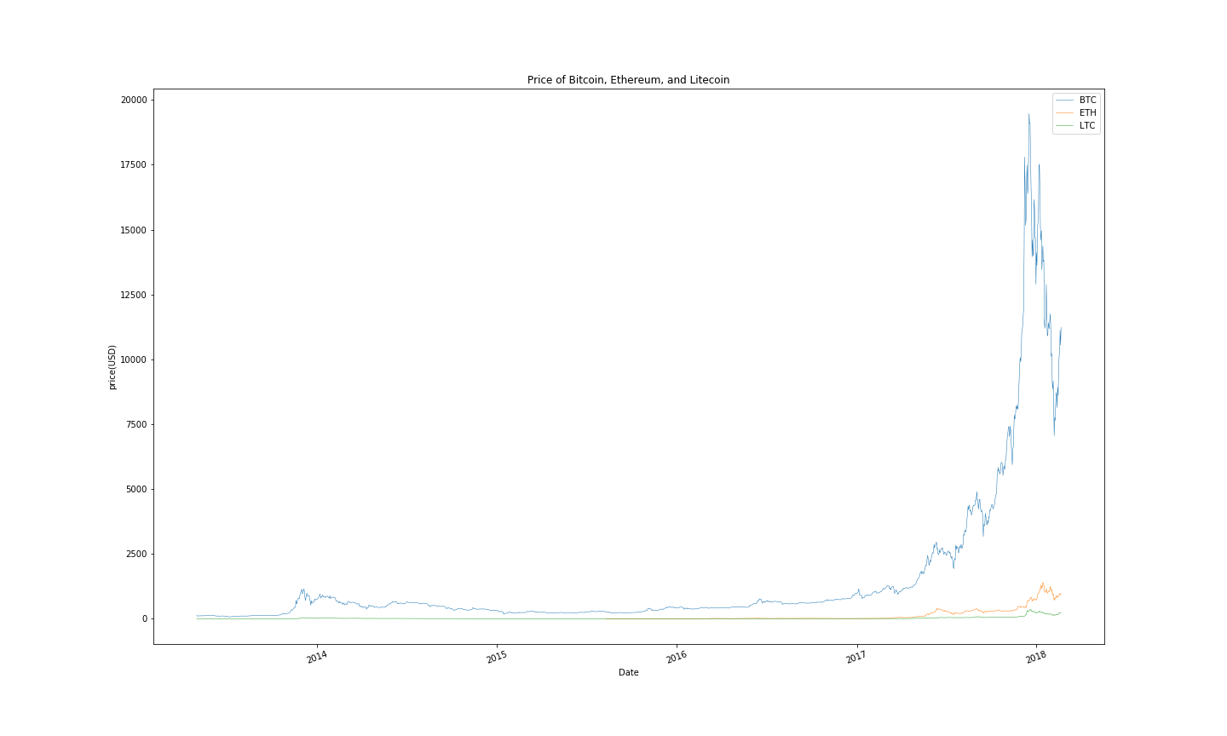

Figure 1: Price of Bitcoin (blue line), Ethereum (yellow line), and Litecoin (green line)

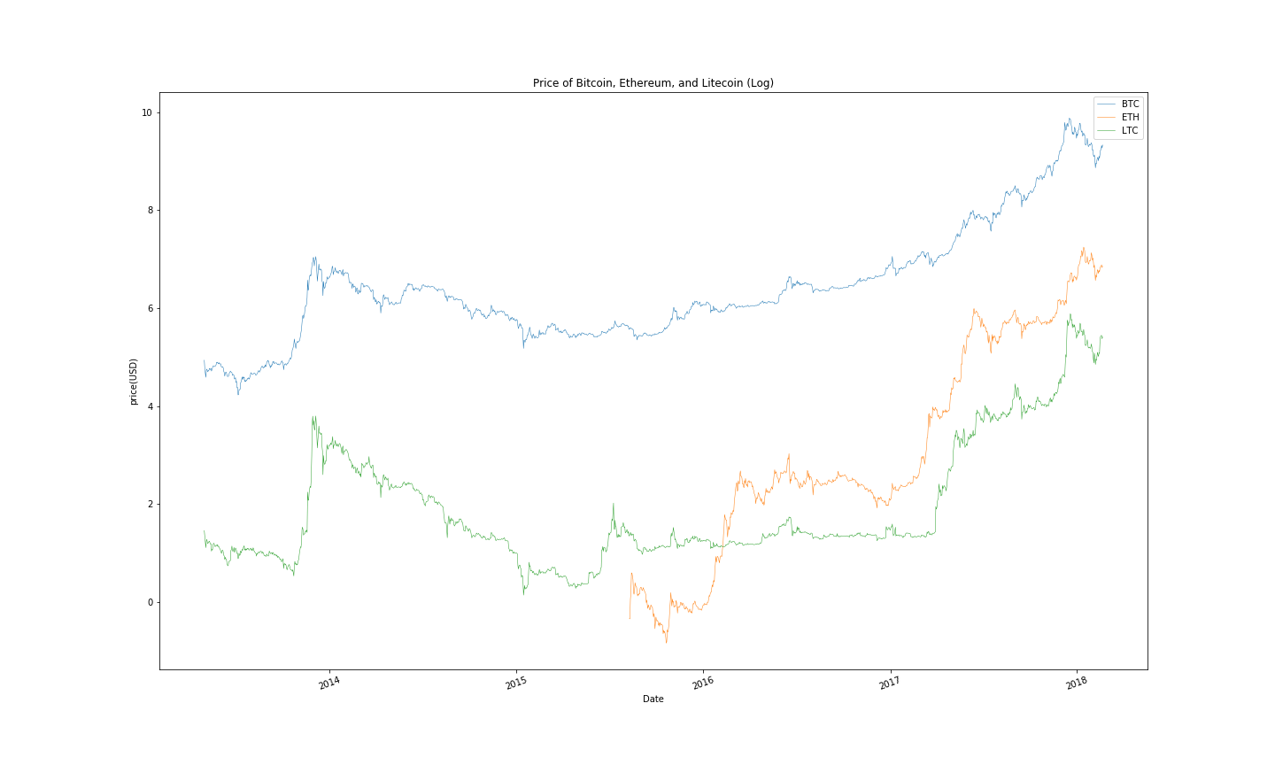

Figure 2: Price (in log space) of Bitcoin (blue line), Ethereum (yellow line), and Litecoin (green line)

1. **Literature Review**

***Brief Background on Cryptocurrencies and Blockchain***

Bitcoin, the first cryptocurrency, was introduced in 2009, and followed by many cryptocurrencies. Cryptocurrencies have no central authorities over transactions, or in other words, decentralized. They use cryptography techniques for secure communication in the presence of third parties, control transactions, manage supply and detect fraud. Once confirmed, all transactions are stored digitally and recorded in a “block”.

When each block is closed, miners have the opportunity to solve a mathematical problem to provide the key to lock it. Whoever solves it first will get a reward of a certain amount of Bitcoin, which serves as an incentive for people to mine, maintain the secure system, and generate new coins. After each block is locked, it then gets placed in a chain of pre-existing blocks, which is why this system is called “blockchain”. As the blockchain continues to grow, the math problems get harder and the coin rewards get smaller.

The supply of most cryptocurrencies increases at a predetermined rate, and cannot be changed by any central authority. This creates concerns about the deflationary aspect of the currency due to its limited supply[3]. However, there is a constant debate among economists whether deflation is good for the economy. Keynesian economists argue that deflation is bad for the economy because it incentivizes individuals to save money instead of spending it. On the other hand, the Austrian economists claim that as deflation occurs, prices as well as the cost for production also decreases, but profits will not change. Therefore, it will increase incentive for entrepreneurs to invest in long-term projects.

Bitcoin’s algorithm provides an effective safeguard against “counterfeit” by assuming that the majority of users are honest. If a record of someone is different than anyone else, it is likely that this person cheated, and their record will become invalidated. So far, this algorithm is effective in maintaining the integrity of the whole system, but many critics worry about what will happen if 51% of the users’ cheat. This topic is out of the scope of my paper, but can be an interesting topic to research about.

On the other hand, cryptocurrency become vulnerable while trading. Bitcoin can be stolen through wallets or exchange, and by February 2014, it was revealed that $450 million worth of Bitcoins were stolen from Mt. Gox which shut down the exchange [7]. Recently, there has also been a hack that stolen $31 million worth of Bitcoin [20]. However, according to Justina Lee [20], these attacks does not prevent more consumers from entering this market. First, the price of Bitcoin experienced a small shock, which dropped from $8300 to $7800, but it soon went back up.

***Current Cryptocurrency Market***

Bitcoin was initially popular in part because its anonymity enabled trade in illegal goods [5]. In October 2013, the US government shut down the largest website facilitating such trades. After that, though Bitcoin’s price continued to climb, its price fluctuates more due to speculation, security problems, and general uncertainty about the technology.

Meanwhile, more cryptocurrencies are being introduced in the eco-system. Almost all other cryptocurrencies were based on the Bitcoin protocol. They fix Bitcoin’s shortcomings, while providing alternatives for consumers, which is why they are called *altcoins*, cryptocurrencies that are alternatives to Bitcoin. While some altcoins are better versions of Bitcoin, some do not provide any improvement over Bitcoin. This is because there is virtually no barrier to entry in the market, since Bitcoin is an open-source protocol, and new comers can still capture significant profits from their short lived period.

Many critics express concerns that Bitcoin will deflate heavily due to its limited supply. To be specify, Bitcoin’s model only allows miners to mine Bitcoin at the decreasing rate[4], and eventually capped at 21 million coins, which is similar to the rate at which gold is mined [19]. This intensify worries that as Bitcoin’s price gets so high, it will lose its transactional value, network gains, … In the case of gold when the US was a colony, gold was replaced silver coins, its inferior goods. If I apply this to the current state of Bitcoin, Bitcoin’s alternatives are more so its superiors since they are improvement on the Bitcoin’s protocol, and come with lower cost to own. Therefore, this analogy would suggest that as Bitcoin deflate significantly, it is likely that it will be replaced by its alternatives.

However, current literature disagrees on this issue. Gandal et al argued that Bitcoin will eventually loses its dominant role due to its limited structure and other superior coins will take over. Meanwhile, other researchers believed that Bitcoin will forever be the dominant player in this market because its first mover advantage is really significant.

Therefore, we want to learn more about how these coins are behaving in regard to one another. Cheah et al, as well as almost all Bitcoin researchers, confirmed that Bitcoin exhibits extremely speculative nature and has no fundamental value. However, if we treat these cryptocurrencies as “money or currency”, then money’s intrinsic value is calculated on its transactional demand. The Macro Note section elaborates more on demand for money.

***Macro Note: Money Demand [17, 18]***

In the discussion *The Transaction Demand for Money: A Close Look*, Kari summarizes the two main reasons why people would hold money, which can be translated into why people would hold Bitcoin if we treat Bitcoin as “money”.

People want to hold money because they need it to purchase goods and services with the cost that they have to compromise the potential interest they would have gained if they were to put that money in a saving account. Transactional demand for money depends on *interest rate* (if interest rates are low, then it is not worth it to move out of money into other assets and then back to money, and vice versa), *aggregate income* (if the volume of income and output produced in the goods markets increase, then the number of transactions and exchanges increase, and consequently, people would want to hold more money to perform their transaction promptly), and *price level* (if price increases, people will need to hold more money to support their given level of transactions).

In addition to transactional demand, speculative demand encourages consumers to hold money. This goes back to the asset market concept in macroeconomics. Suppose that interest rates fluctuate. At two percent a person can get $1020 in a year’s time in exchange for $1000 in cash now. However, they expect the interest rate to rise to ten percent, and as a result instead of $1020, they will make up to $1100 if they make the investment. So if interest rates are unusually low, and it is expected to rise, rational consumers would keep their wealth instead of holding on to cash to profit.

***Bitcoin as “money”***

Though cryptocurrencies are distributed through a decentralized system and have slightly different attributes than money, they still share some similarities in terms of why people wants to hold on to them: purchase power and speculation. According to Schuh and Shy [4], while many consumers who own cryptocurrencies use them to either make payments for goods and services (evidence for transaction demand), they are also likely to expect the currency to appreciate (speculative demand). As a result, we modeled demand for Bitcoin as well as other cryptocurrencies as “currencies” to learn more about how they are interacting with one another. Cianan et al attempted to model Bitcoin using the traditional market forces and Bitcoin’s attractiveness for investors, and these factors appeared to have a significant impact on Bitcoin price with variation over time. My research project will elaborate more on their method, but adding some proxies for other currencies to observe their interactions.

First, to model Bitcoin as a currency, we tried to look at Bitcoin’s traditional determinants such as supply and demand. Ciaian et al (2016) modeled Bitcoin price formation similarly to gold. They denominate the stock of money base of Bitcoin in dollars for their research assuming that users have to convert everything to the dollars when they pay for goods and services. According to them, the Bitcoin money supply is the product of the total stock of Bitcoin in circulation and its price (dollar per unit of Bitcoin), and demand for Bitcoin is assumed to depend on the general price level, the size of Bitcoin economy, and the velocity of Bitcoin is circulation. They derived that in perfect markets, the equilibrium price is negatively correlated with the velocity and the stock of Bitcoin, while positively correlated with the size of Bitcoin economy and general price level.

Speculative demand for Bitcoin, or in Ciaian’s words, attractiveness to investors and users is proved to be a significant driver of Bitcoin demand. A research done by Lee (2014) confirmed that news affect price of Bitcoin depending on the type of news (positive news increases price, while negative news decreases it). Therefore, we hypothesize that using Google search term for Bitcoin, we can capture the public attention to this currency. We might not be able to distinguish good vs bad news, but we believe this variable will be able to capture the speculative nature of Bitcoin’s users. As Bitcoin gets more popular, more people will buy into it, hoping they can get a small profit out of the hype.

In addition to the Google trend, the Volatility Index (VIX), may be able to explain price of Bitcoin in some ways. Qadan and Yagil (2012) have found a connection between gold and the VIX between 1995 and 2010. The relationship between VIX and price of gold was negative. A higher VIX reflect a bearish condition in the exchange or the market as a whole, while a lower VIX reflects neutral to bullish condition in the exchange. Therefore, when VIX is low, we expect investors to invest more into assets like gold to hedge their investment. Similarly, since Bitcoin is not tied to any central fiat currency, investing in Bitcoin when the market is dull can be a decent strategy to diversify risk.

Bitcoin Futures

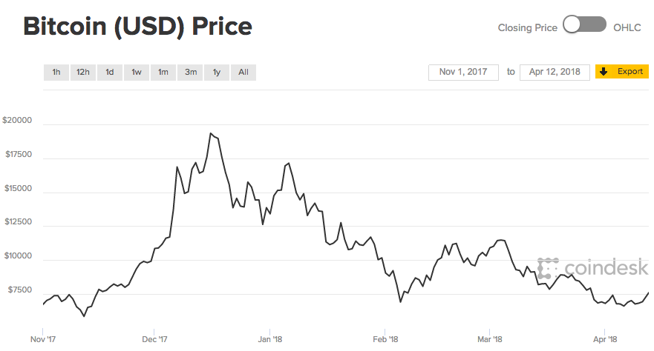

Figure 2: Bitcoin (USD) Price’s turning point

In late December 2017, the Bitcoin Futures Exchange was open, giving BTC speculators another platform to speculate. Ever since, along with tightened regulation and manipulation from the BTC whales (a group of people that hold the largest share of BTC), the price of BTC fall sharply. Despite some small increase in BTC price, its price in generally has been decreasing significantly ever since. Therefore, we want to further understand of how the factors of explaining BTC price will change their “role” along with this event.

Many critics argued that since BTC futures open, a lot of the speculation transitioned from the “real” exchange to the futures exchange, and therefore, we do not see as much speculative demand for BTC as we used to do before. According to Pylypczak-Wasylyszyn (2015), the Commodity Futures Trading Commission (CFTC), the government body responsible for futures market, classifies market participants as “commercial traders” to lock in pricing, or “non-commercial traders” or speculators in order words. While in agriculture and banking, it is popular to trade on futures market to ensure a stable future price, speculation on futures is more for the purpose of directionally betting.

As trader always look for new ways to capitalize on the price movements of assets, and they are only interested in the price appreciation, rather than owning the commodity. Goods like gold and oil are extremely widely traded on these market. One example is that one invest may feel that gold offers better risk-to-reward profile during an economic downturn, so they would purchase gold futures to capitalize on the downturn. Therefore, as speculation for BTC continues to grow, investors can capture more profits from trading on BTC futures exchange, so the we might not see as much speculation on BTC as we did before.

As BTC price dropped tremendously, some economists argued that this is the “growing pain” of this currency. Some optimists also believe that as the price decreases, and the speculation wears off, we might be able to see more of its transactional demand more clearly.

1. **Economics Model**

*Transaction Demand in Cryptocurrency Market*

According to the Macro Note about Money demand, one of the reason why people would want to hold on to money is its purchasing power, or liquidity. Cash gives them the flexibility so that they can make almost any transactions with it. Similarly, previous literature demonstrated that there is evidence that people are holding cryptocurrencies in order to make payments and purchase goods and services with them. Fundamentally, I think this is one of the most important aspect of cryptocurrencies, introducing a new system of money and transaction that is not subject to any centralized authority. Considering this type of demand for cryptocurrencies, how the market behaves if we assumed people only want to buy cryptocurrencies to pay for goods.

3

D1

3

D2

2

D1

1

D0

2

S1

Market of Bitcoin’s Alternatives (altcoins)

Market for Bitcoin

Quantity

Price

S

Quantity

1

D0

S0

Price

**Figure 1. A breakdown of the current Cryptocurrency Market (Transaction Demand)**

Hypothetically, price of Bitcoin increases (caused by a supply shock or something unexpected happened, S0 shifts to S1, point 1 to point2 in market for Bitcoin). The higher price in Bitcoin increases the demand for its alternatives.

However, if demand of Bitcoin increases because there are more people flooding into the market (Demand for Bitcoin D0 shifts to D1, point 1 to point 3), this will prompt the consumers who already considered altcoins as Bitcoin alternatives to switch over to buy altcoins (Demand for Altcoin D0 to D2, point 1 to point 3). So overall, the price of Altcoins would also increase as well as their quantity.

*Speculative Demand*

This demand is put as people are interested in buying more Bitcoin because they think the returns will be lower if they were to buy other (financial) assets with their money. While this is a part of money demand, and helped explains why people wanted to hold money, similarly, Bitcoin, or cryptocurrency in this example. Due to the increase Bitcoin price, this demand has been growing exponentially large. In this model, I attempted to capture the relationship between Bitcoin and Altcoins assuming there is only speculative demand for them. (Most people who own Bitcoin expect it to appreciate in prices, and existing literature up until 2014, 2015 [8, 9, 11] suggested that Bitcoin has an extremely speculative nature.)

Price

D1’

1

2’

3

D2

2

D1

2

D1

D0

Market of Bitcoin’s Alternatives (altcoins)

Market for Bitcoin

Quantity

S

Quantity

1

D0

S0

Price

**Figure 2. A breakdown of the current Cryptocurrency Market (Speculative Demand)**

Suppose people expect the price of Bitcoin to rise, they would be interested in holding Bitcoin to get some profits, as a result, demand for Bitcoin increases (D0 to D1, point 1 to point 2). As the supply of Bitcoin is increasing at a set rate by the algorithm, I assume supply does not change significantly in the short run. Therefore, the increase in price of Bitcoin would signal other consumers that price of Bitcoin will continue to grow, which create a feeding system for price and demand to grow in tandem of each other (D1 to D2, point 2 to point 3,…)

In the market of Altcoins, if I assume that people only hold on to cryptocurrencies for speculative purposes, and there’s no new consumers in this market, the demand for altcoins would decreases because their buyers are putting their bets on Bitcoin. However, if there are more people entering the market to buy cryptocurrencies, since the price of Bitcoin is too high, and they might expect Altcoins to appreciate as well, demand for Altcoins can also increases. Therefore, the overall impact on the Altcoins’ market is ambiguous in this argument.

*Network demand*

The network effect suggests that as the number of users of a network increases, its value increase. I use the analogy of Facebook and Google+, where Bitcoin is the existing player and alternative coins are Google+. What would happen, clearly, is that as the Bitcoin gets more popular, its demand will increase because of the network effect. As a result, its alternatives will likely to be neglected, since consumers do not see the value of holding other cryptocurrencies. Below are my graphs with the assumption that the Bitcoin’s network effect gives Bitcoin an advantage in the market.

Market of Bitcoin’s Alternatives (altcoins)

Market for Bitcoin

Quantity

Price

2

1

S

D1

D0

Quantity

3

2

1

D2

D1

D0

S

Price

**Figure 3. A breakdown of the current Cryptocurrency Market with the Network Effect**

As Bitcoin gets more popular, its demand increases (since more people are joining the market), which shifts its demand curve from D0 to D1 (point 1 to point 2). As a result, its price increases, which caused more people wanting to own it. Again, its demand increases to D2 (point 2 to point 3), this cycle keeps feeding itself until people lose interest in Bitcoin, or they do not expect Bitcoin to appreciate anymore.

Meanwhile, the market for Bitcoin’s substitute behaves in the opposite direction. As more people invest in Bitcoin, they do not see the point in buying other cryptocurrencies, since they do not expect them to appreciate as much as Bitcoin. Therefore, the demand for them decreases, which results in a drop in price for other cryptocurrencies.

However, when it comes to the network effects, what matters the most is the transaction ability of Bitcoin. Going back to the purpose of Bitcoin, it introduces a new decentralized system of payment, that does not require any central authority to approve payment or control money supply, but rather its cryptography technology. The previous literatures that examine the network effect of this market [2,3] did not address the different forces that driving demand, so I want to answer the question if the network effect of Bitcoin is large enough to give it the competitive edge compared to Altcoins, and if so, what demand that is driving this network effect for Bitcoin.

On the other hand, Gandal et al [2] indicates that instead of the network effect, the fact that newer currencies are improvement upon Bitcoin’s system can lead to a substitution effect in this market. Specifically, as price of Bitcoin goes up, consumers do not see the purpose of buying Bitcoin, so they decide to invest in other currencies with similar functionalities for cheaper price

More recent literature confirm that consumers are using Bitcoin and other cryptocurrencies to pay for goods and services and show evidence that cryptocurrencies can be useful in economic reasons such as trade transaction. Lewis (2017) suggested that while the rapid increase in Bitcoin’s price is driven by speculative demand, but the demand for Bitcoin as a transaction tool is growing in tandem underneath it, and eventually, as the speculative demand wears off, we will be able to see more clearly how the transaction demand is determining Bitcoin’s price.

1. **Methodology**

This model incorporates economic variables like supply and the price of substitutes of Bitcoin, as well as speculative variables that captures Bitcoin’s attractiveness to investors like Google queries for Bitcoin. This model is a time-series regression specified as follows:

*PBTC = f (PATC, ECO, SBTC , GLE, VIX, VOL, VEN, DFUT,)*

Where:

*PBTC =* the price of Bitcoin in time t

*PATC =* the price of Bitcoin’s alternatives like Ethereum, Litecoin, Ripple…

*ECO =* the size of Bitcoin’s economy (number of transactions/addresses)

*SBTC* = the supply of Bitcoin (number of coins in circulation)

*GLE =* the number of BTC queries on Google

*VIX =* the volatility index of the S&P 500

*VEN =* the number of vendors that accept Bitcoin as payment

*DFUT* = a dummy on when the future exchange of Bitcoin is introduced

The signs are hypothesized below:

(+/-) (+) (-) (+) (+/-) (-) (-)

$$PBTC= 0+ 1PATC+ 2 ECO+3SBTC+4GLE+5VIX+6VEN+7DFUT$$

Data Sources and Specifications

We want to incorporate the traditional supply and demand model to model Bitcoin. To simplify the model, we assume that users convert Bitcoin into dollars for transactional purposes (when in fact, they do not have to unless they trade Bitcoin with Dollar).

Data on the price of Bitcoin, as well as other cryptocurrencies that we are using in the model including Litecoin and Ethereum, can be found on Coinmetrics.io. The economy of Bitcoin, or number of transactions in Bitcoin, data is also retrieved from Coinmetrics.io. Coinmetrics claimed that this measure can be underestimated. For example, in case when one sender sends BTC to many receivers, that should be translated to multiple transactions, but it only recorded one transaction. The data on supply of Bitcoin is also from this website. Coinmetrics defined it as “the number of new coins that have been brought into existence on that day”, and they claimed this is not an estimate number, but rather the actual amount of Bitcoin in circulation.

In addition, to capture attractiveness to investors, we use Google search queries for Bitcoin term. Since Google indexed their data after 90-day period, we need to convert it to real term.

VIX is the proxy we use to measure Bitcoin’s speculative demand. In 2017, the price of Bitcoin skyrocketed despite critics and comparisons to the Tulip maniac… However, when the price dropped recently, with the introduction of Bitcoin future exchange, investors were more cautious toward this cryptocurrency, so we want to test if the launch of Bitcoin future affect the way investors spend their money on this currency. We suspect rather than “blind” speculation from the crowd, the professional investors will establish their systematic way of thinking, and make the VIX significantly explain the volatility of Bitcoin’s price.

As an effort to capture transactional demand for Bitcoin, we are interested in seeing how the increases of vendors accepting Bitcoin affect Bitcoin’s demand, and number of vendors accepting Bitcoin might help in explaining it. The data I obtained from coinmap.org. The only problem is that I cannot see how many vendors stop accepting Bitcoin, but I will use this data until I can find a better dataset.

Model Specification

Since this is a time-series analysis, we need to consider the serial correlation that can lead to spurious regression. After running the Durbin-Watson test on the price variables, we can see that these measures are highly non-stationary, and therefore, to avoid spurious regression, we decided to run a dynamic double-log regression to mitigate the serial correlation.

Ssekuma (2011) suggested that cointegration regression is one of the most robust model to for time-series data. The Pesaran method of cointegeration will be used to test whether there is an underlying relationship between the dependent and independent variables (Pesaran, 2001). After running the dynamic model, we also employ the Pesaran cointegration to better understand Bitcoin’s price movement in the short and long run. The short-run Bitcoin cointegration model is specified as follows:

1. Results

Dynamic Double-log Model

The first model that was run and tested was the 2015-present dynamic double-log model, which aimed to understand the effects of the independent variables on the price of Bitcoin since 2015. The results of the regression are outlined in Table 1.

Table 1: 2015-Present Dynamic Double-log Regression Results

|  |  |  |
| --- | --- | --- |
| **Variable** | **Coefficient** | **p-value** |
| ln (BTC price) lagged | 0.9374261*** | 0.0000 |
| ln (ETH price) | -0.0052993* | 0.0120 |
| ln (LTC price) | 0.0303991*** | 0.0000 |
| ln (ECO) | 0.0374202*** | 0.0000 |
| ln (GG search) | 0.0010933 | 0.7460 |
| ln (Cyber attack) | -0.0007177. | 0.4290 |
| ln (VIX) | -0.004661. | 0.4730 |
| ln (VEN) | 0.2675169*** | 0.0000 |
| DFUT | -0.0335925*** | 0.0000 |
| (Intercept) | -2.469088*** | 0.0000 |
|  |  |  |
| R^2 = 0.999 |  |  |
| Adjusted R^2 = 0.999 |  |  |
| Df = 951 |  |  |
| Significance Codes: ***0, **0,001, *0.05, . 0.1 | | |

As the results of the initial regression demonstrated, variables including the lagged BTC price, ETH price, LTC price, ECO (number of transaction in BTC), VEN (number of vendors), and DFUT are highly significant, and the adjusted R-squared is 0.999. These results show us that the independent variables account for a 99.9% of the BTC price variance.

Moreover, ECO, GG search,

1. Cointegration Preliminary Result

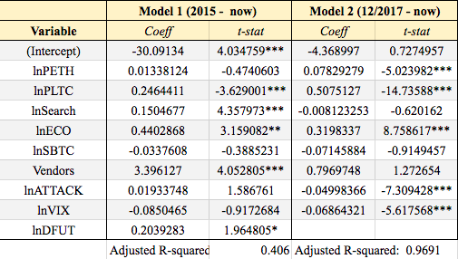

**Bibliography**

Katz, M. & Shapiro, C. (1994). Network externalities competition and compatibility. *American Economics Review*

Gandal, N. & Halaburda, H. (2016). Can We Predict the Winner in a Market with Network Effects? Competition in Cryptocurrency Market

ElBahrawy, A., Alessandretti, L, Kandler, A., Pastor-Satorras, R., & Baronchelli, A. (2017) Evolutionary dynamics of the cryptocurrency market

Schuh, S & Shy, O. (2015). U.S. Consumers’ Adoption and Use of Bitcoin and other Virtual Currencies

Marco S. (2017). Silk Road Goes Dark: Bitcoin Survives Its Biggest Market’s Demise - <https://www.coindesk.com/bitcoin-milestones-silk-road-goes-dark-bitcoin-survives-its-biggest-markets-demise/>

Reiff, N. (2017). What Happens to Bitcoin After All 21 Million are Mined? - <https://www.investopedia.com/news/what-happens-bitcoin-after-all-21-million-are-mined/>

O’Neill, P.H. (2017). The curious case of the missing Mt. Gox bitcoin fortune - <https://www.cyberscoop.com/bitcoin-mt-gox-chainalysis-elliptic/>

Bouoiyour, J., Selmi, R. & Tiwari, A. (2014). Is Bitcoin business income or speculative bubble? Unconditional vs. conditional frequency domain analysis - <https://mpra.ub.uni-muenchen.de/59595/>

Cheah, E, Fry, J.(2015). Speculative bubbles in Bitcoin markets? An empirical investigation into the fundamental value of Bitcoin - <http://www.sciencedirect.com/science/article/pii/S0165176515000890>

Ciaian, P., Rajcaniova & Kancs, A (2016) The economics of Bitcoin price formation – https://arxiv.org/pdf/1405.4498.pdf (data: <https://www.quandl.com/)>

Yermack, D (2013). Is Bitcoin a Real Currency? An Economic Appraisal – <http://www.nber.org/papers/w19747>

2017 List of Big Companies that Accept Bitcoin & Cryptocurrencies - <https://steemit.com/bitcoin/@steemitguide/2017-top-list-of-big-companies-that-accept-bitcoin-and-cryptocurrencies>

CoinDesk (2016). State of Bitcoin and Blockchain -<https://www.slideshare.net/CoinDesk/state-of-bitcoin-and-blockchain-2016-57577869/69-150k_Merchants_Accepting_Bitcoin_Forecasted>

Lewis, N. (2017). What is the Fundamental Value of Bitcoin? - <https://www.forbes.com/sites/nathanlewis/2017/12/07/what-is-the-fundamental-value-of-bitcoin/2/#123d85343c08>

Kristoufek, L. (2015). What are the main drivers of the Bitcoin price? Evidence from wavelet coherence analysis - <https://arxiv.org/pdf/1406.0268.pdf>

Iwamura, M., Kitamura, Y. & Matsumoto, T. (2014). Is Bitcoin the only Cryptocurrency in the Town? Economics of Cryptocurrency and Friedrick A. Hayek - <https://papers.ssrn.com/sol3/papers.cfm?abstract_id=2405790>

Kari, D., The Transaction Demand for Money: A Close Look - <http://www.economicsdiscussion.net/money/demand-for-money/the-transactions-demand-for-money-a-close-look/16115>

Controlled supply - <https://en.bitcoin.it/wiki/Controlled_supply>

Lee, J. (2017). Even a $31 Million Hack Couldn’t Keep Bitcoin Down - <https://www.bloomberg.com/news/articles/2017-11-21/bitcoin-falls-after-31-million-theft-of-cryptocurrency-tether>

Pylypczak-Wasylyszyn, D. (2015). Hedging vs. Speculation with Futures - <http://commodityhq.com/trading-strategies/speculating-vs-hedging-with-futures-explained/>

Data: <https://www.quandl.com/data/BCHAIN-Blockchain?page=4>

<https://www.coindesk.com/9-useful-bitcoin-data-resources/>

Recently, Japan closed two of their cryptocurrency exchanges due to lack of cybersecurity as an effort to protect cryptocurrency holders. Though this was done in Japan’s effort to be the lead of Asia in blockchain and cryptocurrency, this might affect the price of Bitcoin for a short period of time, since people need to figure out new place to trade their coins. Therefore, I suspect this might cause a small shock because the Japanese Yen is the most traded currency for Bitcoin at the moment.

***Coinmetrics Data***

From Coinmetrics, I can obtain some metrics including price of Bitcoin, price of Alternative coins, number of coins in circulation.

Cryptocurrencies’ prices data (<https://coinmetrics.io/on-data-and-certainty/)>

* Date
* txVolume(USD) transaction volume: according to coinmetrics, “this is an answer to the question “approximately how much value, denominated in USD, circulates on the Bitcoin blockchain a day?” However, it is really hard to give an accurate estimate of this measure, so the level of certainty is debatable (<https://coinmetrics.io/difficulty-estimating-chain-transaction-volume/)>
* txCount: number of transactions happening in the public blockchain per day. Unlike txVolume where they can be overestimated, this measure can be underestimated (For example, in case when one sender sends BTC to many receivers)
* marketcap (USD): unit price multiplied number of units in circulation.
* Price: coins’ price drawn from CoinMarketCap (opening price)
* Exchangevolume(USD): CoinMarketCap data (the dollar value of the volume at exchanges like GDAX and Bitfinex) However, CoinMarketCap doesn’t have some information of some important exchange like OTC exchange
* generatedCoins: the number of new coins that have been brought into existence on that day (Coinmetrics claimed that they count the actual number of coins rather than estimating)

fees: native currency instead of USD.

The cost of mining is also important to consider, since the miners also hold Bitcoins. As the cost of mining increases, it no longer provide the incentives for miners to mine rather than just buying or trading coins on exchanges. Therefore, this will increase the demand for Bitcoin, thus increases its price as a result, while its supply grows slower.

1. I will go in more details about Bitcoin’s shortcomings in later section
2. Definition of these two terms will be explained in the Economics Model Section
3. More details on the current state of Bitcoin in the next section “Current Cryptocurrency Market”
4. More details on the supply of Bitcoin can be found in [19]