**FPT ACADEMY INTERNATIONAL**



## FPT – APTECH COMPUTER EDUCATION

**Mavericks dresses**

|  |  |  |  |  |
| --- | --- | --- | --- | --- |
| **Center Name** | | FPT – Aptech – HCM2  Address: 391A, Nam Ky Khoi Nghia, Phuong 8, Quan 3, Ho Chi Minh City | | |
| **Instructr** |  | Ms. Le Mong Thuy | |  |
| **Class** |  | T1.2210.M0 | |  |
| **Group** |  | 5 | |  |
| **Group members** | | **Name** | | **Student ID** |
|  |  | Tran Thien Nhan | | Student1429121 |
|  |  | Vo Ho An | | Student1429123 |
|  |  | Nguyen Trong Nghia  Huynh Tan Anh | | Student1429421  Student1429832 |
|  |  |  | |  |
|  |  |  |
|  |  |  | |  |
|  |  |  | |  |
| **Duration** | Start date | 01st Feb 2023 | |  |
| End date | 03rd Mar 2023 | |  |

**This is to certify that**

**Mr.:**

Tran Thien Nhan

Vo Ho An

Nguyen Trong Nghia

Huynh Tan Anh

**has successfully designed & developed**

eProject: maverick dresseswebsite

**Submitted by:**

Tran Thien Nhan

**Dateofissue: 03-03-2023**

**Authorized Signature:**

**TABLE OF CONTENTS**

****FPT – APTECH COMPUTER EDUCATION 1****

****TABLE OF CONTENTS**** ****2****

****ACKNOWLEGMENT**** ****3****

****SYNOSIS**** ****3****

****PROBLEM DEFINITION**** ****4****

****CUSTOMER'S REQUIREMENTS SPECIFICATIONS (CRS) 6****

****Business/Project Objective**** ****6****

****Hardware/ Software Requirements**** ****7****

****SCOPE OF THE WORK (IN BRIEF) 8****

****Architecture and design of the system 9****

****Diagram of the website 10****

****TASK SHEET REVIEW 1 11****

****SITE MAP 12****

****MOCK OF THE WEBSITE** ...******13****

***1. Homepage 13***

***2. Product .******14***

***3. Blog ..******15***

***4. About Us 1******6***

***5. Contact US 17***

****TASK SHEET REVIEW 2 18****

WEBSITE DESCRIPTION**..******19****

RESPONSIVE

[****JAVASCRIPT DESCRIPTION****](#Javascript)

****TASK SHEET REVIEW 3****

# ACKNOWLEGMENT

On behalf of team members. I would like to thank everyone who supported my team to successfully complete this eProject report. Especially, our teacher, she has supported us a lot since we started studying at FPT Aptect. With this eProject, she guided us very meticulously, enthusiastically and strictly. With her guidance, we were able to successfully complete this project. Besides, I also want to thank all the team members, each of whom worked hard to complete the eProject in earnest during the month of working together. Finally, our group would like to say thank you to my classmates and family for sharing and creating for the group the best environment to focus on the project, motivating the members to achieve their goals.

# SYNOSIS

Maverick Dresses is leading Uniform Manufacturers in the country. They supply many schools in country and they give them the best uniforms. They supply affordable school uniforms for girls and boys. When clients come, they cater to client’s vision. As a team of professionals they understand what clients want and deliver the best results.

At Maverick Dresses, designs are innovative and there are always fresh and new ideas for each and every client. The textiles are of excellent quality and they make each uniform according to the size requirements given. The fit is ingenious and they provide with the best. Maverick Dressesis a part of a continuous strategic process of creative inputs from experts in the field. They consider each client differently and ensure the satisfaction with the end results. Each client is given the uttermost importance.The entire team works together to achieve the same goal.

You are supposed to create a Single-Page-Application and responsive Website for them with the below mentioned requirement specifications.

# 

# PROBLEM DEFINITION

The Web site is to be created based on the following requirements.

1. The Top of the Page should contain logo of the site with suitable images.
2. Products should be categorized as
   1. Shirts
   2. Skirts
   3. Frocks
   4. P.T. T-shirts
   5. P.T. shorts
   6. P.T. track pants
   7. Belts
   8. Ties
   9. Logos
   10. Socks
3. There should be a “Contact Us” section which will have the Address of the Company which is as follows and the mail address which when clicked will invoke the local mail client from where they can send an email.Address of the Company should be displayed using GeoLocation API (eg. GoogleMaps).
4. Contact Us should have link for the address and contact details of various outlets of Maverick Dresses in the city.
5. Site map, Gallery, about us must be added.
6. Feedback must be allowed to enter in the website
7. Navigation must be smooth.
8. Color combination must be uniform throughout the project.

Over and above this, the portal should implement the following functionalities:

* Display a continuous scrolling ticker at the bottom of the page with current date, time, and location (hint: Use geolocation features of HTML5).
* Display a visitor count at the top right corner of the page beside a logo image.
* The menu options should change color on hover and also after clicking.

Fade in and fade out options can be used for the menus

# 

# CUSTOMER'S REQUIREMENTS SPECIFICATIONS (CRS)

**Client: Mavericks dresses**

### Business/Project Objective:

The company advertises by distributing the pamphlets, advertising on television and so on. Due to rapid development in internet field, the company decides to launch a website where people will get all the information about the various products available with them easily.

The website is to be developed for the Windows Platform using HTML5, JavaScript and Geolocation. The site should work well in all leading browsers including Chrome, IE, Firefox etc.

**Input to the system:**

- Searching products based on shirts, skirts,frocks, t-shirts, short, strack pants… and other products.

- Feedback about the quality of products

**Output from the system:**

* Display a continuous scrolling ticker at the bottom of the page with current date,

time, and location (hint: Use geolocation features of HTML5).

* Display a visitor count at the top right corner of the page beside a logo image.
* The menu options should change color on hover and also after clicking.
* Fade in and fade out options can be used for the menus.

**Process**:

* + - * Validate data input from users.
      * Filter product by categories

**Expected delivery date:** 03-Mar-2023.

**List of deliverables:**

- Document Word, PDF.

- User Guide.

- Source code.

### 

### Hardware/ Software Requirements:

* **For developer:**

**Hardware**

* + Intel Core i3/i5 Processor or higher
  + 08 Gigabytes of RAM orhigher
  + Color SVGA
  + Mouse
  + Keyboard

**Software**

* + Web browsers such as Edge, Chrome, Mozilla Firefox, Safari are supporting HTML5, CSS, Bootstrap, JavaScript, jQuery, AngularJS, XML.
  + Data Store: JSON files or TXT files
* **For webusers:**

**Hardware**

* + Intel Core i3/i5 Processor or higher
  + 500 GB Hard Disk space

**Software**

* + Web browsers such as Edge, Chrome, Mozilla Firefox, Safari are supporting HTML5, CSS, Bootstrap, JavaScript, jQuery, AngularJS, XML.

# 

# SCOPE OF THE WORK (IN BRIEF)

After a long and detailed discussion, our group has decided to create a website contain the following webpages:

1. ***Homepage***: There is a search bar to search for products, display promotional information, best-selling products and introduce Maverick dresses.
2. ***Product***: Displays all available products based on the Category (shirts, skirts,frocks, t-shirts, short, strack pants.). In the above categories, products can be filtered by name,capacity and price.
3. ***Gallery***: Display interior design with maverick dresses.
4. ***About Us***: Display the information of the company, clients review and about us.
5. ***Contact Us***: Display the address of the company, Map and allow customers to request any information they want to Maverick dresses.

# ARCHITECTURE AND DESIGN OF THE SYSTEM

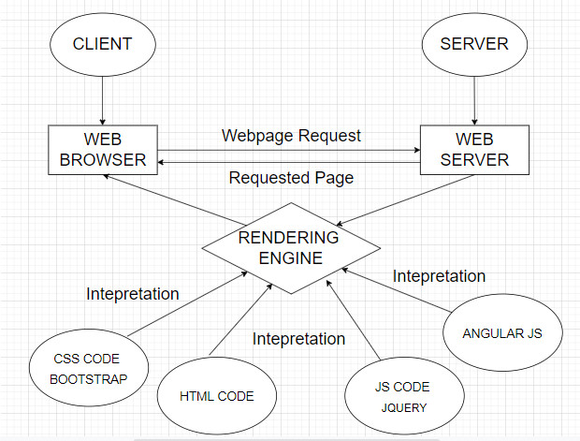

# 

# DIAGRAM OF THE WEBSITE

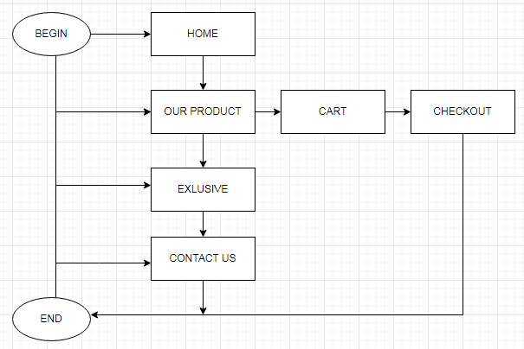



# TASK SHEET REVIEW 1

|  |  |  |  |  |  |  |  |
| --- | --- | --- | --- | --- | --- | --- | --- |
| **Project Ref. No.:**  **eP/Advertisement Portal Management**  **System/01** | | **Project Title:** | **Activity Plan Prepared By:** | **Date of Preparation of Activity Plan:** | | | |
| **Sr.**  **No.** | **Task** | **Actual**  **Start**  **Date** | **Actual Days** | **Team**  **Mate Names** | **Status** |
| 1 | Problem Statement | MAVERICKS DRESSES | Nhan | 01-Mar-23 | 1 | Nhan | Completed |
| 2 | Analysis of Maverick dressesrequirements about the website | 01-Mar-23 | 1 | Nhan | Completed |
| 3 | The scope of the work (in brief) | 01-Mar-23 | 1 | An | Completed |
| 4 | Architecture and design of the system | 01-Mar-23 | 1 | An | Completed |
| 5 | Diagram of the website | 01-Mar-23 | 1 | Nghia | Completed |
| 6 | Task Sheet | 01-Mar-23 | 1 | Anh | Completed |

|  |  |
| --- | --- |
| **Date:** | |
| Signature of Instructor:  **Ms. Le Mong Thuy** | Signature of Team Leader:  **Tran Thien Nhan** |

# SITE MAP

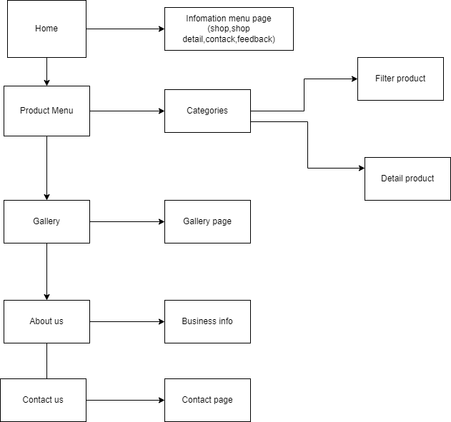

# MOCK OF THE WEB SITE

1. **Homepage**

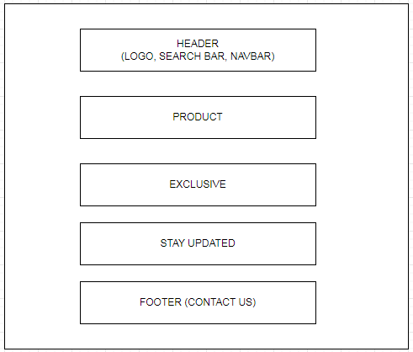

1. **Product Gallery +Filter**

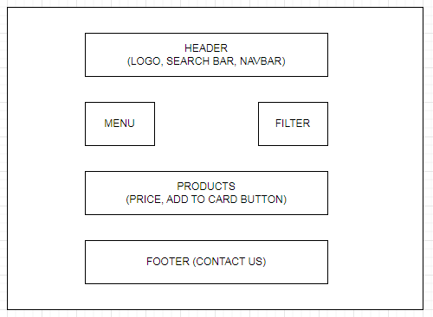

1. **Product info (detail site)**

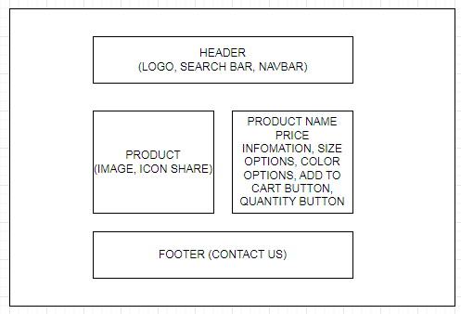

1. **About Us**

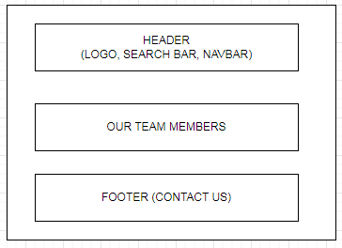

1. **Contact Us**

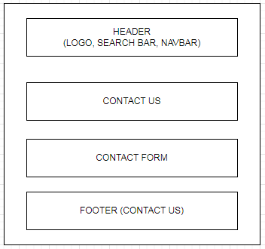

# TASK SHEET REVIEW 2

|  |  |  |  |  |  |  |  |
| --- | --- | --- | --- | --- | --- | --- | --- |
| **Project Ref. No.:**  **eP/Advertisement Portal Management**  **System/01** | | **Project Title:** | **Activity Plan Prepared By:** | **Date of Preparation of Activity Plan:** | | | |
| **Sr.**  **No.** | **Task** | **Actual**  **Start**  **Date** | **Actual Days** | **Team**  **Mate Names** | **Status** |
| 1 | Site Map | MAVERICKS DRESSES | Nhan | 6-Feb-23 | 1 | An | Completed |
| 2 | Mock of the website | 6-Feb-23 | 2 | Nghia | Completed |
| 3 | Task sheet | 6-Feb-23 | 2 | Anh | Completed |

|  |  |
| --- | --- |
| **Date:** | |
| Signature of Instructor:  **Ms. Le Mong Thuy** | Signature of Team Leader:  **Nguyen Luu Gia Bao** |

# TASK SHEET REVIEW 3

# WEBSITE DESCRIPTION

1. **Homepage**
2. Description

Home page displays following information:

- Slide show programs, services and product promotions

- Feature product.

- Some information about the website.

1. Screen shot

*Home page*

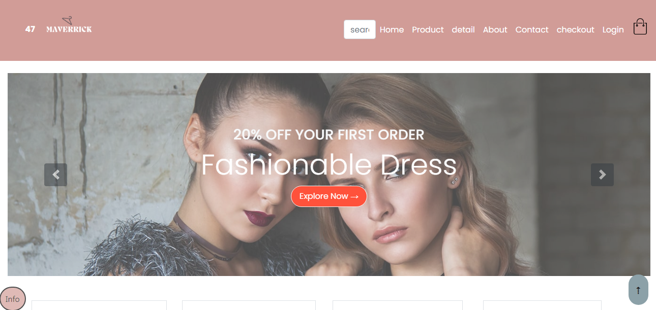

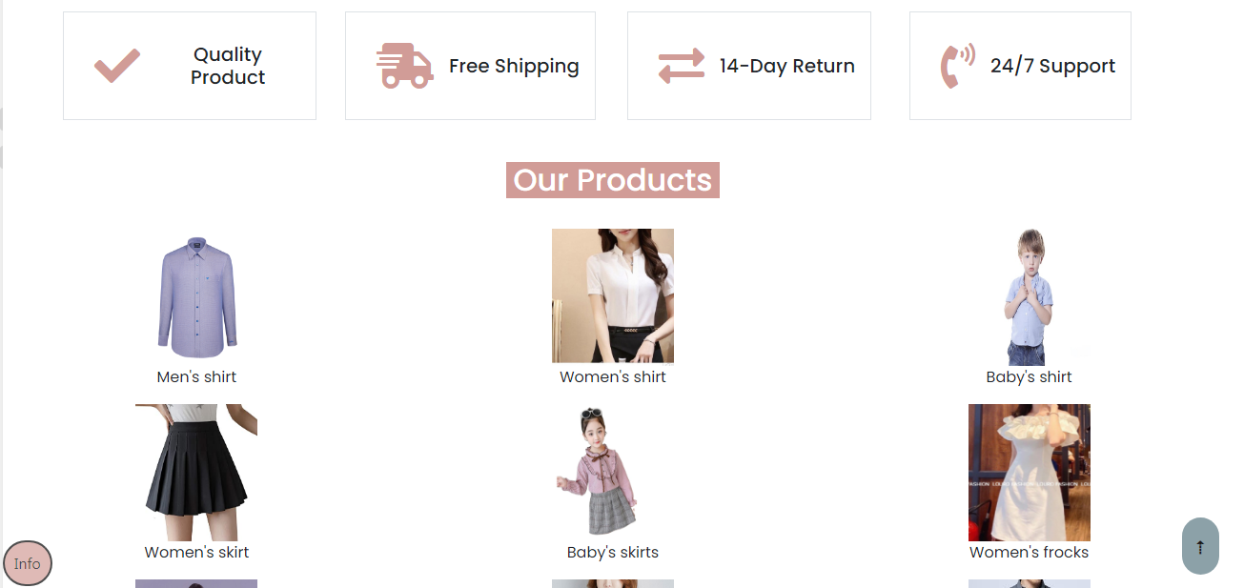

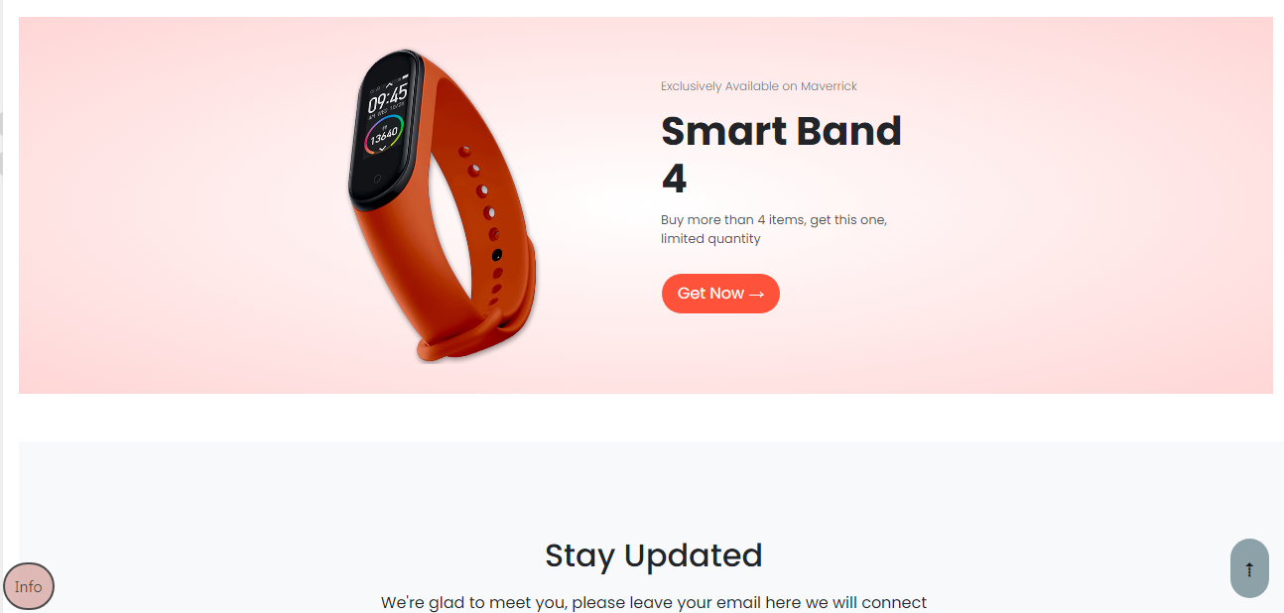

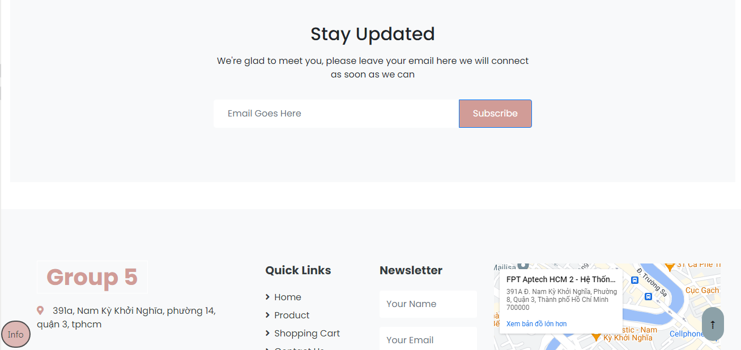

***Product site***

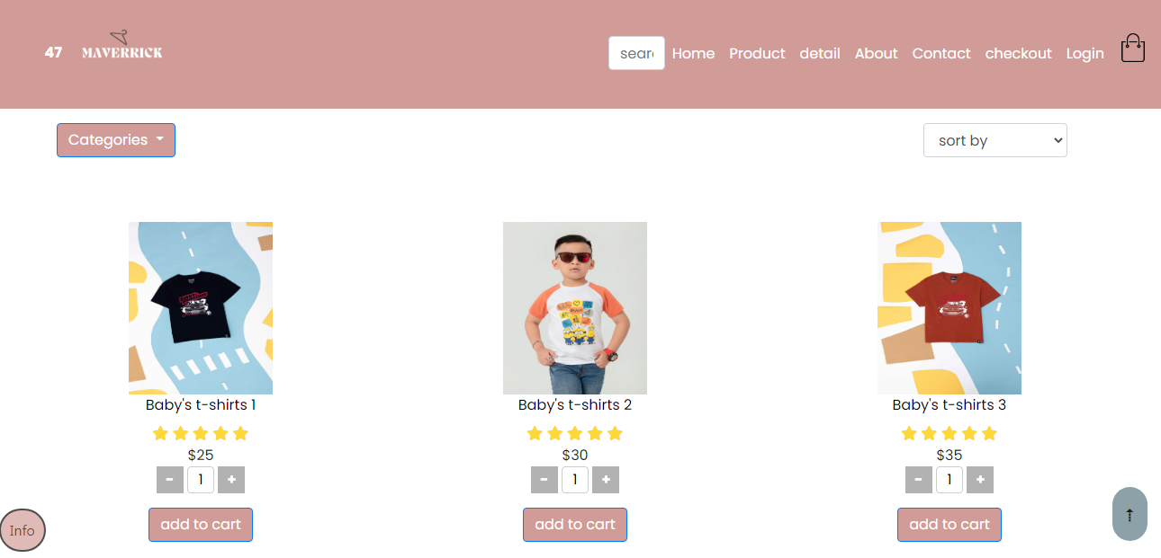

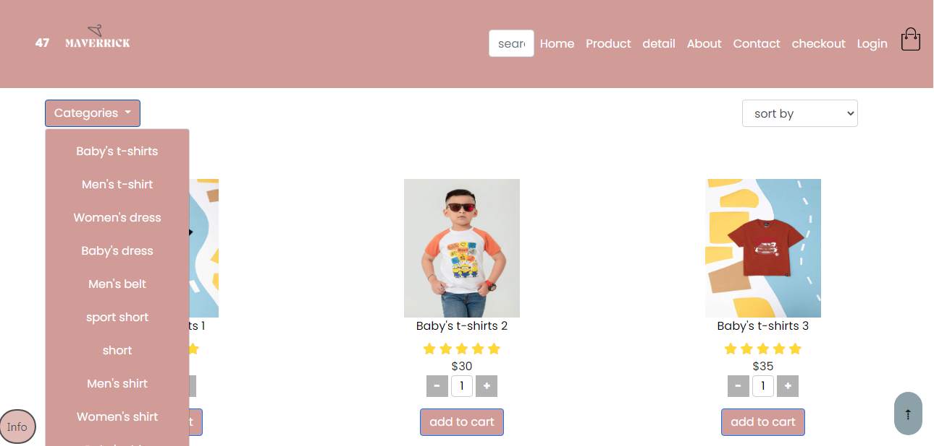

***Product detail site***

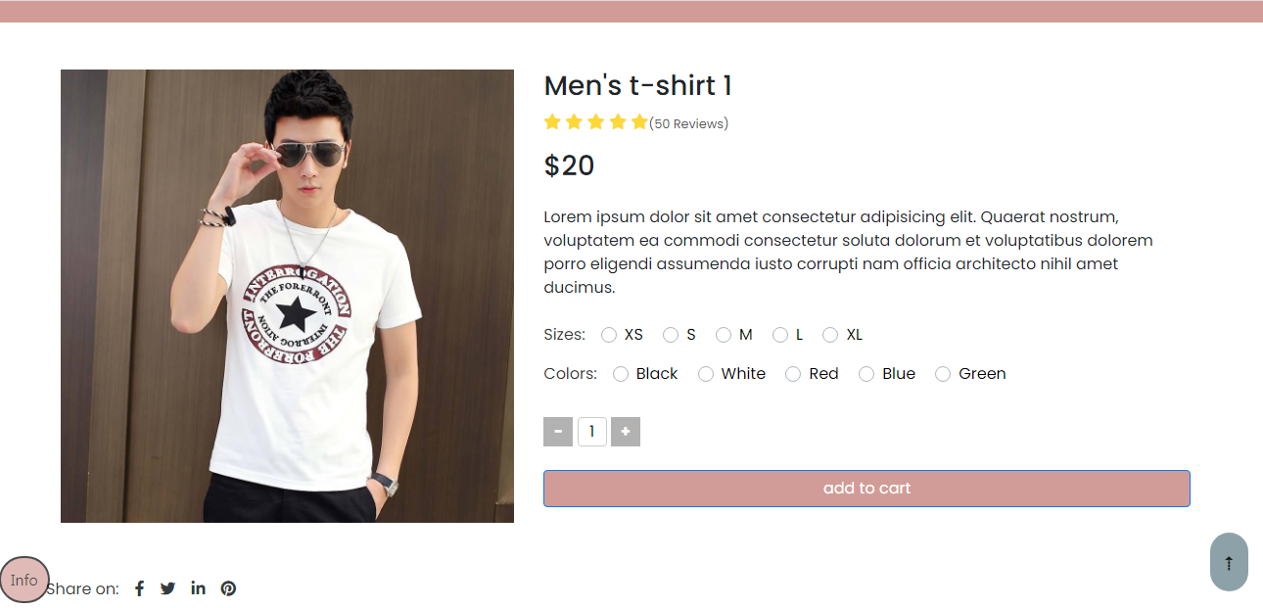

***Contact site***

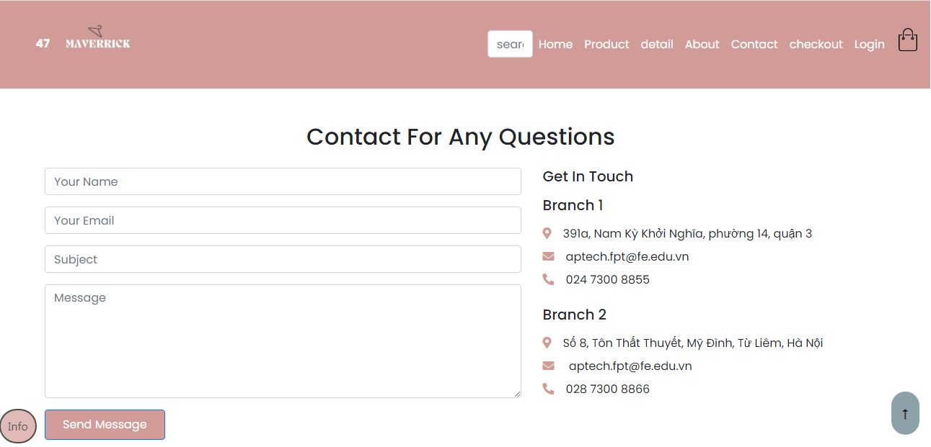

***Cart site***

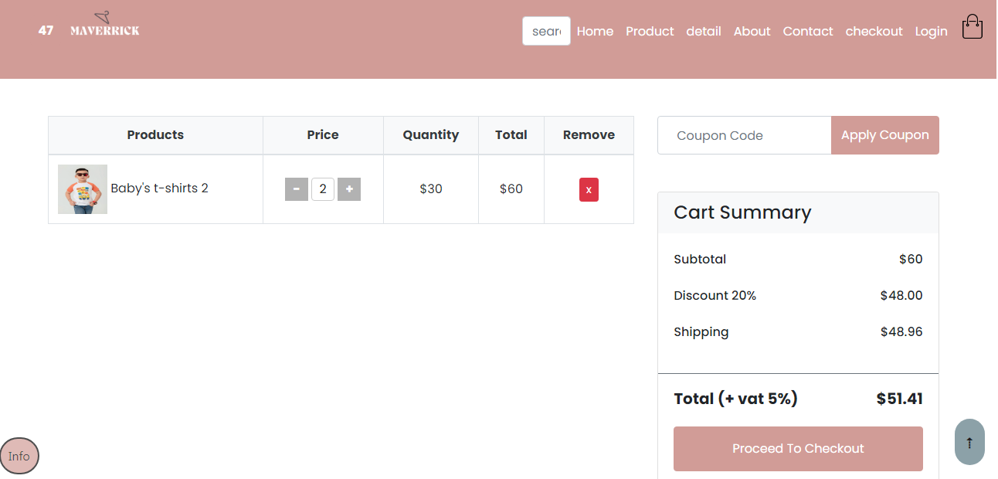

***Checkout site***

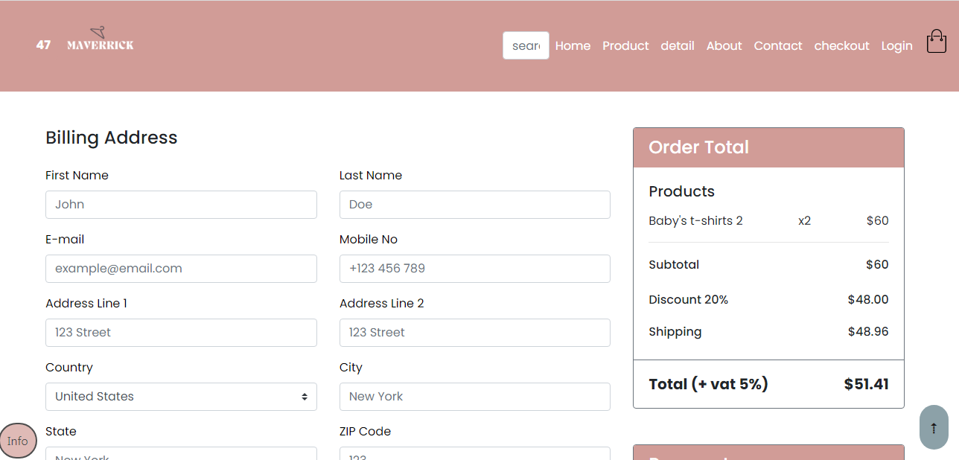

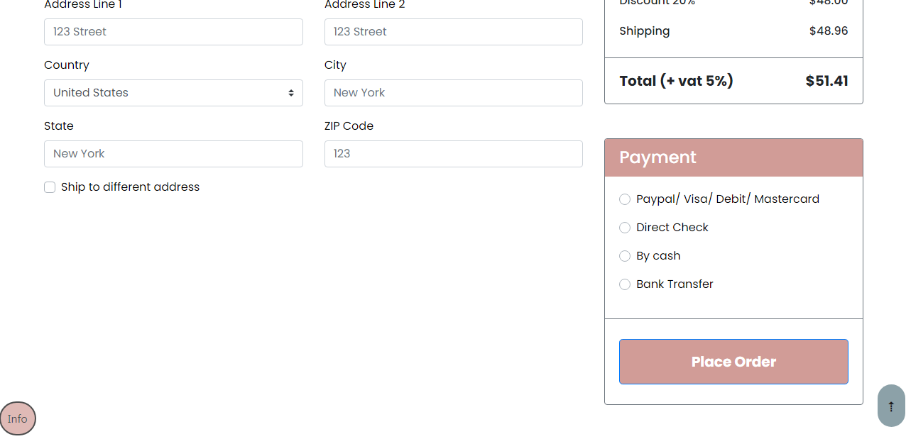

***About us site***

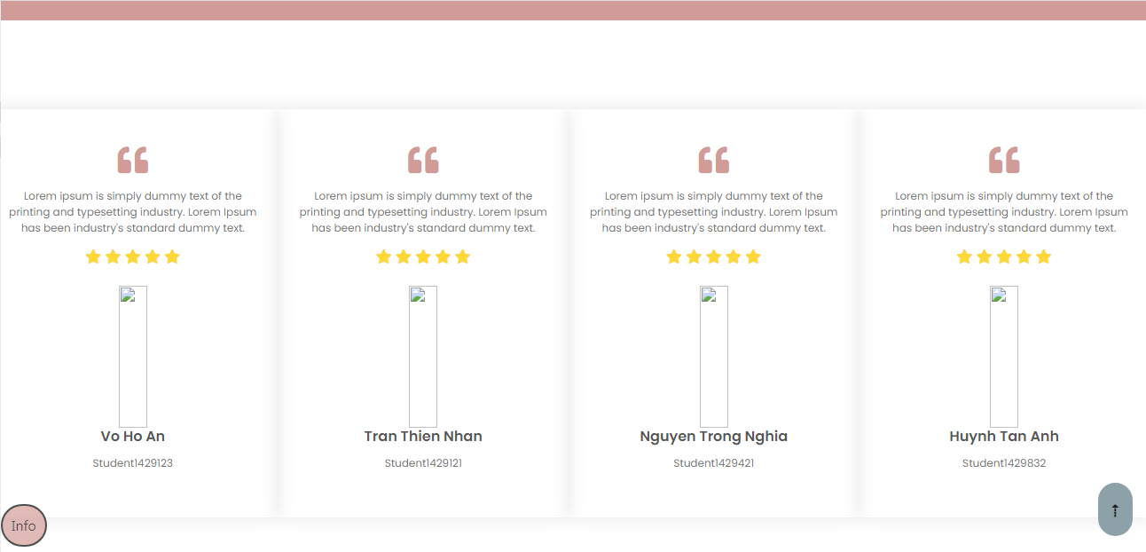

***Login and register site***

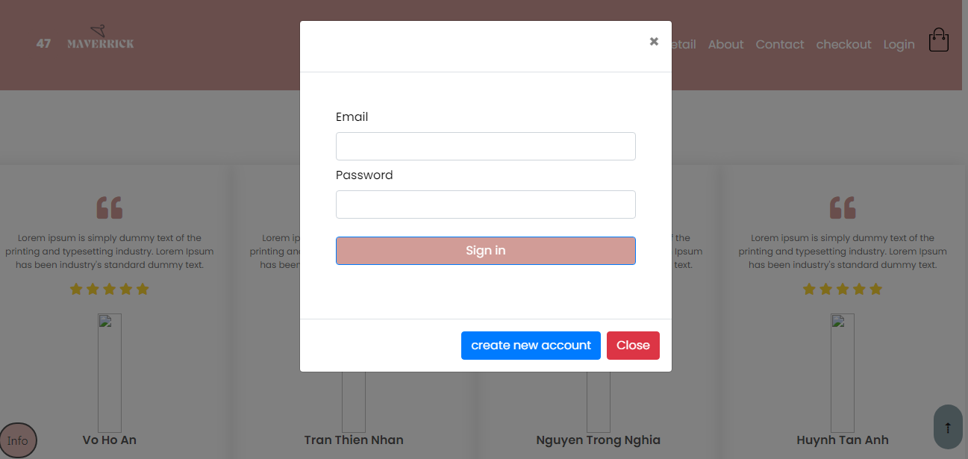

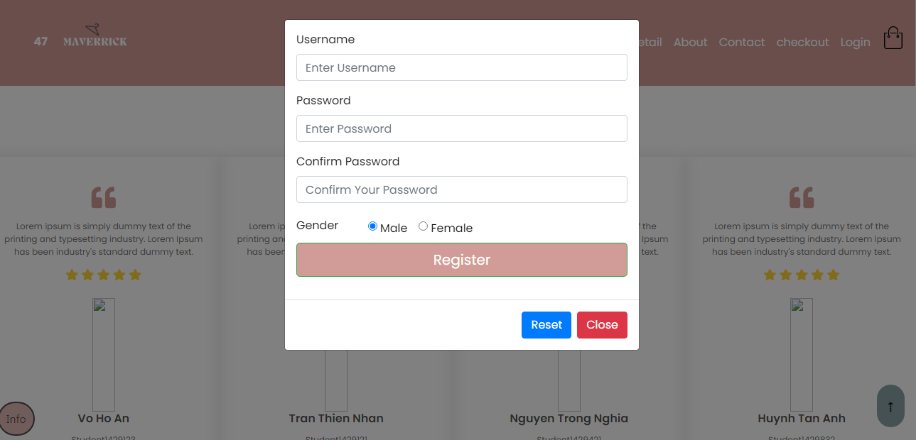

|  |  |  |  |  |  |  |  |
| --- | --- | --- | --- | --- | --- | --- | --- |
| **Project Ref. No.:**  **eP/Advertisement Portal Management**  **System/01** | | **Project Title:** | **Activity Plan Prepared By:** | **Date of Preparation of Activity Plan:** | | | |
| **Sr.**  **No.** | **Task** | **Actual**  **Start**  **Date** | **Actual Days** | **Team**  **Mate Names** | **Status** |
| 1 | Home Page | MAVERICKS DRESSES | Nhan |  |  | An |  |
| 2 | Shop |  |  | Nghia |  |
| 3 | Time |  |  | Nhan |  |
| 4 | About Us |  |  | Anh |  |
| 5 | Contact Us |  |  | Anh |  |
| 6 | Google map |  |  | An |  |
| 7 | Java Script |  |  | Nhan |  |
| 8 | Responsive |  |  | Nghia |  |

|  |  |
| --- | --- |
| **Date:** | |
| Signature of Instructor:  **Ms. Le Mong Thuy** | Signature of Team Leader:  **Nguyen Luu Gia Bao** |