# DATA TABLES

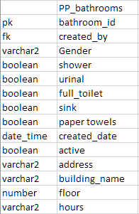

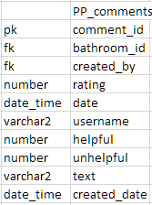

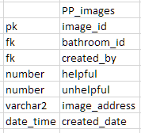

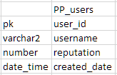

# DATA DICTIONARY

active: PP_bathrooms

address: PP_bathrooms

bathroom_id: PP_bathrooms, PP_comments, PP_images

building_name: PP_bathrooms

comment_id : PP_coments

created_by: PP_bathrooms, PP_comments, PP_images

created_date: PP_bathrooms, PP_comments, PP_images, PP_users

floor: PP_bathrooms

full_toilet: PP_bathrooms

gender: PP_bathrooms

helpful: PP_comments, PP_images

hours: PP_bathrooms

image_address: PP_images

image_id: PP_images

paper_towels: PP_bathrooms

rating: PP_comments

reputation: PP_users

shower: PP_bathrooms

sink: PP_bathrooms

text: PP_comments

unhelpful: PP_comments, PP_images

urinal: PP_bathrooms

user_id: PP_users

username: PP_users