**User’s Manual**

1. ***Product Overview***

Have you ever really had to move your bowels or pee like a racehorse but could never find a nearby restroom? Who hasn’t!

Potty Pool is an application that changes all that – now you can find the nearest public restroom to your current location. Once you have the Potty Pool app, all you must do is open it and you should be able to see all the public restrooms near you. Most public restroom locations will have a star rating and written comments/reviews from other people.

If a public restroom cannot be found or the public restroom has no ratings, it might be because no one has reviewed it. There’s an option to add a location, as well as reviews.

Potty Pool works best in larger cities.

1. ***Getting Started***

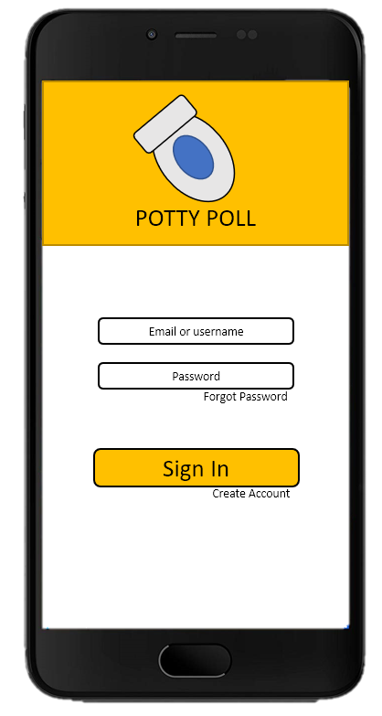***2.1. Log-in***

An Android device is required to use Potty Pool. Please make sure the device is connected to the Internet with location enabled, or the application will not work.

Open the Play Store on your Android device and download the Potty Pool application.

Once the application has been installed, open it on your device. If you already have a Potty Pool account, enter your email address or username and your password into the log-in box and press the “Sign In” button.

If you forgot your password, press “Forgot Password” and you will be sent an email. Follow the instructions inside.

Otherwise, create an account by pressing “create an account.” Fill out all the fields on the form that pops up, and press “sign up.” Re-enter your username or email address and password into the log-in box and press the “Sign In” button.

***2.2. Help Mode***

Need help? Press the “Need Help?” button on the main menu to get tips, FAQs, and other helpful information.

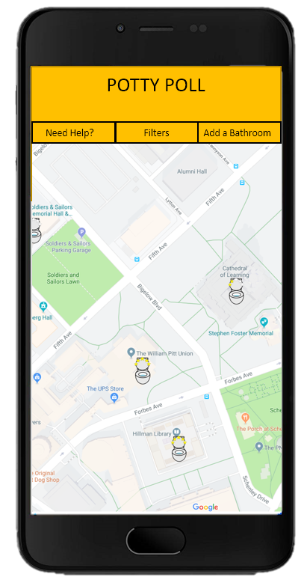

Need further assistance? Email Potty Pool at MadeUpEmail@fakeaddress.edu.

***2.3 Sample Runs***

To use the application, log-in as described above.

Once logged-in, you should see a map. The map contains locations of public restrooms near you that other users have reviewed. Press one of the star ratings on the map.

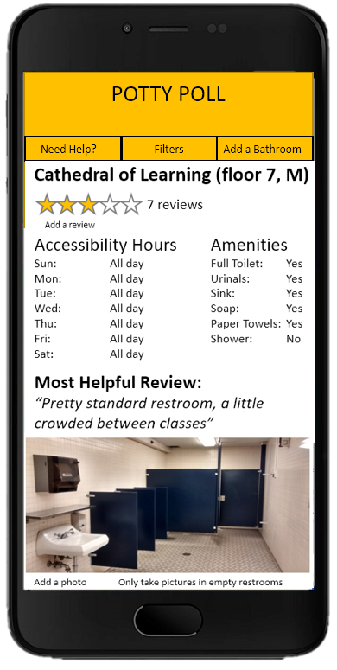A window will open, and here, you will see information about the public restroom location. You can press your finger and slide to view the reviews.

If you’d like to add a review, press the button labeled “Add a review.” Since you already chose a location earlier, you will not have to re-enter this information.

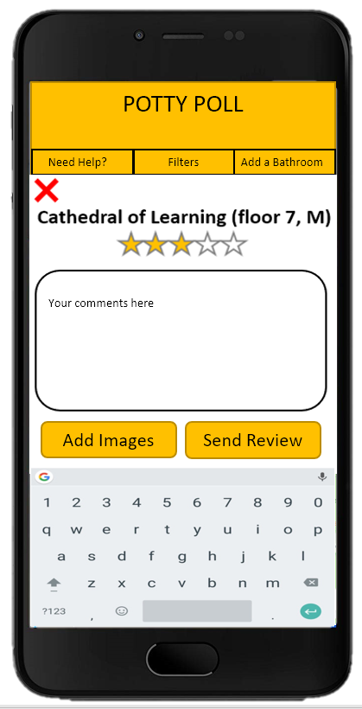Begin typing your review. Feel free to upload any pictures from your device to complement your written review. Make sure the bathroom is empty before taking pictures. Once you are done writing your review, give the public restroom a star rating by pressing the number of stars you’d like to give. The stars you have pressed will light up yellow. Press “Send Review” to complete your review and upload it to the public restroom’s review list.

If you would like to see other reviews, go back to the main map screen by pressing the

“x” on the review window. To see other reviews, other locations, and to write reviews for other locations, follow the previous steps.

To zoom in on a specific region in the map, put two fingertips close together on the map/screen, and slowly increase the distance between them while keeping them on the map/screen. To zoom out, put two fingertips apart from each other on the screen/map. Decrease the distance between them by sliding them closer together.

1. ***Modes of Operation***

Operating the system is done using an Android device and your fingertips.

The three main commands or ways to operate the application with your fingertips are:

pinching, tapping, and sliding. No other finger movements are needed.

Once the application is open on your Android device, every way that you interact with it will be recorded within the Potty Pool system – every review, rating, and account creation.

To use the application effectively, please make sure your location services are enabled on your Android device.

If the application has frozen, force close the application on your device, wait a few minutes, then re-open the application on your device. This may require multiple tries. If the application still isn’t working, feel free to email us.

For example/sample runs and dialogues, view “2. Getting Started.”

By using Potty Pool, you agree to allow Potty Pool to use and store any of the information you enter, as well as information about how you use the application.