Andrew Tran (ant111)

CS 1555

Homework 9

a)

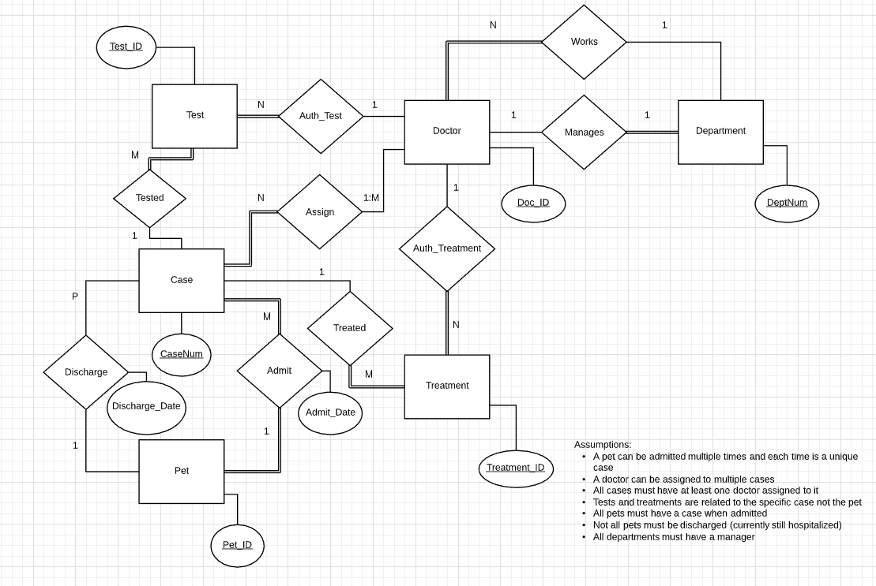

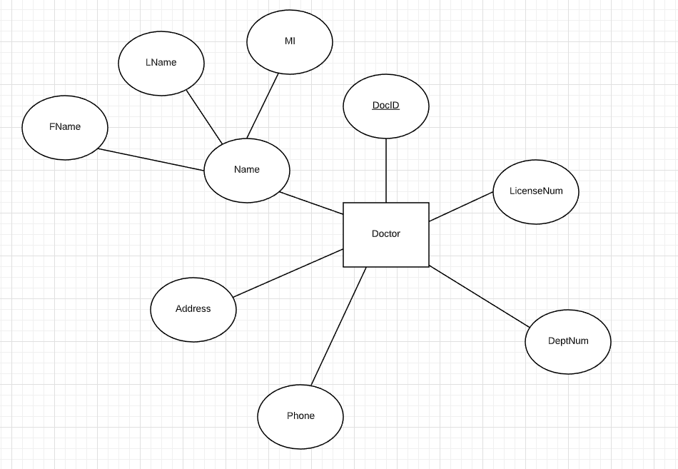

b)

Strong Entities:

* Doctor:

|  |  |  |  |  |  |
| --- | --- | --- | --- | --- | --- |
| Doc_ID | Name(FName, LName, MI) | Address | Phone | DeptNum *(fk)* | __________  LicenseNum |

* Department:

|  |  |  |
| --- | --- | --- |
| DeptNum | DeptName | HeadDocID *(fk)* |

* Pet:

|  |  |  |  |  |  |
| --- | --- | --- | --- | --- | --- |
| Pet_ID | Name | Type | Sex | Age | ____________  InsuranceCode |

* Case:

|  |  |  |  |  |
| --- | --- | --- | --- | --- |
| CaseNum | Pet_ID *(fk)* | Doc_ID *(fk)* | Admit_Date | Discharge_Date |

* Test:

|  |  |  |  |  |
| --- | --- | --- | --- | --- |
| Test_ID | CaseNum *(fk)* | Doc_ID *(fk)* | TestName | Results |

* Treatment:

|  |  |  |  |  |  |
| --- | --- | --- | --- | --- | --- |
| Treatment_ID | CaseNum *(fk)* | Doc_ID *(fk)* | TreatementName | Duration | Reactions |