Andrew Tran

CS 1675

Assignment 2 Report

Due: 1/31/2019

* 1. Mean = 15.0415; Stdev = 5.0279

1.4)

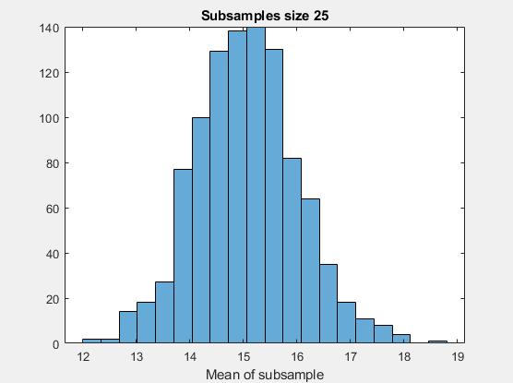

The plot of means appears normally distributed and centered around 15.0572. The mean of this distribution is very close to the true mean of 15 (0.4% error) and even closer to the calculated mean of the sample (0.1% error).

1.5)

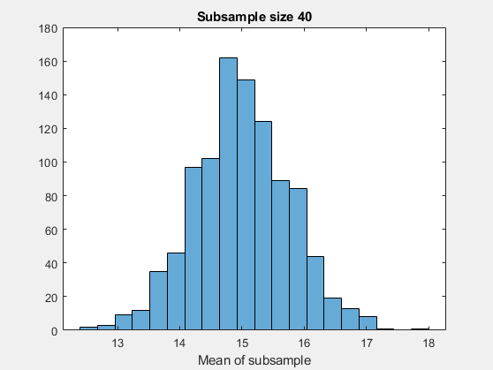

The distribution of these subsamples also seems to be normally distributed and is centered around 15.0069. This distribution, however, is “taller” in the center meaning there were more subsamples with means closer to the true mean than in the previous distribution. Also, the mean of this distribution is much closer to the true mean (0.046% error) than it is to the calculated mean (0.23% error). A conclusion can be made that larger sample/subsample sizes are better for predicting the true mean of a population.

1.6) mean = 14.57; ci = [12.63, 16.50] the true mean 15 does fall within the 95% confidence interval.

2.2) k=10

|  |  |  |
| --- | --- | --- |
| m | Mean | StDev |
| 1 | 1.70 | 4.09 |
| 2 | 3.25 | 2.99 |
| 3 | 1.82 | 2.37 |
| 4 | 2.21 | 3.80 |
| 5 | 3.96 | 4.29 |
| 6 | 2.42 | 2.07 |
| 7 | 2.34 | 3.67 |
| 8 | 2.02 | 3.25 |
| 9 | 2.64 | 2.97 |
| 10 | 2.64 | 2.72 |

3a)

|  |  |
| --- | --- |
| Sum | Probability |
| 2 | 1/36 |
| 3 | 2/36 |
| 4 | 3/36 |
| 5 | 4/36 |
| 6 | 5/36 |
| 7 | 6/36 |
| 8 | 5/36 |
| 9 | 4/36 |
| 10 | 3/36 |
| 11 | 2/36 |
| 12 | 1/36 |

3b)

[(2*1)+(3*2)+(4*3)+(5*4)+(6*5)+(7*6)+(8*5)+(9*4)+(10*3)+(11*2)+(12*1)]/36 = **7**

3c)

Probability of never rolling 4: (1-3/36)5 = **0.647**

Probability of even on every roll: (18/36)5 = **0.031**

4) Number of heads = 65; ML estimate = 65/100 = **0.65**

5a) $\frac{d }{dx}$ (2x) = 2

5b) (5x+2x4) = 5+8x

5c) (e2x^2) = 4x*e2x^2

5d)(sin(x2)) = 2xcos(x)

5e) (1/(5x)) = -1/(5x2)

5f) (1/(2x+x2)) = -(2+2x)/(2x+x2)

5f) (ln x5) = 5/x

5g) (ln (∏ xi)) = ( ∑ i| i=1:n) / x