Andrew Tran

CS 1675

Assignment 3 Report

Due: 2/7/2019

1a) n=100; number of heads = 65

ML estimate = 65/100 = 0.65

1b)





1c) θMAP = (1+65-1)/(1+1+65+35-2) = 0.65

1d)





θMAP = (4+65-1)/(4+2+65+35-2) = 0.6538

2a)



2b) µ = (3.64;7.85)

|  |  |
| --- | --- |
| 3.64 | 1.08 |
| 1.08 | 3.78 |

∑ =

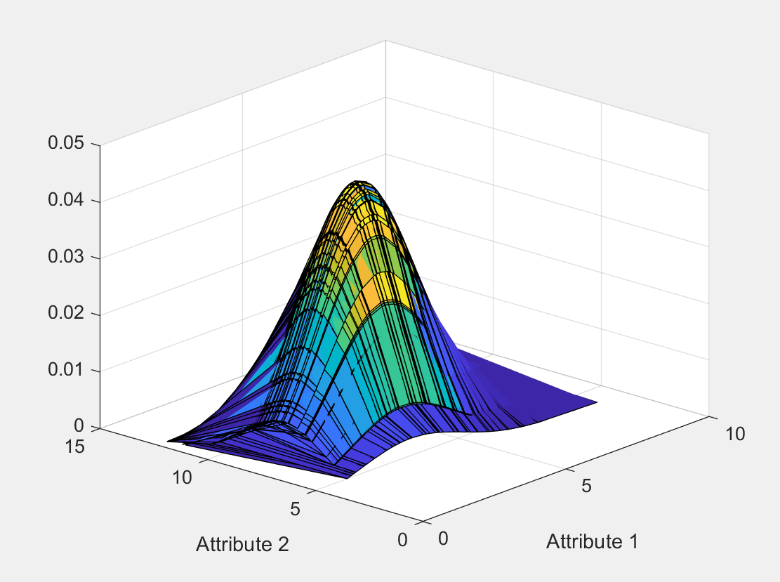

2c) Attribute 1: µ = 3.64; σ = 1.91



Attribute 2: µ = 7.85; σ = 1.95



2d) I think the 3D plot is better at representing multivariate gaussian distributions because is provides at least as much information that two separate plots does. The advantage of the 3d plot is that is allows you to more easily visualize the effects of changing multiple attributes at the same time.

3a)





3b) p(X|b) = (1/b)e-x/b

Likelihood = ∏p(X|b) = (b-n)e(b^-1)∑x

Log Likelihood = -n*ln(b) – (1/b)∑x

d/db(-n*ln(b) – (1/b)∑x) = -n/b + (1/b2)∑x = 0

(1/b2)∑x = n/b

**b = ∑x/n**