**PROGRAMMING FOR SMART DEVICES - MICROCONTROLLERS WITH STM32 SERIES AND QT {TUTORIAL}**

**SOURCE:** <https://www.youtube.com/watch?v=lVCbQZIfCIk&t=17s>

https://www.qt.io/product/develop-software-microcontrollers-mcu

<https://doc.qt.io/QtForMCUs/>

<https://resources.qt.io/qt-mcus>

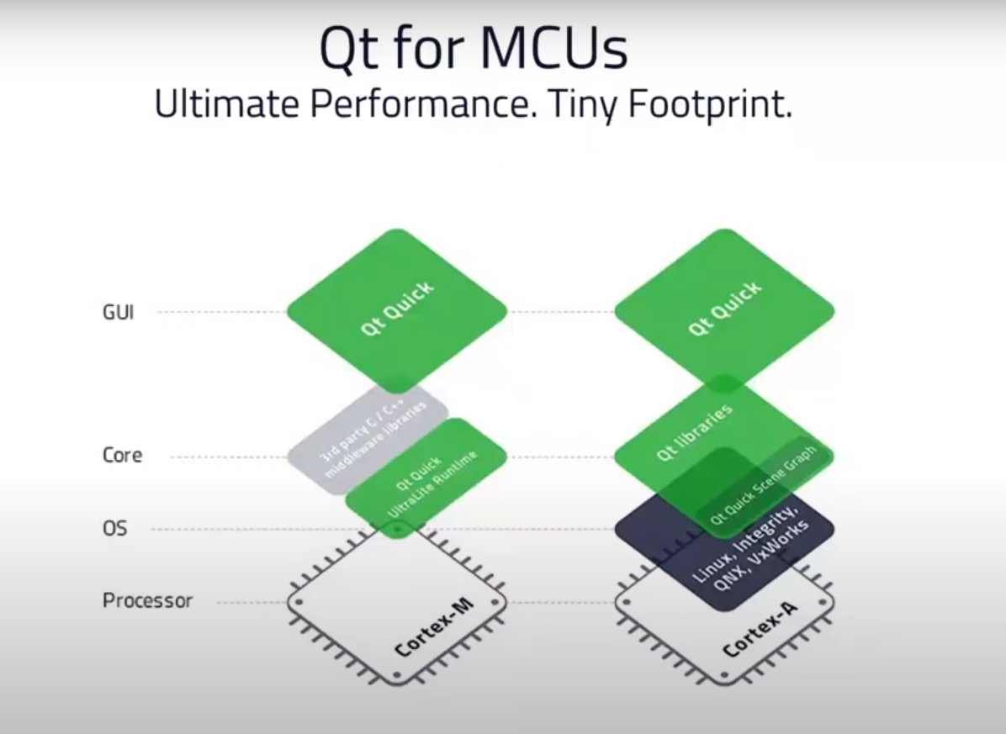

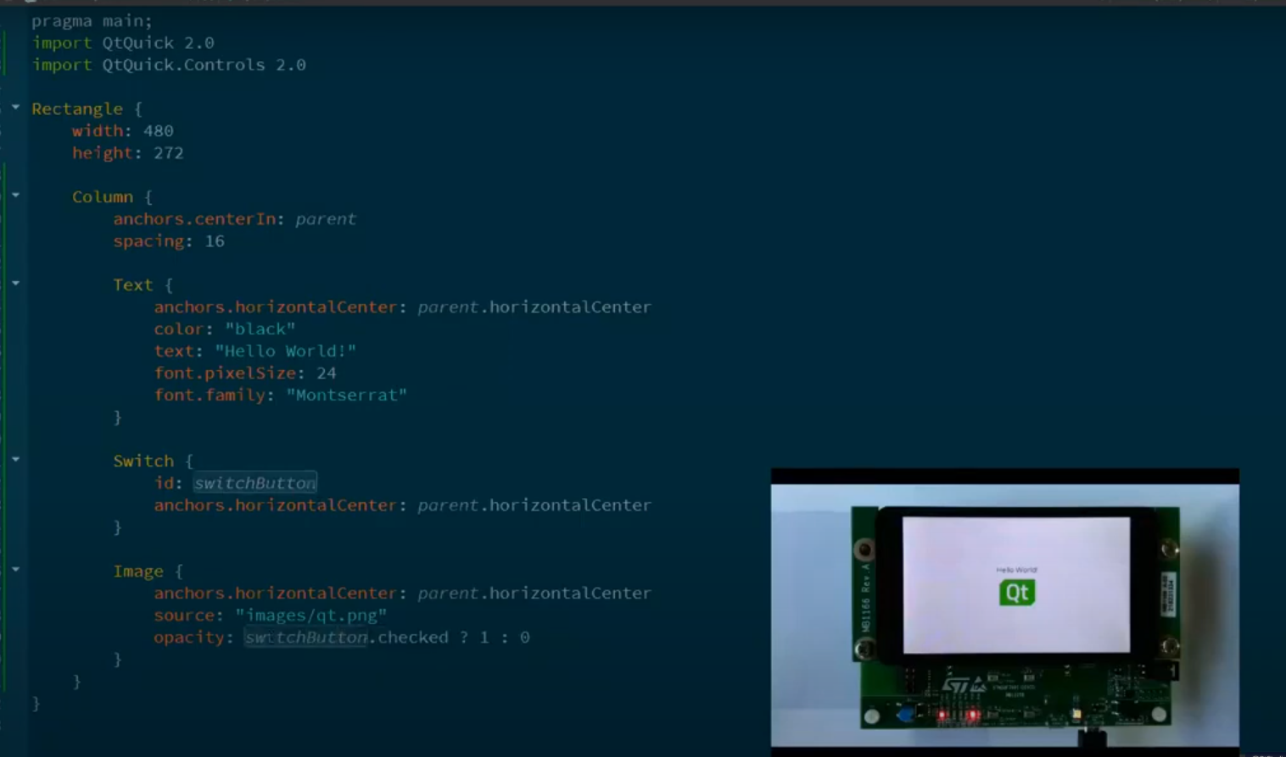

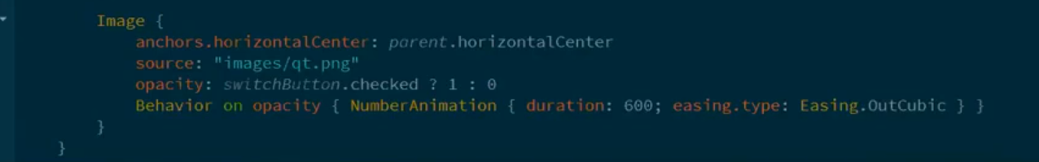

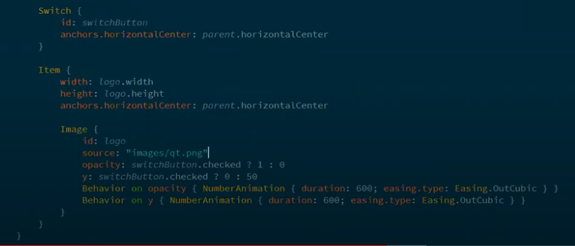

1. Các thuật ngữ cần tìm

* GUI framework ??