H12389A Test Notes.
Description: DTCC record not processed when using multiple companies.

Copy a DTCC sequential file with transactions for multiple companies into the region's hcob/run/rdta directory.
Copy the file below into hcob/run/rdta:
/apex/antoch/mods/H12389A-dtcc-company/DTCC_Records_2_25

Here is the copy command:

[[apdev12@lidp8]]/h2/apdev12/hcob/run/rdta:
# cp /apex/antoch/mods/H12389A-dtcc-company/DTCC_Records_2_25 .

Check the region’s bin directory for a script called ‘dtcc-ci-load’ (or ‘dtcc-ci-load-db’ if database region). If it is not there, copy from /apex/antoch/mods/H12389-dtcc-company
This script will read the DTCC records and build ADMCI records. This script will requires the DTCC file as an argument when run (later).
Make sure the script in the bin directory of the region is executable.
[[apdev12@lidp8]]/h2/apdev12/bin:
Chmod 777 dtcc-ci-load

This DTCC record is going to use cusip 74367M137 to point to plan DGBVULNS in company QA1. Cusip 74367H211 will point to plan LIDPVAEE in company QA1.
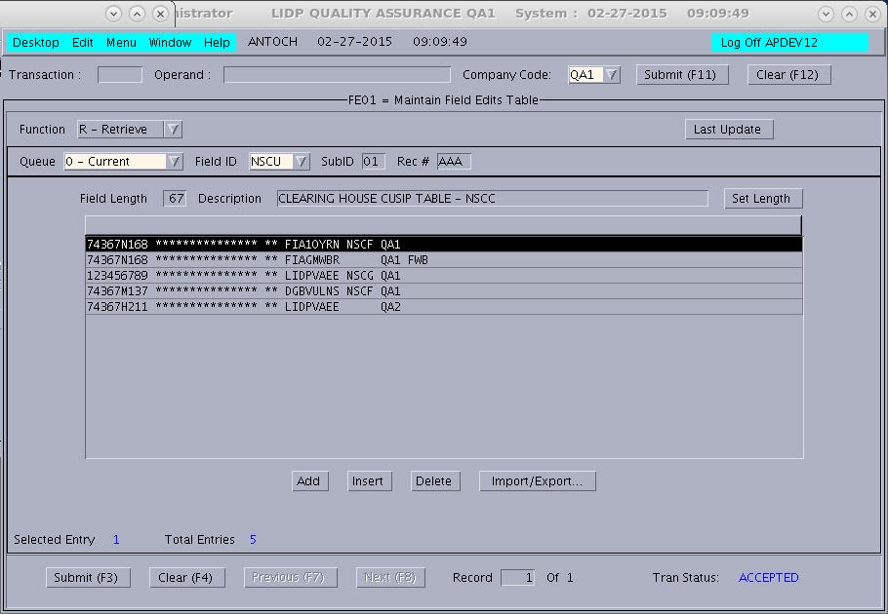

Background transaction ADND needs to be running for company QA1 and QA2. You can see what companies ADND is currently running in by running the following command from a unix region window.

[[apdev12@lidp8]]/h2/apdev12:
# tskscrn -A |grep ADND
START ADND Fri Feb 27 09:09:13 2015 UNQ0013c 7536766 QA1

So, ADND is currently only running in QA1. Lets see what backgrounds are coded in the TO01 ADOP 02 table. Since it is already in the table that means company QA2 needs to be opened through ADOP.
If it is not there, then add an entry for QA2, restart the region and open both companies.

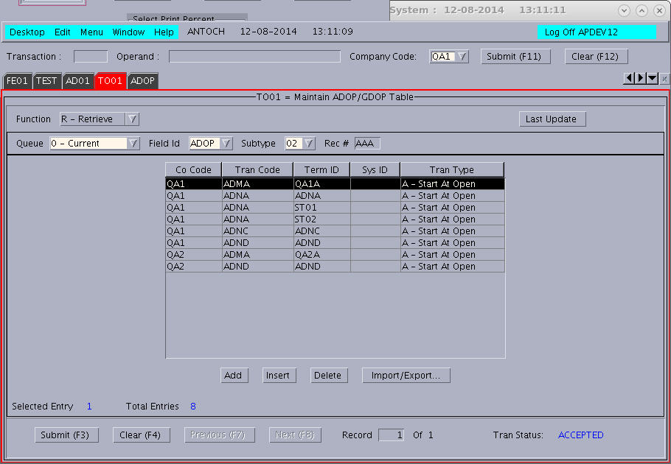

In my case ADND was not running for QA2, but it was in the TO01 table, so that means I just need to open QA2.
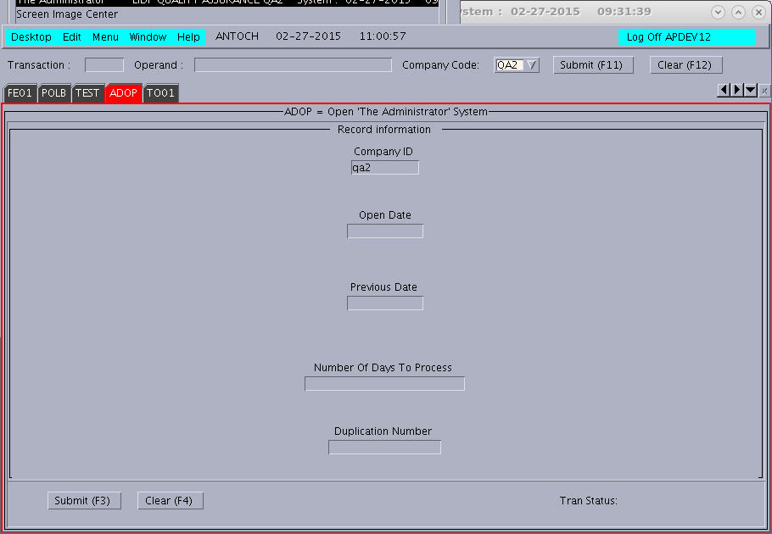

A background ADND transaction should now be running for QA1 and QA2. Go to region window and do a tskscrn to verify ADND is now running for both regions.

[[apdev12@lidp8]]/h2/apdev12:
# tskscrn -A |grep ADND
START ADND Fri Feb 27 11:04:07 2015 UNQ001e7 59375826 QA2
START ADND Fri Feb 27 11:04:24 2015 UNQ001f5 60358792 QA1

[[apdev12@lidp8]]/h2/apdev12:
# tskscrn –A | grep ADND

Delete the CI file on vsam for QA1. There may not be any records.
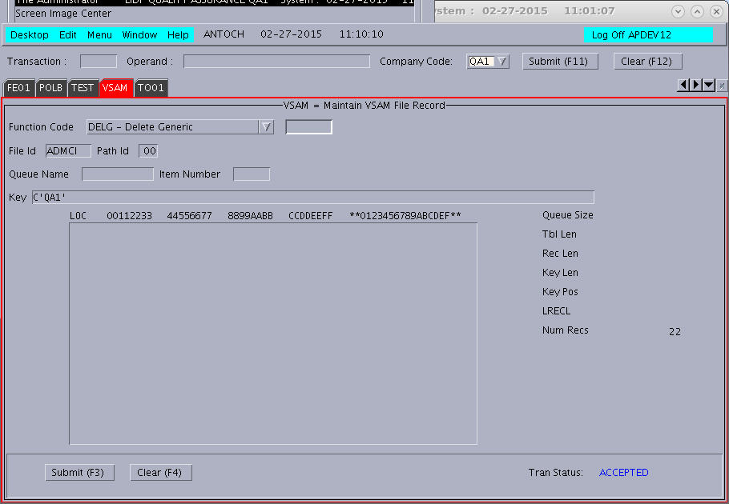

Delete the ‘CI’ records through vsam for company QA2. There may not be any records.
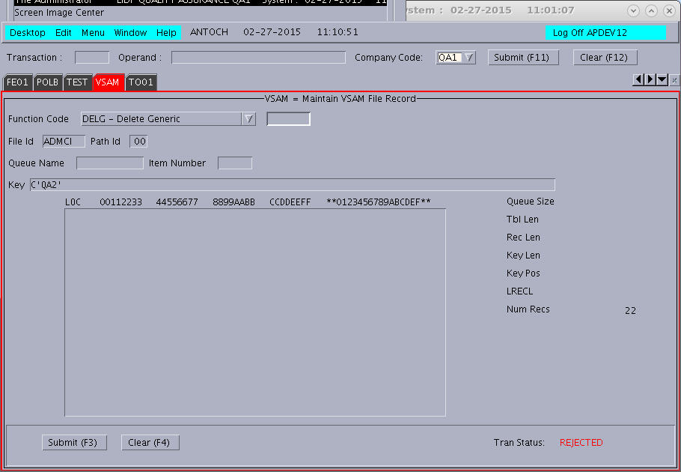

Run the 'dtcc-ci-load' script (or dtcc-ci-load-db if database) in the region. Use the DTCC file installed about as an argument. This creates ADMCI records.

[[apdev12@lidp3]]/c1/apdev12:
# dtcc-ci-load DTCC_Records_2_26

You may need to wait for a few minutes. ADND needs to read the ADMCI records and add the policies.

See if there is a CIAR report is generated. It would not be generated without the project. Go to RWDR while in company QA1.
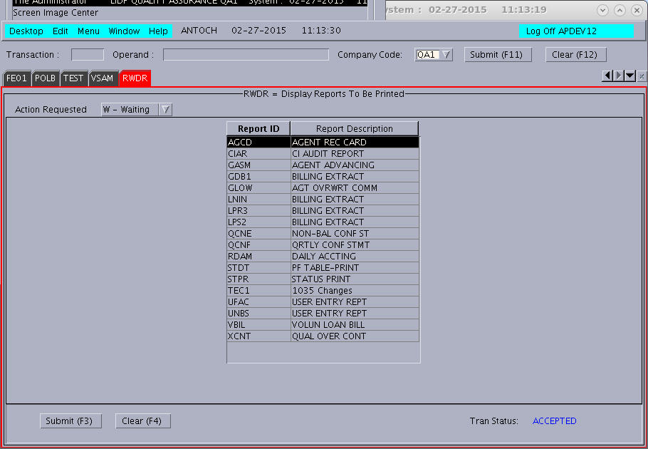

CIAT is an alias of CIAR, so you can print CIAR or CIAT. Print CIAT to adm5.
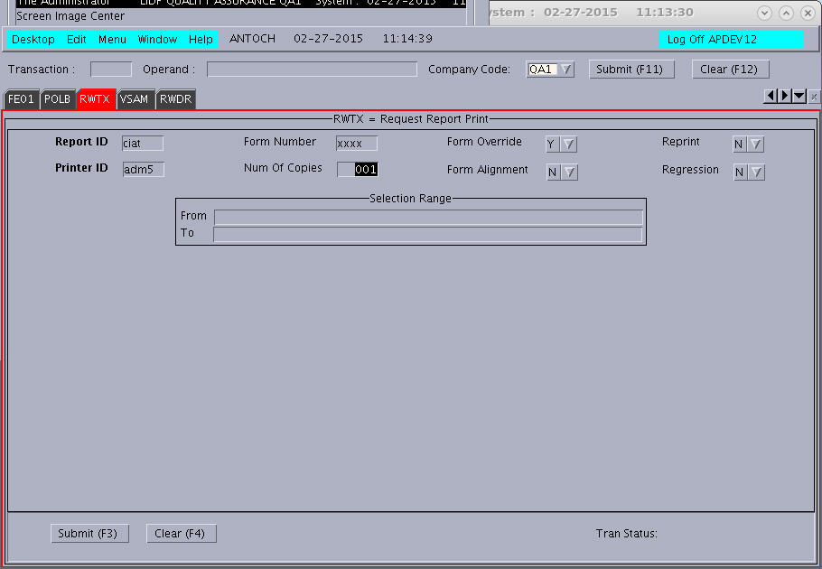

Then go to the region tmp directory and view the lp.adm5 report. The report is now generated. Search for a record with the name STANLEY SALVARY. It that record exists, the fix worked.

[[apdev12@lidp8]]/h2/apdev12/tmp:
# vim lp.adm5

Now go to company QA2 and look for CIAR.
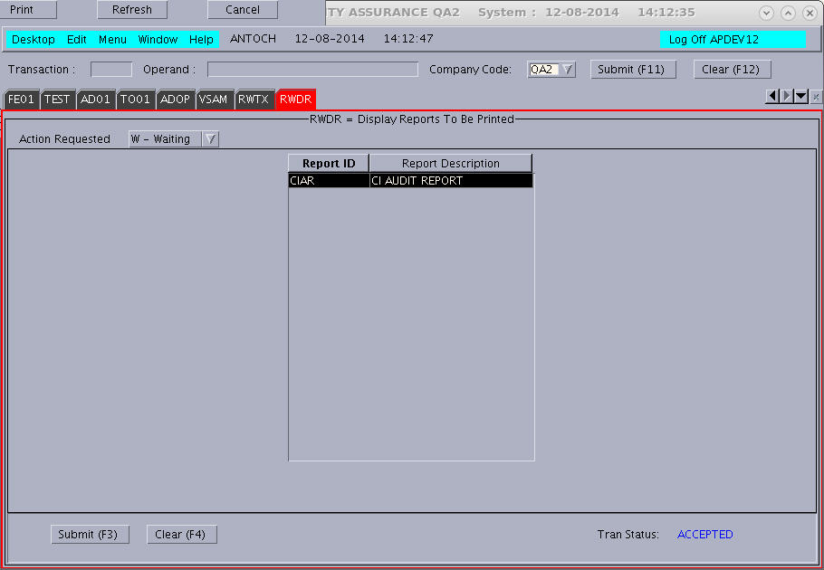

Print the report to adm3 (not adm5)
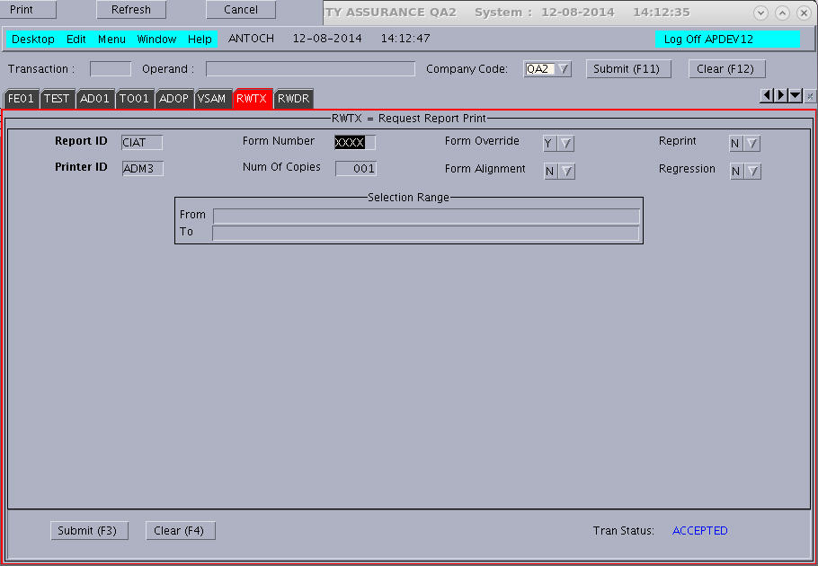

View the report. Note that QA2 is in the company code field.
[[apdev12@lidp8]]/h2/apdev12/tmp:
# vim lp.adm3

