Week 1 Lab 1: Environment Setup
Course: Claude Agents Workshop
Duration: 30 minutes
Focus: Installing Claude Code, cloning the repository, and authenticating

Lab Architecture
This lab establishes your development environment for the workshop.
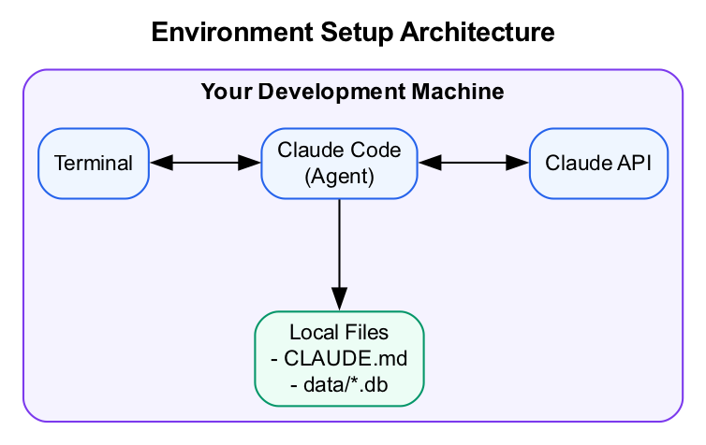
Diagram
What we’re building: A fully configured Claude Code environment ready for the workshop.

Prerequisites
Before starting this lab, verify you have:
- Claude Pro subscription - Active and able to access Claude
- Node.js 18+ - Run node --version to check
- Git - Run git --version to check
- VS Code or preferred editor - For editing files
- Terminal access - macOS Terminal, iTerm2, or Windows with WSL2

Lab Overview (Outcomes)
By the end of this lab, you will:
- Install Claude Code CLI on your machine
- Clone and navigate the workshop repository
- Authenticate Claude Code with your account
- Verify everything works with a test query

Time Breakdown
Task | Topic | Time
1.1 | Pre-Flight Check | 5 min
1.2 | Install Claude Code | 10 min
1.3 | Clone Workshop Repository | 5 min
1.4 | Authenticate & Test | 10 min
 | TOTAL | 30 min

Task 1.1: Pre-Flight Check (5 min)
Verify your prerequisites are met:
- Check Node.js version:
- node --version
- Expected: v18.x.x or higher
- Check Git:
- git --version
- Expected: Any version (e.g., git version 2.39.0)
- Check Claude Pro subscription:
  - Log into claude.ai
  - Verify you have Pro or higher (check account settings)
If any check fails: Raise your hand for facilitator help before proceeding.

Task 1.2: Install Claude Code (10 min)
- Install via the official installer (recommended):
- # macOS/Linux
curl -fsSL https://claude.ai/install.sh | sh
- OR via npm:
- npm install -g @anthropic-ai/claude-code
- Verify the installation:
- claude --version
- Expected: Version number displayed (e.g., claude-code 1.x.x)
- If you see a “command not found” error:
  - Close and reopen your terminal
  - Try again
  - If still failing, check your PATH or ask for help

Task 1.3: Clone Workshop Repository (5 min)
- Clone the repository:
- git clone https://github.com/trancethehuman/workshop-claude-agents
cd workshop-claude-agents
- Verify the clone:
- ls -la
- You should see:
  - CLAUDE.md
  - data/ folder
  - weeks/ folder
  - Other workshop files

Task 1.4: Authenticate & Test (10 min)
- Start Claude Code in the repository:
- claude
- Follow the authentication prompts:
  - A browser window will open
  - Log in with your Claude account
  - Authorize Claude Code
  - Return to terminal
- Test that it’s working:
- > What files are in this repository?
- Expected result: Claude lists the files and folders in the repo, using the Glob or Bash tool.

Troubleshooting

Installation Issues
Problem | Solution
command not found: claude | Close and reopen terminal, or add to PATH manually
npm permission errors | Don’t use sudo. Fix npm permissions: npm config set prefix ~/.npm-global
Node version too old | Use nvm: nvm install 18 && nvm use 18

Authentication Issues
Problem | Solution
Browser doesn’t open | Copy the URL from terminal and open manually
“Not authorized” error | Verify Claude Pro subscription is active
Token expired | Run claude again to re-authenticate

Windows-Specific Issues
Problem | Solution
Scripts don’t run | Use WSL2 (Windows Subsystem for Linux)
Path issues | Use forward slashes in paths
Terminal compatibility | Use Windows Terminal with WSL

Final Checklist
Before proceeding to Lab 2, verify:
- Claude Code installed - claude --version returns a version number
- Repository cloned - You can cd workshop-claude-agents and see files
- Authentication working - Claude responds to queries
- Test query successful - “What files” query returns repo contents

End of Lab 1

