Week 2 Lab 2: Building a Research Workflow
Course: Claude Agents Workshop
Duration: 45 minutes
Focus: Combining database queries with web research for investment analysis

Lab Architecture
This lab combines structured database queries with web research tools.
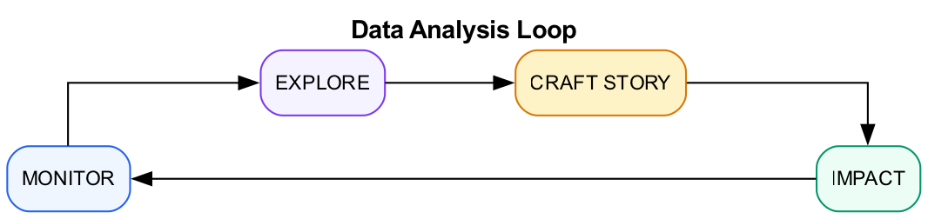
Research Workflow
What we’re building: An investment analysis brief that combines structured data with web research.

Prerequisites
Before starting this lab, verify:
- Lab 1 complete - Database exploration done
- Know the schema - Familiar with startups, funding_rounds, investors tables
- Claude Code running - Start with claude in the repo directory

Lab Overview (Outcomes)
By the end of this lab, you will:
- Query database for AI coding tool startups
- Use WebSearch and WebFetch to enrich company data
- Apply the Data Analysis Loop (Monitor, Explore, Craft, Impact)
- Create an investment analysis brief combining multiple sources
- Compare sector performance to broader market

Time Breakdown
Task | Topic | Time
2.1 | Database Foundation | 10 min
2.2 | Web Enrichment | 15 min
2.3 | Synthesize Analysis | 15 min
2.4 | Connect to Broader Market | 5 min
 | TOTAL | 45 min

Scenario
You’re analyzing AI coding tools for an investment memo. You’ll combine database queries with web research to create a comprehensive analysis.

Task 2.1: Database Foundation (10 min)
Start with structured data.
- Query the database for AI coding startups:
- > From startup-funding.db, find all AI/ML startups in the Developer Tools or IDEs sub-industry.
> Show me their funding history, investors, and latest valuation.
> Focus on companies that have raised Series A or later.
- Record the companies found:
Company | Stage | Total Raised | Lead Investor

Task 2.2: Web Enrichment (15 min)
Add context from the web.
- Research 3 companies from your results:
- > For Cursor, Replit, and Codeium:
> 1. Search for their latest funding news
> 2. Find their current employee count (if available)
> 3. Look for any product announcements in the last 6 months
> Compile findings into a comparison table.
- Watch how Claude:
  - Uses WebSearch to find relevant articles
  - Uses WebFetch to get detailed content
  - Synthesizes information from multiple sources
- Record your comparison:
Company | Latest News | Employees | Recent Product
Cursor
Replit
Codeium

Task 2.3: Synthesize Analysis (15 min)
Apply the Data Analysis Loop to create a brief.
- Ask Claude to create an investment brief:
- > Based on the database data and web research, create an investment brief:
>
> **Monitor:** Current state of AI coding tool funding
> **Explore:** Key differentiators between top players
> **Craft:** 3-5 key insights with supporting evidence
> **Impact:** Which company is best positioned for Series B/C success and why?
>
> Save the brief to output/ai-coding-tools-analysis.md
- Verify the output:
  - Check that the file was created
  - Review the structure follows the Data Analysis Loop
  - Confirm insights are supported by data

Task 2.4: Connect to Broader Market (5 min)
Put findings in context.
- Ask Claude to compare:
- > Compare the AI coding tools funding to the broader Developer Tools category.
> - How does their average deal size compare?
> - Are they raising at higher or lower valuations?
> - What does this suggest about market sentiment?
- Key insight questions:
  - Is AI coding a hot subsector or cooling off?
  - How do investor patterns differ from the broader category?

Troubleshooting

Web Tool Issues
Problem | Solution
WebSearch returns no results | Try different search terms, be more specific
WebFetch fails | Site may block bots, try a different source
Outdated information | Add year to search query (e.g., “Cursor funding 2024”)
Rate limiting | Wait a moment between web requests

File Output Issues
Problem | Solution
File not created | Check the output/ directory exists
Permission denied | Verify write access to the directory
Content incomplete | Ask Claude to continue or regenerate

Final Checklist
Before completing this lab, verify:
- Database query complete - AI coding startups identified with funding history
- Web research complete - 3 companies enriched with web data
- Analysis brief created - File saved to output/ai-coding-tools-analysis.md
- Data Analysis Loop applied - Monitor, Explore, Craft, Impact sections present
- Market context added - Compared to broader Developer Tools category

Reference: Data Analysis Loop
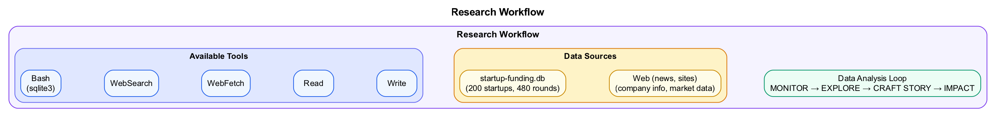
Diagram
Phase | What To Do | Example
Monitor | Run recurring queries, check metrics | “Deal count by month for AI/ML”
Explore | Dig into anomalies, segment data | “Why did Q3 spike? Check by sub-industry”
Craft | Synthesize 3-5 insights with evidence | “Series A sizes growing 20% YoY because…”
Impact | Recommend actions, size opportunities | “Invest in X because of factors A, B, C”

End of Lab 2

