Week 4 Lab 1: Your First Skill - Database Profiler
Course: Claude Agents Workshop
Duration: 30 minutes
Focus: Creating your first SKILL.md file to encode a database profiling workflow

Lab Architecture
This lab demonstrates how Agent Skills encode domain knowledge that Claude can discover and use automatically.
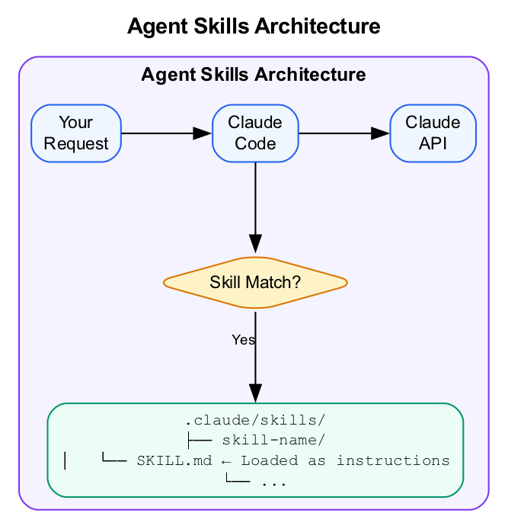
Agent Skills Architecture
What we’re building: A Database Profiler skill that provides systematic data exploration with consistent structure.

Prerequisites
Before starting this lab, verify:
- Week 3 complete - Familiar with MCP servers and external data sources
- Claude Code running - Start with claude in the repo directory
- Repository cloned - Access to data/startup-funding.db
- Text editor ready - For creating SKILL.md files
Understanding helpful but not required: - YAML frontmatter syntax - Basic SQL patterns from Week 2

Lab Overview (Outcomes)
By the end of this lab, you will:
- Create a skill directory structure with SKILL.md
- Write effective skill descriptions that trigger automatically
- Understand YAML frontmatter fields
- Test that skills discover and execute correctly

Time Breakdown
Task | Topic | Time
1.1 | Create Skill Directory | 5 min
1.2 | Write SKILL.md File | 15 min
1.3 | Test the Skill | 10 min
 | TOTAL | 30 min

Understanding Skills
A skill is a folder with a SKILL.md file that teaches Claude a specific workflow. When your request matches a skill’s description, Claude asks permission to use it and follows your instructions.
Key concept: Skills change how Claude thinks, not just what it can do. They load new instructions into Claude’s context.

Task 1.1: Create the Skill Directory (5 min)
- Create the skill folder:
- mkdir -p .claude/skills/database-profiler
- Verify the location:
- ls -la .claude/skills/
- You should see the database-profiler directory.
- Important: Skills must be in .claude/skills/ (not just skills/ at the root).

Task 1.2: Write the SKILL.md File (15 min)
- Create the SKILL.md file:
- Open your editor and create .claude/skills/database-profiler/SKILL.md with this content:
- ---
name: database-profiler
description: Profile SQLite databases to understand structure, quality, and statistics. Use when analyzing a new database, checking data quality, or exploring data before analysis.
---
# Database Profiler
When profiling a database, provide:
## 1. Structure Overview
- List all tables
- For each table: column names, data types, row count
- Identify primary keys and foreign key relationships
## 2. Quality Assessment
- Missing values per column (count and percentage)
- Duplicate rows per table
- Referential integrity issues (orphaned foreign keys)
## 3. Statistical Summary
For numeric columns:
- Min, max, mean, median
- Standard deviation
- Outlier candidates (beyond 3 std devs)
For categorical columns:
- Unique value count
- Most common values (top 5)
- Distribution skew
For date columns:
- Date range (earliest to latest)
- Gaps or clustering
## 4. Recommendations
Based on findings, suggest:
- Data quality issues to address
- Interesting patterns to explore
- Next steps for analysis
## Context Management
- Always use LIMIT when exploring individual tables
- Start with aggregations before drilling down
- Report row counts so analyst knows the scale
## Output Format
Use markdown tables for statistics. Be concise but thorough.
- Save the file.
- Understand the structure:
Section | Purpose
YAML frontmatter | name and description for discovery
Instructions | Step-by-step guidance for Claude
Context Management | Guardrails for efficient execution
Output Format | Consistent structure for results

Task 1.3: Test the Skill (10 min)
- Restart Claude Code to pick up the new skill:
- # Exit and restart
claude
- Trigger the skill with a matching request:
- > Profile the startup-funding.db database
- Watch for these behaviors:
  - Claude asks permission to use the database-profiler skill
  - Output follows the four-section structure
  - Queries use LIMIT and aggregations first
  - Tables are formatted in markdown
- Try variations that should also trigger:
- > Check the data quality of startup-funding.db
> Explore what data is in the funding database
- Record your results:
Request | Skill Triggered? | Output Followed Structure?
“Profile the database”
“Check data quality”
“Explore the data”

Troubleshooting

Skill Not Triggering
Problem | Solution
Skill not discovered | Check it’s in .claude/skills/ (not skills/)
Wrong description | Add keywords users might say
Claude didn’t ask permission | Restart Claude Code to reload skills

YAML Errors
Problem | Solution
Invalid frontmatter | Use spaces, not tabs
Missing required fields | Add both name and description
Name format wrong | Use lowercase with hyphens only

Output Not Following Structure
Problem | Solution
Missing sections | Add clearer section headers in SKILL.md
Wrong format | Include explicit examples in the skill
Too verbose | Add “Be concise” instruction

Final Checklist
Before completing this lab, verify:
- Skill directory created - Located at .claude/skills/database-profiler/
- SKILL.md has valid YAML frontmatter - Both name and description present
- Skill triggers correctly - Claude asks permission when request matches
- Output follows structure - Four sections (Structure, Quality, Statistics, Recommendations)
- Context management works - Queries use LIMIT and aggregations first
Document your skill:
Element | Your Implementation
Skill name
Trigger phrases that work
Output sections generated

Reference: YAML Frontmatter Fields
Field | Required | Description
name | Yes | Lowercase, hyphens only (max 64 chars)
description | Yes | What + when (max 1024 chars)
allowed-tools | No | Restrict tools: Read, Grep, Bash(python:*)
context | No | fork for isolated sub-agent context
hooks | No | PreToolUse, PostToolUse, Stop handlers

End of Lab 1

