Week 5 Bonus Lab: RAG with Vectorize.io
Course: Claude Agents Workshop
Duration: 30+ minutes
Focus: Adding retrieval-augmented generation (RAG) to your GTM pipeline using Vectorize.io

Lab Architecture
This bonus lab adds knowledge retrieval to your pipeline.
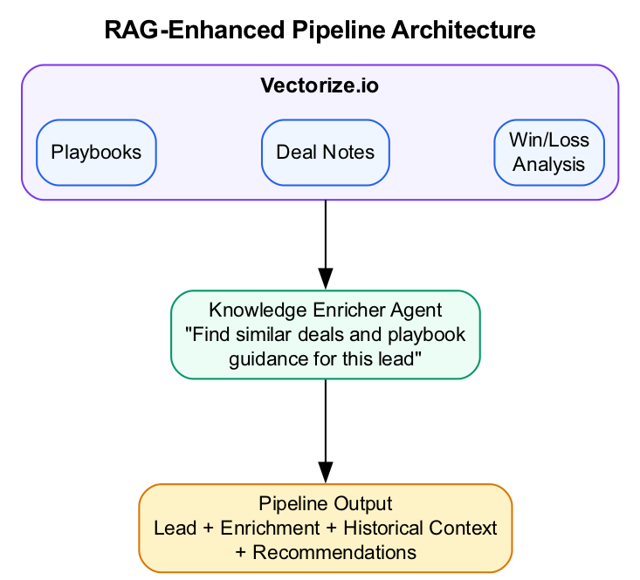
RAG-Enhanced Pipeline Architecture
What we’re building: A knowledge-enriched pipeline that leverages historical sales data for better lead processing.

Prerequisites
Before starting this lab, verify:
- Lab 2 complete - GTM pipeline working with lead-enricher and email-drafter
- Vectorize.io account - Create at vectorize.io
- Sales documents ready - Playbooks, deal notes, or win/loss analyses to upload
- Claude Code running - Start with claude in the repo directory

Lab Overview (Outcomes)
By the end of this lab, you will:
- Set up a Vectorize.io pipeline with your sales documents
- Create an MCP agent in Vectorize for retrieval
- Connect the MCP server to Claude Code
- Build a knowledge-enricher agent
- Run the enhanced pipeline with historical context

Time Breakdown
Task | Topic | Time
B.1 | Set Up Vectorize.io | 10 min
B.2 | Create MCP Agent in Vectorize | 5 min
B.3 | Connect to Claude Code | 5 min
B.4 | Test the RAG Integration | 10 min
 | TOTAL | 30 min

Scenario
Your company has historical deal notes, win/loss analyses, and sales playbooks. When processing new leads, you want to:
- Find similar past deals
- Pull relevant playbook sections
- Get recommendations based on what worked before

Task B.1: Set Up Vectorize.io (10 min)
- Create an account at vectorize.io
- Create a new pipeline:
  - Click “New Pipeline”
  - Name it “Sales Knowledge Base”
  - Choose your embedding model
- Upload your documents:
  - Sales playbooks (PDF, Word, Markdown)
  - Historical deal summaries
  - Win/loss analysis reports
- Configure retrieval settings:
  - Chunk size: 500-1000 tokens
  - Enable metadata filtering if needed

Task B.2: Create MCP Agent in Vectorize (5 min)
- Navigate to Agents in the Vectorize dashboard
- Create a new MCP Agent:
  - Name: “Sales Knowledge Agent”
  - Select your pipeline as the data source
  - Function name: search_knowledge_base
- Generate API credentials:
  - Create a new API key named “Claude Code”
  - Copy the API key and Agent ID

Task B.3: Connect to Claude Code (5 min)
- Add the Vectorize MCP server:
- claude mcp add vectorize-mcp \
--env VECTORIZE_API_KEY=YOUR_API_KEY \
-- npx -y mcp-remote@latest \
https://agents.vectorize.io/api/agents/YOUR_AGENT_ID/mcp \
--header "Authorization: Bearer ${VECTORIZE_API_KEY}"
- Verify the connection:
- > /mcp
- You should see vectorize-mcp in the list.

Task B.4: Test the RAG Integration (10 min)
- Test knowledge retrieval:
- > Search our knowledge base for deals we won in the Healthcare industry.
> What were the common winning factors?
- Try more queries:
- > Find information about how we handle security objections
> What's our playbook for selling to enterprise companies with 1000+ employees?
- Create a knowledge-enricher agent:
- Create .claude/agents/knowledge-enricher.md:
- ---
name: knowledge-enricher
description: Enrich leads with insights from our sales knowledge base using Vectorize. Use when you need historical context, playbook guidance, or similar deal examples.
model: haiku
tools: ["mcp__vectorize-mcp__search_knowledge_base"]
---
# Knowledge Enricher
Search our sales knowledge base to provide context for new leads.
## Process
1. **Identify search criteria** from the lead:
- Industry vertical
- Company size range
- Likely pain points
2. **Search the knowledge base** for:
- Similar past deals (won and lost)
- Industry-specific playbook sections
- Relevant objection handling
3. **Return structured insights**:
```json
{
"similar_deals": [
{"company": "...", "outcome": "...", "key_factors": "..."}
],
"playbook_guidance": "...",
"recommended_approach": "...",
"potential_objections": ["..."]
}
- ```
- Run the full pipeline with knowledge enrichment:
- > Process this lead through the full pipeline with knowledge enrichment:
>
> Company: MedTech Solutions
> Industry: Healthcare
> Size: 300 employees
> Contact: VP of Operations

Troubleshooting

Vectorize Issues
Problem | Solution
Connection refused | Check API key and agent ID
No results returned | Verify documents were indexed; check query terms
Slow retrieval | Reduce chunk size or number of results
MCP not showing | Restart Claude Code after adding server

Integration Issues
Problem | Solution
Agent not using knowledge base | Ensure tool name matches exactly
Poor quality results | Add more documents or adjust chunking
Context too large | Limit number of retrieved chunks

Final Checklist
Before completing this lab, verify:
- Vectorize.io account created - Pipeline set up and running
- Documents uploaded - Sales knowledge indexed
- MCP agent configured - API key and agent ID working
- MCP connected to Claude Code - Server shows in /mcp
- Knowledge enricher agent created - .claude/agents/knowledge-enricher.md
- Sample query returns results - Tested retrieval working
Document your RAG setup:
Element | Your Implementation
Pipeline name
Number of documents
Chunk size
MCP agent ID

Reference: Vectorize MCP Connection
# Full connection command
claude mcp add vectorize-mcp \
--env VECTORIZE_API_KEY=YOUR_API_KEY \
-- npx -y mcp-remote@latest \
https://agents.vectorize.io/api/agents/YOUR_AGENT_ID/mcp \
--header "Authorization: Bearer ${VECTORIZE_API_KEY}"
Parameter | Description
vectorize-mcp | Name for this MCP server in Claude Code
VECTORIZE_API_KEY | Your API key from Vectorize dashboard
YOUR_AGENT_ID | Agent ID from the MCP agent you created

End of Bonus Lab

