Week 7 Lab 2: Run the Eval Suite
Course: Claude Agents Workshop
Duration: 40 minutes (+ optional stretch task)
Focus: Running automated evaluations and analyzing results to identify improvement areas

Lab Architecture
This lab demonstrates how to run and analyze automated agent evaluations.
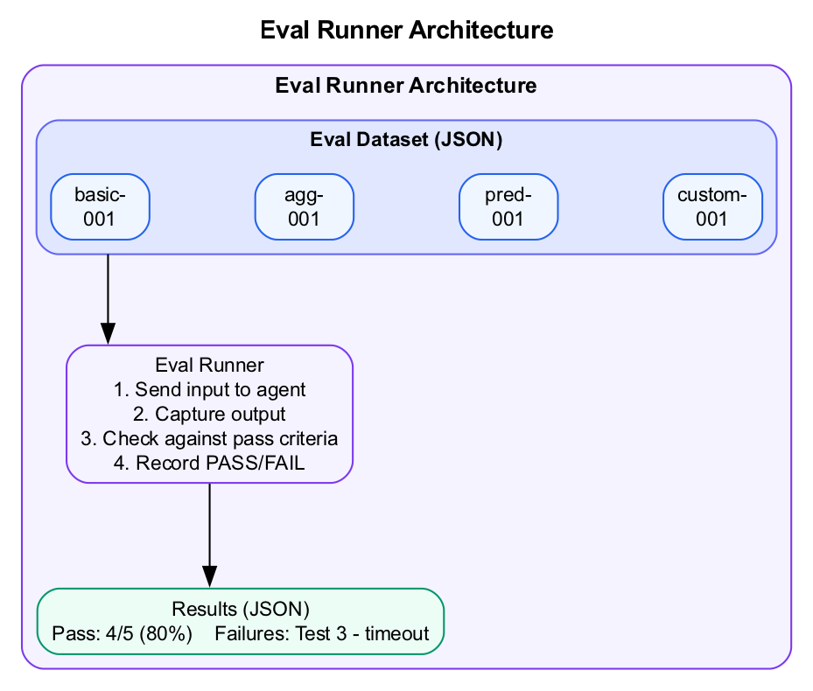
Eval Runner Architecture
What we’re building: Automated eval runs with pass/fail analysis and improvement recommendations.

Prerequisites
Before starting this lab, verify:
- Lab 1 complete - Golden dataset created and manually tested
- Python 3 installed - Required for the eval runner script
- Claude Code running - Start with claude in the repo directory
- Repository cloned - Access to scripts/run-funding-evals.py and data/evals/

Lab Overview (Outcomes)
By the end of this lab, you will:
- Explore the eval dataset without running it
- Run a single eval and understand the output format
- Run all evals by difficulty level
- Analyze results JSON to identify patterns
- Document failures and improvement areas
- (Stretch) Add a custom eval to the suite

Time Breakdown
Task | Topic | Time
2.1 | Explore the Eval Dataset | 5 min
2.2 | Run a Single Eval | 10 min
2.3 | Run All Evals by Difficulty | 15 min
2.4 | Analyze the Results | 10 min
 | TOTAL | 40 min
Stretch | Add Custom Eval | 15+ min

Task 2.1: Explore the Eval Dataset (5 min)
The workshop includes a pre-built eval suite for the funding database.
- View available evals without running them:
- python3 scripts/run-funding-evals.py --dry-run
- Understand what you’ll see:
  - Eval ID and name
  - Difficulty level (easy, medium, hard)
  - Category (retrieval, aggregation, prediction)
  - Input prompt
  - Pass criteria
- Count the evals:
  - How many easy evals?
  - How many hard evals?
  - What categories are covered?
- Record your findings:
Difficulty | Count | Categories
Easy
Medium
Hard

Task 2.2: Run a Single Eval (10 min)
Start with one eval to understand the output format.
- Run the basic count eval:
- python3 scripts/run-funding-evals.py --id=basic-001
- Watch the output carefully:
- Diagram
- Identify the key elements:
  - Tool calls shown in boxes
  - Agent’s reasoning visible
  - Final pass/fail verdict
  - Duration in seconds
- Record your observation:
Element | What You Saw
Tool used
Query run
Result
Duration

Task 2.3: Run All Evals by Difficulty (15 min)
- Run easy evals first:
- python3 scripts/run-funding-evals.py --filter=easy
- Expected: Most should pass (95%+ target)
- Run medium evals:
- python3 scripts/run-funding-evals.py --filter=medium
- Expected: ~80% pass rate
- Run hard evals:
- python3 scripts/run-funding-evals.py --filter=hard
- Expected: ~60% pass rate (failures are expected)
- Record your results:
Difficulty | Passed | Failed | Pass Rate
Easy
Medium
Hard
Total

Task 2.4: Analyze the Results (10 min)
- Check the results file:
- cat output/eval-results.json | python3 -m json.tool
- Look for patterns:
  - Which specific evals failed?
  - What category has the most failures?
  - Are failures due to wrong answers or criteria issues?
- Examine a failed eval:
  - Find a failed eval ID in the results
  - Look at the output field - what did the agent say?
  - Check criteria_results - which criterion failed?
- Document your analysis:
- ## Eval Analysis
**Overall Pass Rate:** __/%
**Failures:**
| Eval ID | Why It Failed |
|---------|---------------|
| | |
| | |
**Patterns Noticed:**
-
-
**Suggested Improvements:**
-
-

Stretch Task: Add Your Own Eval
If you finish early, add a custom eval to the suite.
- Open the eval file:
- code data/evals/funding-analysis-evals.json
- Add a new eval case:
- {
"id": "custom-001",
"name": "Your Custom Eval",
"category": "your-category",
"difficulty": "medium",
"input": "Your question to the agent",
"pass_criteria": [
"Must include X",
"Returns a number greater than Y"
]
}
- Run your custom eval:
- python3 scripts/run-funding-evals.py --id=custom-001
- Did it pass or fail? Why?

Stretch Success Criteria
- Custom eval added to JSON file
- Eval runs successfully
- Pass criteria are specific and testable
- Result documented (pass/fail and why)

Troubleshooting

Eval Runner Issues
Problem | Solution
python3: command not found | Use python or install Python 3
No module named 'json' | Ensure Python 3.6+ is installed
Script hangs | Press Ctrl+C and try with --id= for single eval
Permission denied | Run chmod +x scripts/run-funding-evals.py

Claude Code Issues
Problem | Solution
Agent not responding | Restart Claude Code with claude
Wrong tool being used | Check allowed tools in your skill
Timeout on eval | Increase timeout or simplify the query

Pass Criteria Issues
Problem | Solution
Everything fails | Criteria may be too specific; loosen requirements
Everything passes | Criteria may be too loose; add specificity
“Needs review” results | Criteria couldn’t be auto-checked; manual review needed

Final Checklist
Before completing this lab, verify:
- Explored eval dataset - Used --dry-run to see available evals
- Ran single eval - Understood the output format
- Ran by difficulty - Easy, medium, and hard evals completed
- Results recorded - Pass rates documented for each difficulty
- Analyzed results JSON - Examined failure details
- Patterns documented - Identified common failure modes
- Improvements identified - Know what to fix before demo day
Document your eval results:
Metric | Your Result
Total evals run
Overall pass rate
Weakest category
Top improvement

Reference: Eval JSON Format
{
"id": "eval-001",
"name": "Descriptive Name",
"category": "retrieval|aggregation|prediction|context",
"difficulty": "easy|medium|hard",
"input": "The exact prompt to send to the agent",
"pass_criteria": [
"Criterion 1 - what must be true",
"Criterion 2 - what must be true",
"Returns exactly X"
]
}
Criterion patterns that auto-check: - "Returns exactly 200" → checks for “200” in output - "Does NOT hardcode" → checks “hardcode” not in output - "Uses COUNT(*)" → checks for “count(*)” in output

Reference: Context Management Criteria (For Data Agents)
Criterion | Pass | Fail
Acknowledges limits | “Showing top 100 of 45,000” | Presents limited data as complete
Uses LIMIT | Adds LIMIT clause | Returns unbounded results
Tracks truncation | Notes when data was limited | Makes claims on incomplete data

Reference: Why Binary Pass/Fail?
1-10 scales are subjective and inconsistent: - One person’s “7” is another’s “5” - Hard to aggregate across many tests - Doesn’t drive clear action
Binary pass/fail: - Forces specific criteria definition - Easy to calculate pass rates - Clear signal: “This works” or “This needs fixing”

End of Lab 2

