Week 8 Lab 2: Record and Practice Your Demo
Course: Claude Agents Workshop
Duration: 30 minutes
Focus: Recording a backup demo video and practicing with feedback

Lab Architecture
This lab prepares your backup recording and practice presentation.
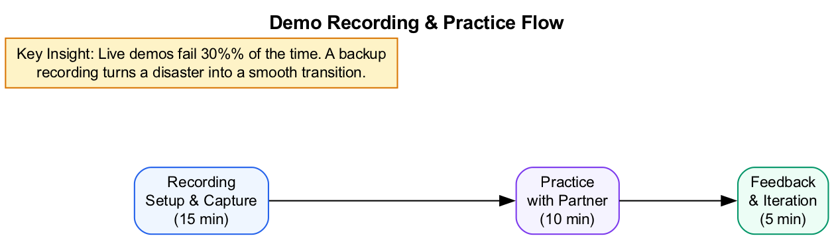
Diagram
What we’re building: A 3-minute backup recording and practiced presentation skills.

Prerequisites
Before starting this lab, verify:
- Lab 1 complete - Demo outline and opening line ready
- Screen recording tool ready - QuickTime, Loom, or OBS installed
- Agent working - Tested within the last hour
- Partner available - For practice session (or self-record)

Lab Overview (Outcomes)
By the end of this lab, you will:
- Set up your recording environment
- Record a 3-minute backup demo video
- Practice your full presentation with timing
- Receive and incorporate feedback

Time Breakdown
Task | Topic | Time
2.1 | Prepare Your Recording Setup | 5 min
2.2 | Record Your Demo | 10 min
2.3 | Pair Up and Practice | 10 min
2.4 | Give and Receive Feedback | 5 min
 | TOTAL | 30 min

Task 2.1: Prepare Your Recording Setup (5 min)
- Choose your recording tool:
  - macOS: QuickTime Player (File > New Screen Recording)
  - Windows: Windows + G (Game Bar) or OBS
  - Cross-platform: Loom, OBS Studio
- Set up your screen:
  - Close unnecessary applications
  - Clear desktop notifications
  - Open only the windows you need:
    - Terminal with Claude Code ready
    - Any output destinations (browser, files)
    - Sample data files
- Test audio:
  - Select correct microphone
  - Do a quick test recording (10 seconds)
  - Check playback volume
- Checklist before recording:
Item | Ready?
Recording tool open | [ ]
Microphone selected | [ ]
Notifications disabled | [ ]
Sample data ready | [ ]
Agent tested and working | [ ]

Task 2.2: Record Your Demo (10 min)
Record a 3-minute walkthrough of your agent in action.
Recording checklist: - [ ] State your name and project name at the start - [ ] Show the input you’re giving the agent - [ ] Narrate what’s happening as the agent works - [ ] Show the final output - [ ] Keep it under 3 minutes
Recording tips: - Speak slowly and clearly - Pause after important points - If something fails, keep recording and explain what should happen - You can edit later, but a single take is often better
Script for your recording: 1. “Hi, I’m [name] and this is [project name]” 2. “I’m going to show you [what]” 3. “Here’s my input: [show input]” 4. [Run agent, narrate as it works] 5. “And here’s the result: [show output]”
Save your recording as: demo-backup-[yourname].mp4

Verify your recording:
- File plays back correctly
- Audio is audible and clear
- Agent output is visible
- Duration is under 3 minutes

Task 2.3: Pair Up and Practice (10 min)
Find a partner. Each person presents while the other times and takes notes.
For the presenter: - Present your full 5-minute demo - Use your outline as a guide - Practice transitioning between sections - Use your recorded backup if the live demo fails
For the observer: - Start a timer when they begin - Note when they hit each section - Write down: - One thing that was clear and compelling - One thing that was confusing - One suggestion for improvement
Timing notes template:
Section | Target | Actual | Notes
Problem | 0:30
Solution | 1:30
Demo | 4:00
Learnings | 5:00
No partner available? - Record yourself presenting - Watch the playback - Note your own timing and areas to improve

Task 2.4: Give and Receive Feedback (5 min)
After both partners present, share feedback using this framework:
What Worked Well: - Specific things that impressed you - Clever solutions or clear explanations - Good use of concepts from the course
Questions I Had: - Clarifying questions about the implementation - How would it handle edge cases? - Scalability or reliability considerations
Suggestions: - Ideas for the presentation (not the code) - How to make the demo clearer - What to cut if running long

Feedback Template
Feedback for: _______________
Category | Notes
What worked well
Questions I had
Suggestion

Troubleshooting

Recording Issues
Problem | Solution
No audio in recording | Check microphone selected in recording app
Recording too large | Use a lower resolution or compress with HandBrake
Screen not captured | Grant screen recording permission in System Preferences
Choppy playback | Close other applications, restart and re-record

Demo Issues
Problem | Solution
Agent hangs during demo | Show backup recording, explain what should happen
Wrong output | Acknowledge it, explain expected output, move on
Takes too long | Prepare a “skip ahead” version with cached output
Nervous/rushed | Breathe, slow down, focus on one section at a time

Practice Issues
Problem | Solution
Running way over time | Cut the solution section, go straight to demo
Not sure what to say | Read your outline, don’t improvise until comfortable
Partner’s feedback harsh | Focus on actionable suggestions, ignore tone
No partner available | Record yourself and watch playback

Final Checklist
Before demo day, verify:
Backup Recording: - [ ] 3-minute backup recording saved - [ ] Audio is clear and audible - [ ] File can be played back successfully - [ ] File uploaded/accessible during demo session
Technical Setup: - [ ] Agent runs without errors on current machine - [ ] All required MCP servers connected - [ ] Screen sharing tested (Zoom/Meet/Teams) - [ ] Notifications disabled on demo machine
Presentation Ready: - [ ] Practiced at least once with a partner - [ ] Received and incorporated feedback - [ ] Know your time slot (if assigned) - [ ] Confident with opening line and transitions
Document your preparation:
Item | Status
Backup recording file
Timing during practice
Key feedback received
Adjustment made

Reference: Demo Dos and Don’ts

Do
Action | Why
Prepare a backup recording | Live demos fail 30% of the time
Have sample data ready | Avoids scrambling during demo
Keep it concise | Respect everyone’s time
Show real output | The output is the star, not your code
Acknowledge limitations | Builds credibility

Don’t
Action | Why
Read from slides | You know your project, talk naturally
Spend too long on setup | Get to the demo quickly
Apologize for “rough” work | Undermines your credibility
Skip the demo | Everyone wants to see it work
Go over time | Others are waiting

Reference: Feedback Framework

Giving Feedback
Structure: 1. Start with something specific that impressed you 2. Ask clarifying questions (not challenges) 3. Offer one constructive suggestion
Good feedback examples: - “The way you handled the multi-step workflow was really elegant.” - “I’m curious how it would handle edge case X?” - “Have you considered adding Y? It might help with Z.”
Avoid: - “I would have done it completely differently…” - “That’s not how I understood the assignment…” - “Why didn’t you use X technology?”

Receiving Feedback
- Say “thank you” first
- Write down suggestions (even if you disagree)
- Ask for clarification if feedback is vague
- Don’t defend or explain unless asked

End of Lab 2

