Week 4: Agent Skills - Teaching Claude New Capabilities

Session Goals
- Understand the Agent Skills specification
- Create effective SKILL.md files
- Build skills for data analytics and GTM use cases
- Learn progressive disclosure and skill organization

Block 1: Theory - What Are Agent Skills? (30 min)

The Problem Skills Solve
Claude is powerful but generic. Skills let you: - Teach Claude your specific workflows - Encode team knowledge and standards - Create reusable capabilities - Ensure consistent behavior

Why Skills Matter: SOPs for Your Agent
Think of skills as SOPs (Standard Operating Procedures) for Claude.
In any organization, you don’t train every new hire by having them shadow you forever. You write down the process: “Here’s how we score leads. Here’s our data quality checklist. Here’s the format for weekly reports.” Then they follow the SOP.
Skills work the same way. You have knowledge Claude doesn’t have: - How your team scores leads - What makes a good data quality check at your company - The specific steps for your weekly reporting workflow - Your industry’s benchmarks and red flags
Skills let you write that expertise down once and have Claude use it automatically, forever.
Real examples:
Your Expertise | Without a Skill | With a Skill
Lead scoring criteria | Explain rubric every time | Claude scores leads your way automatically
Data quality standards | Manually check each dataset | Claude applies your standards consistently
Email writing style | Edit every draft Claude writes | Claude writes in your voice from the start
Report format | Copy-paste template, fix formatting | Claude generates reports in your exact format
This is the core skill of this bootcamp: turning what’s in your head into something an agent can use.

How to Build Skills: Start With Your Source of Truth
The most important principle for building skills: start with what already works.
Source of Truth | Example
How you already do the work | Your personal process for scoring leads, your email templates
The best person on your team | How your top sales rep qualifies deals, how your best analyst profiles data
A best practices doc | Your company’s style guide, your team’s SOP for customer research
A trusted external source | A methodology from a respected practitioner, an industry framework you’ve vetted
The right workflow:
- Find or create your source of truth (the “golden” version)
- Write it down as clear, step-by-step instructions
- Format it as a SKILL.md with the right structure
- Test it with Claude and iterate
You can use AI to help build the skill. Once you have your source of truth, Claude can help you structure it, identify gaps, and format it correctly. But AI assists the process, it doesn’t replace the expertise.
What NOT to do:
Anti-Pattern | Why It Fails
Ask AI to “create a lead scoring skill” from scratch | AI will generate generic content that doesn’t reflect your actual criteria
Copy skills from “awesome-claude-code” repos online | Some influencer’s workflow isn’t your workflow. Their scoring rubric isn’t your rubric.
Start with AI and hope it matches your process | You end up with a skill that looks professional but produces wrong outputs
The best skills encode real expertise. They capture what the best person on your team actually does, not what a random AI thinks they should do. Start with your truth, then use AI to help structure and improve it.

The Architecture: Incremental File Exploration
Skills are part of an emerging pattern in agent design: incremental file exploration.
The naive approach is to dump all knowledge into the prompt upfront. “Here’s everything you might need to know.” This hits context limits fast and wastes tokens on irrelevant information.
The better approach: let the agent explore and load knowledge on-demand.
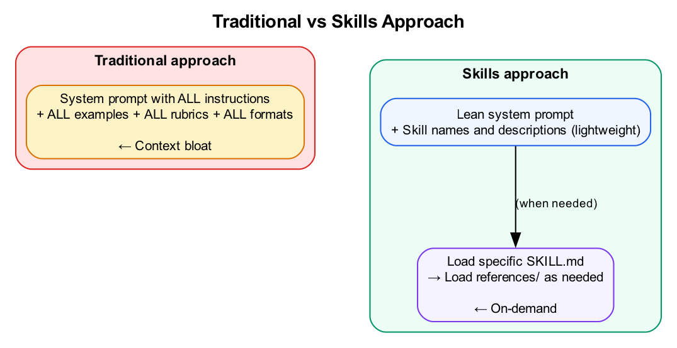
Diagram
How it works:
- At startup, Claude only loads skill name and description (a few lines each)
- When your request matches a skill, Claude loads the full SKILL.md
- If that skill references detailed docs, Claude loads those only when needed
- The agent manages its own context window by exploring incrementally
This is the same pattern we saw in Week 2 with filesystem + bash. Instead of stuffing everything into the prompt, the agent retrieves context as it needs it. Skills extend this pattern to domain knowledge.

How Skills Work
A skill is just a folder with a SKILL.md file. Claude reads it like a recipe and follows the steps.
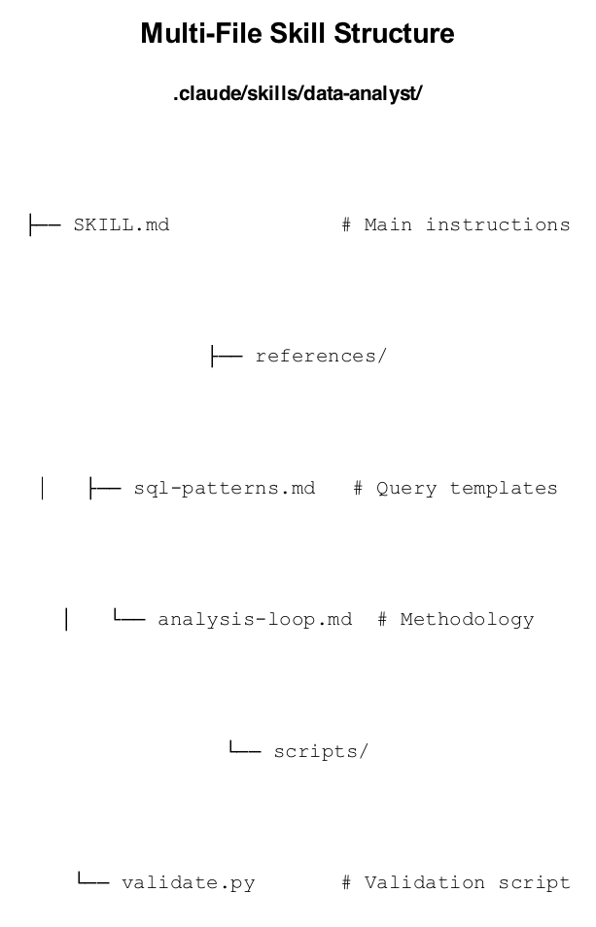
Diagram
When you ask Claude something that matches a skill’s description, Claude asks permission to use it, loads the instructions, and works from your playbook instead of improvising.
The key difference from tools:
Tools execute and return results. Skills prepare the agent to solve a problem. When Claude invokes a skill, it loads the SKILL.md as new instructions, adjusts its execution context, and continues with this enriched environment. Skills change how Claude thinks, not just what it can do.

The Story Behind Skills
Agent Skills started inside Anthropic as a way to make Claude Code more useful for specialized tasks. As models got more capable, the team needed a scalable way to equip agents with domain expertise without bloating the base prompt.
At an internal hackathon, teams built skills for everything from code review to customer research. The pattern worked so well that Anthropic productized it.
October 2025: Anthropic launched Agent Skills publicly. They also released a “skill-creator” skill that uses Claude to generate new skills interactively.
December 2025: Anthropic published the Agent Skills specification as an open standard at agentskills.io, following the same playbook as MCP.

Skills as an Open Standard
The format is now supported across major AI tools:
Platform | Status
Claude (Claude.ai, Claude Code, Agent SDK) | Native
GitHub Copilot (VS Code, CLI, coding agent) | Native
OpenAI Codex CLI | Native
Cursor, Gemini CLI, and others | Native or compatible
Skills you create work across this ecosystem. Put a SKILL.md in .claude/skills/ or .github/skills/, and most agents pick it up automatically. Your investment in writing skills pays off regardless of which AI tools you use.
Anthropic also launched a directory with skills from commercial partners: Atlassian, Canva, Cloudflare, Figma, Notion, Ramp, and Sentry. These are production-grade examples of how companies package their workflows as skills.
References: - Anthropic: Introducing Agent Skills - Anthropic Engineering: Equipping Agents for the Real World - Agent Skills Open Standard - GitHub: Agent Skills Repository

Skills vs Slash Commands
Aspect | Slash Commands | Agent Skills
Invocation | Explicit: /command | Automatic: Claude detects
Structure | Single .md file | Directory with SKILL.md
Complexity | Simple prompts | Multi-file workflows
Discovery | Manual | Automatic (by description)

SKILL.md Structure
---
name: skill-name
description: What it does and when to use it. Include trigger keywords.
---
# Skill Title
## Instructions
Step-by-step guidance for Claude.
## Examples
Concrete input/output examples.

YAML Frontmatter Fields
Field | Required | Description
name | Yes | Lowercase, hyphens only (max 64 chars)
description | Yes | What + when (max 1024 chars)
allowed-tools | No | Restrict tools: Read, Grep, Bash(python:*)
context | No | fork for isolated sub-agent context
hooks | No | PreToolUse, PostToolUse, Stop handlers

Demo
Show a skill in action: 1. Create a simple skill 2. Trigger it with a matching request 3. See Claude ask permission and execute

Block 2: Lab (Part 1) - Your First Skill (30 min)
Lab Document: weeks/md/week4-lab.md or weeks/docx/week4-lab.docx
Complete Part 1 of the Week 4 Lab.
Overview: - Create skill directory structure - Write SKILL.md with YAML frontmatter - Test that skill triggers correctly - Observe structured output
Success criteria: - Skill created at .claude/skills/database-profiler/ - Claude discovers and asks to use the skill - Output follows the four-section structure

BREAK (10 min)

Block 3: Theory - Advanced Skill Patterns (30 min)

Multi-File Skills
For complex skills, add supporting files:
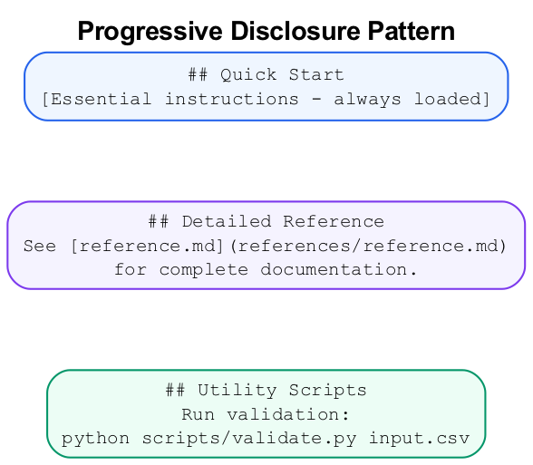
Diagram
Reference files load on demand:
For SQL query patterns, see [sql-patterns.md](references/sql-patterns.md).

Progressive Disclosure
Keep SKILL.md under 500 lines. Structure for efficiency:
## Quick Start
[Essential instructions - always loaded]
## Detailed Reference
See [reference.md](references/reference.md) for complete documentation.
## Utility Scripts
Run validation: `python scripts/validate.py input.csv`

Description Best Practices
Bad:
description: Helps with data.
Good:
description: Analyze datasets using the Data Analysis Loop (Monitor → Explore → Craft → Impact). Use when profiling data, investigating anomalies, or building analytical reports.
Include: - What it does (capabilities) - When to use it (trigger scenarios) - Keywords users might say

Restricting Tools
Use allowed-tools for focused skills:
---
name: read-only-analyzer
description: Analyze code without making changes
allowed-tools: Read, Grep, Glob
---
Patterns: - Read - exact tool name - Bash(python:*) - Bash with python prefix only - Bash(git:*) - Git commands only

Hooks for Skills
Add validation or logging:
---
name: secure-operations
hooks:
PreToolUse:
- matcher: "Bash"
hooks:
- type: command
command: "./scripts/security-check.sh $TOOL_INPUT"
---

Block 4: Lab (Part 2) - Build a Data Analysis Skill (45 min)
Lab Document: weeks/md/week4-lab.md or weeks/docx/week4-lab.docx
Complete Part 2 of the Week 4 Lab.
Overview: - Create skill with references directory - Add SQL patterns reference file - Implement tool restrictions (allowed-tools) - Test with analytical questions
Success criteria: - Data analyst skill created with references - Tool restrictions working (only allowed tools) - Data Analysis Loop applied in output

Bonus: Data Visualization Skill (Optional Lab Extension)

Building a Visualization Generator Skill
Skills can include scripts that Claude executes. This is powerful for data visualization, where you want consistent chart styles and formats.
Create the skill structure:
mkdir -p .claude/skills/data-visualizer/scripts
Create SKILL.md:
---
name: data-visualizer
description: Generate charts and visualizations from data. Use when asked to visualize data, create charts, plot trends, or build graphs. Supports bar charts, line charts, scatter plots, and pie charts.
allowed-tools: Read, Bash, Write
---
# Data Visualizer
Generate professional visualizations from query results or data files.
## Supported Chart Types
| Type | Use When |
|------|----------|
| Bar chart | Comparing categories |
| Line chart | Showing trends over time |
| Scatter plot | Showing correlations |
| Pie chart | Showing proportions |
## Process
1. Get the data (from query or file)
2. Identify the best chart type for the question
3. Run the visualization script with appropriate parameters
4. Save the output image to `output/charts/`
## Execution
Use the Python script in `scripts/visualize.py`:
\`\`\`bash
python .claude/skills/data-visualizer/scripts/visualize.py \
--input data.csv \
--chart-type bar \
--x-column category \
--y-column value \
--title "My Chart" \
--output output/charts/chart.png
\`\`\`
## Chart Selection Guide
- "Compare X across categories" → Bar chart
- "Show trend over time" → Line chart
- "Correlation between X and Y" → Scatter plot
- "Distribution/proportion" → Pie chart
Create scripts/visualize.py:
#!/usr/bin/env python3
"""
Data visualization script for the data-visualizer skill.
Generates charts from CSV data using matplotlib.
"""
import argparse
import pandas as pd
import matplotlib.pyplot as plt
import matplotlib
matplotlib.use('Agg') # Non-interactive backend
def create_bar_chart(df, x_col, y_col, title, output):
plt.figure(figsize=(10, 6))
plt.bar(df[x_col], df[y_col], color='steelblue')
plt.xlabel(x_col)
plt.ylabel(y_col)
plt.title(title)
plt.xticks(rotation=45, ha='right')
plt.tight_layout()
plt.savefig(output, dpi=150)
print(f"Chart saved to {output}")
def create_line_chart(df, x_col, y_col, title, output):
plt.figure(figsize=(10, 6))
plt.plot(df[x_col], df[y_col], marker='o', color='steelblue')
plt.xlabel(x_col)
plt.ylabel(y_col)
plt.title(title)
plt.xticks(rotation=45, ha='right')
plt.tight_layout()
plt.savefig(output, dpi=150)
print(f"Chart saved to {output}")
def create_scatter_plot(df, x_col, y_col, title, output):
plt.figure(figsize=(10, 6))
plt.scatter(df[x_col], df[y_col], alpha=0.6, color='steelblue')
plt.xlabel(x_col)
plt.ylabel(y_col)
plt.title(title)
plt.tight_layout()
plt.savefig(output, dpi=150)
print(f"Chart saved to {output}")
def create_pie_chart(df, label_col, value_col, title, output):
plt.figure(figsize=(10, 8))
plt.pie(df[value_col], labels=df[label_col], autopct='%1.1f%%')
plt.title(title)
plt.tight_layout()
plt.savefig(output, dpi=150)
print(f"Chart saved to {output}")
def main():
parser = argparse.ArgumentParser(description='Generate charts from CSV data')
parser.add_argument('--input', required=True, help='Input CSV file')
parser.add_argument('--chart-type', required=True,
choices=['bar', 'line', 'scatter', 'pie'])
parser.add_argument('--x-column', required=True, help='X-axis column')
parser.add_argument('--y-column', required=True, help='Y-axis column')
parser.add_argument('--title', default='Chart', help='Chart title')
parser.add_argument('--output', default='chart.png', help='Output file')
args = parser.parse_args()
df = pd.read_csv(args.input)
chart_functions = {
'bar': create_bar_chart,
'line': create_line_chart,
'scatter': create_scatter_plot,
'pie': create_pie_chart
}
chart_functions[args.chart_type](
df, args.x_column, args.y_column, args.title, args.output
)
if __name__ == '__main__':
main()
Test the skill:
> Query the funding database for total funding by industry, then visualize it as a bar chart

Creating Interactive Dashboards
For dashboards that users can interact with in a browser, Claude can generate HTML, CSS, and JavaScript.
When to use this approach: - Stakeholders want a visual interface - Data needs to be presented in multiple views - You want filtering, sorting, or drill-down capabilities
Example prompt:
> Create an HTML dashboard that displays:
> 1. Funding by industry (bar chart)
> 2. Funding over time (line chart)
> 3. A filterable table of all startups
>
> Use Chart.js for the charts. Make it look professional.
> Save to output/dashboard/index.html
Claude will generate a complete HTML file with embedded CSS and JavaScript using Chart.js. Open the file in a browser to see your dashboard.

Wrap-Up (15 min)

Key Takeaways
- Skills = Reusable Knowledge - Encode workflows Claude can discover
- Description is Critical - Include what, when, and keywords
- Progressive Disclosure - Keep SKILL.md lean, reference details
- Test Thoroughly - Verify discovery and output quality
- Data Analysis Loop - Encode methodology, not just tools

Homework
Create Two Skills for Your Project:
Build two skills that encode expertise from your domain. Each skill should capture a repeatable workflow.
Domain | Example Skills
GTM/Sales | Lead scorer, email writer, company researcher, pipeline forecaster
Developer Tools | Code reviewer, documentation generator, PR summarizer
Content/Marketing | Content brief writer, SEO analyzer, repurposing guide
Customer Support | Ticket classifier, response drafter, escalation checker
Operations | Invoice processor, compliance checker, report formatter
Data Analytics | Data profiler, anomaly detector, trend analyzer, report generator
For each skill: - Clear trigger description (when should it activate?) - Step-by-step instructions Claude can follow - Defined output format - Put detailed references in references/ subdirectory
Submit: - Skill directories - Screenshot of each skill in action - Brief description of when each triggers

Next Week Preview
Week 5: Sub-agents - Orchestrating specialized agents for complex workflows

Facilitator Notes

Common Issues
- Skill not triggering: Check description keywords match request
- Wrong location: Must be .claude/skills/ not skills/
- YAML errors: Check frontmatter syntax (spaces, not tabs)
- Reference not loading: Verify relative path is correct

Skill Quality Checklist
- Name is lowercase with hyphens
- Description includes what + when + keywords
- Instructions are step-by-step
- Output format is defined
- Examples are included

Timing Adjustments
- Lab 1 is essential - ensure everyone completes
- Lab 2 can be simplified to just SKILL.md if time short
- References can be homework if needed

