Week 5: Context Engineering - Sub-agents and RAG

Session Goals
- Understand sub-agent architecture and use cases
- Use the Task tool to spawn specialized agents
- Define custom agents with focused capabilities
- Build multi-agent workflows for GTM pipelines
- Connect to vector databases for retrieval-augmented generation

Block 1: Theory - Why Sub-agents? (30 min)

The Problem with Single Agents
Complex workflows strain a single agent: - Context window fills up with intermediate steps - Focus dilutes across tasks - Errors cascade
The real killer: context flooding.
Imagine your agent needs to research 10 companies. Without sub-agents, every web search result, every page fetch, every intermediate analysis floods the main agent’s context. By the time you’re on company #5, the agent has forgotten what it learned about company #1.

What Are Sub-agents?
A sub-agent is a separate agent instance that handles a focused subtask within a larger workflow. Think of it like a boss delegating to employees: you give them a clear brief, they work independently, and they report back with results. You don’t see every step they took, just the output.
The key insight: sub-agents are black boxes for context management.
When a sub-agent runs: 1. It does all its work in its own context (web scrapes, file reads, analysis) 2. All those intermediate steps stay in the sub-agent’s context 3. Only the final result returns to the main agent 4. The main agent’s context stays clean
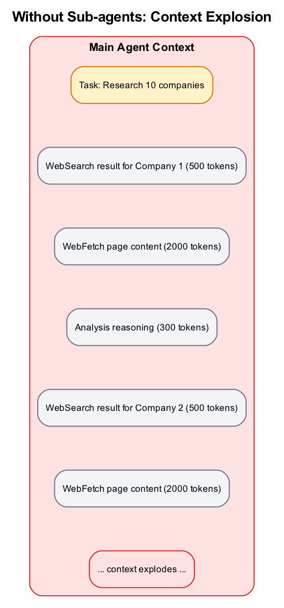
Diagram
Key characteristics:
- Isolated context: Each sub-agent starts fresh, focused only on its task
- Own conversation: Sub-agent messages don’t pollute the main agent’s context
- Specialized tools: You can restrict which tools a sub-agent can use
- Defined model: Sub-agents can use different models (Haiku for speed, Opus for complexity)
- Single level: Sub-agents cannot spawn their own sub-agents
Sub-agents are essential for building production agent systems. Without them, you’re limited to what fits in a single context window with a single set of instructions.

Sub-agents Solve This
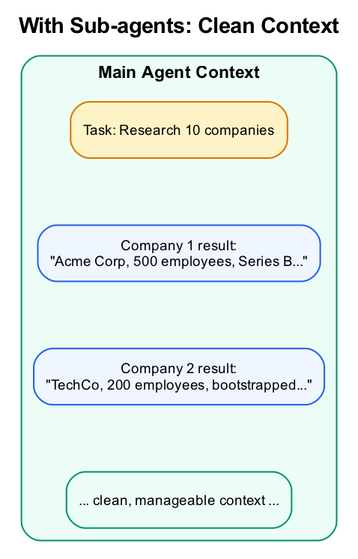
Diagram
Benefits: - Focused context per task - Parallel execution possible - Specialized tools per agent - Isolated failures

The Task Tool
The Task tool is how you invoke sub-agents in Claude Code. When Claude uses the Task tool, it spawns a new agent instance with its own isolated conversation.
> Use the code-reviewer agent to review this PR
How Task tool works:
- Creates isolated context for sub-agent
- Passes the prompt and configuration you specify
- Gives sub-agent access to its allowed tools
- Sub-agent runs independently until completion
- Returns final result to main agent
Task tool parameters:
Parameter | Required | Description
prompt | Yes | The task for the sub-agent to perform
description | Yes | Short summary (3-5 words) of what the agent does
subagent_type | Yes | Which agent type to use
model | No | Override model (sonnet, opus, haiku)
max_turns | No | Limit API round-trips
run_in_background | No | Run asynchronously
resume | No | Continue from previous execution
Foreground vs Background:
By default, sub-agents run in the foreground: you wait for them to finish. For long-running tasks, use run_in_background: true. Background agents return an output file path you can check later.

Built-in Sub-agent Types
Claude Code comes with built-in agents optimized for common tasks:
Agent Type | Model | Use Case | Tools | Best For
Explore | Haiku | Codebase exploration | Glob, Grep, Read (read-only) | Quick searches, finding files, understanding code
Plan | Inherited | Architecture planning | All except Edit/Write | Designing implementation before coding
Bash | Inherited | Command execution | Bash only | Git operations, running scripts
general-purpose | Inherited | Flexible tasks | All tools | Complex multi-step work
When to use each:
- Explore: Use for research tasks. It’s fast (Haiku) and read-only, perfect for “find all files that…” or “how does X work in this codebase?”
- Plan: Use before implementing features. Creates a plan file for user approval before any code changes.
- Bash: Use for terminal operations like git commits, test runs, or build commands.
- General-purpose: Use when you need full capabilities but want isolated context.

Three Ways to Create Sub-agents
1. Built-in agents (Claude Code CLI):
Use the types above. No configuration needed.
2. Filesystem-based agents (Claude Code CLI):
Create agent definitions in .claude/agents/:
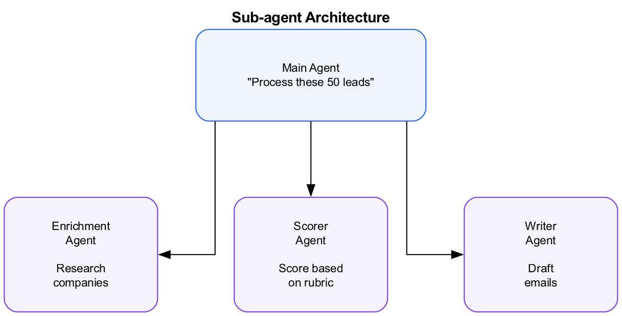
Diagram
Each file uses YAML frontmatter:
---
name: lead-enricher
description: Research companies and enrich lead data with firmographic info
model: haiku
tools: ["Read", "WebSearch", "WebFetch", "Write"]
---
# Lead Enricher
Research the company thoroughly. Find:
- Company size and employee count
- Industry and sub-industry
- Recent news and announcements
- Key decision makers and their roles
- Technology stack (if B2B tech)
Output a structured summary in markdown.
3. Programmatic agents (Agent SDK):
Define agents in code when using the SDK:
const result = await query({
prompt: "Process these leads",
options: {
agents: {
"lead-enricher": {
description: "Research companies and enrich lead data",
prompt: "Research thoroughly. Find size, industry, news, key people.",
tools: ["Read", "WebSearch", "WebFetch", "Write"],
model: "haiku"
}
}
}
});

Agent Configuration Options
Whether using filesystem or SDK, agents support these configuration fields:
Field | Required | Description
name | Yes | Identifier for the agent (lowercase, hyphens)
description | Yes | What it does and when to use it. Critical for automatic invocation.
prompt | No | System instructions for the agent
tools | No | Array of allowed tools. Omit for all tools.
model | No | haiku, sonnet, or opus
permissionMode | No | default, acceptEdits, or bypassPermissions
hooks | No | PreToolUse/PostToolUse handlers
Tool restriction patterns:
# Specific tools only
tools: ["Read", "Grep", "Glob"]
# All tools except dangerous ones
tools: ["Read", "Write", "Edit", "Glob", "Grep", "WebSearch", "WebFetch"]
# Bash with command prefix restriction
tools: ["Read", "Bash(python:*)"] # Only python commands
Permission modes:
- default: Prompts for approval on sensitive actions
- acceptEdits: Auto-approves file edits (useful for automation)
- bypassPermissions: No prompts (only for trusted, sandboxed environments)

Resuming Sub-agents
Sub-agents can be resumed to continue work with their full previous context. This is useful for: - Long-running research tasks you check on later - Iterative workflows where you add requirements - Following up on partial results
When a sub-agent completes, it returns an agent ID. Use this ID to resume:
Main agent: "Research Acme Corp"
Sub-agent: [completes with agent_id: "abc123"]
Later...
Main agent: "Resume agent abc123 and also find their competitors"
Sub-agent: [continues with full previous context]
In the SDK, use the resume parameter:
await query({
prompt: "Also find their competitors",
options: {
resume: "abc123" // Previous agent ID
}
});

Demo
Show a multi-agent workflow: 1. Main agent receives list of leads 2. Spawns enrichment agent for each company 3. Collects and summarizes results

Block 2: Lab (Part 1) - Using Built-in Sub-agents (30 min)
Lab Document: weeks/md/week5-lab.md or weeks/docx/week5-lab.docx
Complete Part 1 of the Week 5 Lab.
Overview: - Use the Explore agent for codebase discovery - Observe parallel sub-agent execution - Create a custom company-researcher agent - Test custom agent invocation
Success criteria: - Observed built-in sub-agent spawning - Saw parallel execution in action - Created a custom agent definition - Successfully invoked custom agent

BREAK (10 min)

Block 3: Theory - Building Multi-Agent Workflows (30 min)

Workflow Patterns
Sequential Pipeline: 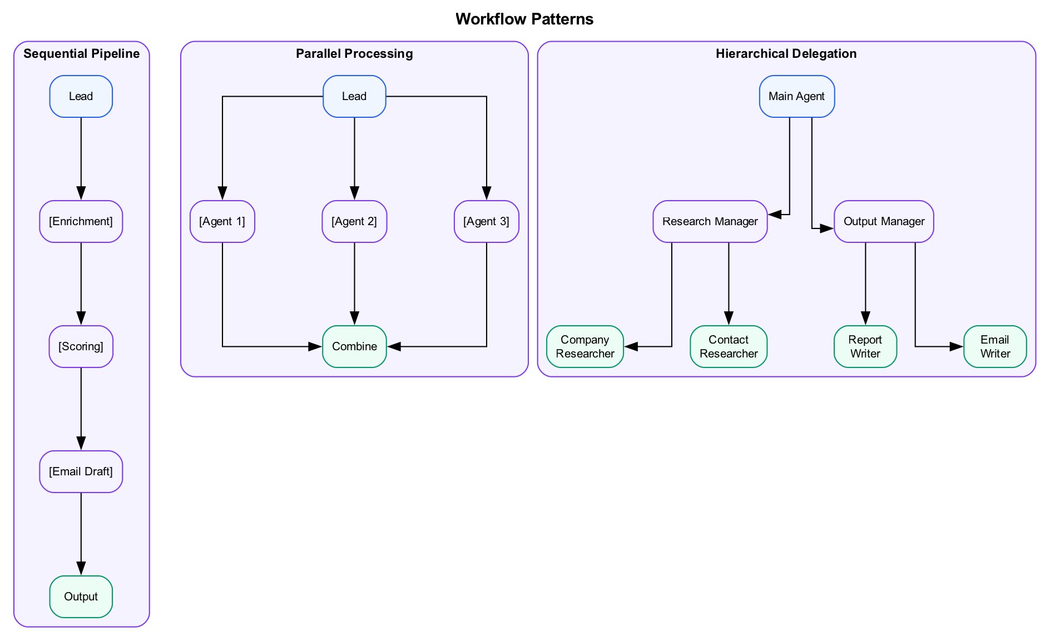
Parallel Processing: 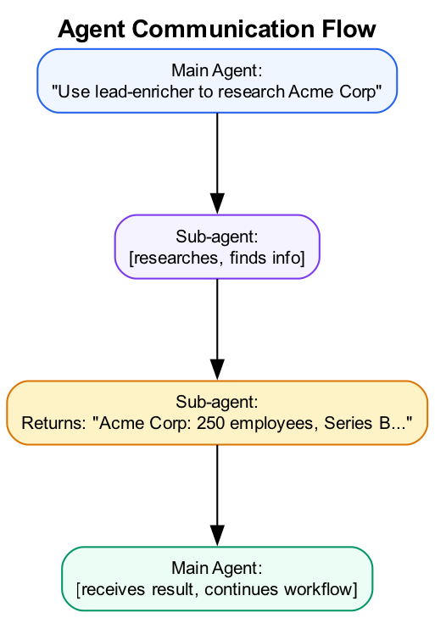
Hierarchical Delegation: 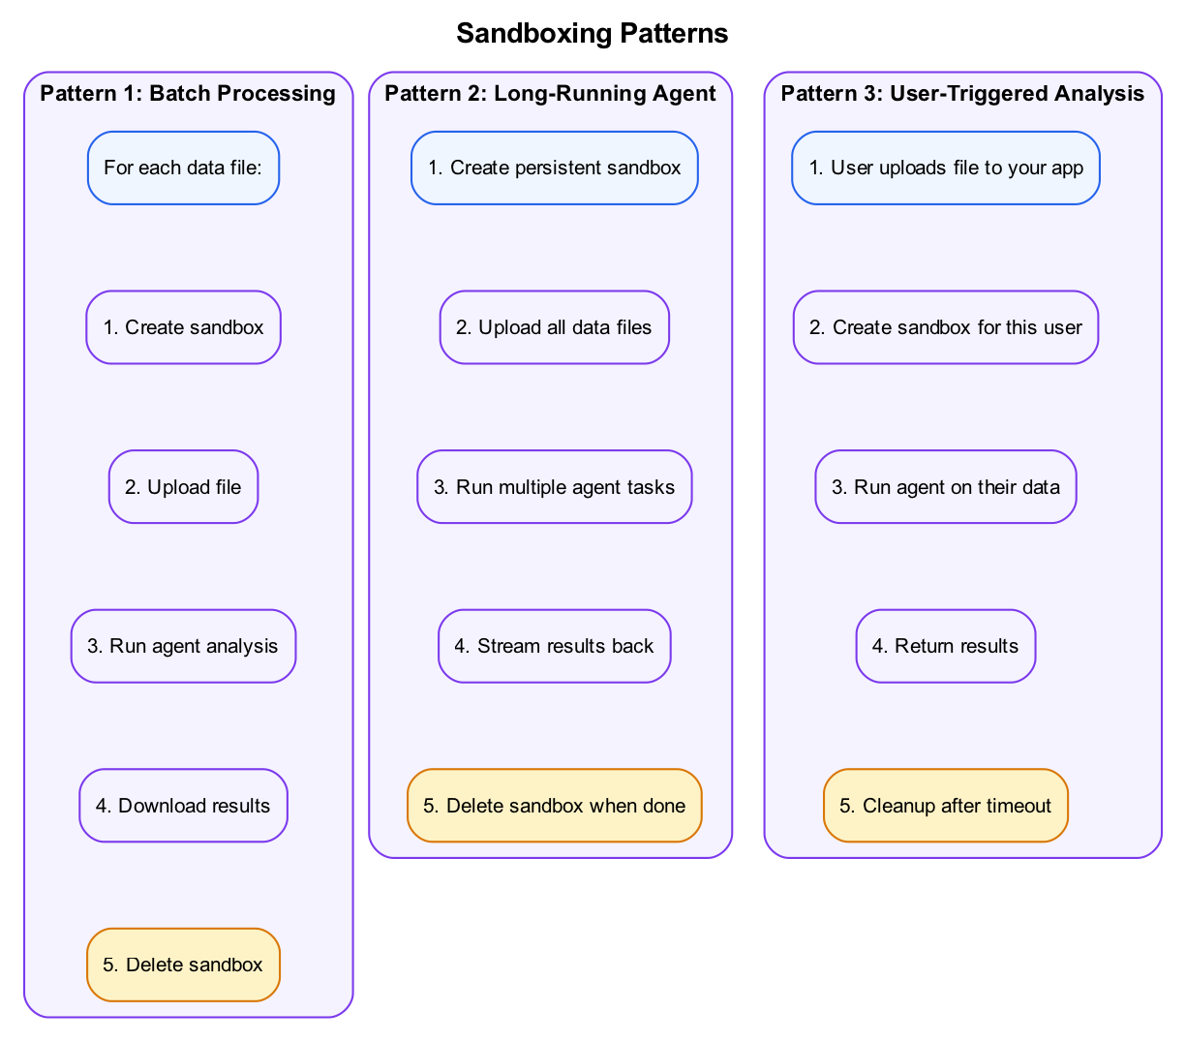

Designing Agent Responsibilities
Good decomposition: - Each agent has clear, focused purpose - Minimal overlap between agents - Well-defined inputs and outputs
Anti-patterns: - Too many tiny agents (overhead) - Agents that do “everything” - Circular dependencies
Too many agents anti-pattern
Too many agents anti-pattern
Don’t be this person. “Whimsy-injector.md” is not a real agent you need.

Agent Communication
Sub-agents return results to parent:
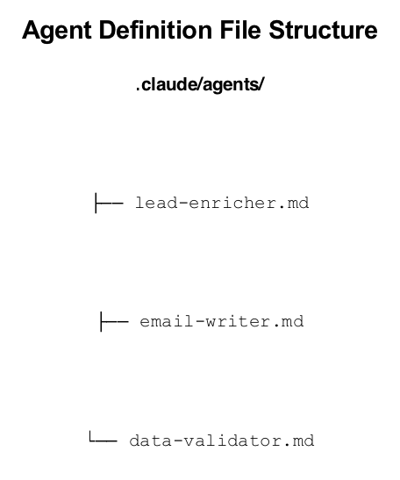
Diagram

Error Handling
When sub-agents fail: - Main agent receives error message - Can retry with different approach - Can skip and continue with others
> If enrichment fails for a company, note it as "Research Failed" and continue with the next lead.

Context, Memory, and Retrieval
Sub-agents are powerful, but what happens when you need agents to work with large knowledge bases? This is where retrieval-augmented generation (RAG) comes in.
The evolution: - RAG started as “embed documents, find similar chunks, stuff into prompt” - Modern agents treat retrieval as just another tool - Claude can decide when to search, what to search for, and how to use results
RAG vs Agentic Search:
Traditional RAG | Agentic Search
Fixed retrieval pipeline | Agent decides when to retrieve
Same query for all questions | Agent reformulates queries
Top-K results stuffed in prompt | Agent filters and synthesizes
One-shot retrieval | Iterative search and refinement
When to use vector search vs filesystem:
Use Case | Best Approach
Structured data (CSVs, databases) | SQL/grep - precise matching
Unstructured docs (PDFs, notes) | Vector search - semantic similarity
Code search | Grep + embeddings hybrid
Finding similar past deals/cases | Vector search - similarity matching
Connecting to vector databases via MCP:
For this workshop, we’ll use Vectorize.io, which provides: - A visual UI for uploading and managing documents - Automatic vectorization of your files (PDFs, docs, text) - Built-in MCP integration for Claude Code - No code required for basic RAG workflows
Once connected, Claude can: - Search for semantically similar content - Retrieve context for complex questions - Enrich data based on proprietary knowledge

Tracking Sub-agent Progress (SDK)
When using the Agent SDK, you can track sub-agent progress through streaming:
import { query } from "@anthropic-ai/claude-agent-sdk";
for await (const message of query({
prompt: "Research these 5 companies",
options: {
agents: {
"researcher": {
description: "Research a company",
tools: ["WebSearch", "WebFetch"]
}
}
}
})) {
// Messages from sub-agents include parent_tool_use_id
if (message.parent_tool_use_id) {
console.log(`Sub-agent progress: ${message.content}`);
}
// Tool calls show which agent is acting
if (message.type === 'tool_use') {
console.log(`Tool: ${message.name}`);
}
}
What you can track:
- When sub-agents start and complete
- Which tools each sub-agent uses
- Intermediate results before final output
- Errors or retries within sub-agents

Block 4: Lab (Part 2) - Build a GTM Pipeline (45 min)
Lab Document: weeks/md/week5-lab.md or weeks/docx/week5-lab.docx
Complete Part 2 of the Week 5 Lab.
Overview: - Create specialized agents (lead-enricher, email-drafter) - Build a lead-pipeline skill for orchestration - Test the pipeline with startup funding database - Iterate and refine the workflow
Success criteria: - Working lead-pipeline skill created - Pipeline tested with startup data - Sample output with 5 processed leads - Screenshot of pipeline execution

Bonus Lab: RAG with Vectorize.io (Optional)

Scenario: Enrich Deals with Proprietary Knowledge
Your company has historical deal notes, win/loss analyses, and sales playbooks. When processing new leads, you want to: - Find similar past deals - Pull relevant playbook sections - Get recommendations based on what worked before
This is a perfect use case for vector search + agents.

Step 1: Set Up Vectorize.io
Vectorize.io provides a visual workflow builder for RAG pipelines with direct Claude Code integration via MCP.
- Create an account at vectorize.io
- Create a new pipeline:
  - Click “New Pipeline”
  - Name it “Sales Knowledge Base”
  - Choose your embedding model (OpenAI or Cohere recommended)
- Upload your documents directly in the UI:
  - Sales playbooks (PDF, Word, Markdown)
  - Historical deal summaries
  - Win/loss analysis reports
  - Product documentation
  - Competitor battlecards
- Configure retrieval settings:
  - Set chunk size (500-1000 tokens recommended)
  - Enable metadata filtering if you want to filter by deal type, industry, etc.

Step 2: Create an MCP Agent in Vectorize
- Navigate to Agents in the Vectorize dashboard
- Create a new MCP Agent:
  - Name: “Sales Knowledge Agent”
  - Select your pipeline as the data source
  - Configure the retrieval function:
    - Function name: search_knowledge_base
    - Description: “Search historical deals, playbooks, and sales documentation”
- Generate API credentials:
  - Go to Agent API Keys
  - Create a new key named “Claude Code”
  - Copy the API key and Agent ID

Step 3: Connect to Claude Code
Run this command to add the Vectorize MCP server:
claude mcp add vectorize-mcp \
--env VECTORIZE_API_KEY=YOUR_API_KEY \
-- npx -y mcp-remote@latest \
https://agents.vectorize.io/api/agents/YOUR_AGENT_ID/mcp \
--header "Authorization: Bearer ${VECTORIZE_API_KEY}"
Verify the connection:
claude mcp list
You should see vectorize-mcp in the list.

Step 4: Test the RAG Integration
Start a new Claude Code session and test:
> Search our knowledge base for deals we won in the Healthcare industry.
> What were the common winning factors?
Claude will automatically use the Vectorize MCP to search your indexed documents and return relevant context.
More example queries:
> Find information about how we handle security objections
> What's our playbook for selling to enterprise companies with 1000+ employees?
> Search for deals where we competed against [Competitor Name]. What worked?

Step 5: Integrate into Your Pipeline
Create .claude/agents/knowledge-enricher.md:
---
name: knowledge-enricher
description: Enrich leads with insights from our sales knowledge base using Vectorize. Use when you need historical context, playbook guidance, or similar deal examples.
model: haiku
tools: ["mcp__vectorize-mcp__search_knowledge_base"]
---
# Knowledge Enricher
Search our sales knowledge base to provide context for new leads and deals.
## Process
1. **Identify search criteria** from the lead:
- Industry vertical
- Company size range
- Likely pain points based on role/title
2. **Search the knowledge base** for:
- Similar past deals (won and lost)
- Industry-specific playbook sections
- Relevant objection handling
3. **Return structured insights**:
```json
{
"similar_deals": [
{"company": "...", "outcome": "...", "key_factors": "..."}
],
"playbook_guidance": "...",
"recommended_approach": "...",
"potential_objections": ["..."]
}
### Step 6: Run the Full Pipeline
Process this lead through the full pipeline with knowledge enrichment:
Company: MedTech Solutions Industry: Healthcare Size: 300 employees Contact: VP of Operations
- Use knowledge-enricher to find similar deals and playbook guidance
- Apply lead scoring
- Draft a personalized email that incorporates the lessons learned
### What Makes Vectorize Different
| Feature | Benefit |
|---------|---------|
| **Visual UI** | Upload files directly, no code needed |
| **Workflow builder** | Configure chunking, embedding, retrieval visually |
| **MCP integration** | Native Claude Code support via agent MCP |
| **Hosted infrastructure** | No vector DB to manage |
| **Automatic updates** | Re-upload docs and vectors update automatically |
### Example Queries That Shine with Vector Search
Vector search finds semantically similar content, not just keyword matches:
| Query | What Vector Search Finds |
|-------|-------------------------|
| "Deals where budget was the main concern" | Deals mentioning cost, pricing, ROI, budget constraints |
| "Skeptical technical buyers" | Deals with CTOs who needed proof, security reviews, POCs |
| "Fast-moving startups" | Deals with short cycles, founder-led, quick decisions |
### Deliverable
- [ ] Vectorize.io account created
- [ ] Documents uploaded to pipeline
- [ ] MCP agent configured and connected to Claude Code
- [ ] Knowledge enricher agent working
- [ ] Sample query showing relevant results from your docs
---
## Wrap-Up (15 min)
### Key Takeaways
1. **Sub-agents = Focused Workers** - Isolated context, specialized tools
2. **Task Tool** - Built-in way to spawn sub-agents
3. **Design Matters** - Clear responsibilities, defined I/O
4. **Orchestration** - Main agent coordinates, sub-agents execute
### Homework
**Part 1: Extend Your Pipeline**
1. Add a new stage to your pipeline. Examples by domain:
| Domain | New Stage Ideas |
|--------|----------------|
| GTM/Sales | Competitor research, social media analysis, intent signals |
| Developer Tools | Security scanning, test coverage analysis, dependency check |
| Content/Marketing | SEO analysis, competitor content audit, distribution planning |
| Customer Support | Sentiment analysis, FAQ matching, priority scoring |
| Operations | Compliance checking, audit trail, approval routing |
2. Create a custom agent definition for this stage
3. Test with 10+ items from your dataset
4. Document:
- Pipeline diagram
- Agent responsibilities
- Sample results
**Part 2: Multi-Source Analysis (Explore on Your Own)**
Real data analysis often requires context from multiple sources. When you see an anomaly in your funding data, you might want to know: Was there industry news? Did a major competitor get acquired? Was there a market shift?
This is how professional data scientists work—they don't just query data, they synthesize information from multiple sources to explain what happened and why.
**Your task:** Connect at least one additional MCP server and combine it with the startup funding database.
**Recommended MCPs to explore:**
| MCP | What It Enables | Example Use Case |
|-----|-----------------|------------------|
| **Slack** | Search channels, read messages | Find team discussions about companies in your database |
| **Linear/Jira** | Query issues and projects | Correlate product releases with funding trends |
| **Notion** | Query databases and pages | Pull company research notes alongside funding data |
| **Google Drive** | Search documents | Find historical analysis or meeting notes |
**Setup (pick one):**
```bash
# Slack
claude mcp add slack
# Linear
claude mcp add linear
# Notion
claude mcp add --transport http notion https://mcp.notion.com/mcp
Example workflow:
- Query funding database: “Which AI companies raised the largest rounds last quarter?”
- Search Slack/Notion: “Find any team discussions or notes about these companies”
- Synthesize: Write a 3-bullet summary combining quantitative funding data with qualitative context
Deliverable:
Document your multi-source analysis showing: - The data query and results from the funding database - Context gathered from your connected MCP - Your synthesized explanation (what the data shows + what the context reveals)

Next Week Preview
Week 6: Agent SDK (TypeScript) - Running agents headlessly at scale

Facilitator Notes

Common Issues
- Agent not found: Check that .claude/agents/ directory exists and file has .md extension
- Agent not triggering: Description doesn’t match what user asked. Add more trigger keywords.
- YAML syntax errors: Validate frontmatter. Use online YAML validator if needed.
- Sub-agent not spawning: Task tool might not be in allowed tools list
- Results not returning: Sub-agent may have errored. Check Claude’s output for errors.
- Slow execution: Too many sequential sub-agents. Use parallel execution where possible.
- Context overflow: Sub-agents doing too much in one task. Break into smaller agents.
- MCP tools not available: Background sub-agents cannot access MCP tools. Run in foreground for MCP.

Key Constraints to Emphasize
- Sub-agents cannot spawn other sub-agents (single level only)
- Background sub-agents auto-deny unpermitted operations
- Each sub-agent starts with fresh context (no memory from main agent except the prompt)
- Use Haiku for fast, simple tasks. Use Sonnet/Opus for complex reasoning.

Optimization Tips
- Batch similar tasks together (e.g., enrich 5 leads at once)
- Use parallel execution when tasks are independent
- Keep sub-agent scope narrow and well-defined
- Cache repeated lookups to avoid redundant web searches
- Use model: haiku for research and data gathering
- Use model: sonnet for writing and complex analysis
Reference: Claude Models Overview

Timing Adjustments
- Lab 1 can be shortened if concepts are clear
- Creating custom agents (Lab 1 Step 3-4) is essential. Don’t skip.
- Lab 2 pipeline can be simplified to 2 stages if time is short
- Full pipeline with all agents can extend to homework

