Week 1 Lab 2: First Steps with Claude Code
Course: Claude Agents Workshop
Duration: 45 minutes
Focus: Exploring built-in tools, customizing CLAUDE.md, and previewing the data

Lab Architecture
This lab explores how Claude Code interacts with files and data in the workshop repository.
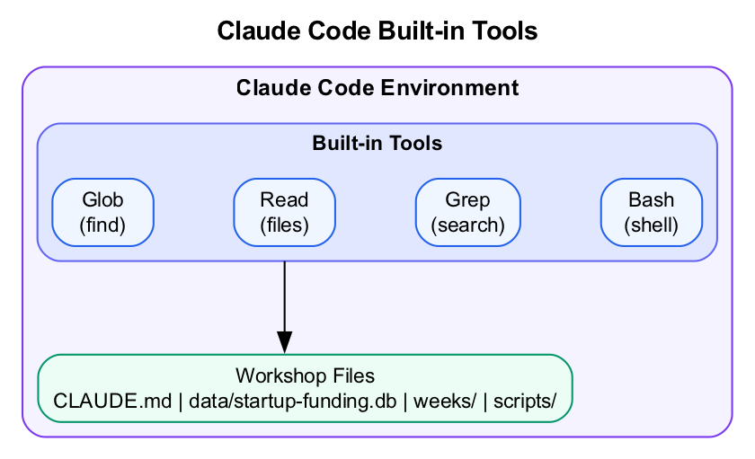
Diagram
What we’re building: Familiarity with Claude Code’s built-in tools and your personalized project context.

Prerequisites
Before starting this lab, verify you have completed Lab 1:
- Claude Code installed and authenticated
- Workshop repository cloned
- Test query “What files are in this repository?” works

Lab Overview (Outcomes)
By the end of this lab, you will:
- Understand the repository structure
- Use built-in tools (Glob, Read, Grep, Bash)
- Customize CLAUDE.md with your project context
- Explore the startup funding database

Time Breakdown
Task | Topic | Time
2.1 | Explore the Repo Structure | 5 min
2.2 | Explore Built-in Tools | 15 min
2.3 | Customize Your CLAUDE.md | 15 min
2.4 | Data Exploration Preview | 10 min
 | TOTAL | 45 min

Task 2.1: Explore the Repo Structure (5 min)
- Ask Claude to explain the repository:
- > Explain the structure of this repository and what each folder is for.
- Observe:
  - Which tools does Claude use? (Look for Read, Glob, Grep)
  - Does Claude read the CLAUDE.md file?
  - Is the explanation accurate?
- Expected: Claude correctly describes the workshop structure using context from CLAUDE.md.

Task 2.2: Explore Built-in Tools (15 min)
Try each of these commands and observe which tools Claude uses:
- File finding with Glob:
- > Find all markdown files in this repo
- Reading files:
- > Read the CLAUDE.md file and summarize what it says
- Searching content with Grep:
- > Search for any files that mention "revenue" or "customer"
- Listing folder contents:
- > What files are in the data folder?
- Running commands with Bash:
- > Show me the current git status
Record your observations:
Query | Tool(s) Used | Result
Find markdown files
Read CLAUDE.md
Search for “revenue”
List data folder
Git status

Task 2.3: Customize Your CLAUDE.md (15 min)
The CLAUDE.md file provides context that Claude uses in every conversation.
- Open CLAUDE.md in your editor:
- code CLAUDE.md
# or: vim CLAUDE.md
# or: nano CLAUDE.md
- Add a section for your project context:
- ## My Project Context
I'm building agents for [data analytics / GTM / sales / other].
My focus area: [describe your use case in 1-2 sentences]
Key metrics I care about:
- [metric 1]
- [metric 2]
- [metric 3]
Domain expertise I want to encode:
- [expertise area 1]
- [expertise area 2]
- Save the file.
- Test that Claude uses your context:
- > Based on my project context, what kind of agent would be most useful for me?
- Expected: Claude’s response should reference the specific details you added to CLAUDE.md.

Task 2.4: Data Exploration Preview (10 min)
The workshop includes startup-funding.db, a SQLite database with venture capital data. We’ll use this throughout the course.
- Ask Claude to explore the database:
- > Look at data/startup-funding.db. Tell me:
> 1. What tables exist
> 2. How many rows in each table
> 3. What the columns represent
> 4. Any observations about the data
- Observe how Claude:
  - Uses Bash to run SQLite commands
  - Explores the schema
  - Summarizes findings
- Try a specific query:
- > Which AI coding tool companies are in the database? List their funding rounds.
This previews the data analysis workflows we’ll build in Week 2.

Troubleshooting

Query Issues
Problem | Solution
Claude doesn’t find files | Check you’re in the right directory with pwd
“No such file” errors | Verify repo cloned correctly with ls -la
Database queries fail | Ensure sqlite3 is installed: which sqlite3

CLAUDE.md Issues
Problem | Solution
Changes not reflected | Start a new Claude session or run /clear
File not being read | Ensure you’re in the repo root directory

Final Checklist
Before leaving this lab, verify:
- Tools functional - Tested Glob, Read, Grep, and Bash
- CLAUDE.md customized - Added your project context
- Context working - Claude references your project details
- Database accessible - Claude can query startup-funding.db
- Model confirmed - Run /model to see which model is active
Bonus (if time permits):
- Changed model with /model sonnet or /model opus
- Explored additional Claude Code commands with /help

Next Steps
Homework before Week 2:
Write a 1-paragraph description of an agent you want to build. Requirements: - Must involve a repeatable workflow you want to automate - Must be something useful to you (real or realistic) - Must be achievable in 7 weeks of incremental building
Submit to the facilitator before Week 2.
Week 2 Preview: Tool Calling - How Claude decides which tools to use, tool schemas, and building custom tools.

End of Lab 2

