Week 2 Lab 1: Exploring the Startup Funding Database
Course: Claude Agents Workshop
Duration: 45 minutes
Focus: Schema discovery, SQL queries, and trend analysis with Claude’s tool calling

Lab Architecture
This lab demonstrates Claude’s tool calling loop with database queries.
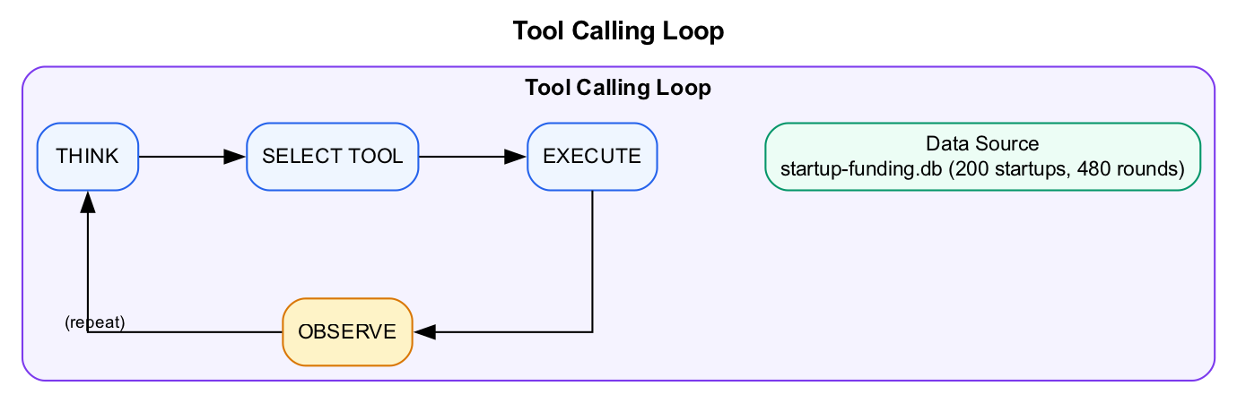
Diagram
What we’re building: Mastery of natural language to SQL queries using Claude’s Bash tool.

Prerequisites
Before starting this lab, verify:
- Week 1 complete - Claude Code installed and authenticated
- Workshop repo cloned - Access to data/startup-funding.db
- Claude Code running - Start with claude in the repo directory
Familiarity helpful but not required: - Basic SQL (SELECT, WHERE, GROUP BY) - Understanding of startup funding stages (Seed, Series A, B, C)

Lab Overview (Outcomes)
By the end of this lab, you will:
- Understand the startup funding database schema
- Translate business questions into SQL queries
- Analyze funding trends over time
- Identify top investors and their patterns
- Make data-backed predictions about companies

Time Breakdown
Task | Topic | Time
1.1 | Schema Discovery | 5 min
1.2 | Basic Aggregations | 10 min
1.3 | Trend Analysis | 15 min
1.4 | Investor Analysis | 10 min
1.5 | Analytical Question | 5 min
 | TOTAL | 45 min

About the Dataset
The workshop includes data/startup-funding.db, a SQLite database with: - 200 startups across AI/ML, Fintech, Healthcare, Developer Tools, and more - 66 investors including Y Combinator, Sequoia, a16z - ~480 funding rounds from Pre-Seed through Series C (2018-2025) - Growth metrics for ~50 startups

Task 1.1: Schema Discovery (5 min)
Start by understanding what data is available.
- Ask Claude to explore the database structure:
- > What tables are in the startup-funding.db database? Show me the schema for each.
- Expected behavior:
  - Claude uses Bash with sqlite3
  - Runs .tables and .schema commands
  - Lists all tables and their columns
- Record what you find:
Table | Key Columns | Row Count
startups
funding_rounds
investors

Task 1.2: Basic Aggregations (10 min)
Practice translating business questions into SQL queries.
- Ask Claude to answer these questions:
- > From startup-funding.db, answer these questions:
> 1. How many funding rounds happened each year? Break down by stage.
> 2. What's the total funding amount by industry?
> 3. Which stage has the highest average deal size?
- Watch how Claude:
  - Thinks about which query to write
  - Uses GROUP BY and aggregation functions
  - Formats output for readability
- Example SQL patterns Claude might use:
- -- Rounds by year and stage
SELECT strftime('%Y', funding_date) as year, stage, COUNT(*)
FROM funding_rounds
GROUP BY year, stage
ORDER BY year, stage;
-- Total funding by industry
SELECT s.industry, printf('$%.1fM', SUM(fr.amount_usd)/1000000.0)
FROM funding_rounds fr
JOIN startups s ON fr.startup_id = s.id
GROUP BY s.industry
ORDER BY SUM(fr.amount_usd) DESC;
- Record your findings:
Question | Key Finding
Rounds by year/stage
Total by industry
Highest avg deal size

Task 1.3: Trend Analysis (15 min)
Dive deeper with time-series analysis.
- Run this analysis prompt:
- > Analyze monthly funding trends for AI/ML companies from 2023 onwards.
> Show me:
> - Deal count per month
> - Total funding per month
> - Average deal size per month
> Format as a table sorted by month.
- The SQL pattern for this:
- SELECT
strftime('%Y-%m', funding_date) as month,
COUNT(*) as deal_count,
printf('$%.1fM', SUM(amount_usd)/1000000.0) as total_funding,
printf('$%.1fM', AVG(amount_usd)/1000000.0) as avg_deal_size
FROM funding_rounds fr
JOIN startups s ON fr.startup_id = s.id
WHERE s.industry = 'AI/ML'
AND funding_date >= '2023-01-01'
GROUP BY month
ORDER BY month DESC;
- Analysis questions to consider:
  - Is funding increasing or decreasing over time?
  - Are deal sizes getting larger or smaller?
  - Are there seasonal patterns?

Task 1.4: Investor Analysis (10 min)
Understand who the key players are.
- Ask Claude:
- > Who are the top 15 investors by portfolio size?
> For each, show:
> - Number of portfolio companies
> - Total investments (count of rounds)
> - Follow-on rate (avg rounds per company)
> Only include investors with at least 3 portfolio companies.
- The SQL pattern:
- SELECT
i.name as investor,
i.type,
COUNT(DISTINCT fr.startup_id) as portfolio_companies,
COUNT(*) as total_investments,
ROUND(COUNT(*) * 1.0 / COUNT(DISTINCT fr.startup_id), 2) as follow_on_rate
FROM investors i
JOIN funding_rounds fr ON fr.lead_investor_id = i.id
GROUP BY i.id
HAVING portfolio_companies >= 3
ORDER BY portfolio_companies DESC
LIMIT 15;
- Key insight: Follow-on rate indicates investor conviction. Higher = more committed to portfolio companies.

Task 1.5: Analytical Question (5 min)
Apply the full Data Analysis Loop.
- Ask Claude this prediction question:
- > Which AI coding tools raised Series A in 2024-2025?
> Rank them by likelihood of getting Series B based on:
> - Funding amount vs. industry median
> - Time since founding to Series A
> - Investor track record (has the lead investor backed other Series B+ companies?)
> Give me your prediction with supporting evidence.
- This combines all four phases:
  - Monitor: Query current state of AI coding tool funding
  - Explore: Dig into factors that predict Series B success
  - Craft: Build a thesis with supporting data
  - Impact: Make a concrete prediction
- Record Claude’s prediction:
Company | Series A Amount | Lead Investor | Prediction | Confidence

Troubleshooting

SQL Query Issues
Problem | Solution
Syntax error | Check quote escaping, SQLite uses single quotes for strings
No results | Verify table and column names match schema
Date filtering issues | Use format 'YYYY-MM-DD' for dates
NULL handling | Use COALESCE(column, 0) or IFNULL(column, 0)

Common SQL Patterns
-- Format currency
printf('$%.1fM', amount/1000000.0)
-- Extract year from date
strftime('%Y', funding_date)
-- Count distinct
COUNT(DISTINCT startup_id)
-- Conditional aggregation
SUM(CASE WHEN stage = 'Series A' THEN 1 ELSE 0 END)
-- Window function for ranking
RANK() OVER (PARTITION BY industry ORDER BY amount DESC)

Final Checklist
Before proceeding to Lab 2, verify:
- Schema explored - Know the tables and relationships in startup-funding.db
- Basic queries run - Aggregations by year, industry, stage
- Trend analysis complete - Monthly funding patterns analyzed
- Investor analysis done - Top investors identified with follow-on rates
- Prediction made - Ranked AI coding tools by Series B likelihood
Record your key findings:
Metric | Your Finding
Most active funding year
Top industry by total funding
Top investor by portfolio size
AI coding tool most likely to raise Series B

End of Lab 1

