Week 3 Lab 2: Combined Multi-Source Workflow
Course: Claude Agents Workshop
Duration: 30 minutes
Focus: Combining the startup funding database with external MCP services

Lab Architecture
This lab combines multiple data sources for comprehensive analysis.
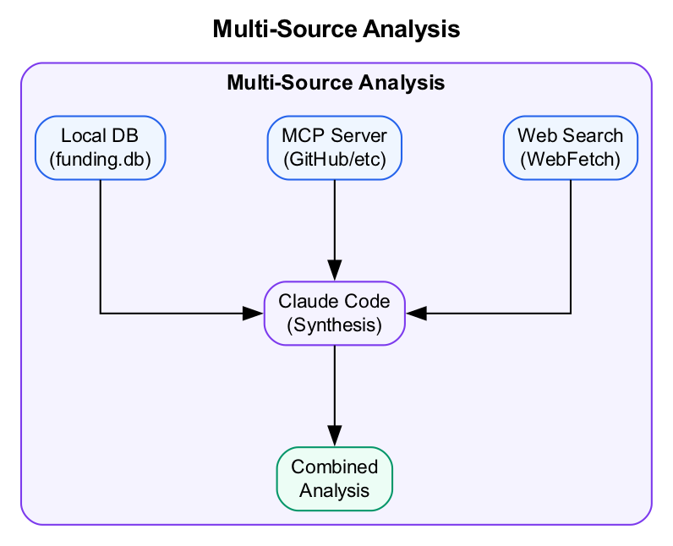
Diagram
What we’re building: A multi-source research workflow that combines structured data with external context.

Prerequisites
Before starting this lab, verify:
- Lab 1 complete - At least 1 MCP server connected
- Access to startup-funding.db - Local database available
- MCP connection verified - /mcp shows connected servers

Lab Overview (Outcomes)
By the end of this lab, you will:
- Combine database queries with web research
- Enrich funding data with GitHub insights (if connected)
- Apply the Data Analysis Loop with multiple sources
- Create a comparison table from multiple data sources

Time Breakdown
Task | Topic | Time
2.1 | Funding + Web Research | 10 min
2.2 | Funding + GitHub (optional) | 10 min
2.3 | Data-Driven Research | 10 min
 | TOTAL | 30 min

Task 2.1: Funding + Web Research (10 min)
Using both the local database and web search:
- Run this combined analysis:
- > Find AI coding tool companies in the funding database.
> Then research each company's current product and recent news.
> Create a comparison table with: Company, Total Funding, Latest Stage, Product Focus, Recent News
- Observe how Claude:
  - Queries the local SQLite database
  - Uses WebSearch for each company
  - Synthesizes information from multiple sources
- Record your comparison table:
Company | Total Funding | Latest Stage | Product Focus | Recent News

Task 2.2: Funding + GitHub (if connected) (10 min)
If you connected GitHub MCP in Lab 1:
- Run this analysis:
- > Which AI coding tools in our database have public GitHub repos?
> Compare their GitHub stars to their funding amounts.
> Is there a correlation between community popularity and funding?
- Record findings:
Company | GitHub Stars | Total Funding | Ratio
If you didn’t connect GitHub: Skip to Task 2.3, or use web search to find GitHub stats manually.

Task 2.3: Data-Driven Research (10 min)
Apply the full Data Analysis Loop with multiple sources:
- Run this comprehensive analysis:
- > I want to understand the Series A landscape for AI startups.
> 1. Query the database for all AI/ML Series A rounds in 2024
> 2. Calculate the median round size and time from founding to Series A
> 3. Research 2-3 of these companies online to understand what made them fundable
> 4. Summarize patterns you see
- Record the patterns:
Pattern | Evidence | Source
 |  | Database
 |  | Web research

Troubleshooting

Multi-Source Query Issues
Problem | Solution
Queries take too long | Break into smaller steps, query one source at a time
MCP disconnected mid-query | Reconnect with claude mcp add, then retry
Web search returns old info | Add year to search query (e.g., “Cursor funding 2024”)

Data Synthesis Issues
Problem | Solution
Conflicting information | Note the source, ask Claude to reconcile
Missing data | Try alternative sources or note as “N/A”
Too much data | Use LIMIT, focus on top results

Final Checklist
Before completing this lab, verify:
- Combined multiple sources - Used database + web or database + MCP
- Created comparison table - Multi-source data synthesized
- Documented findings - Recorded patterns with evidence
- Applied Data Analysis Loop - Monitor, Explore, Craft, Impact
Record your key insight:
What’s the most interesting finding from combining multiple data sources?
_______________________________________________________________
_______________________________________________________________

Reference: Context Management for Data
When working with databases or large datasets through MCP:

Query Strategically
- Always use LIMIT for exploration:
- SELECT * FROM funding_rounds LIMIT 100;
- Aggregate first, then drill down:
- -- Start with aggregates
SELECT industry, COUNT(*) FROM startups GROUP BY industry;
-- Then drill into specifics
SELECT * FROM startups WHERE industry = 'AI/ML' LIMIT 50;
- Be specific about what you need:
- -- Bad: grab everything
SELECT * FROM funding_rounds;
-- Good: specific columns, filtered, limited
SELECT name, stage, amount_usd
FROM funding_rounds fr
JOIN startups s ON fr.startup_id = s.id
WHERE fr.stage = 'Series A'
ORDER BY fr.amount_usd DESC
LIMIT 20;

Context Management by Phase
Phase | Strategy
Monitor | Run aggregation queries first (safe, bounded)
Explore | Drill down with LIMIT, explore segments one at a time
Craft | Work with summarized insights, not raw data
Impact | Present recommendations, not data dumps

End of Lab 2

