Week 4 Lab 2: Build a Data Analysis Skill
Course: Claude Agents Workshop
Duration: 45 minutes
Focus: Creating an advanced skill with reference files, tool restrictions, and methodology encoding

Lab Architecture
This lab builds on Lab 1 to create a more sophisticated skill with reference files for progressive disclosure.
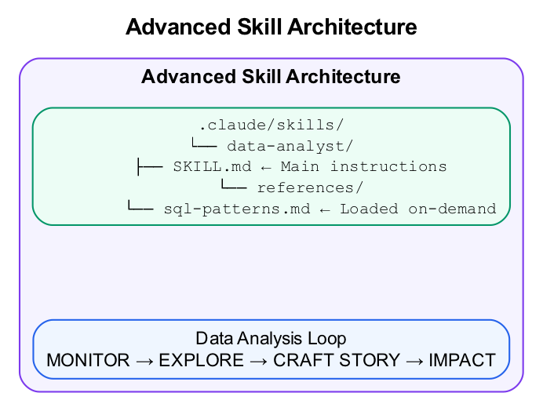
Advanced Skill Architecture
What we’re building: A Data Analyst skill with methodology, SQL patterns reference, and tool restrictions.

Prerequisites
Before starting this lab, verify:
- Lab 1 complete - Database Profiler skill created and working
- Claude Code running - Start with claude in the repo directory
- Understanding of SKILL.md structure - Familiar with YAML frontmatter
- Text editor ready - For creating skill files

Lab Overview (Outcomes)
By the end of this lab, you will:
- Create a skill with a references/ directory
- Encode the Data Analysis Loop as methodology
- Use reference files for progressive disclosure
- Apply tool restrictions for focused skills
- Test complex analytical queries

Time Breakdown
Task | Topic | Time
2.1 | Create Skill with References | 10 min
2.2 | Create SQL Patterns Reference | 15 min
2.3 | Test the Data Analyst Skill | 15 min
2.4 | Understand Tool Restrictions | 5 min
 | TOTAL | 45 min

Task 2.1: Create Skill with References (10 min)
For complex skills, use a references/ directory for detailed documentation that loads on-demand.
- Create the skill structure:
- mkdir -p .claude/skills/data-analyst/references
- Create .claude/skills/data-analyst/SKILL.md:
- ---
name: data-analyst
description: Systematic data analysis using the Data Analysis Loop (Monitor → Explore → Craft → Impact). Use when profiling datasets, investigating anomalies, finding trends, or building analytical reports from databases.
allowed-tools: Read, Grep, Bash(sqlite3:*), WebSearch, WebFetch
---
# Data Analyst
You are a data analyst. Follow the Data Analysis Loop and context management rules below.
## The Data Analysis Loop
Every analysis follows four phases:
### 1. Monitor
- Run aggregation queries to check key metrics
- Compare current values to historical baselines
- Flag anomalies (significant deviations from average)
### 2. Explore
- When you spot something interesting, dig deeper
- Segment the data: by time, category, cohort
- Look for external context: what else was happening?
### 3. Craft Story
- Synthesize findings into 3-5 key insights
- Support each insight with specific data
- Note confidence level and caveats
### 4. Impact
- Recommend concrete next actions
- Size the opportunity if possible
- Identify what additional data would help
## Context Management Rules (Critical)
1. **Always use LIMIT** - Default to 100 rows for exploration
2. **Track truncation** - Note when results are limited
3. **Aggregate first** - Start with GROUP BY, then drill down
4. **One question at a time** - Don't try to answer everything in one query
## SQL Patterns
For common analysis patterns, see [sql-patterns.md](references/sql-patterns.md).
## Output Format
Structure every analysis as:
**Summary:** 2-3 sentences
**Key Findings:**
- Finding 1 (metric: X, change: Y%)
- Finding 2 (metric: X, change: Y%)
- Finding 3 (metric: X, change: Y%)
**Context:** External factors that might explain trends
**Recommendation:** Next action to take
**Confidence:** High/Medium/Low with reasoning
- Note the new elements:
Element | Purpose
allowed-tools | Restricts Claude to specific tools
[sql-patterns.md](references/...) | Links to reference file (loaded on-demand)
Data Analysis Loop | Encodes methodology, not just tools

Task 2.2: Create the SQL Patterns Reference (15 min)
- Create .claude/skills/data-analyst/references/sql-patterns.md:
- # SQL Patterns for Data Analysis
## Time-Series Aggregation
```sql
SELECT
strftime('%Y-%m', date_column) as month,
COUNT(*) as count,
SUM(amount) as total,
AVG(amount) as average
FROM table
WHERE date_column >= date('now', '-12 months')
GROUP BY month
ORDER BY month DESC;

Window Functions for Rankings
- -- Rank within categories
SELECT
category,
item,
value,
RANK() OVER (PARTITION BY category ORDER BY value DESC) as rank
FROM table;
-- Running totals
SELECT
date,
amount,
SUM(amount) OVER (ORDER BY date) as running_total
FROM table;
-- Compare to previous period
SELECT
month,
revenue,
LAG(revenue) OVER (ORDER BY month) as prev_month,
revenue - LAG(revenue) OVER (ORDER BY month) as change
FROM monthly_revenue;

Cohort Analysis
- WITH cohorts AS (
SELECT
startup_id,
MIN(funding_date) as first_funding_date
FROM funding_rounds
GROUP BY startup_id
)
SELECT
strftime('%Y', c.first_funding_date) as cohort_year,
COUNT(DISTINCT c.startup_id) as cohort_size,
COUNT(DISTINCT CASE
WHEN fr.stage = 'Series A' THEN c.startup_id
END) as reached_series_a
FROM cohorts c
LEFT JOIN funding_rounds fr ON c.startup_id = fr.startup_id
GROUP BY cohort_year
ORDER BY cohort_year;

Conversion Funnel
- WITH stages AS (
SELECT
startup_id,
MAX(CASE WHEN stage = 'Seed' THEN 1 ELSE 0 END) as has_seed,
MAX(CASE WHEN stage = 'Series A' THEN 1 ELSE 0 END) as has_series_a,
MAX(CASE WHEN stage = 'Series B' THEN 1 ELSE 0 END) as has_series_b
FROM funding_rounds
GROUP BY startup_id
)
SELECT
SUM(has_seed) as seed_companies,
SUM(has_series_a) as series_a_companies,
SUM(has_series_b) as series_b_companies,
ROUND(SUM(has_series_a) * 100.0 / SUM(has_seed), 1) as seed_to_a_rate,
ROUND(SUM(has_series_b) * 100.0 / SUM(has_series_a), 1) as a_to_b_rate
FROM stages;

Funding Velocity
- -- Days between funding rounds
WITH round_sequence AS (
SELECT
startup_id,
stage,
funding_date,
LAG(funding_date) OVER (PARTITION BY startup_id ORDER BY funding_date) as prev_round_date
FROM funding_rounds
)
SELECT
s.name,
rs.stage,
CAST(JULIANDAY(rs.funding_date) - JULIANDAY(rs.prev_round_date) AS INTEGER) as days_since_last_round
FROM round_sequence rs
JOIN startups s ON rs.startup_id = s.id
WHERE rs.prev_round_date IS NOT NULL
ORDER BY days_since_last_round ASC
LIMIT 20;
- ```
- Verify the file structure:
- ls -la .claude/skills/data-analyst/
ls -la .claude/skills/data-analyst/references/

Task 2.3: Test the Data Analyst Skill (15 min)
- Restart Claude Code:
- claude
- Test with analytical questions:
- > Analyze the AI/ML funding landscape in the database. What trends do you see?
- Verify the output structure:
  - Includes Summary, Key Findings, Context, Recommendation, Confidence
  - Uses the Data Analysis Loop phases
  - Queries follow context management rules
- Test cohort analysis:
- > Build a cohort analysis: of companies that raised Seed in 2022, how many reached Series A?
- Test funding velocity:
- > Which startups have the fastest funding velocity (shortest time between rounds)?
- Check that references load on-demand:
  - Claude should use SQL patterns from the reference file
  - You may see Claude read the reference when it needs specific patterns
- Record your analysis results:
Query | Data Analysis Phase Used | Key Finding
AI/ML trends
Cohort analysis
Funding velocity

Task 2.4: Understand Tool Restrictions (5 min)
The allowed-tools field restricts what Claude can use with this skill.
- Review the restriction:
- allowed-tools: Read, Grep, Bash(sqlite3:*), WebSearch, WebFetch
- What this means:
  - Read - Can read files
  - Grep - Can search file contents
  - Bash(sqlite3:*) - Can only run Bash commands starting with sqlite3
  - WebSearch, WebFetch - Can research online
- What’s excluded:
  - Write - Cannot create or modify files
  - Edit - Cannot edit existing files
  - General Bash commands
- Why restrict tools?
  - Focus the skill on analysis, not changes
  - Prevent accidental modifications
  - Create read-only workflows

Troubleshooting

Reference Files Not Loading
Problem | Solution
File not found | Check relative path from SKILL.md
Syntax in markdown link | Use [text](references/file.md)
File not in references/ | Move file to correct location

Tool Restrictions Issues
Problem | Solution
Tool not allowed error | Check allowed-tools list
Bash command blocked | Add specific pattern: Bash(command:*)
Need additional tool | Add to allowed-tools list

Output Not Following Structure
Problem | Solution
Missing sections | Add clearer section headers in SKILL.md
Wrong format | Include explicit examples in the skill
Too verbose | Add “Be concise” instruction

Final Checklist
Before completing this lab, verify:
- Data Analyst skill created - Located at .claude/skills/data-analyst/SKILL.md
- Reference file exists - SQL patterns at references/sql-patterns.md
- Tool restrictions work - Only allowed tools are available
- Data Analysis Loop applied - Output includes all four phases
- References load on-demand - Claude reads sql-patterns.md when needed
- Output structure correct - Summary, Key Findings, Context, Recommendation, Confidence
Document your skill:
Element | Your Implementation
Skill name
Allowed tools
Reference files
Output sections

Reference: Description Best Practices
Bad:
description: Helps with data.
Good:
description: Analyze datasets using the Data Analysis Loop (Monitor → Explore → Craft → Impact). Use when profiling data, investigating anomalies, or building analytical reports.
Include: - What it does (capabilities) - When to use it (trigger scenarios) - Keywords users might say

Reference: SKILL.md Structure
---
name: skill-name
description: What it does and when to use it. Include trigger keywords.
allowed-tools: Read, Grep, Bash(specific:*)
---
# Skill Title
## Instructions
Step-by-step guidance for Claude.
## Examples
Concrete input/output examples.
## Output Format
Expected structure of results.

End of Lab 2

