Week 5 Lab 1: Using Built-in Sub-agents
Course: Claude Agents Workshop
Duration: 30 minutes
Focus: Understanding and using built-in sub-agents for codebase exploration and parallel execution

Lab Architecture
This lab demonstrates how sub-agents enable complex workflows by isolating context and parallelizing work.
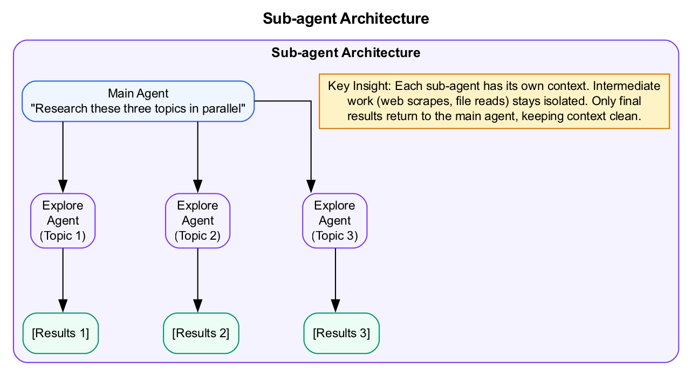
Sub-agent Architecture
What we’re building: Familiarity with built-in sub-agents and creating your first custom agent.

Prerequisites
Before starting this lab, verify:
- Week 4 complete - Comfortable creating Agent Skills
- Claude Code running - Start with claude in the repo directory
- Repository cloned - Access to workshop codebase
Understanding helpful but not required: - How the Task tool spawns sub-agents - Difference between built-in agents (Explore, Plan, Bash) and custom agents

Lab Overview (Outcomes)
By the end of this lab, you will:
- Understand how sub-agents provide context isolation
- Use built-in sub-agents for codebase exploration
- Observe parallel sub-agent execution
- Create your first custom agent definition

Time Breakdown
Task | Topic | Time
1.1 | Explore with Built-in Agents | 10 min
1.2 | Create Your First Custom Agent | 15 min
1.3 | Test Your Custom Agent | 5 min
 | TOTAL | 30 min

Understanding Sub-agents
Sub-agents are separate agent instances that handle focused subtasks. They: - Run in isolated context (their intermediate work doesn’t pollute main agent) - Can use different models (Haiku for speed, Opus for complexity) - Return only final results to the parent agent - Cannot spawn their own sub-agents (single level only)

Task 1.1: Explore with Built-in Agents (10 min)
Claude Code has built-in agents optimized for common tasks.
- Ask a broad exploration question:
- > How does the authentication system work in this codebase?
- Watch Claude spawn an Explore agent:
  - Notice it uses Haiku for speed
  - Observe read-only tools (Glob, Grep, Read)
  - See how it searches methodically
- Request parallel exploration:
- > I need to understand three things in parallel:
> 1. How data validation works
> 2. How errors are handled
> 3. How logging is configured
- Observe parallel execution:
  - Multiple sub-agents spawn simultaneously
  - Each searches independently
  - Results compile at the end
- Record your observations:
Agent Type | Model Used | Tools Available | Time Taken
Explore

Task 1.2: Create Your First Custom Agent (15 min)
Custom agents let you define specialized workers with specific instructions and tools.
- Create the agents directory:
- mkdir -p .claude/agents
- Create .claude/agents/company-researcher.md:
- ---
name: company-researcher
description: Research a company for sales preparation. Use when preparing for sales calls or evaluating prospects.
model: haiku
tools: ["Read", "WebSearch", "WebFetch"]
---
# Company Researcher
Research the target company and provide a concise briefing:
1. **Company Overview** - What they do, size, industry
2. **Recent News** - Last 3 months of relevant news
3. **Key People** - Leadership team and decision makers
4. **Potential Pain Points** - Based on their industry and size
Keep the briefing under 500 words. Focus on actionable intelligence for a sales conversation.
- Understand the configuration:
Field | Value | Purpose
name | company-researcher | Identifier for invocation
description | Research a company… | Triggers automatic detection
model | haiku | Fast model for research
tools | Read, WebSearch, WebFetch | Limited to research tools
- Restart Claude Code to pick up the new agent:
- claude

Task 1.3: Test Your Custom Agent (5 min)
- Invoke the agent explicitly:
- > Use company-researcher to research Stripe
- Verify the agent is discovered:
  - Claude should ask permission to use company-researcher
  - Output should follow the four-section structure
  - Research should be concise (under 500 words)
- Try implicit invocation:
- > I'm preparing for a sales call with Figma tomorrow. What should I know?
- The description includes “sales preparation” so it should trigger.
- Record your results:
Request | Agent Triggered? | Output Quality
“Use company-researcher to research Stripe”
“Preparing for a sales call with Figma”

Troubleshooting

Agent Not Found
Problem | Solution
Agent not discovered | Check .claude/agents/ directory exists
Missing .md extension | Agent files must end in .md
YAML syntax error | Validate frontmatter (use spaces, not tabs)

Agent Not Triggering
Problem | Solution
Description doesn’t match | Add more trigger keywords to description
Agent too specific | Broaden the “when to use” section
Forgot to restart | Restart Claude Code after adding agents

Sub-agent Issues
Problem | Solution
Results not returning | Sub-agent may have errored; check output
Slow execution | Use parallel execution for independent tasks
Context overflow | Break into smaller, focused agents
MCP tools not working | Background sub-agents can’t access MCP; use foreground

Final Checklist
Before completing this lab, verify:
- Built-in agents explored - Used Explore agent for codebase questions
- Parallel execution observed - Multiple sub-agents ran simultaneously
- Agents directory created - .claude/agents/ exists
- Custom agent created - company-researcher.md works correctly
- Agent triggers correctly - Matches on relevant requests
Document your observations:
Element | Your Finding
Built-in agent model
Parallel tasks completed
Custom agent trigger phrases

Reference: Built-in Agent Types
Agent Type | Model | Tools | Best For
Explore | Haiku | Glob, Grep, Read | Quick searches, finding files
Plan | Inherited | All except Edit/Write | Architecture planning
Bash | Inherited | Bash only | Git, scripts, commands
general-purpose | Inherited | All tools | Complex multi-step work

Reference: Agent Configuration Fields
Field | Required | Description
name | Yes | Lowercase, hyphens only
description | Yes | What + when (triggers auto-detection)
model | No | haiku, sonnet, or opus
tools | No | Array of allowed tools
permissionMode | No | default, acceptEdits, bypassPermissions

End of Lab 1

