Week 5 Lab 2: Build a GTM Pipeline
Course: Claude Agents Workshop
Duration: 45 minutes (+ optional bonus)
Focus: Building a multi-agent GTM pipeline with specialized agents and orchestration

Lab Architecture
This lab builds a complete multi-agent pipeline for lead processing.
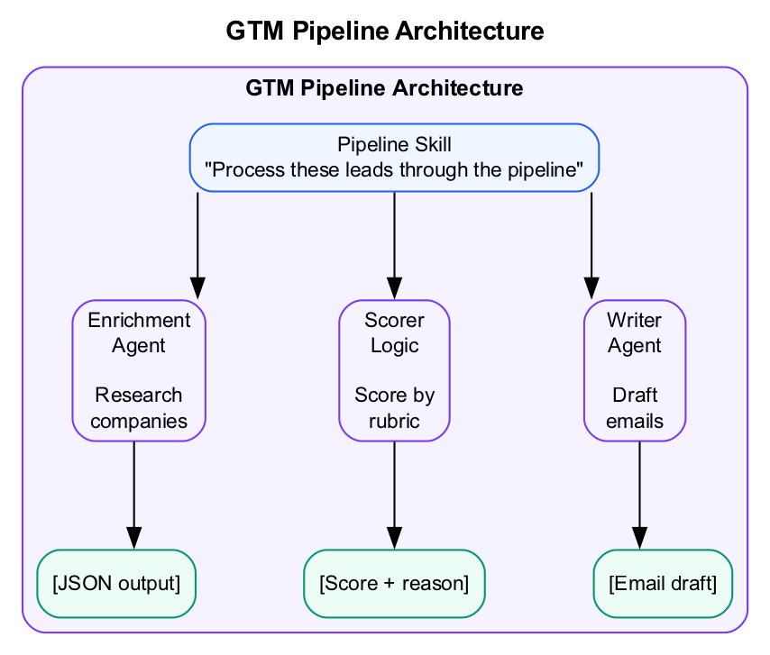
GTM Pipeline Architecture
What we’re building: A multi-agent GTM pipeline that enriches leads, scores them, and drafts personalized outreach.

Prerequisites
Before starting this lab, verify:
- Lab 1 complete - Custom agent created and tested
- Claude Code running - Start with claude in the repo directory
- Repository cloned - Access to data/startup-funding.db
- Agents directory exists - .claude/agents/ created in Lab 1

Lab Overview (Outcomes)
By the end of this lab, you will:
- Create specialized agents for lead enrichment and email drafting
- Design a pipeline skill that orchestrates multiple agents
- Run the full pipeline with real data
- Evaluate and iterate on pipeline quality

Time Breakdown
Task | Topic | Time
2.1 | Create Specialized Agents | 15 min
2.2 | Design the Pipeline Skill | 15 min
2.3 | Test the Pipeline | 10 min
2.4 | Iterate and Improve | 5 min
 | TOTAL | 45 min

Task 2.1: Create Specialized Agents (15 min)
Build the agents that will power your pipeline.
- Create .claude/agents/lead-enricher.md:
- ---
name: lead-enricher
description: Enrich a lead with company research. Use when you need firmographic data about a company.
model: haiku
tools: ["Read", "WebSearch", "WebFetch"]
---
# Lead Enricher
Research the company and provide:
1. **Company Size** - Employee count, revenue if public
2. **Industry** - Primary industry and sub-vertical
3. **Recent News** - Funding, product launches, leadership changes
4. **Key People** - Decision makers relevant to our product
5. **Tech Stack** - Known technologies they use
Output as structured JSON:
```json
{
"company": "...",
"size": "...",
"industry": "...",
"news": ["..."],
"key_people": ["..."],
"tech_stack": ["..."]
}
- ```
- Create .claude/agents/email-drafter.md:
- ---
name: email-drafter
description: Draft personalized outreach emails based on lead data. Use when you have enriched lead info and need to create outreach.
model: sonnet
tools: ["Read", "Write"]
---
# Email Drafter
Write a short, personalized outreach email:
1. Reference something specific about their company (from research)
2. Connect to a pain point relevant to their industry/size
3. Clear, low-friction call to action
4. Under 100 words
Be conversational, not salesy. No generic openers like "I hope this email finds you well."
- Note the different models:
Agent | Model | Why
lead-enricher | haiku | Fast research, data gathering
email-drafter | sonnet | Better writing quality needed

Task 2.2: Design the Pipeline Skill (15 min)
Create a skill that orchestrates the agents.
- Create the skill directory:
- mkdir -p .claude/skills/lead-pipeline
- Create .claude/skills/lead-pipeline/SKILL.md:
- ---
name: lead-pipeline
description: Process leads through enrichment, scoring, and email drafting. Use when processing a batch of leads or running the full GTM pipeline.
---
# Lead Processing Pipeline
This skill orchestrates multiple specialized agents to process leads.
## Pipeline Stages
### Stage 1: Enrichment
For each lead, research the company:
- Company size and industry
- Recent news and announcements
- Key decision makers
- Technology stack (if B2B tech)
Use the lead-enricher agent for each company.
### Stage 2: Scoring
Score each enriched lead based on:
- Company size (larger = higher score)
- Industry fit (AI/ML, Developer Tools = higher)
- Funding stage (Series A-C = higher)
- Recent activity (news, growth signals)
Score from 0-100. Only proceed with leads scoring 60+.
### Stage 3: Email Drafting
For leads scoring 60+, use the email-drafter agent to create personalized outreach:
- Reference specific company details
- Address likely pain points
- Clear call to action
## Execution
Process leads sequentially or in small batches (3-5) to manage context.
## Output Format
| Lead | Company | Enrichment Summary | Score | Email Draft |
|------|---------|-------------------|-------|-------------|
| ... | ... | ... | ... | ... |
Save detailed results to `output/pipeline-results.json`

Task 2.3: Test the Pipeline (10 min)
- Restart Claude Code:
- claude
- Run the pipeline with database data:
- > Query the funding database for AI startups that raised Series A in 2024.
> Pick the top 3 by funding amount and run them through the lead pipeline.
- Watch the pipeline execute:
  - Database query for candidates
  - Sub-agents spawn for enrichment
  - Scoring applied to each lead
  - Emails drafted for qualifying leads
- Record the pipeline results:
Company | Enrichment Found | Score | Email Drafted?

Task 2.4: Iterate and Improve (5 min)
Based on your results, identify improvements:
- Check enrichment quality:
  - Did the agent find accurate company info?
  - Were there gaps in the research?
- Review scoring logic:
  - Are the criteria appropriate for your use case?
  - Should weights be adjusted?
- Evaluate email drafts:
  - Are they personalized enough?
  - Is the tone right?
  - Is the CTA clear?
- Document one improvement you would make:
Issue | Proposed Change

Troubleshooting

Pipeline Issues
Problem | Solution
Too many API calls | Batch similar tasks (e.g., enrich 3-5 leads at once)
Inconsistent output | Add explicit output format to agent instructions
Missing data | Check agent has required tools (WebSearch for research)

Agent Coordination Issues
Problem | Solution
Agents not chaining | Ensure skill explicitly references agents by name
Output format mismatch | Standardize JSON schemas across agents
Scoring inconsistent | Add explicit examples to scoring criteria

Final Checklist
Before completing this lab, verify:
- Pipeline agents created - lead-enricher and email-drafter defined
- Pipeline skill created - lead-pipeline orchestrates the workflow
- Pipeline tested - Processed 3+ leads through full pipeline
- Results documented - Recorded enrichment, scores, and emails
- Improvement identified - Documented one enhancement
Document your agent stack:
Agent | Model | Tools | Purpose
lead-enricher
email-drafter

Reference: Task Tool Parameters
Parameter | Required | Description
prompt | Yes | Task for the sub-agent
description | Yes | Short summary (3-5 words)
subagent_type | Yes | Which agent type to use
model | No | Override model
run_in_background | No | Run asynchronously
resume | No | Continue from previous execution

End of Lab 2

