Week 6 Lab 1: Your First SDK Agent
Course: Claude Agents Workshop
Duration: 30 minutes
Focus: Setting up the Agent SDK and building a Database Analyzer agent

Lab Architecture
This lab demonstrates how to run Claude agents programmatically using the Agent SDK.
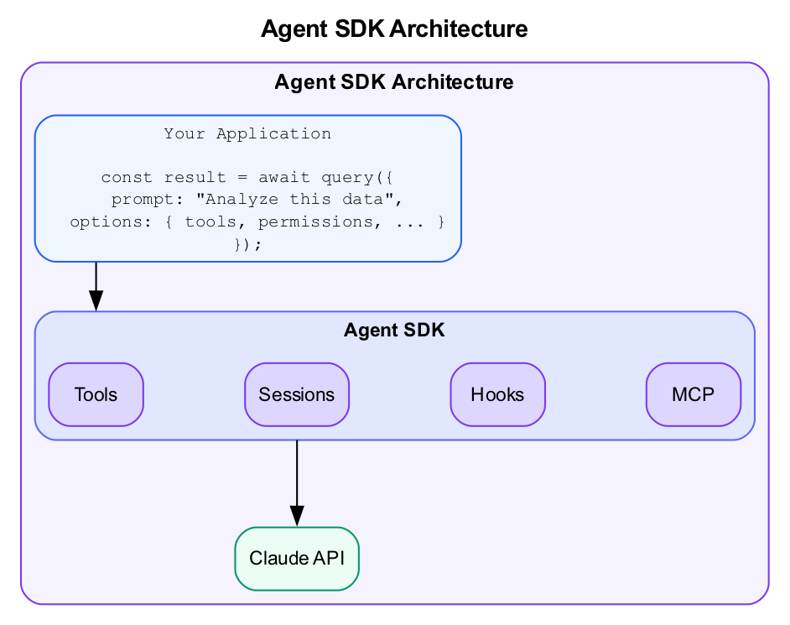
Agent SDK Architecture
What we’re building: A Database Analyzer agent that explores SQLite databases and produces structured reports.

Prerequisites
Before starting this lab, verify:
- Week 5 complete - Familiar with sub-agents and multi-agent patterns
- Node.js 18+ (for TypeScript) OR Python 3.9+ - Run node --version or python --version
- Anthropic API key - Set as ANTHROPIC_API_KEY environment variable
- Repository cloned - Access to data/startup-funding.db
Choose your language: - TypeScript: npm/yarn installed - Python: pip/venv available

Lab Overview (Outcomes)
By the end of this lab, you will:
- Set up the Agent SDK in TypeScript or Python
- Build a Database Analyzer agent using query()
- Understand tool callbacks and logging
- Run an agent programmatically

Time Breakdown
Task | Topic | Time
1.1 | Set Up the Project | 10 min
1.2 | Build the Database Analyzer | 15 min
1.3 | Run and Test | 5 min
 | TOTAL | 30 min

Task 1.1: Set Up the Project (10 min)
Choose TypeScript or Python and set up your project.

Option A: TypeScript Setup
- Create the project:
- mkdir -p agents/database-analyzer
cd agents/database-analyzer
npm init -y
npm install @anthropic-ai/claude-agent-sdk typescript ts-node zod
npx tsc --init
- Create the directory structure:
- mkdir src
- Verify installation:
- npx ts-node --version

Option B: Python Setup
- Create the project:
- mkdir -p agents/database-analyzer
cd agents/database-analyzer
python -m venv venv
source venv/bin/activate # On Windows: venv\Scripts\activate
pip install claude-agent-sdk pandas
- Verify installation:
- python -c "from claude_agent_sdk import query; print('SDK installed')"

Task 1.2: Build the Database Analyzer (15 min)
Create an agent that analyzes SQLite databases and produces structured reports.

TypeScript (src/index.ts):
import { query } from "@anthropic-ai/claude-agent-sdk";
interface AnalysisResult {
text: string;
toolCalls: number;
}
async function analyzeDatabase(dbPath: string): Promise<AnalysisResult> {
let toolCalls = 0;
const result = await query({
prompt: `Analyze the SQLite database at ${dbPath}. Provide:
1. List of tables and row counts
2. Schema for each table (columns and types)
3. Summary statistics for numeric columns
4. Key relationships between tables`,
options: {
maxTurns: 5,
onToolCall: (tool) => {
toolCalls++;
console.log(`[Tool] ${tool.name}`);
}
}
});
return {
text: result.text,
toolCalls
};
}
// Run the analyzer
async function main() {
console.log('Starting database analysis...\n');
const result = await analyzeDatabase('../../data/startup-funding.db');
console.log('\n=== Analysis Result ===\n');
console.log(result.text);
console.log(`\nTotal tool calls: ${result.toolCalls}`);
}
main().catch(console.error);

Python (analyzer.py):
import asyncio
from claude_agent_sdk import query, ClaudeAgentOptions
async def analyze_database(db_path: str) -> dict:
"""Analyze a SQLite database and return structured results."""
tool_calls = 0
result_text = ""
prompt = f"""Analyze the SQLite database at {db_path}. Provide:
1. List of tables and row counts
2. Schema for each table (columns and types)
3. Summary statistics for numeric columns
4. Key relationships between tables"""
async for message in query(
prompt=prompt,
options=ClaudeAgentOptions(
max_turns=5,
allowed_tools=["Read", "Bash", "Glob"]
)
):
if message.type == "tool_use":
tool_calls += 1
print(f"[Tool] {message.name}")
if hasattr(message, "result"):
result_text = message.result
return {
"text": result_text,
"tool_calls": tool_calls
}
async def main():
print('Starting database analysis...\n')
result = await analyze_database('../../data/startup-funding.db')
print('\n=== Analysis Result ===\n')
print(result["text"])
print(f'\nTotal tool calls: {result["tool_calls"]}')
if __name__ == "__main__":
asyncio.run(main())

Task 1.3: Run and Test (5 min)
- Run your analyzer:
- TypeScript:
- npx ts-node src/index.ts
- Python:
- python analyzer.py
- Observe the output:
  - Watch the tool call logs
  - Note how many turns the agent needed
  - Check that the analysis is complete
- Record your results:
Metric | Your Result
Total tool calls
Tools used
Turns to complete
Analysis sections covered

Troubleshooting

SDK Installation Issues
Problem | Solution
Module not found error | Verify package installed: npm list or pip list
TypeScript compilation errors | Check tsconfig.json has "esModuleInterop": true
Python import errors | Ensure virtual environment is activated

API & Authentication Issues
Problem | Solution
API key not set | Export ANTHROPIC_API_KEY environment variable
Rate limiting | Add delays between requests, reduce concurrency
Permission denied | Check dangerouslyAllowAllTools or permissions config

Execution Issues
Problem | Solution
Tool calls fail | Verify tools are in allowed list
JSON parsing fails | Agent output may not be clean JSON; add error handling
Timeout errors | Increase maxTurns or simplify the task

Final Checklist
Before completing this lab, verify:
- SDK installed - TypeScript or Python
- Project structure created - Directory and files in place
- query() function works - Agent receives prompts
- Tool callbacks log correctly - See [Tool] messages
- Database analysis completes - All 4 sections covered
Document your setup:
Element | Your Implementation
Language used
SDK version
Tools enabled
Output quality

Reference: SDK Key Functions

TypeScript
import { query, Session } from "@anthropic-ai/claude-agent-sdk";
// Basic query
const result = await query({
prompt: "Your task here",
options: {
maxTurns: 10,
tools: ['Read', 'Write', 'Bash', 'WebSearch'],
onToolCall: (tool) => console.log(tool.name),
}
});
// With session (for multi-turn)
const session = new Session({
systemPrompt: "You are a specialist...",
});
await query({ prompt: "First task", session });
await query({ prompt: "Follow-up", session });

Python
from claude_agent_sdk import query, ClaudeAgentOptions
# Basic query (streaming)
async for message in query(
prompt="Your task here",
options=ClaudeAgentOptions(
max_turns=10,
allowed_tools=["Read", "Write", "Bash"]
)
):
if hasattr(message, "result"):
print(message.result)

Reference: Model Selection
Model | Use Case | Cost
claude-sonnet-4-5-20250514 | Most agent work (default) | $$ |  | `claude-opus-4-5-20250514` | Complex reasoning | $$  $$
claude-haiku-3-5-20241022 | Fast, simple tasks | $

End of Lab 1

