Week 6 Lab 2: Build a Headless GTM Agent
Course: Claude Agents Workshop
Duration: 45 minutes (+ optional bonus)
Focus: Building a batch lead enrichment service with concurrency and structured output

Lab Architecture
This lab builds a production-ready lead enrichment service that processes leads in batches.
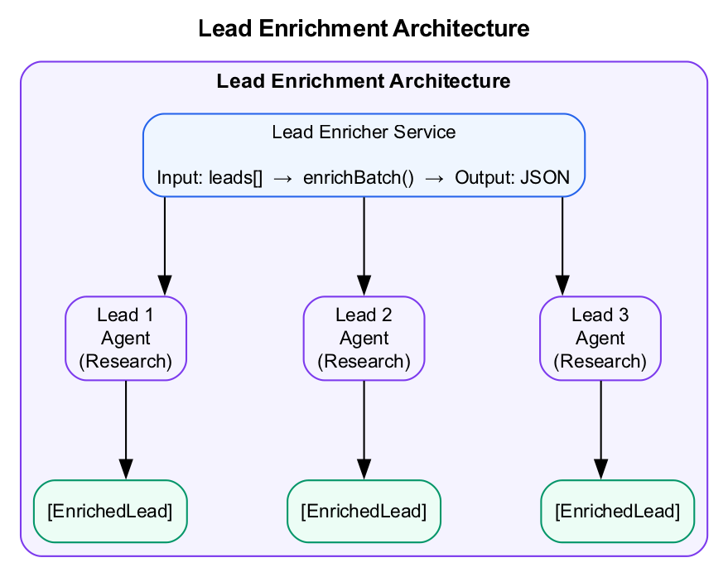
Lead Enrichment Architecture
What we’re building: A Lead Enrichment Service for headless batch processing with concurrency control.

Prerequisites
Before starting this lab, verify:
- Lab 1 complete - SDK installed and working
- Database Analyzer runs - query() function tested
- Anthropic API key set - ANTHROPIC_API_KEY exported

Lab Overview (Outcomes)
By the end of this lab, you will:
- Define TypeScript types for leads and enrichment
- Build a single lead enricher
- Implement batch processing with concurrency control
- Output structured JSON results
- Handle errors and edge cases

Time Breakdown
Task | Topic | Time
2.1 | Create Project Structure | 5 min
2.2 | Build the Enricher | 20 min
2.3 | Create the Main Runner | 10 min
2.4 | Run and Validate | 10 min
 | TOTAL | 45 min
Bonus | Sandboxed Execution | 30 min

Task 2.1: Create Project Structure (5 min)
Build a lead enrichment service that processes leads in batches.
- Create the project:
- mkdir -p agents/lead-enricher/src
cd agents/lead-enricher
npm init -y
npm install @anthropic-ai/claude-agent-sdk typescript ts-node zod
- Create the types file (src/types.ts):
- export interface Lead {
name: string;
company: string;
email: string;
title?: string;
}
export interface EnrichedLead extends Lead {
companySize?: string;
industry?: string;
recentNews?: string[];
linkedinUrl?: string;
enrichedAt: Date;
score?: number;
}
export interface EnrichmentResult {
lead: EnrichedLead;
success: boolean;
error?: string;
duration: number;
}

Task 2.2: Build the Enricher (20 min)
Create the core enrichment logic.
- Create src/enricher.ts:
- import { query } from "@anthropic-ai/claude-agent-sdk";
import { Lead, EnrichedLead, EnrichmentResult } from './types';
const ENRICHMENT_PROMPT = `
You are a lead research specialist. Given a lead, research their company and provide:
1. Company size (employees)
2. Industry/vertical
3. Recent news (last 3 months)
4. LinkedIn profile URL if findable
Be concise. If you can't find information, say "Not found" for that field.
Output as JSON:
{
"companySize": "...",
"industry": "...",
"recentNews": ["...", "..."],
"linkedinUrl": "..."
}
`;
export async function enrichLead(lead: Lead): Promise<EnrichmentResult> {
const startTime = Date.now();
try {
const result = await query({
prompt: `Research this lead:
Name: ${lead.name}
Company: ${lead.company}
Email: ${lead.email}
Title: ${lead.title || 'Unknown'}
${ENRICHMENT_PROMPT}`,
options: {
maxTurns: 8,
tools: ['WebSearch', 'WebFetch'],
dangerouslyAllowAllTools: true,
}
});
// Parse the JSON from response
const jsonMatch = result.text.match(/\{[\s\S]*\}/);
if (!jsonMatch) {
throw new Error('No JSON found in response');
}
const enrichment = JSON.parse(jsonMatch[0]);
const enrichedLead: EnrichedLead = {
...lead,
...enrichment,
enrichedAt: new Date(),
};
return {
lead: enrichedLead,
success: true,
duration: Date.now() - startTime,
};
} catch (error) {
return {
lead: { ...lead, enrichedAt: new Date() },
success: false,
error: error instanceof Error ? error.message : 'Unknown error',
duration: Date.now() - startTime,
};
}
}
export async function enrichBatch(
leads: Lead[],
concurrency: number = 2
): Promise<EnrichmentResult[]> {
const results: EnrichmentResult[] = [];
// Process in batches for rate limiting
for (let i = 0; i < leads.length; i += concurrency) {
const batch = leads.slice(i, i + concurrency);
console.log(`\nProcessing batch ${Math.floor(i/concurrency) + 1}...`);
const batchResults = await Promise.all(
batch.map(lead => {
console.log(` Enriching: ${lead.name} @ ${lead.company}`);
return enrichLead(lead);
})
);
results.push(...batchResults);
console.log(`Completed ${Math.min(i + concurrency, leads.length)}/${leads.length} leads`);
}
return results;
}

Task 2.3: Create the Main Runner (10 min)
- Create src/index.ts:
- import { enrichBatch } from './enricher';
import { Lead } from './types';
import * as fs from 'fs';
// Sample leads (in production, load from CSV or API)
const leads: Lead[] = [
{
name: "Sarah Chen",
company: "Anthropic",
email: "sarah@anthropic.com",
title: "VP Engineering"
},
{
name: "Mike Johnson",
company: "OpenAI",
email: "mike@openai.com",
title: "CTO"
},
{
name: "Lisa Park",
company: "Stripe",
email: "lisa@stripe.com",
title: "Head of Product"
}
];
async function main() {
console.log('=== Lead Enrichment Service ===');
console.log(`Starting enrichment of ${leads.length} leads...\n`);
const results = await enrichBatch(leads, 2);
// Summary
const successful = results.filter(r => r.success).length;
const failed = results.filter(r => !r.success).length;
const totalDuration = results.reduce((sum, r) => sum + r.duration, 0);
console.log('\n=== Enrichment Complete ===');
console.log(`Successful: ${successful}`);
console.log(`Failed: ${failed}`);
console.log(`Total time: ${(totalDuration / 1000).toFixed(1)}s`);
console.log(`Avg per lead: ${(totalDuration / results.length / 1000).toFixed(1)}s`);
// Save results
const outputDir = 'output';
if (!fs.existsSync(outputDir)) {
fs.mkdirSync(outputDir, { recursive: true });
}
fs.writeFileSync(
`${outputDir}/enriched-leads.json`,
JSON.stringify(results, null, 2)
);
console.log('\nResults saved to output/enriched-leads.json');
// Display enriched data
console.log('\n=== Enriched Leads ===\n');
results.forEach(r => {
console.log(`${r.lead.name} @ ${r.lead.company}`);
console.log(` Industry: ${r.lead.industry || 'N/A'}`);
console.log(` Size: ${r.lead.companySize || 'N/A'}`);
console.log(` Status: ${r.success ? 'Success' : 'Failed'}`);
console.log('');
});
}
main().catch(console.error);

Task 2.4: Run and Validate (10 min)
- Run the enricher:
- npx ts-node src/index.ts
- Check the output file:
- cat output/enriched-leads.json
- Record your results:
Metric | Your Result
Leads processed
Success rate
Average time per lead
Data fields populated
- Try with different leads:
  - Add a lead with a less-known company
  - Add a lead with incomplete information
  - Observe how the agent handles edge cases

Bonus Task: Add Lead Scoring
Extend the enricher to score leads after enrichment:
// Add to enricher.ts
export async function scoreLead(lead: EnrichedLead): Promise<number> {
const result = await query({
prompt: `Score this lead from 0-100 based on:
- Company size (larger = higher score for B2B)
- Title seniority (VP/C-level = higher)
- Industry fit (tech = higher)
Lead:
${JSON.stringify(lead, null, 2)}
Return only a number 0-100.`,
options: {
maxTurns: 1,
}
});
return parseInt(result.text.trim()) || 50;
}

Bonus: Sandboxed Execution with Daytona (30 minutes)
For production agents, running code in a sandbox adds a layer of security.

Task B.1: Set Up Daytona (10 min)
- Get API key: Sign up at daytona.io
- Install the SDK:
- Python:
- pip install daytona-sdk
- TypeScript:
- npm install @daytonaio/sdk
- Set environment variable:
- export DAYTONA_API_KEY=your_api_key_here

Task B.2: Run Agent in Sandbox (20 min)
Create a sandboxed analysis agent.
Python (sandboxed_analyzer.py):
import asyncio
from daytona_sdk import Daytona
from claude_agent_sdk import query, ClaudeAgentOptions
async def run_sandboxed_agent(task: str, data_file: str):
"""Run an agent in a Daytona sandbox with file access."""
daytona = Daytona()
sandbox = daytona.create()
try:
# Upload data file to sandbox
print(f"Uploading {data_file} to sandbox...")
sandbox.fs.upload_file(data_file, f"/workspace/{data_file}")
# Run the agent
print("Running agent in sandbox...")
async for message in query(
prompt=f"""
You are running in a sandboxed environment.
Working directory: /workspace
Data file: /workspace/{data_file}
Task: {task}
Execute any analysis code directly. The environment has Python
with pandas, numpy, and sqlite3 installed.
""",
options=ClaudeAgentOptions(
allowed_tools=["Read", "Write", "Bash"],
permission_mode="bypassPermissions" # Safe because sandboxed
)
):
if hasattr(message, "result"):
print(message.result)
# Download results if created
try:
sandbox.fs.download_file("/workspace/output/results.json", "./results.json")
print("\nResults downloaded to ./results.json")
except:
print("\nNo results file created")
finally:
print("Cleaning up sandbox...")
sandbox.delete()
if __name__ == "__main__":
asyncio.run(run_sandboxed_agent(
task="Analyze the funding data and show top 5 investors by deal count",
data_file="../../data/startup-funding.db"
))
TypeScript (sandboxed-analyzer.ts):
import { Daytona } from "@daytonaio/sdk";
import { query } from "@anthropic-ai/claude-agent-sdk";
async function runSandboxedAgent(task: string, dataFile: string) {
const daytona = new Daytona();
const sandbox = await daytona.create({ language: "python" });
try {
// Upload data file
console.log(`Uploading ${dataFile} to sandbox...`);
await sandbox.fs.uploadFile(dataFile, `/workspace/${dataFile}`);
// Run the agent
console.log("Running agent in sandbox...");
for await (const message of query({
prompt: `
You are running in a sandboxed environment.
Working directory: /workspace
Data file: /workspace/${dataFile}
Task: ${task}
Execute any analysis code directly.
`,
options: {
allowedTools: ["Read", "Write", "Bash"],
permissionMode: "bypassPermissions"
}
})) {
if ("result" in message) {
console.log(message.result);
}
}
// Download results
try {
await sandbox.fs.downloadFile("/workspace/output/results.json", "./results.json");
console.log("\nResults downloaded to ./results.json");
} catch {
console.log("\nNo results file created");
}
} finally {
console.log("Cleaning up sandbox...");
await sandbox.delete();
}
}
runSandboxedAgent(
"Analyze the funding data and show top 5 investors by deal count",
"../../data/startup-funding.db"
).catch(console.error);

Bonus Success Criteria
- Daytona SDK installed and configured
- Sandbox created successfully
- Data file uploaded to sandbox
- Agent executed within sandbox
- Sandbox cleaned up after execution

Troubleshooting

Execution Issues
Problem | Solution
Tool calls fail | Verify tools are in allowed list
JSON parsing fails | Agent output may not be clean JSON; add error handling
Timeout errors | Increase maxTurns or simplify the task
Batch processing hangs | Reduce concurrency, add timeout per request

Daytona Issues
Problem | Solution
Sandbox creation fails | Check Daytona API key is valid
File upload fails | Verify file path exists locally
Code execution errors | Check Python packages are available in sandbox

Final Checklist
Before completing this lab, verify:
- Type definitions created - Lead, EnrichedLead, EnrichmentResult
- Single lead enrichment works - enrichLead() returns data
- Batch processing with concurrency - enrichBatch() handles multiple leads
- JSON output saved to file - output/enriched-leads.json exists
- Summary statistics displayed - Success/fail counts, timing
- At least 2 leads enriched - Actual company data found
Document your service:
Metric | Your Implementation
Concurrency level
Average enrichment time
Success rate
Output file size

End of Lab 2

