Week 8 Lab 1: Structure Your Demo
Course: Claude Agents Workshop
Duration: 20 minutes
Focus: Creating a demo outline and talking points for your capstone presentation

Lab Architecture
This lab prepares your demo structure and talking points.
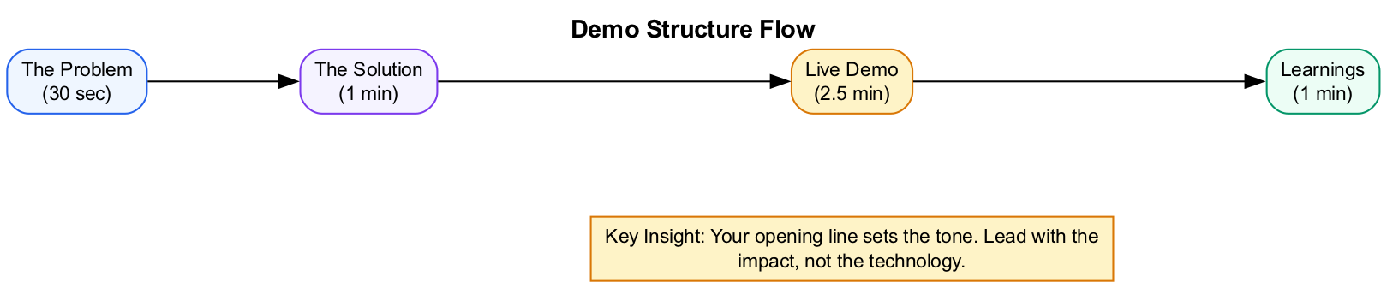
Demo Structure Flow
What we’re building: A 5-minute demo outline with clear sections and a compelling opening.

Prerequisites
Before starting this lab, verify:
- Capstone agent completed - Your agent from Weeks 1-7 is working
- Evals passing - At least 3 of 5 test cases from Week 7
- Sample data prepared - Real or realistic test inputs for your demo
- Notes ready - What your agent does and why it matters
Bring to this lab: - Your working agent (Claude Code skill, SDK script, or sub-agent system) - Notes on key capabilities and limitations - Ideas for what to demonstrate

Lab Overview (Outcomes)
By the end of this lab, you will:
- Understand the 5-minute demo format
- Create a complete demo outline with all sections
- Write a compelling opening line
- Prepare talking points for each section

Time Breakdown
Task | Topic | Time
1.1 | Complete Your Demo Outline | 15 min
1.2 | Write Your Opening Line | 5 min
 | TOTAL | 20 min

Demo Format
You have 5 minutes for your presentation plus 2 minutes for Q&A.
Section | Time | Content
The Problem | 30 sec | What workflow are you automating? Who benefits?
The Solution | 1 min | High-level architecture, key components
Live Demo | 2.5 min | Show the agent working on a real use case
Learnings | 1 min | What worked, what was hard, what you’d change

Task 1.1: Complete Your Demo Outline (15 min)
Fill out this template for your presentation:
# [Your Agent Name] Demo
## The Problem (30 sec)
- I'm solving: _______________________________________________
- This helps: ________________________________________________
- Before my agent: ___________________________________________
## The Solution (1 min)
- Architecture: [Skills / MCP / Sub-agents / SDK]
- Key components:
1. _______________________________________________________
2. _______________________________________________________
3. _______________________________________________________
## Live Demo (2.5 min)
- I'll show: _________________________________________________
- Sample input: ______________________________________________
- Expected output: ___________________________________________
- Backup if live fails: _______________________________________
## Learnings (1 min)
- What worked well: __________________________________________
- What was challenging: ______________________________________
- What I'd do differently: ____________________________________
Save this as demo-outline.md in your project folder.

Section Guidelines
The Problem (30 sec) - Be specific about who experiences this problem - Quantify if possible (“3 hours per week”, “200 tickets per day”) - Make it relatable to your audience
The Solution (1 min) - Name the architecture pattern you used - List 2-3 key components (skills, MCP servers, agents) - Don’t go into code details yet
Live Demo (2.5 min) - Pick ONE compelling use case - Show real input → agent working → output - Have a backup plan ready
Learnings (1 min) - Be honest about challenges - Share one insight others could learn from - Mention what you’d do differently with more time

Task 1.2: Write Your Opening Line (5 min)
Your opening line sets the tone. Write a single sentence that explains why your agent matters.
Bad openings: - “So, um, I built this agent that kind of does some stuff…” - “This is my project. It uses Claude Code.” - “I’m sorry this isn’t more polished, but…”
Good openings: - “Every week I spend 3 hours enriching leads manually. My agent does it in 3 minutes.” - “Our team gets 200 support tickets daily. This agent routes and drafts responses automatically.” - “I read 50 articles a week to stay current. This agent summarizes them for me.”
Template: “[Time/effort spent on problem]. [My agent does X].”
Your opening line:
___________________________________________________________
___________________________________________________________
Write it down. Memorize it. This is how you’ll start your demo.

Troubleshooting

Outline Issues
Problem | Solution
Can’t articulate the problem | Think about what you did manually before the agent
Too many things to show | Pick the ONE most impressive capability
Demo takes too long | Remove explanation, let the output speak
Not sure what to say | Read your outline aloud, adjust to natural speech

Opening Line Issues
Problem | Solution
Sounds generic | Add specific numbers or time saved
Too technical | Lead with the human impact, not the tech
Too long | Cut to one sentence, max two
Can’t remember it | Write it on a sticky note, practice 5x

Final Checklist
Before completing this lab, verify:
- Demo outline created - All four sections filled in
- Opening line written - Compelling, specific, memorized
- Sample input chosen - Realistic data for the demo
- Expected output documented - Know what success looks like
- Backup plan ready - What to show if live demo fails
- File saved - demo-outline.md in project folder
Document your demo structure:
Element | Your Implementation
Opening line
Architecture type
Key capability shown
Backup plan

Reference: Example Project Showcases
These examples show what participants have built:

GTM / Sales
Project | Stack | Description
Lead Enrichment Pipeline | Sub-agents + WebSearch | Enriches and scores inbound leads
Email Sequence Generator | Skills + Gmail MCP | Creates personalized outreach
CRM Sync Agent | SDK + HubSpot MCP | Keeps CRM data consistent

Developer Tools
Project | Stack | Description
Code Review Bot | GitHub MCP + Skills | Reviews PRs and suggests fixes
Documentation Generator | SDK + Repo tools | Creates docs from code
Dependency Auditor | Sub-agents + npm/pip | Flags outdated packages

Content / Marketing
Project | Stack | Description
Content Repurposer | Skills + Google Docs MCP | Turns blog posts into social threads
SEO Analyzer | WebSearch + Skills | Audits pages and suggests improvements
Newsletter Curator | Sub-agents + RSS | Aggregates and summarizes industry news

Operations / Data
Project | Stack | Description
Invoice Processor | Skills + Google Sheets | Extracts data from PDF invoices
Data Quality Monitor | Skills + Evals | Profiles CSVs and flags issues
Compliance Checker | Sub-agents + Notion MCP | Audits records against policy rules

End of Lab 1

