Week 1: Overview & Setup - The Age of AI Agents

Session Goals
- Understand what agent engineering is and why it matters
- See the landscape: Claude Code, Agent SDK, tools, skills, MCP
- Get fully set up with Claude Code and TypeScript environment
- Define a personal project idea for the series

Block 1: Theory - What Are AI Agents? (30 min)

The Shift from Chatbots to Agents
Chatbot (2022-2023): - Human asks question → AI responds → Human acts - AI is a consultant
Agent (2024+): - Human defines goal → AI plans, acts, iterates → Human reviews outcome - AI is a worker

The Agent Loop
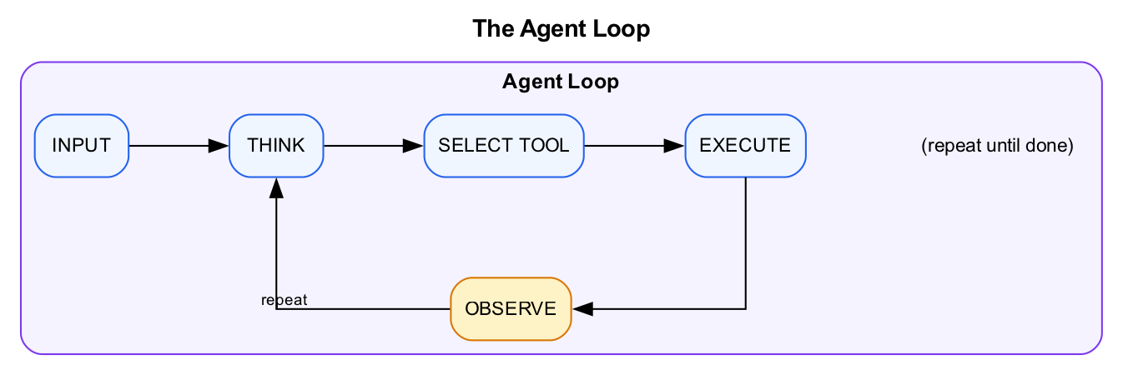
Diagram

Core Concepts We’ll Cover
Week | Concept | What It Is
2 | Tool Calling | How Claude executes actions (read files, run code, call APIs)
3 | MCP | Universal protocol for connecting to external services
4 | Agent Skills | Markdown files that teach Claude new capabilities
5 | Sub-agents | Specialized agents that handle focused subtasks
6 | Agent SDK | Run agents headlessly at scale (TypeScript)
7 | Evals | Measure and improve agent quality systematically

Why Now?
- Models are good enough to reason reliably
- Tool use is mature and standardized
- Context windows are large enough for real work
- Cost has dropped 10-100x

The Rise of GTM Engineering
A new role is emerging: GTM Engineer. These are technical people who build AI agents for sales, marketing, and revenue teams.
Vercel’s story: They replaced 9 of 10 inbound SDRs with an AI agent in six weeks, using one part-time GTM engineer. Conversion rates stayed flat while speed improved.
“For us, we had 10 SDRs doing this inbound workflow, and now we just have one that is effectively QAing the agent. The other nine, we deployed on outbound. It was six weeks before we felt confident going from 10 to 1.” - Jeanne DeWitt Grosser, COO at Vercel
The job market reflects this shift. GTM engineering jobs grew 205% year-over-year in 2025. Vercel pays $202K-$302K for this role.
Why this matters for you: The skills you learn in this bootcamp are exactly what GTM engineers do. Data analysis, CRM automation, lead scoring, email workflows. You’re learning to build the agents that are transforming go-to-market teams.
References: - Vercel GTM Engineer Job Posting - Vercel’s AI Sales Agent: 10 SDRs Down to 1

Claude Code: Beyond Coding
Even the creator of Claude Code is surprised by how people use it.
Boris Cherny tweet about Claude Code non-technical use cases
Boris Cherny tweet about Claude Code non-technical use cases
Boris Cherny, who created Claude Code as a side project in September 2024, notes that people are using it for “all sorts of things from coding, to devops, to research, to non-technical use cases.”
The key insight: “Increasingly, code is no longer the bottleneck.”

The Future of Analytics
Here’s where this is heading: You won’t manage dashboards. You’ll ask for insights.
Today, business users interact with BI tools. They build dashboards, write queries, maintain reports, refresh data. They manage the tools to get answers.
Tomorrow, they’ll just ask questions. The agent handles the rest.
Today | Tomorrow
“Let me check the dashboard” | “What’s our conversion rate this week?”
“I need to pull a report” | “Show me deals at risk of slipping”
“Can someone query this?” | “Which customers should I call today?”
Managing tools | Asking questions
Vercel’s GTM team already works this way. They ask their agent to qualify leads. The agent searches their data, scores the lead, and drafts a response. No dashboard. No query. Just the answer.
This bootcamp teaches you to build that future. Not to replace BI tools, but to put an agent in front of them that understands what you actually need.

Why Claude Code Over Alternatives?
You might wonder: why not LangChain, LangGraph, or CrewAI?
The short answer: Claude Code is arguably the best general-purpose agent harness available today.
It’s not just another framework. It’s a complete agent runtime built by Anthropic, the same team that builds Claude. That means it’s designed around how Claude actually thinks and works, not bolted on as an afterthought.
The insight: LLMs are filesystem-native. They’ve seen grep, find, cat, and bash billions of times during training. These aren’t new skills we teach them. They already know how to navigate directories, read files, and pipe commands.
Claude Code bets on this. Instead of building complex abstractions, it gives Claude a filesystem and bash. That’s the core loop.
Vercel validated this approach. They rebuilt their text-to-SQL agent by stripping it down to one capability: execute bash commands in a sandboxed filesystem. The agent browses their data (YAML, Markdown, JSON files) using standard Unix tools, just like a human analyst would.
Their results after removing 80% of their tools:
Metric | Before | After
Success rate | 80% | 100%
Execution time | 275 seconds | 77 seconds (3.5x faster)
Token usage | Higher | 37% fewer tokens
Steps required | More | 42% fewer steps
One query that failed after 724 seconds now succeeds in 141 seconds.
The alternatives and their tradeoffs:
Framework | Approach | Problem
LangChain | Prompt chaining | Simple chains don’t leverage what LLMs already know
LangGraph | Low-level DAG/graph control | Overkill. You’re building plumbing, not solutions
CrewAI | Role-based agents with personas | Too many abstractions between you and the model
Claude Code | Filesystem + bash + tools | Works with how LLMs think, not against it
Why filesystems work:
- Training distribution - LLMs have seen Unix commands billions of times. grep, cat, find, awk. These aren’t new skills we teach. They’re native operations.
- Natural structure - Customer data, CRM records, conversations already have hierarchy that maps to directories
- Precise retrieval - Load only what you need, unlike vector search (imprecise) or prompt stuffing (token explosion)
- Debuggable - You can see exactly which files the agent accessed and which commands it ran
- Minimal maintenance - No custom retrieval pipelines per data type
Real example: Sales call summarization
Vercel built an agent to analyze sales calls. Instead of stuffing transcripts into prompts, they structured data as files:
/customers/cust_12345/
├── profile.json
├── tickets/
│ ├── ticket_001.md
│ └── ticket_002.md
└── conversations/2024-01-15.txt
The agent uses bash to navigate: ls to explore, grep to find patterns like “pricing objection”, cat to read specific files. It loads only what it needs, when it needs it.
Results: Cost dropped from $1.00 to $0.25 per call. Quality improved. Same model (Claude Opus).
The lesson from Vercel: “Addition by subtraction is real. The best agents might be the ones with the fewest tools.”
References: - Vercel: How to Build Agents with Filesystems and Bash - Vercel: We Removed 80% of Our Agent’s Tools

What If You Don’t Like Terminals?
If the command line feels intimidating, Anthropic just launched Claude Cowork. Same agentic capabilities, but in a desktop GUI instead of a terminal.
Cowork runs in the Claude Desktop app (macOS). It can: - Read and write files directly on your computer - Create Excel spreadsheets, PowerPoints, and formatted documents - Break complex tasks into parallel workstreams - Handle long-running projects without timeouts
Think of it as Claude Code without the terminal. Same filesystem-native approach, friendlier interface.
This bootcamp uses Claude Code because it’s more powerful for automation and integrations. But if you’re non-technical and want to apply these concepts without learning the command line, Cowork is a valid path.
Reference: - Getting Started with Cowork

Demo: Claude Code in Action
Live demo: Give Claude Code a multi-step task and watch it work.
Example: “Analyze this CSV, find the top 10 customers by revenue, and create a summary”
Watch how Claude: 1. Uses tools to read the file 2. Reasons about what to do 3. Executes code to analyze 4. Iterates until complete

Block 2: Lab (Part 1) - Environment Setup (30 min)
Lab Document: weeks/md/week1-lab.md or weeks/docx/week1-lab.docx
Complete Part 1 of the Week 1 Lab.
Overview: - Pre-flight check (Node.js, Git, Claude Pro) - Install Claude Code CLI - Clone workshop repository - Authenticate and test
Success criteria: Claude responds correctly to “What files are in this repository?”

BREAK (10 min)

Block 3: Theory - The Claude Agent Stack (30 min)

Layer 1: Tool Calling
Claude can use tools to take actions. Built-in tools include:
Tool | What It Does
Read | Read files
Write | Create new files
Edit | Modify existing files
Bash | Run terminal commands
Glob | Find files by pattern
Grep | Search file contents
WebSearch | Search the web
WebFetch | Fetch web pages
Week 2 dives deep into how tool calling works.

Layer 2: MCP (Model Context Protocol)
MCP connects Claude to external services:
# Add a GitHub MCP server
claude mcp add --transport http github https://api.githubcopilot.com/mcp/
# Add a database server
claude mcp add --transport stdio db -- npx -y @bytebase/dbhub --dsn "postgresql://..."
Now Claude can query GitHub issues, read your database, etc.
Week 3 covers MCP in depth.

Layer 3: Agent Skills
Skills are Markdown files that teach Claude new capabilities:
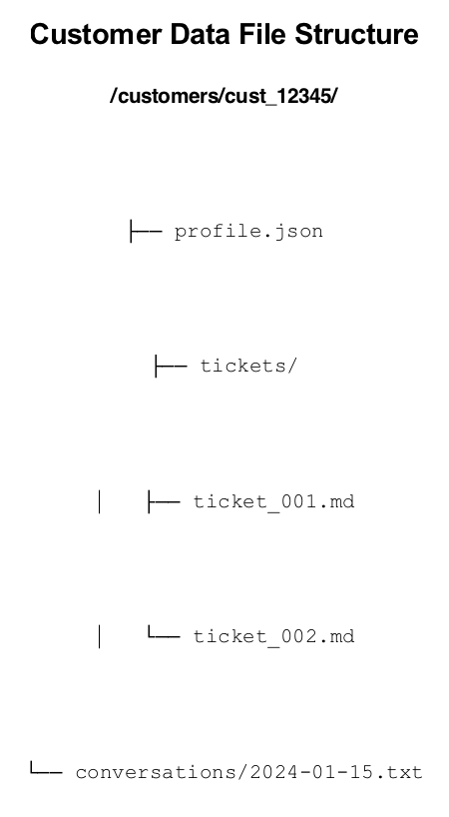
Diagram
Claude automatically discovers and uses skills when relevant.
Week 4 covers creating effective skills.

Layer 4: Sub-agents
The Task tool spawns specialized agents:
// Main agent delegates to specialist
> "Use the code-reviewer agent to review this PR"
// code-reviewer runs with focused context
// Returns results to main agent
Week 5 covers sub-agent orchestration.

Layer 5: Agent SDK
Run agents headlessly from TypeScript:
import { query } from "@anthropic-ai/claude-agent-sdk";
for await (const message of query({
prompt: "Process all leads in data/leads.csv",
options: { allowedTools: ["Read", "Write", "Bash"] }
})) {
console.log(message);
}
Week 6 covers SDK and fleet running.

Claude Code CLI vs Agent SDK
A common question: what’s the difference between running Claude Code as a CLI and using the Agent SDK?
Claude Code CLI is the complete product you interact with in the terminal: - Full agent loop with built-in tools and permission management - Runs as a standalone executable - Great for interactive development work - Can run in sandboxes (Daytona, Docker, etc.) for isolation
# Interactive mode
claude
# Headless mode (for automation)
claude --dangerously-skip-permissions -p 'your task' --output-format stream-json
Claude Agent SDK is a library you embed in your own application: - Same agent loop and tools, but programmatic control - Add custom tools as TypeScript/Python functions - Full streaming, hooks, and session management - Ideal for building products on top of Claude
import { query } from "@anthropic-ai/claude-agent-sdk";
const result = await query({
prompt: "Analyze the data",
options: { maxTurns: 10 }
});
Key Differences:
Aspect | Claude Code CLI | Claude Agent SDK
What it is | Complete CLI tool | Library for your app
Control | Shell commands, parse output | Full programmatic control
Custom tools | MCP servers only | In-process MCP servers via code
Permissions | --dangerously-skip-permissions | permissionMode + hooks
Session state | Managed externally | Built-in resumption
Integration | Subprocess | First-class SDK
When to use which: - CLI in sandbox: Running untrusted code, CI/CD pipelines, giving users isolated environments - SDK: Building products, API servers, custom workflows, production automation
Both need sandboxing for production. The SDK does not provide isolation by itself.

The Full Stack
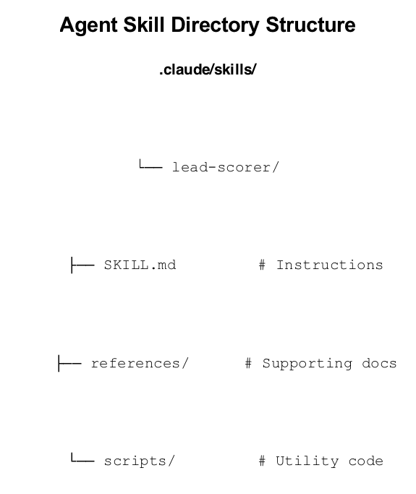
Diagram

Block 4: Lab (Part 2) - First Steps with Claude Code (45 min)
Lab Document: weeks/md/week1-lab.md or weeks/docx/week1-lab.docx
Complete Part 2 of the Week 1 Lab.
Overview: - Explore the repo structure with Claude - Test built-in tools (Glob, Read, Grep, Bash) - Customize CLAUDE.md with project context - Preview the startup funding database
Success criteria: - Tools tested and working - CLAUDE.md customized - Database accessible via Claude

Wrap-Up (15 min)

The 8-Week Journey
Week | What You’ll Learn | What You’ll Build
1 | Setup and basics | ✓ Environment ready, project defined
2 | Tool calling | Research workflows using web + file tools
3 | MCP integrations | Connections to your databases and services
4 | Agent Skills | Custom skills encoding your domain expertise
5 | Sub-agents | Multi-stage pipeline for your workflow
6 | Agent SDK | Headless batch processor in TypeScript
7 | Evals | Test suite to validate your agent’s behavior
8 | Demo day | Present your project to the group

Homework: Define Your Project
Due before Week 2:
Write a 1-paragraph description of an agent you want to build.
Requirements: - Must involve a repeatable workflow you want to automate - Must be something useful to you (real or realistic) - Must be achievable in 7 weeks of incremental building
Examples by Domain:
Domain | Example Project
GTM/Sales | Research companies, score leads, and draft personalized outreach emails
Data Analytics | Profile datasets, identify anomalies, generate weekly quality reports
Developer Tools | Review PRs, generate documentation, track technical debt
Content/Marketing | Research topics, draft blog posts, repurpose content across channels
Customer Support | Categorize tickets, draft responses, escalate complex issues
Operations | Process invoices, reconcile data, generate compliance reports
Pick something from your actual work. The course uses GTM examples, but the patterns apply to any domain.
Submit: Share with the facilitator before Week 2.

Resources
- Claude Code Documentation
- Claude Models Overview
- Agent SDK Documentation
- Agent Skills Specification
- MCP Protocol

Next Week Preview
Week 2: Tool Calling - How Claude decides which tools to use - Tool schemas and input validation - Building custom tools - Lab: Data analysis tools

Facilitator Notes

Common Setup Issues
- Claude not authenticated: Run claude and follow prompts
- Node version too old: Use nvm to install Node 18+
- npm permissions: Avoid sudo, fix npm permissions
- Windows users: Recommend WSL2

Timing Adjustments
If setup takes longer than expected: - Lab 2 Task 3 can be shortened or made homework - Focus on getting everyone to successful “What files are in this repo?” test

Engagement Tips
- Ask participants to share their project ideas in chat during wrap-up
- Create breakout rooms for troubleshooting during setup
- Have TA/co-facilitator monitor chat for stuck participants

