Week 2: Tool Calling - How Claude Takes Action

Session Goals
- Understand how Claude uses tools to interact with the world
- Learn the tool calling loop: think, select, execute, observe
- Practice with built-in tools for data analysis and research
- Master the Data Analysis Loop: Monitor, Explore, Craft, Impact
- Build analysis workflows using SQL and web search

Block 1: Theory - How Tool Calling Works (30 min)

The Key Insight
Last week we learned that Claude Code bets on filesystems and bash. This week we go deeper: how does tool calling actually work?
When you give Claude access to tools, it stops being a chatbot and becomes an agent. It can read files, search the web, and execute commands. But the most important tool is one you might not expect: bash.

The Tool Calling Loop
Every time Claude uses a tool, it follows this loop:
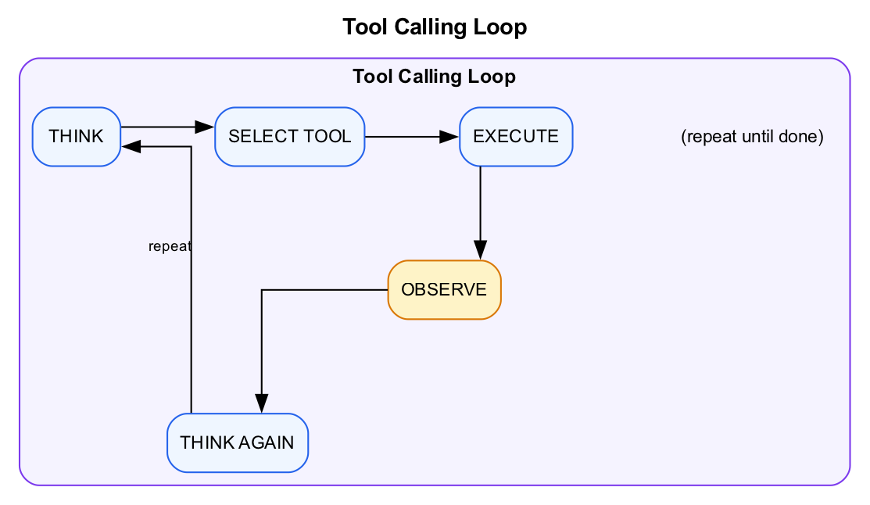
Diagram
Example: “Find the top-funded AI startups in 2024”
- Think: I need to query the funding database
- Select: Use Bash with sqlite3
- Execute: Run the query
- Observe: I see 50 results with columns: startup_name, amount, stage…
- Think: Now I need to filter for AI industry and sort by amount
- Select: Refine the SQL query
- Execute: Run the updated query
- Observe: Here are the results…
- Think: Task complete, present findings

Why Bash Is the Most Important Tool
Remember Vercel’s lesson from Week 1: they removed 80% of their agent’s tools and got better results. What did they keep? Bash.
Here’s what Vercel removed from their text-to-SQL agent: - Schema lookup tool - Query validation tool - Error recovery tool - Entity join finder - Context recall mechanism - Results formatter - Data visualization tool - …and 5 more specialized tools
What replaced all of them? An agent that can execute bash commands and explore files.
Why this works:
LLMs have seen grep, cat, find, and ls billions of times during training. These commands are native operations, not bolted-on behaviors. When you give Claude bash access, you’re not teaching it something new. You’re letting it use skills it already has.
How agents use bash:
Command | What It Does | Agent Use Case
ls | List files | “What data do I have to work with?”
cat | Read file contents | “Let me look at this file”
grep | Search for patterns | “Find all mentions of ‘Series A’”
find | Locate files | “Where are the funding reports?”
head/tail | Preview files | “Show me the first 10 rows”
wc | Count lines/words | “How many records are in this file?”
sort | Order data | “Sort by funding amount descending”
sqlite3 | Query databases | “Run SQL on the funding database”
On-demand context retrieval:
Instead of stuffing everything into the prompt upfront, agents retrieve context as they need it:
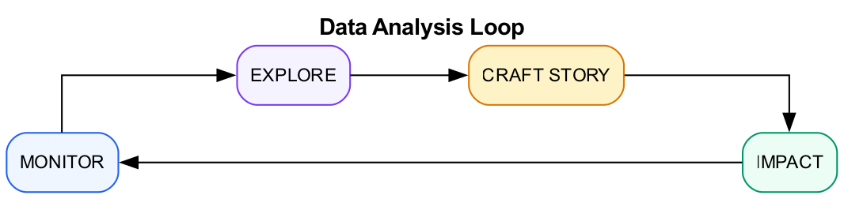
Diagram
This is why Vercel’s agent dropped from $1.00 to $0.25 per sales call analysis. It loads only what it needs, when it needs it.
The philosophy:
“Every agent needs filesystem and bash. If you’re building an agent, resist the urge to create custom tools. Instead, ask: can I represent this as files?”

Built-in Tools
Claude Code comes with these tools ready to use:
Tool | What It Does | Business Use Cases
Read | Read files | Analyze data, read reports, review documents
Write | Create files | Generate reports, save analysis results
Edit | Modify files | Update data, fix errors in documents
Bash | Run commands | Execute scripts, run SQL, process data
Glob | Find files | Locate reports, find datasets
Grep | Search content | Find mentions, search across files
WebSearch | Search the web | Research companies, find market data
WebFetch | Fetch web pages | Get company info, pull public data

How Claude Decides Which Tool to Use
Claude reads your request and matches it to available tools:
Your Request | Claude’s Thinking | Tool Selected
“What’s in this database?” | Need to explore schema | Bash (sqlite3)
“Find all AI startups” | Need to query database | Bash (sqlite3)
“Research Cursor AI funding” | Need current web info | WebSearch
“Create a summary report” | Need to write output | Write
“How many Series A rounds in 2024?” | Need to count from database | Bash (sqlite3)
“Top investors by portfolio size” | Need to aggregate and rank | Bash (sqlite3)

The Data Analysis Loop
Professional data analysis follows a repeatable workflow. This is what separates good analysts from great ones:
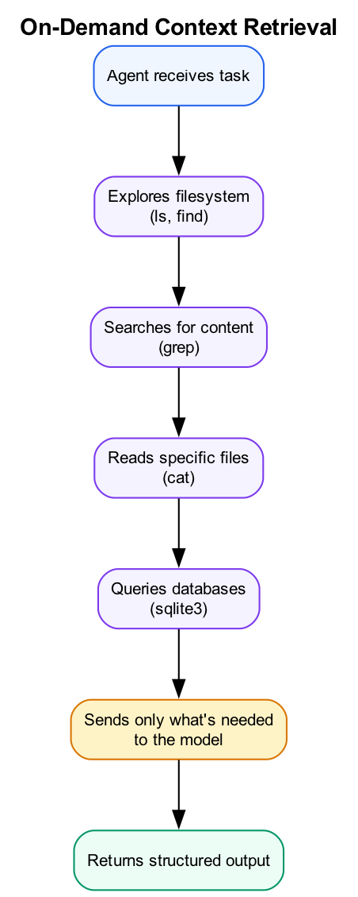
Diagram
1. Monitor - Run recurring queries to check key metrics - Compare current values to historical baselines - Flag anomalies (>10% deviation from average)
2. Explore - When you spot an anomaly, dig deeper - Segment the data: by time, category, cohort - Look for external context: was there a market shift? A news event?
3. Craft Story - Synthesize findings into 3-5 key insights - Support each insight with specific data - Note confidence level and caveats
4. Impact - Recommend concrete next actions - Size the opportunity if possible - Identify what additional data would help
Claude can help at every phase of this loop.

AI-Assisted SQL and Data Warehouse Querying
One of the most powerful applications of AI agents is querying structured data. Whether you’re working with a SQL database, data warehouse, or CSV files, Claude can translate your business questions into precise queries.
From natural language to SQL:
Business Question | Claude Generates
“Top 10 funded AI startups” | SELECT name, SUM(amount_usd) FROM startups s JOIN funding_rounds fr ON s.id = fr.startup_id WHERE s.industry = 'AI/ML' GROUP BY s.id ORDER BY SUM(amount_usd) DESC LIMIT 10
“Funding velocity by stage” | WITH rounds AS (SELECT startup_id, stage, funding_date, LAG(funding_date) OVER (PARTITION BY startup_id ORDER BY funding_date) as prev_date FROM funding_rounds) SELECT stage, AVG(JULIANDAY(funding_date) - JULIANDAY(prev_date)) as avg_days_between FROM rounds WHERE prev_date IS NOT NULL GROUP BY stage
“Series A to Series B conversion rate by year” | See intermediate SQL examples below
Working with data warehouses:
When your data lives in Snowflake, BigQuery, Redshift, or another warehouse, the same principle applies. Claude can: - Write complex analytical queries with window functions - Generate CTEs for multi-step transformations - Create aggregations across dimensions - Handle time-series analysis and cohort queries
Best practices for AI-assisted querying:
- Validate AI-generated queries - Always review before running on production data
- Start with sample data - Test queries on a subset first
- Use LIMIT clauses - Prevent runaway queries
- Iterate conversationally - “Now filter that to only AI/ML industry”
Intermediate SQL Patterns:
This workshop uses SQL patterns beyond basic SELECT queries:
-- Window function: Rank startups by funding within industry
SELECT
s.name,
s.industry,
fr.amount_usd,
fr.stage,
RANK() OVER (PARTITION BY s.industry ORDER BY fr.amount_usd DESC) as industry_rank
FROM funding_rounds fr
JOIN startups s ON fr.startup_id = s.id
WHERE fr.stage = 'Series A';
-- CTE: Calculate funding velocity (days between rounds)
WITH round_sequence AS (
SELECT
startup_id,
stage,
funding_date,
LAG(funding_date) OVER (PARTITION BY startup_id ORDER BY funding_date) as prev_round_date
FROM funding_rounds
)
SELECT
s.name,
rs.stage,
JULIANDAY(rs.funding_date) - JULIANDAY(rs.prev_round_date) as days_since_last_round
FROM round_sequence rs
JOIN startups s ON rs.startup_id = s.id
WHERE rs.prev_round_date IS NOT NULL
ORDER BY days_since_last_round ASC
LIMIT 20;
-- Cohort analysis: Series A to Series B conversion by year
WITH series_a AS (
SELECT startup_id, funding_date as series_a_date
FROM funding_rounds WHERE stage = 'Series A'
),
series_b AS (
SELECT startup_id, funding_date as series_b_date
FROM funding_rounds WHERE stage = 'Series B'
)
SELECT
strftime('%Y', a.series_a_date) as series_a_year,
COUNT(DISTINCT a.startup_id) as series_a_count,
COUNT(DISTINCT b.startup_id) as converted_to_b,
ROUND(COUNT(DISTINCT b.startup_id) * 100.0 / COUNT(DISTINCT a.startup_id), 1) as conversion_rate
FROM series_a a
LEFT JOIN series_b b ON a.startup_id = b.startup_id
GROUP BY series_a_year
ORDER BY series_a_year;

About the Workshop Dataset
Throughout this workshop, we’ll use data/startup-funding.db - a SQLite database modeled on real startup funding data. The dataset tracks venture capital activity from 2018-2025, covering the AI boom, pandemic-era funding surge, and the 2023-2024 correction.
What’s in it: - 200 startups across industries: AI/ML, Fintech, Healthcare, Developer Tools, Cybersecurity, Climate Tech, and more - 66 investors including well-known names (Y Combinator, Sequoia, a16z, Accel) and sector-focused funds - ~480 funding rounds from Pre-Seed through Series C, with realistic amounts and valuations - Growth metrics for ~50 startups showing ARR, employee count, and user growth over time
Why this dataset: - It’s structured like real VC/market research data you’d encounter professionally - The relationships (startups → funding rounds → investors) let us practice JOINs and analytical queries - Time-series data enables trend analysis, cohort studies, and anomaly detection - Includes recognizable AI coding tools (Cursor, Replit, Codeium) for relatable analysis
Sample question the data can answer: - “Which AI coding startups raised Series A in 2024, and who led those rounds?” - “What’s the average time from Seed to Series A by industry?” - “Which investors have the best track record getting portfolio companies to Series B?”
Claude can query this directly:
sqlite3 data/startup-funding.db "SELECT stage, COUNT(*), printf('$%.1fM', AVG(amount_usd)/1000000.0) FROM funding_rounds GROUP BY stage"

Bash vs. Other Approaches
Why not just use RAG (retrieval augmented generation) or vector search?
Approach | How It Works | Problem
Prompt stuffing | Load everything into context | Hits token limits fast
Vector search | Find semantically similar chunks | Imprecise for structured data
SQL + AI | Translate questions to queries | Precise, scalable, production-ready
Bash + filesystem | Exact pattern matching, on-demand | Precise, efficient, debuggable
When you need “all Series A rounds over $20M in AI/ML”, vector search might return similar-sounding content. SQL gives you exactly what you asked for:
SELECT s.name, fr.amount_usd, fr.funding_date
FROM funding_rounds fr
JOIN startups s ON fr.startup_id = s.id
WHERE fr.stage = 'Series A'
AND fr.amount_usd > 20000000
AND s.industry = 'AI/ML';
Claude knows how to write these queries. Let it.

Demo: Watch Claude Work
Live demo with this prompt:
Look at the startup-funding.db database. Tell me:
1. How many startups are there by industry?
2. What's the total funding by stage?
3. Who are the top 5 investors by number of deals led?
4. Which AI coding tools (Cursor, Replit, Codeium, etc.) have raised Series A?
Watch how Claude: 1. Uses Bash with sqlite3 to explore the schema 2. Writes and executes SQL queries 3. Reasons about the results 4. Presents structured findings

Block 2: Lab (Part 1) - Exploring the Startup Funding Database (45 min)
Lab Document: weeks/md/week2-lab.md or weeks/docx/week2-lab.docx
Complete Part 1 of the Week 2 Lab.
Overview: - Schema discovery with Claude - Basic aggregations (GROUP BY, COUNT, SUM) - Trend analysis with time-series queries - Investor analysis with JOINs - Analytical predictions using the Data Analysis Loop
Success criteria: - Completed schema exploration - Ran at least 3 SQL queries through Claude - Applied the Data Analysis Loop to a prediction question

BREAK (10 min)

Block 3: Theory - Web Tools for Research (30 min)

Why Web Tools Matter
Your data lives in databases. But context lives on the web: - Company websites - News articles - LinkedIn profiles - Industry reports - Competitor information
Claude’s web tools bridge the gap between your internal data and external context.

WebSearch: Finding Information
WebSearch queries the web and returns relevant results.
Good prompts for WebSearch:
> Search for recent news about Cursor AI funding
> Find information about the AI coding tools market size 2024
> Look up reviews of Replit AI features
What you get back: - Search result titles and snippets - URLs to sources - Dates when available

WebFetch: Getting Page Content
WebFetch retrieves and reads a specific URL.
When to use WebFetch: - You have a specific URL to read - You need detailed content from a page - You want to extract structured data from a site
Example flow: 1. WebSearch → find relevant URLs 2. WebFetch → get detailed content from best result 3. Analyze → synthesize findings

Combining Data and Web Research
The real power comes from combining your structured data with web context:
Example Workflow:
1. Query database: "Show me AI coding startups that raised Series A in 2024"
2. For top results, WebSearch: "[startup name] latest news"
3. WebFetch: Get detailed info from relevant articles
4. Synthesize: "Cursor raised $60M Series B, growing 3x YoY"
5. Update analysis: Add context to database findings
This is the Monitor → Explore → Craft → Impact loop in action.

Practical Research Patterns
Research Goal | Tool Sequence
Validate funding data | Query DB → WebSearch for announcements
Company deep dive | Query DB → WebFetch company site → WebSearch news
Market sizing | Query DB aggregates → WebSearch industry reports
Competitive analysis | Query DB for comparables → WebSearch each
Trend validation | Query DB time series → WebSearch for explanations

Beyond Built-in: External Web Services
Claude’s built-in WebSearch and WebFetch cover most needs. But when you need more control, there are specialized services:
Service | What It Does | When to Use
Tavily | AI-native search API | When you need structured search results optimized for agents
Firecrawl | Web scraping and crawling | When you need to extract data from complex sites
Bright Data | Web scraping with anti-bot | When sites block automated access
These services connect to Claude through MCP servers. We’ll cover MCP in Week 3.

Limitations to Know
- Rate limits: Don’t hammer with requests
- Paywalled content: Can’t access subscription sites
- Dynamic content: Some sites don’t render well
- Accuracy: Web data may be outdated

Block 4: Lab (Part 2) - Building a Research Workflow (45 min)
Lab Document: weeks/md/week2-lab.md or weeks/docx/week2-lab.docx
Complete Part 2 of the Week 2 Lab.
Overview: - Build database foundation for AI coding tools - Enrich with web research (news, employee counts, announcements) - Apply Data Analysis Loop to synthesize findings - Create investment brief with predictions
Success criteria: - Queried funding database for AI coding startups - Enriched at least 3 companies with web research - Created analysis brief saved to output/ai-coding-tools-analysis.md

Wrap-Up (15 min)

Key Takeaways
- Claude is an agent, not a chatbot - It uses tools to take action
- The loop: Think → Select Tool → Execute → Observe → Repeat
- The Data Analysis Loop: Monitor → Explore → Craft Story → Impact
- Built-in tools: Read, Write, Bash, Glob, Grep, WebSearch, WebFetch
- SQL is your friend - Window functions, CTEs, and aggregations unlock powerful analysis
- Combine structured data with web context - Database findings + web research = complete picture

What We Didn’t Cover (But You Can Explore)
- Custom tools via MCP - Next week’s topic
- Tool schemas - How tools define their inputs
- Error handling - What happens when tools fail
- Permissions - Controlling what Claude can do

Homework
Data Analysis Assignment:
- Pick a domain from the startup-funding.db to analyze:
Domain | Analysis Focus
Fintech | Compare to AI/ML funding trends
Healthcare | Identify fastest-growing sub-industries
Climate Tech | Map investor specialization
Cybersecurity | Analyze Series A to B conversion
Your choice | Define your own analysis question
- Apply the Data Analysis Loop:
  - Monitor: Run 3 baseline queries
  - Explore: Dig into one anomaly or trend
  - Craft: Write 3-5 insights with supporting data
  - Impact: Make one concrete prediction or recommendation
- Create an analysis document with:
  - Your SQL queries (with explanations)
  - Key findings with data
  - One insight enriched with web research
  - Your prediction and confidence level
- Save to output/week2-homework-[your-domain].md

Next Week Preview
Week 3: MCP Integration - Connect Claude to external services - Build a data MCP with context management - Access private data sources - Create connected workflows for your domain

Facilitator Notes

Common Issues
- SQLite syntax errors: Help with quote escaping, date functions
- WebSearch returns no results: Check query specificity, try different terms
- WebFetch fails: Some sites block automated access, try alternatives
- Slow responses: Database queries are fast, web tools take longer

Timing Adjustments
- Lab 1 is denser than before - allow full 45 minutes
- Lab 2 can be shortened if running long by skipping Step 4
- Focus on ensuring everyone runs at least 3-4 SQL queries

Discussion Prompts
- “What surprised you about how Claude wrote SQL?”
- “Where did you see the Data Analysis Loop in action?”
- “What analysis would you run on your own company’s data?”

Energy Management
- SQL can be intimidating - celebrate successful queries
- Have participants share interesting findings during labs
- The startup data is engaging - lean into “which startups will succeed?” discussions

SQL Cheat Sheet (for reference)
-- Count by category
SELECT industry, COUNT(*) FROM startups GROUP BY industry;
-- Join tables
SELECT s.name, fr.amount_usd
FROM funding_rounds fr
JOIN startups s ON fr.startup_id = s.id;
-- Window function (rank)
RANK() OVER (PARTITION BY industry ORDER BY amount DESC)
-- CTE (common table expression)
WITH cte AS (SELECT ...) SELECT * FROM cte;
-- Date filtering
WHERE funding_date >= '2024-01-01'
-- Formatted output
printf('$%.1fM', amount/1000000.0)

