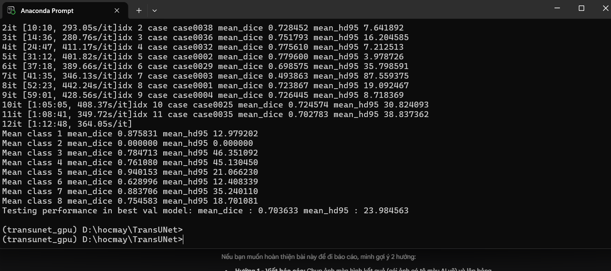
(transunet_gpu) D:\hocmay\TransUNet>python test.py --dataset Synapse --vit_name R50-ViT-B_16 --max_epochs 150 --img_size 224 --batch_size 4 --is_savenii
Namespace(volume_path='../data/Synapse/test_vol_h5', dataset='Synapse', num_classes=9, list_dir='./lists/lists_Synapse', max_iterations=20000, max_epochs=150, batch_size=4, img_size=224, is_savenii=True, n_skip=3, vit_name='R50-ViT-B_16', test_save_dir='../predictions', deterministic=1, base_lr=0.01, seed=1234, vit_patches_size=16, Dataset=<class 'datasets.dataset_synapse.Synapse_dataset'>, z_spacing=1, is_pretrain=True, exp='TU_Synapse224')
TU_pretrain_R50-ViT-B_16_skip3_epo150_bs4_224
12 test iterations per epoch
0it [00:00, ?it/s]idx 0 case case0008 mean_dice 0.546194 mean_hd95 11.045968
1it [06:14, 374.15s/it]idx 1 case case0022 mean_dice 0.791837 mean_hd95 20.900818
2it [10:10, 293.05s/it]idx 2 case case0038 mean_dice 0.728452 mean_hd95 7.641892
3it [14:36, 280.76s/it]idx 3 case case0036 mean_dice 0.751793 mean_hd95 16.204585
4it [24:47, 411.17s/it]idx 4 case case0032 mean_dice 0.775610 mean_hd95 7.212513
5it [31:12, 401.82s/it]idx 5 case case0002 mean_dice 0.779600 mean_hd95 3.978726
6it [37:18, 389.66s/it]idx 6 case case0029 mean_dice 0.698575 mean_hd95 35.798591
7it [41:35, 346.13s/it]idx 7 case case0003 mean_dice 0.493863 mean_hd95 87.559375
8it [52:23, 442.24s/it]idx 8 case case0001 mean_dice 0.723867 mean_hd95 19.092467
9it [59:01, 428.56s/it]idx 9 case case0004 mean_dice 0.726445 mean_hd95 8.718369
10it [1:05:05, 408.37s/it]idx 10 case case0025 mean_dice 0.724574 mean_hd95 30.824093
11it [1:08:41, 349.72s/it]idx 11 case case0035 mean_dice 0.702783 mean_hd95 38.837362
12it [1:12:48, 364.05s/it]
Mean class 1 mean_dice 0.875831 mean_hd95 12.979202
Mean class 2 mean_dice 0.000000 mean_hd95 0.000000
Mean class 3 mean_dice 0.784713 mean_hd95 46.351092
Mean class 4 mean_dice 0.761080 mean_hd95 45.130450
Mean class 5 mean_dice 0.940153 mean_hd95 21.066230
Mean class 6 mean_dice 0.628996 mean_hd95 12.408339
Mean class 7 mean_dice 0.883706 mean_hd95 35.240110
Mean class 8 mean_dice 0.754583 mean_hd95 18.701081
Testing performance in best val model: mean_dice : 0.703633 mean_hd95 : 23.984563

(transunet_gpu) D:\hocmay\TransUNet>
(transunet_gpu) D:\hocmay\TransUNet>

