Assignment task 2

Group : SE03

Class : CC01

Task 2.1. Draw an activity diagram to capture Major (not all) functional requirements of the desired system.

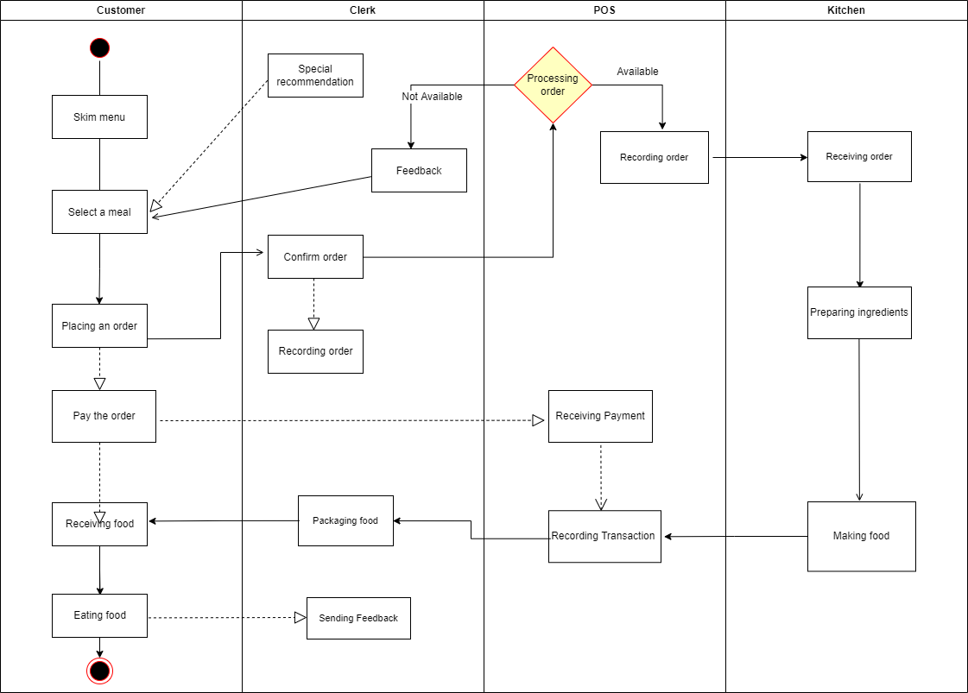

Task 2.2. Draw a sequence diagram for use-case in Task 1.3.