Table of Contents

Missing Person Detection on the Edge — Project Report
Team project for the Intelligent Edge System course.

Project overview
We built a system that scans a camera feed (or an uploaded video) for people, checks whether any of them match a short “missing persons” database, and raises an alert when it finds one. The whole pipeline runs locally, which matters for this course: we wanted to show that a practical surveillance tool can work on edge hardware without streaming every frame to a cloud service.
The output looks like this:
Morgan Freeman | Scarlett Johansson
 | 
Transition WATCHING → LOCKED at ~53% (peak 63%) | Low-confidence demo, LOCKED at ~37%
The orange box is the system accumulating evidence (WATCHING), the red box is a confirmed lock, and the inset in the bottom-right is a small tactical view with a trail for each locked target.

Why edge and not cloud
Two reasons this fits an edge deployment better than a hosted API:
- Latency. Even at 10 FPS capture, a round trip to a cloud inference service adds 150–400 ms per frame. For a tracking system, that is the difference between a bbox that sticks to the person and one that lags half a step behind.
- Privacy and connectivity. Video of people in a public space is sensitive. Keeping inference on-device means the raw frames never leave the network, and the system still works when the link is down. It just can’t report outward — which is acceptable for a scanner that still records locally.
The whole thing runs on CPU on our development machines (Mac and Linux), with no GPU required. Every model we picked is small enough to load in a few seconds and execute in tens of milliseconds per frame.

System architecture
┌─────────────────┐
camera │ │ annotated
/ video ─┤ Edge Pipeline ├─► frames + events
/ file │ │ (WebSocket / HTTP)
└───────┬─────────┘
│
┌────────┼─────────┬──────────────┐
▼ ▼ ▼ ▼
YOLOv8 ArcFace ByteTrack State Machine
(persons)(faces + (identity (IDLE → WATCHING
embeddings)persistence) → LOCKED)
Every processed frame flows through the four stages left-to-right. The state machine sits on top of ByteTrack so that noisy per-frame similarities become a stable decision about who is on screen, not just what scores we saw this millisecond.

The AI models we used
We reused three open models rather than training our own. For a semester project that lets us focus engineering time on integration and on the logic that ties everything together.

1. Person detection — YOLOv8n
YOLOv8 is a single-shot detector from Ultralytics. Single-shot means one forward pass through the network produces all bounding-box predictions at once — there’s no separate region proposal network like in Faster R-CNN. The variant we use, yolov8n (“nano”), has around 3.2 M parameters and is designed for CPU / edge inference.
At a high level the model looks like this:
input image (640×640)
│
▼
CSPDarknet backbone → multi-scale feature maps
│
▼
PAN-FPN neck → fused features at 3 resolutions
│
▼
anchor-free head → (bbox, class, confidence) per grid cell
│
▼
NMS + threshold → final person bounding boxes
We only use the person class (COCO class 0) and throw away everything else. In our config, YOLO_CONFIDENCE_THRESHOLD = 0.5 is the minimum score for a detection to survive.

2. Face detection + embeddings — InsightFace (buffalo_l)
For every person bbox, we crop that region and hand it to InsightFace. The buffalo_l bundle is actually two networks glued together:
- RetinaFace for face detection inside the crop. It outputs a face bounding box plus 5 landmarks (eyes, nose, mouth corners). Those landmarks are used to align the face into a canonical pose before the embedding step, which matters a lot for matching.
- ArcFace (ResNet100) for the actual embedding. The aligned 112×112 face goes through a ResNet-100 backbone trained with the ArcFace loss. The output is a 512-dimensional vector normalised to the unit sphere.
ArcFace’s key idea is an additive angular margin in the loss function: during training it pushes the angle between different identities apart by a fixed margin while pulling same-identity samples together. The practical effect is that cosine similarity between normalised embeddings becomes a very clean similarity signal. Same person, same lighting, different pose ≈ 0.5–0.7. Different person ≈ around 0.
We precompute one embedding per reference photo of each missing person and store them in embeddings.pkl. At runtime we compare the current face embedding against all stored embeddings with cosine similarity — the best match is what drives the state machine.
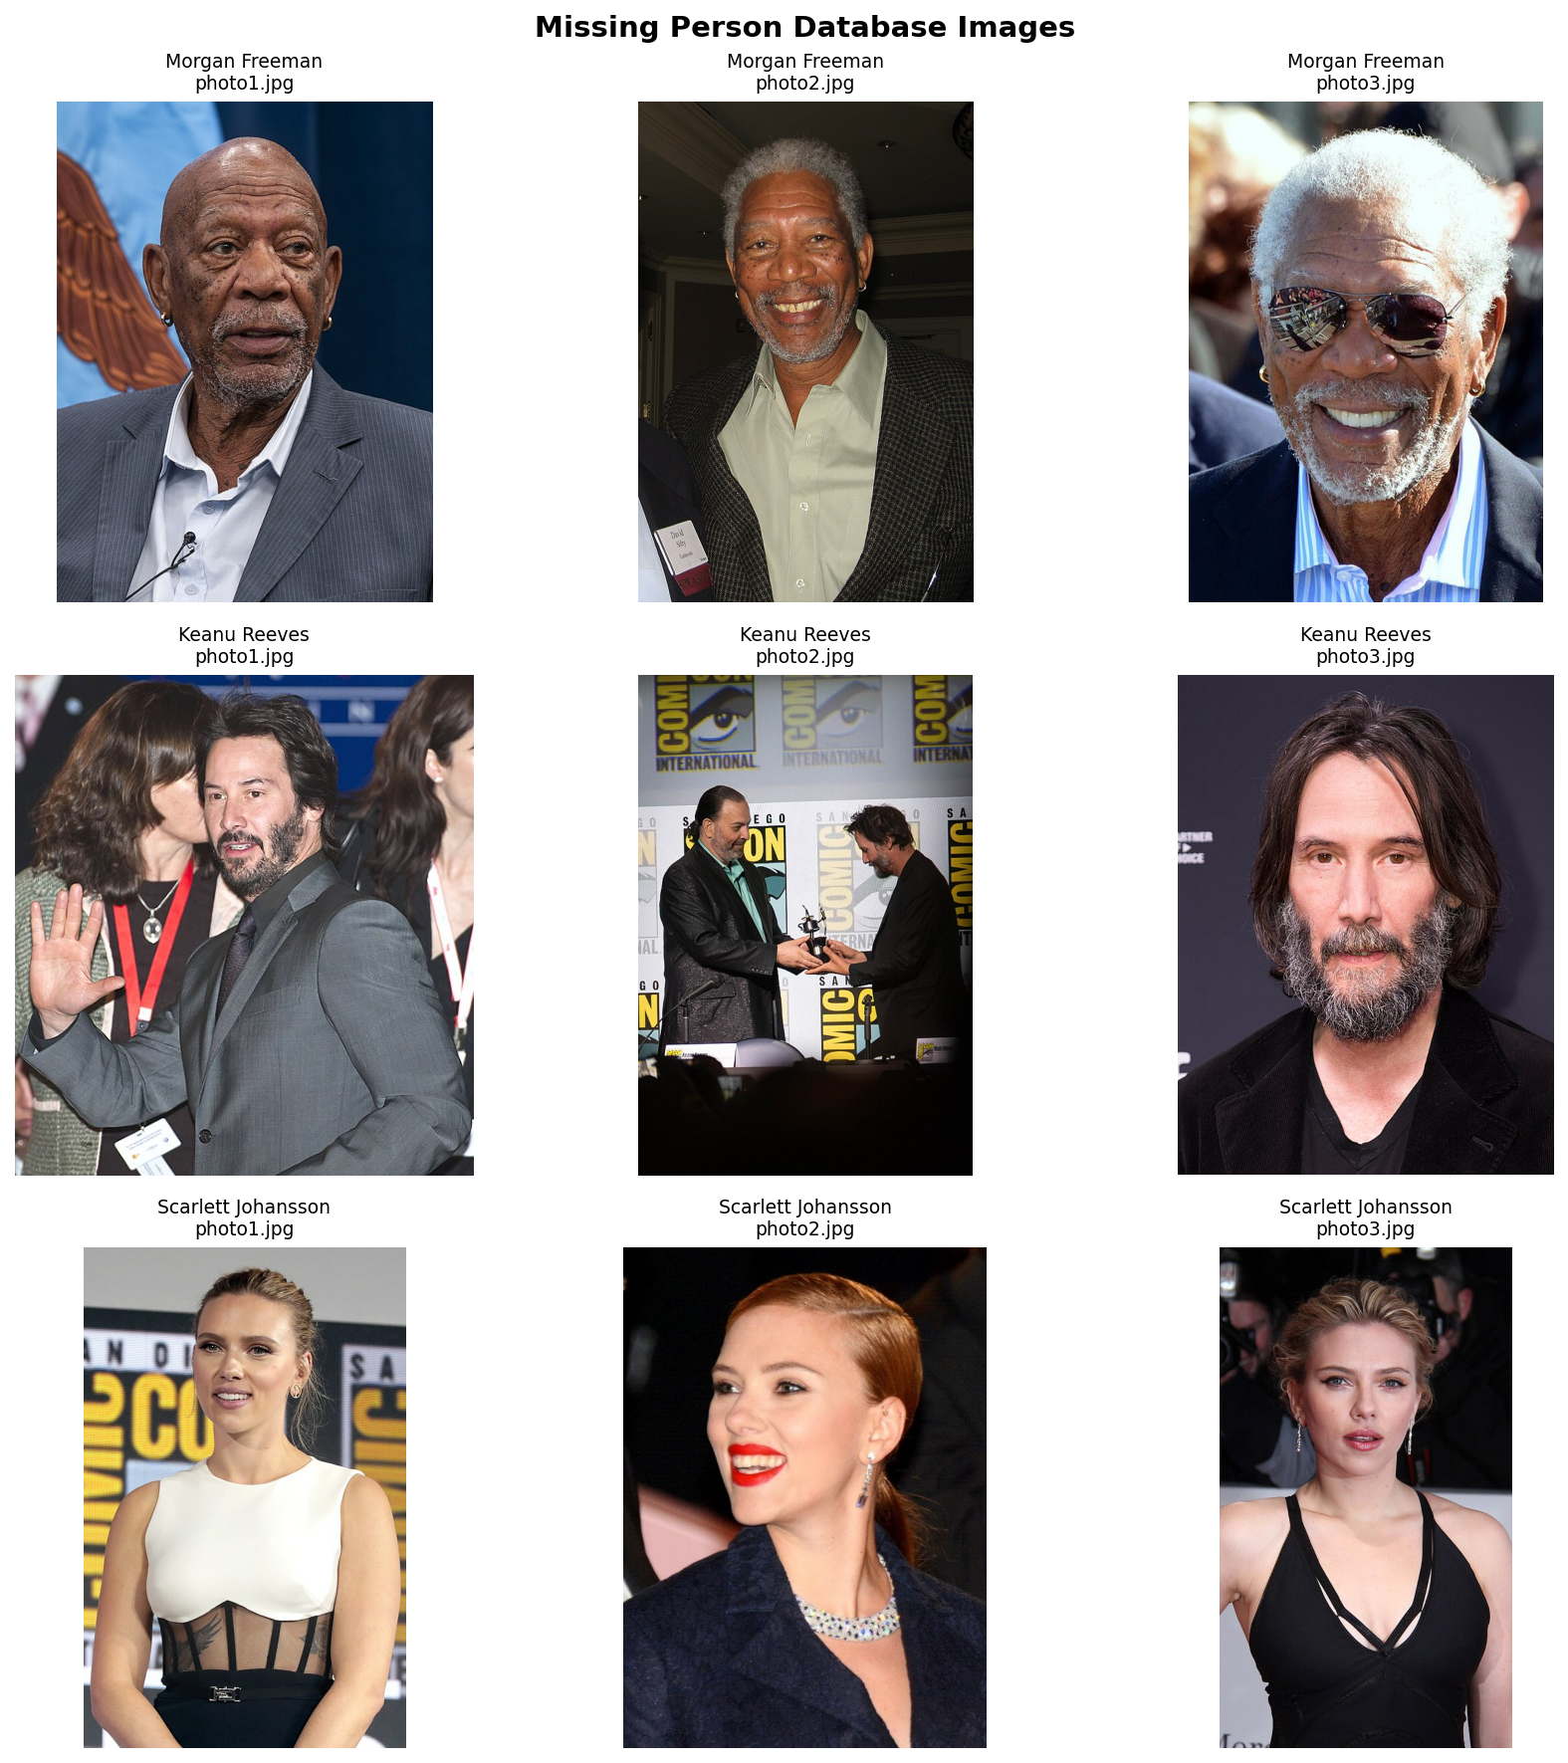
database overview
Reference database used for evaluation: three missing persons with three photos each.
How well-separated are those embeddings? We measured intra-person vs. inter-person cosine similarity on our database:
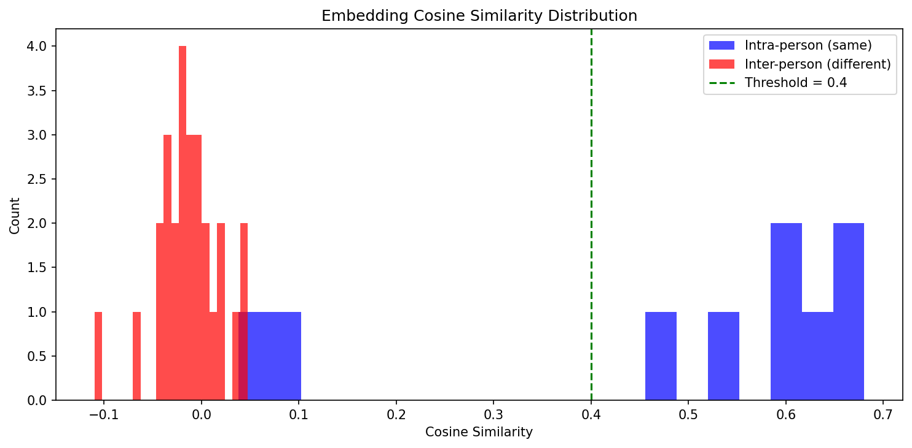
similarity distribution
The blue distribution (same person across photos) sits well above the red distribution (different persons). The max inter-person similarity on our set is around 0.05, the minimum intra-person similarity is around 0.04 (one of the Keanu Reeves photos is really dissimilar from the others). We picked 0.4 as the default recognition threshold — comfortably above all the inter-person noise and below most of the intra-person signal.
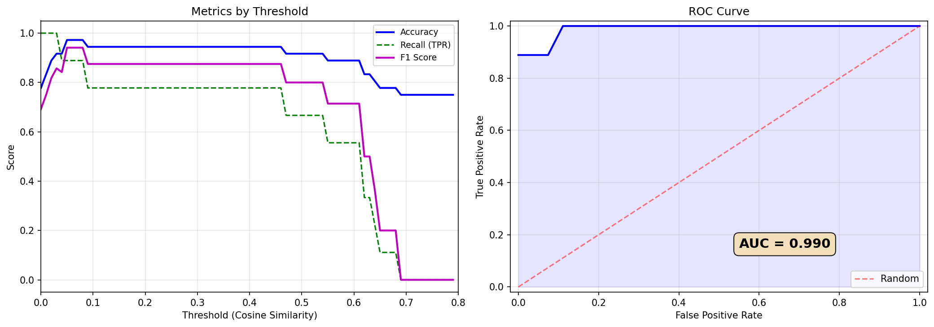
threshold tuning
F1-optimal threshold would be 0.20, but we intentionally chose a more conservative 0.40 to keep false positives low on unknown strangers (which the closed-set evaluation can’t capture).

3. Multi-object tracking — ByteTrack
ByteTrack turns per-frame detections into consistent track IDs. For each active track it runs:
- a Kalman filter that predicts where the track will be next, using a constant-velocity motion model,
- a two-stage matching step that associates incoming detections to existing tracks by IoU. High-confidence detections are matched first; the surviving low-confidence detections get a second chance against unmatched tracks. This is the “BYTE” idea — don’t throw away weak detections, they often keep a track alive through short occlusions.
- a lost-track buffer that keeps an un-matched track alive for a configurable number of frames before retiring its ID.
We use the implementation from the supervision library and feed it only the YOLO person detections.

Our state machine on top
ByteTrack gives us stable IDs. Face matching gives us noisy per-frame similarities. By themselves neither is enough — we still need to decide when the system should say “this track is person X”. So we wrote a small state machine per track:
similarity ≥ 0.35
IDLE ──────────────────────────────► WATCHING
▲ (2 consecutive frames) │
│ │ weighted ≥ 0.40
│ │ AND peak ≥ 0.50
│ ▼
│ LOCKED
│ │
│ re-verify fails / bbox lost │
└─────────────────────────────────────┘
Notable design choices:
- Re-verify instead of re-score. Once LOCKED, we don’t update the identity per frame. Every 30 processed frames we simply check that the face still matches. This stops the label from flickering and makes the track behave like a soft lock rather than a hard per-frame classifier.
- Two separate exit conditions. Re-verify failure (3 consecutive low checks) handles the “wrong person but the same track slot” case. A 2-second bbox-lost timeout handles the “person briefly occluded” case. We also drop the track immediately if more than 60% of its bbox leaves the image — we know they’re gone, no need to wait.
- Identity freeze. The person name, ID, and best-similarity are frozen the moment a track enters LOCKED. Re-verification can unseat the lock, but it can’t rename it.

Problems we hit
Three worth calling out because the fixes were more interesting than the bugs.

“My face got labelled as Morgan Freeman”
When one of us held up a printed photo of Morgan Freeman, YOLO correctly detected two persons (the photo and the person holding it). Face detection found two faces. Our tracker then labelled both tracks as Morgan, because any face whose bbox overlapped a track bbox by ≥30% IoU was a candidate, and both tracks picked the higher-scoring face.
The fix was to treat face→track assignment as a 1:1 bipartite assignment, scored by containment (how much of the face bbox sits inside the person bbox), tie-broken by face-centre to track-centre distance. Once each face can only be used by one track, the small photo bbox “claims” Morgan, and the person-holding-the-photo gets their own face back.

Velocity drift in predicted bboxes
Our initial prediction-between-detections logic overwrote last_bbox with the predicted position on every skipped frame. The next real detection’s velocity was then computed from a predicted point, not an actual one. The bboxes visibly lagged behind fast-moving people.
We split the state into two fields: last_detection_bbox (only the detector writes to this) and last_bbox (used for drawing, may be a prediction). Velocity is derived only from actual detections, so it stays accurate across skipped frames.

ByteTrack recycling track IDs
ByteTrack reuses track IDs after its lost buffer expires. If person A walks out and person B walks in within about a second, B can get A’s old ID. Our state kept the LOCKED identity associated with that slot, so B would be incorrectly labelled as A for several frames until re-verify caught up.
The fix detects the tell-tale signature of an ID being recycled: a visual gap of ≥ 0.4 s combined with a spatial jump larger than 1.5 bbox-diagonals. When we see that pattern we wipe the slot entirely before treating the new detection, so B starts from a clean IDLE state.

The web interface
We wrapped the pipeline in a FastAPI backend with a plain HTML / JS frontend. Three pages:
- Dashboard (/) — live WebSocket stream of the annotated camera feed, plus telemetry, confidence gauge, and a Leaflet-based tactical map.
- Quick training (/training) — drag-drop face photos for a new missing person and trigger an embedding rebuild without leaving the browser.
- Upload video (/upload) — upload a local video file, the backend runs the same pipeline headlessly and sends back the annotated output plus a summary.

Tactical map markers
When a track enters LOCKED for the first time, the backend crops the face snapshot, saves it, and broadcasts a lock_event WebSocket message. The frontend adds a Leaflet marker near the user’s current GPS fix (with a small random offset so repeated locks don’t stack on top of each other). Hovering the marker shows a popup with the cropped face image and the exact time the lock happened. One snapshot per lock, not per frame, so the map stays uncluttered.

Evaluation summary
Metric | Value
Person-detection model | YOLOv8n (~3.2 M params)
Face-embedding model | ArcFace ResNet100 (buffalo_l), 512-d
Recognition threshold | 0.40 cosine (conservative)
Intra-person similarity (avg / min) | 0.48 / 0.04
Inter-person similarity (avg / max) | -0.01 / 0.05
Tracking | ByteTrack, lost-buffer 30 frames
LOCKED trigger | weighted ≥ 0.40 AND peak ≥ 0.50
LOCKED re-verify interval | every 30 processed frames
Bbox-lost timeout | 2.0 s
CPU FPS (end-to-end) | ~2–5 processed frames/s

What we learned
The biggest lesson was that identity is a temporal object, not a per-frame decision. Most of the bugs we hit — velocity drift, ID recycling, the photo issue — were all the same class of mistake: state from one moment leaking into another moment it shouldn’t have touched. Once we started treating each track’s lifecycle as a thing to manage explicitly (resetting cleanly on drop, separating detection state from drawing state, freezing identity at the right moment), the pipeline got much more stable without changing any of the models underneath.
On the edge-system side, we also got a practical feel for the tradeoff between detection frequency and tracking smoothness. Running YOLO every frame gives you perfect bboxes but halves your frame rate. Running it every five frames is fast but the boxes jump. The middle path — decent detection frequency plus a motion model and a state machine — is what lets a small model behave like a more expensive one.

Limitations and future work
- No liveness detection. The 1:1 face-to-track fix helps when the photo is visible as a separate person, but it can’t stop someone holding a photo inside their own silhouette. A real deployment would need a PAD (Presentation Attack Detection) model.
- CPU-only. Our numbers are CPU-only. Moving to a small GPU (or even Apple’s Neural Engine via CoreML) should push us past real-time without changing the pipeline.
- GPS comes from the browser. The tactical map uses the browser’s geolocation as a stand-in for the camera’s real position. For a drone / fixed camera deployment this would come from the flight controller or a static config.
- Evaluation is closed-set. We can measure that we separate persons in our database well, but we haven’t measured how often strangers get mis-classified as one of them in the wild.

References
- YOLOv8, Ultralytics — single-stage anchor-free person detection
- InsightFace (buffalo_l) — RetinaFace + ArcFace ResNet100, 512-d normalised embeddings
- ByteTrack (via the supervision library) — Kalman + Hungarian assignment with the BYTE two-stage matching trick
- FastAPI + Uvicorn — backend HTTP + WebSocket server
- Leaflet + OpenStreetMap — tactical map tiles and markers
All thresholds, frame-skip values, and tracking parameters live in config.py, so they can be tuned for a new camera or deployment without touching the pipeline code.

