HowTo
create unit tests with VCAR

Version: 1
Protection Class: ZFLS confidential

RELEASED

Last Review
Version | Full Name | Department | Phone | Date
1 | Holger Ehm | PC-DESC | 4556 | 21.11.2013

Change history

Vers. | Author | Department | Phone | Date | Changes | Reason
1 | Arthur Adler | PS-DESC | 4607 | 2013-04-09 | Initial version | Software Project 4.0

Table of contents
1 Change history 2
2 Table of contents 3
3 Introduction 4
3.1 VCAR overview 4
4 Create VCAR tests 5
4.1 Preparing 5
4.1 Testarossa 8
4.1.1 Input (*_ti.txt) 9
4.1.1 Output Reference (*_tr.odat) 10
4.1.2 Output (*_to.dat) 11
5 Execute VCAR tests 13
5.1 Start 13
5.1 Best practice 14
6 Measure code coverage 15
7 Code example 17
7.1 EngineRun_tc.c 17
7.1 EngineRun_th.h 17

Creation of unit test specification
Goal of the unit test is to verify the consistency of the code to the unit specification. The unit specification consists of unit requirements (design requirements) and the unit design or unit model. Therefore as first step testcases must be specified that cover the specified functionality of the unit under test. Each testcase in the testspecification is structured in the following way:

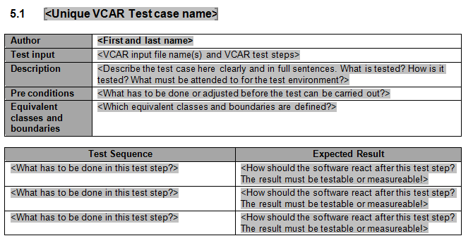

Field | Description of content
Unique test case name | Unique logical name of test case. E.g. “Read & write access to NVRAM”
Author | Name of developer who did the last change this test case
Test input | File name of test input file, where this testcase is implemented.
Description | Short description of test case – what is tested?
Pre conditions | Possible pre-conditions like init functions that must be called or or initial states that must be reached in before
Equivalent classes & boundaries | In order not to test each input value combination define equivalent classes and boundaries:  Equivalent classes are value intervalls where within the functionality under test behave the same. Beetween this type of equivalent classes there are boundaries.  Another example of equivalent classes are intervalls defined to check the form of a characteristic. There are no boundaries beetween equivalent classes of this type.  Example:  Equivalent classes:  Value A / Value B: [0..100 / x] , [101..255 / 0],  [101..255 / >0]  Boundaries:  Value A: 100-101  Value B: 0-1

Test case implementation (VCAR)

The VCAR is a tool for implementation and execution of module tests. It is in demand by the defined software standard process and checks whether the specified functionality of a module was implemented correctly and completely. Also in focus is the behaviour of the examined functionality referred to the input and output (white box test). Thereby the verification of the tested module is done and the tester gets the protocol of the test results.

VCAR is meant to be used in the command line by executing predefined targets. This triggers the environment for the module test. A test driver will be generated to stimulate and execute the test objects (functions to be tested). Prepared VCAR code, which has first to be built in at defined points in the code, will be proceeded.

The VCAR testing environment contains following parts:

- Testarossa Excel-GUI for manual test execution
- *_ti.txt VCAR-Input file with test cases
- *_th.h or *_tc.c Test module/header file
- *_to.dat VCAR-Output file protocols the test results
- *_tr.odat Reference for the expected test results
- vcar.exe Generated driver for the current tests
- gnucar.bat Batchfile for the working with Testarossa
- Module to be tested *.c and *.h files

Create VCAR tests

This chapter contains creation of test files for the VCAR.

Preparing

First there is the module to be tested. So the user has an implemented *.c file and *.h file. For testing with VCAR these sources have to be prepared in special way. In this files few #define macros have to be inserted at certain positions. At the later stage these macros do code insertions in the tested files. These testing elements should be managed in a test file, e.g. myfile_th.h oder myfile_tc.c, see also the chapter with code examples.

C-file contains:
- T_CFILE – definitions which are globally valid in the present module
- T_MYFUNC_START and T_ MYFUNC _END – definitions which are locally valid for the function they are build in (MYFUNC is the name of a function, see examples below)

H-file contains:
- T_HFILE – definitions which are globally valid in the present module
- T_ MYFUNC _START and T_ MYFUNC _END – definitions which are locally valid for the function they are build in (MYFUNC is the name of a function, see examples below)

In the most cases a test header like myfile_th.h does the needed job. It contains the defined macros that the test driver subsequently merges in the module to be tested.

- T_CFILE global defines for *.c
- T_HFILE global defines for *.h
- T_ MYFUNC _START local defines for the present function at the start
- T_ MYFUNC _END local defines for the present function at the end

Here are some examples how it could be done in the code:

T_CFILE
#if defined (T_CFILE)
tSI16 TestVariable;
tSI16 TestVariable2;
#undef T_CFILE
#endif

T_HFILE
#if defined (T_HFILE)
#define TESTCONST 14
#undef T_HFILE
#endif

T_ MYFUNC _START
#if defined (T_MYFUNC_START)
local_var = test_var; //Set some var to test value
#undef T_MYFUNC_START
#endif

T_ MYFUNC _END
#if defined (T_MYFUNC_END)
result_var = local_var; //Get the local result to the glocal test variable
#undef T_MYFUNC_END
#endif

After the sources and according test files (header/module) are created and prepared, they must be introduced to the VCAR test driver. It calls declared functions which also have to be implemented by the software tester:

void init_test_object(void) {}
void terminate_test_object(void) {}
tUI32 zTestnummer_gdu32;
void cyclic_test_object(void)
{
switch (zTestnummer_gdu32)
{
case 0:
{
My_function();
break;
}
case 1:
{
My_function_2();
break;
}
default:
{
break;
}
}
}

The init and terminate functions offer the possibility for random pre or post actions for a test run. For the standard test these features are usually empty. The more interesting function is the cyclic. That is the location for calling the functions to be tested from the source module. One global switch variable e.g. zTestnummer_gdu32 navigates through the available functions to be tested. The value of this variable must be set in the test input file. For more information see the chapter Testarossa-Input 5.2.1. In the given example the software tester must set the switch variable to “0”. Then the My_function() will be called with defined test values.

If the tested component consists of two or more modules to be tested, then these three functions should be implemented only in one test header/module. Otherwise VCAR generates error. The picture below shows a little overview how the code parts are handled.

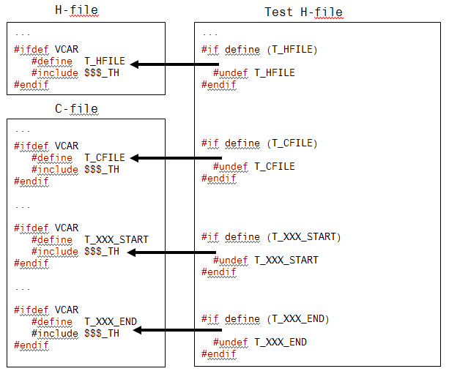

After the test header is done, VCAR needs the input and output (reference) information which is handled by Testarossa.

Testarossa

Testarossa is an Excel tool, which is usually set up in the environment and needs to feed the vcar.exe with input (*_ti.txt) and output-reference (*_tr.odat) files. This tool is a GUI for manual management of the VCAR tests. Its duty is to handle, format and summary the test input values and also reference for the output. Next picture shows the main sheet of the tool.

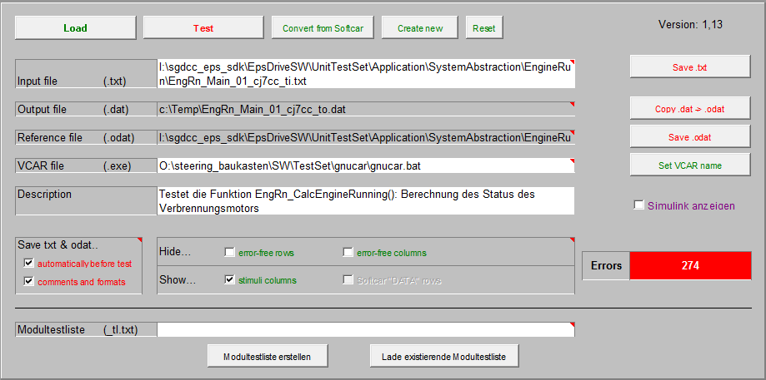

The configuration of the test happens in different Excel sheets (tabs) like in the following picture.

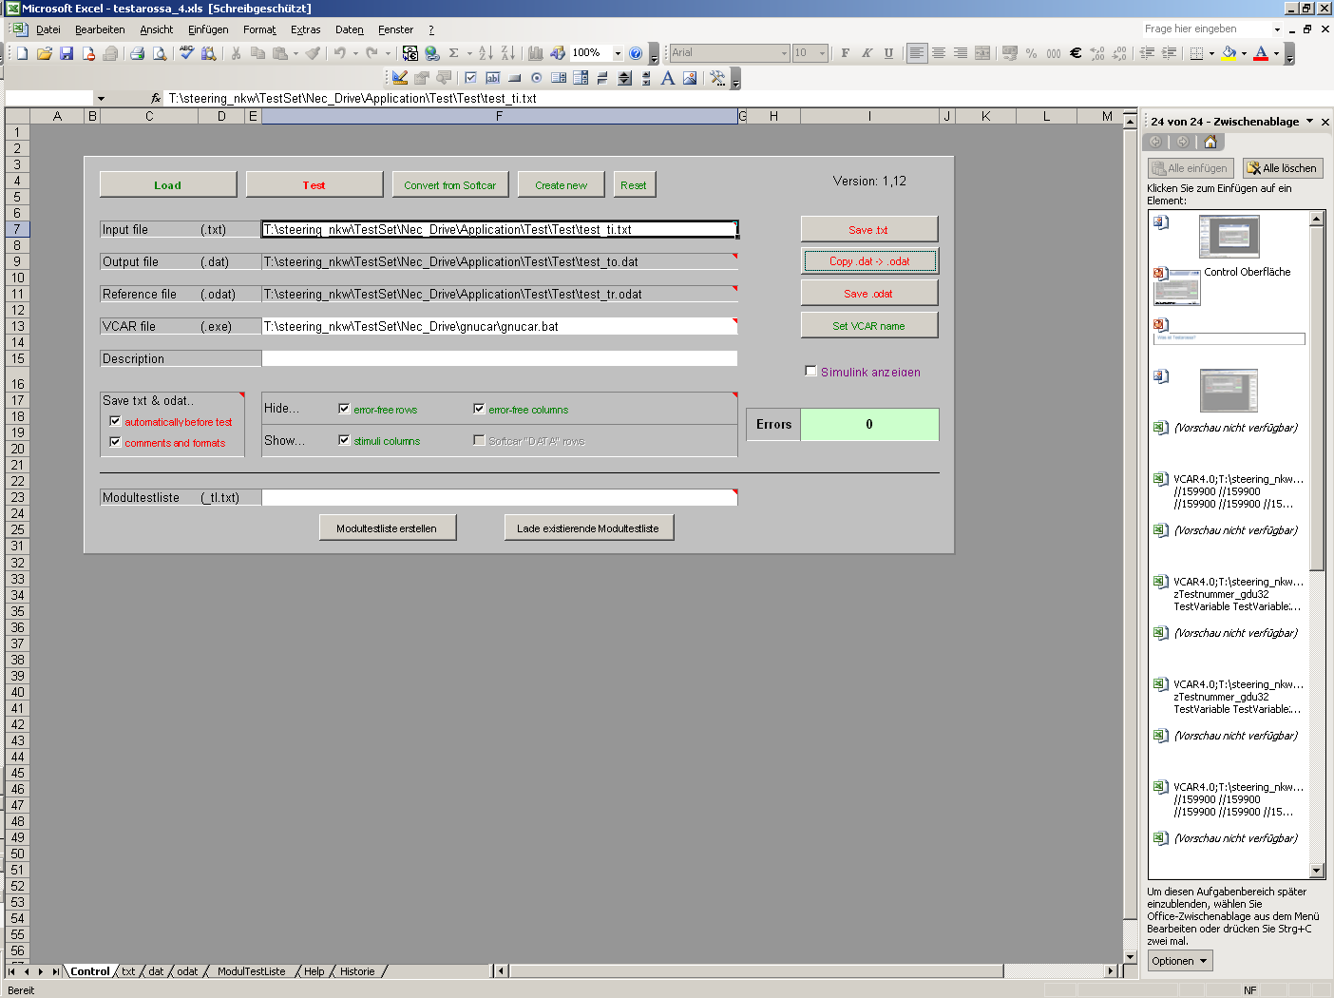

- Control main sheet of the GUI
- txt input test file
- dat output test file
- odat output reference file
- ModulTestliste optional test list (contains all *_ti.txt)
- Help short help bar
- Historie change history

Input (*_ti.txt)

The next picture shows the txt file loaded by Testarossa.
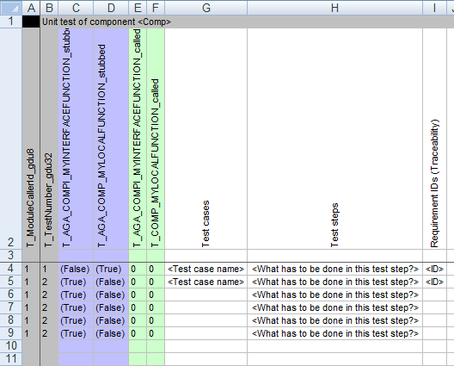

In the second line of the picture all variables are listed that are needed for actual test. The example variables T_XXX_stubbed and T_XXX_called within colored columns are for testing purpose. They are used if the software tester wants a function to be called/stubbed or not. The column “Test cases” has to be filled and reference the unique VCAR test case name from the software unit test specification for the component/module to be tested. In the column “Test steps” short descriptions or just head words describing the test steps must be added. The column “Requirement IDs(Traceability)” ensures the traceability to the unit requirements (design requirements) and unit design. There the ID of the corresponding requirement(s) and if detailed information is given in the module design the diagram or chapter name must be given.

The software tester has to set the values appropriate to the meant test case. Starting with the fourth line and then going downwards. The usual test cases are about boundary of the data type or some critical points in the function. For example a test of an if-statement must set the input variable to the possible values:

if (myVariable >= 2)
{
My_function();
{

The software tester has to setup different values for the variable used in the if-statement.

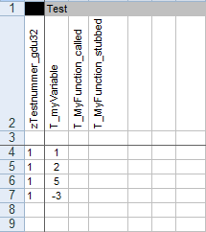

Some of the variables need the same value for the whole testing cycle or at least few rows and could be left blank like in the example picture above for the variable T_My_Function_called. That means the VCAR uses the last known value of the variable (at least default). If all work at this point is finished then the output-reference file must be proceeded.

Output Reference (*_tr.odat)

The next picture shows an example of the odat (output reference) file loaded by Testarossa.

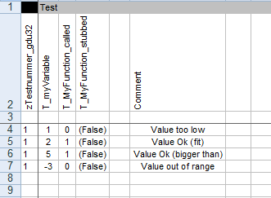

The reference values are needed for each variable and test. The software tester specifies the expected results with the intended use of the function (or its parts) to be tested. It is highly recommended to write some comment information for each test line.

Output (*_to.dat)

The next picture shows an existing component dat (output) file loaded by Testarossa.

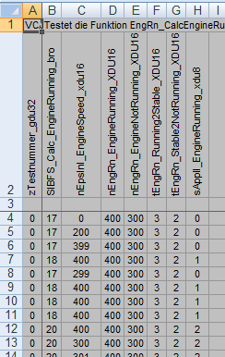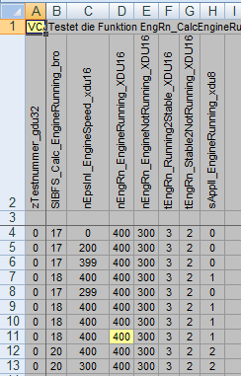

In matters of the generated output Testarossa takes this reference values from odat file and looks for different results. If everything is fine, then the dat sheet is grey colored like in the left picture. In other case the mismatch cells are shown yellow. That means VCAR returned some result value that was not intended by the software tester. The consequence of a mismatch for later test steps will be no 100% code coverage.

Execute VCAR tests

The content of this chapter describes the procedure of executing the VCAR test.

Start

The trigger which starts the execution is prompted in the command line by user. That is step one. For example by typing “make vcar”. This target is defined in the make environment and could differ in some projects. If no errors occur, then few files are generated (some temps, object and the vcar.exe etc.) and the testing can proceed. The step two is done by the software tester with click on the “Test” button in Testarossa Control sheet. The tool checks all needed paths and files (input, reference, formats etc.) and then the process begin.

The next picture shows the procedure within VCAR schematically.

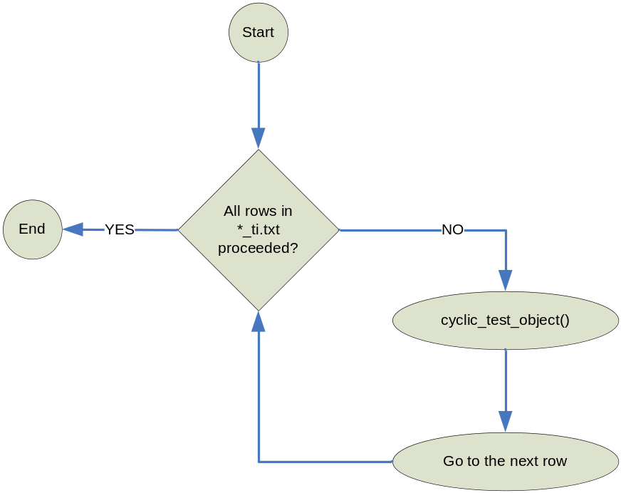

VCAR gets the declared *_ti.txt file and looks for the first input row. The input value which was found is copied to RAM. The software processes to the end of the function to be tested (to the return-expression). VCAR gets back the result value from RAM and writes to the output file. Then the cycle starts with the next input row till there are no more lines left.

After VCAR is done with one test input file, it generates the output regarding environment path. Testarossa shows the results of the current run.

Best practice

The management of big modules shows that it is reasonable to split one module to be tested in few separate input (and appropriate reference) files. If one input file contains too many test rows of one function or many different functions, the understanding and overview of such tests gets limited.

The next hint is about description of the tests in the input and output (reference) file. The more and easier is the description text (test steps) the faster the reviewer or next tester gets the idea of the current test. Don’t hesitate to use some colours or other formatting features to highline the important parts of the test.

If there are some errors in the input or reference file then the Testarossa shows usually hints in the output (dat) sheet. Also possible information could be found in the echo of the command window where the vcar target was build. In this case Testarossa doesn’t show any error, it is just blank in the output sheet.

Some functions leads to abrupt cut of the output file without warning or other error message. The problem is probable because of the usage of pointers knotted with bad input values or not defined variables.

Measure code coverage

The measurement of the code coverage is also needed by the used software standard process.

Therefore the software tester has to build the regression target for certain component and adjacent the coverage target. Both targets are usually already set up in the environment and could be prompted like this: make regression “xfile=enginerun”.

The make process is now building the appropriate vcar.exe and gets all input files for the test. To do so the make looks for the listings with input files for the given component like myfile_tl.txt or testlist.xml.

An example of the testlist.xml is shown in next picture.

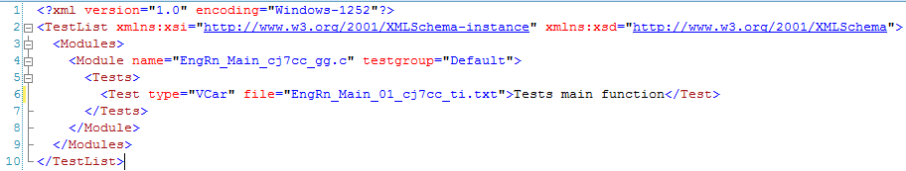

The make tool executes all tests found in the list and generates the output. Usually the results are shown as regression.html containing the VCAR and coverage part. See the next picture.

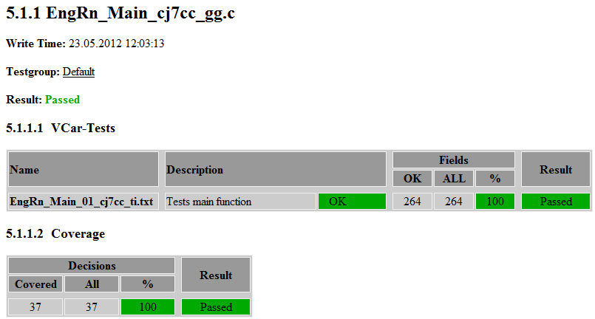

The measurement of the coverage and also its finer exposure is done by the output of the following command: make coverage.

At this point is important to know, that this call have to be placed after regression run. Because the coverage measurement is based on the temporarily files created by the regression command. The generated output shows CTC++ coverage report. That files summary contains information about the instrumentation mode and in accordance to it the coverage of tested functions.

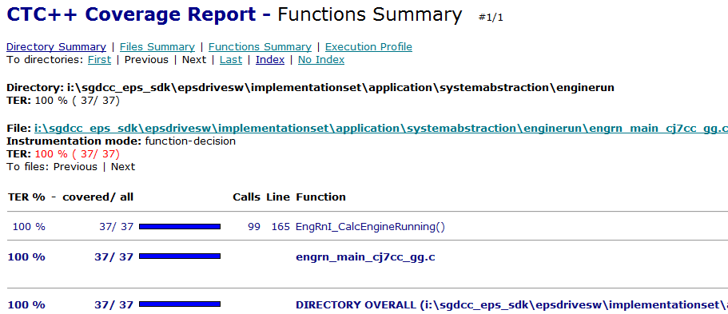

Code example

EngineRun_tc.c

#include "types_aehcc_hh.h"

// Inputs
tUI16 nEpsInI_EngineSpeed_xdu16 = 0;
// Measurements and outputs
tUI8 sApplI_EngineRunning_xdu8 = 0 ;

// Application values
const volatile tUI16 nEngRn_EngineRunning_XDU16 = 400;
const volatile tUI16 nEngRn_EngineNotRunning_XDU16 = 300;
const volatile tUI16 tEngRn_Running2Stable_XDU16 = 4;
const volatile tUI16 tEngRn_Stable2NotRunning_XDU16 = 3;

// Stubbed functions (from other components)
void AscWdI_SetCatastrophicError (void) {}

// cyclic VCAR
tUI32 zTestnummer_gdu32;

void init_test_object(void) {}
void terminate_test_object(void) {}

void cyclic_test_object(void)
{
switch (zTestnummer_gdu32)
{
case 0:
{
EngRnI_CalcEngineRunning();
break;
}

default:
{
break;
}
}
}

EngineRun_th.h

#if defined (T_HFILE)

#undef T_HFILE
#endif

#ifdef T_CFILE

#undef T_CFILE
#endif

/* Function start */
#ifdef T_EngRnI_CalcEngineRunning_START

static tUI16 z_EngRnI_CalcEngineRunning_Calls_tdu16 = 0;
static eBOOL f_EngRnI_CalcEngineRunning_Stubbed_tdb = False;

z_EngRnI_CalcEngineRunning_Calls_tdu16++;

if( f_EngRnI_CalcEngineRunning_Stubbed_tdb )
{
return;
}

#undef T_EngRnI_CalcEngineRunning_START
#endif

/* Function end */
#ifdef T_EngRnI_CalcEngineRunning_END
#undef T_EngRnI_CalcEngineRunning_END
#endif

