- Purpose: We will setup and run free5gc using only 1 dockerfile.
- Docker vs VM: https://geekflare.com/docker-vs-virtual-machine/
- Install Docker: https://docs.docker.com/engine/install/ubuntu/
- Running docker: sudo systemctl start docker
- Run sudo systemctl enable docker
- Run sudo systemctl restart docker
- sudo systemctl unmask docker
sudo systemctl start docker
- Remove all conflict packages: sudo apt remove podman or snap remove podman. https://askubuntu.com/questions/935569/how-to-completely-uninstall-docker
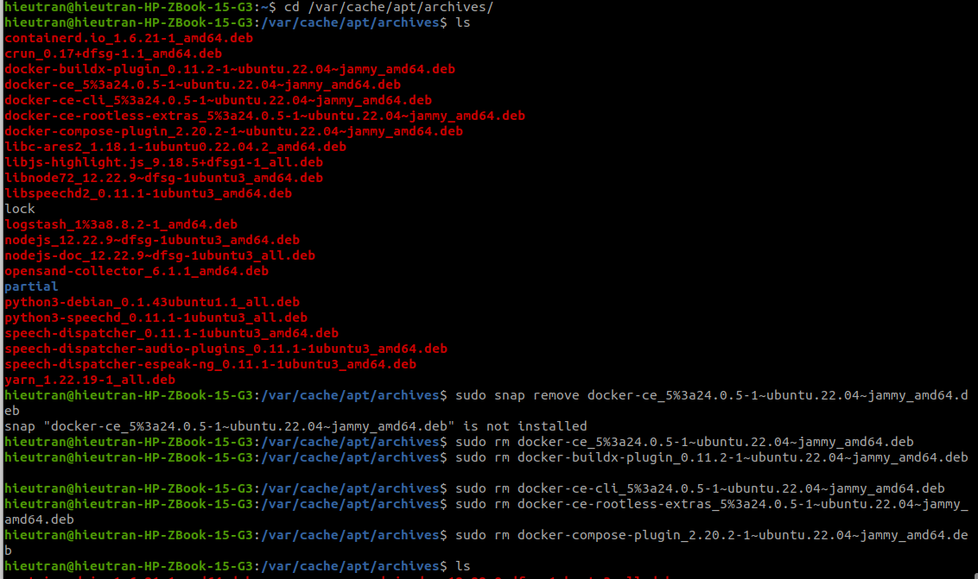
- Totally remove podman to prevent conflict with Docker: check chatGPT

- Create free5gc using dockerfile:
- Create a Dockerfree5gc folder to contain free5gc:
- create Dockferfile in Dockerfree5gc folder.
- Go to chatGPT search Dockerfile Ubuntu 22.04 and copy into Dockerfile
- Building Dockerfile using https://free5gc.org/guide/3-install-free5gc/#a-prerequisites
- Bugs:
- Fail to run docker build -t free5gc:1.0.0 .
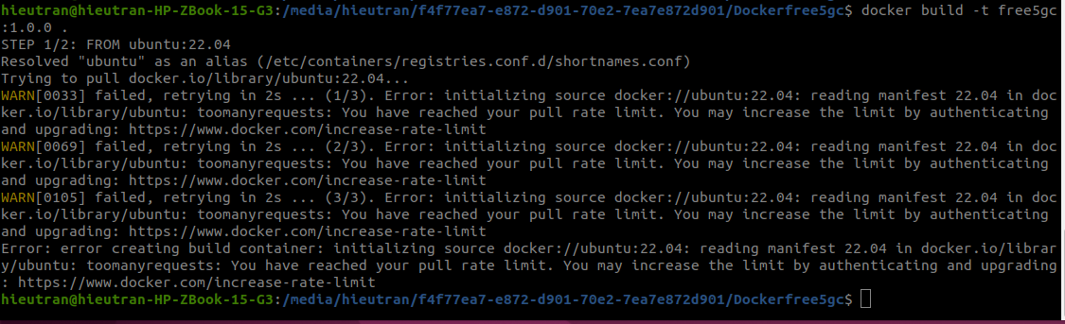
- https://github.com/GoogleContainerTools/kaniko/issues/2342
- Reinstall Docker, remove all conflict packages, e.g., podman
- Error when installing Docker:
- Run Dockerfile at home normally since Nokia has Proxy.
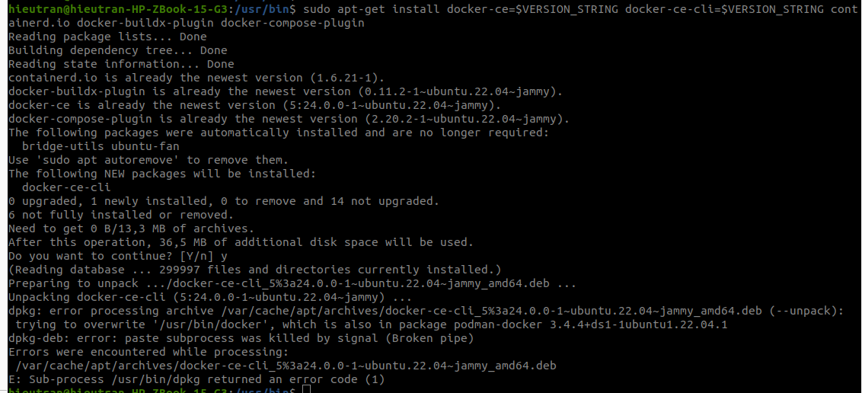
- Copy error to ChatGPT: sudo dpkg -i --force-overwrite /var/cache/apt/archives/docker-ce-cli_5%3a24.0.0-1~ubuntu.22.04~jammy_amd64.deb then we run sudo apt remove podman
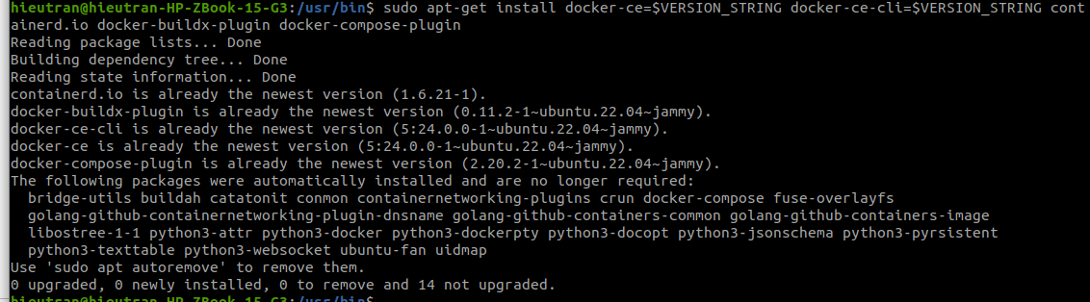
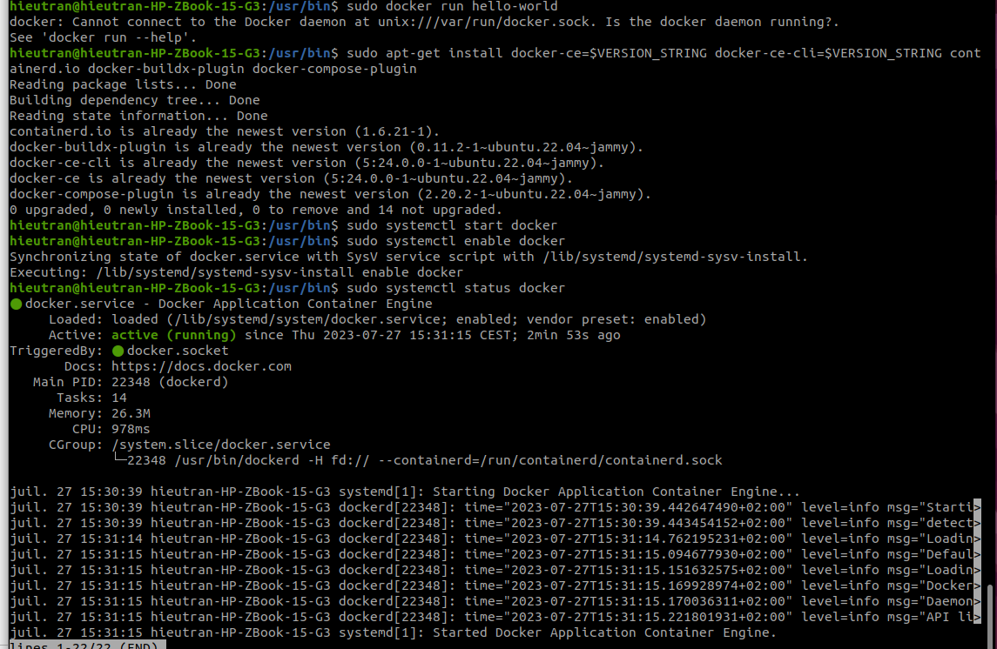
- Cannot connect to Docker Daemon:
  - https://stackoverflow.com/questions/44678725/cannot-connect-to-the-docker-daemon-at-unix-var-run-docker-sock-is-the-docker
- Trial run directly inside Docker to test error:
- docker run -it free5gc:1.0.0 bash
- docker run -t free5gc:1.0.0 sh
- Change Dockerfile from read only to edit: sudo chmod 777 Dockerfile
- Search ChatGPT: sh config for go Ubuntu 22.04
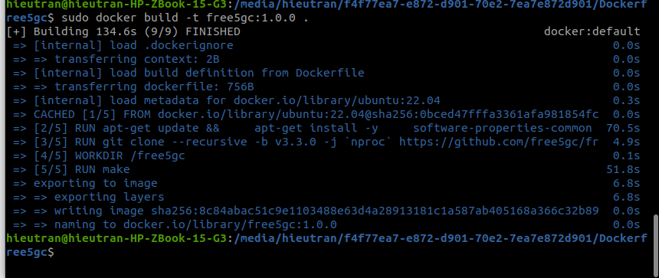
- Test by running docker:sudo docker run -it free5gc:1.0.0 sh then ./run.sh
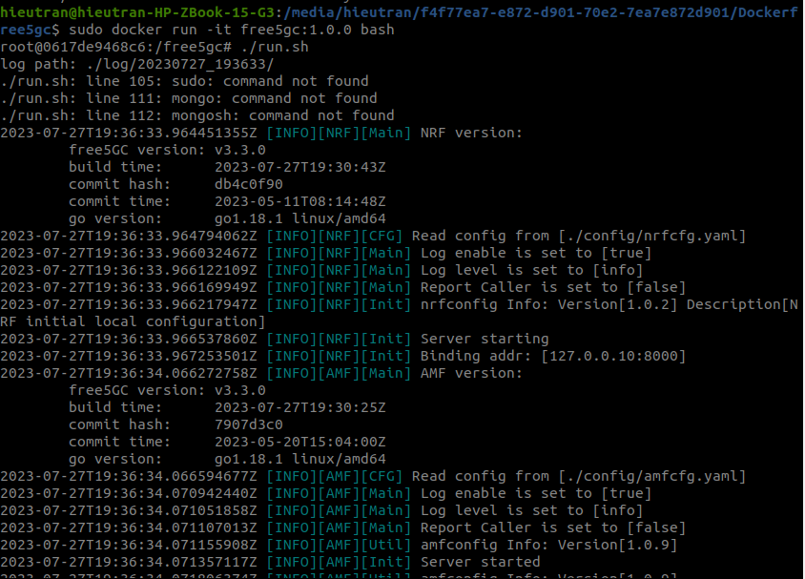
- Build each NF separately:
- Create different folders for Nfs, e.g., AMF, UPF,…
- In each folder copy the Dockerfile and change make to make amf (i.e., name of NF needs to be run).
- Installing Mongodb Ubuntu 22.04: https://www.fosstechnix.com/how-to-install-mongodb-on-ubuntu-22-04-lts/
- Check the order in code/testbeds/saw-ntn/configurations:
  - https://hub.docker.com/r/free5gc/base https://github.com/abousselmi/docker-free5gc
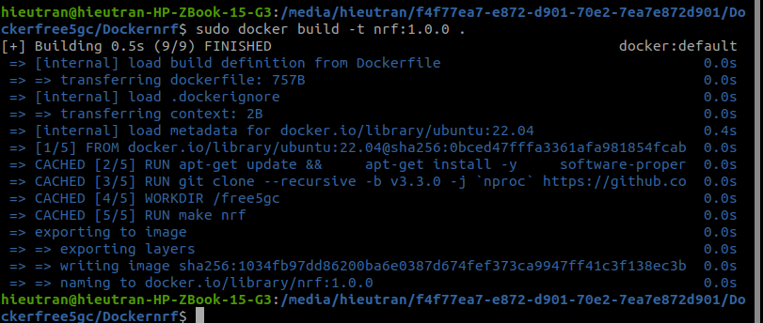
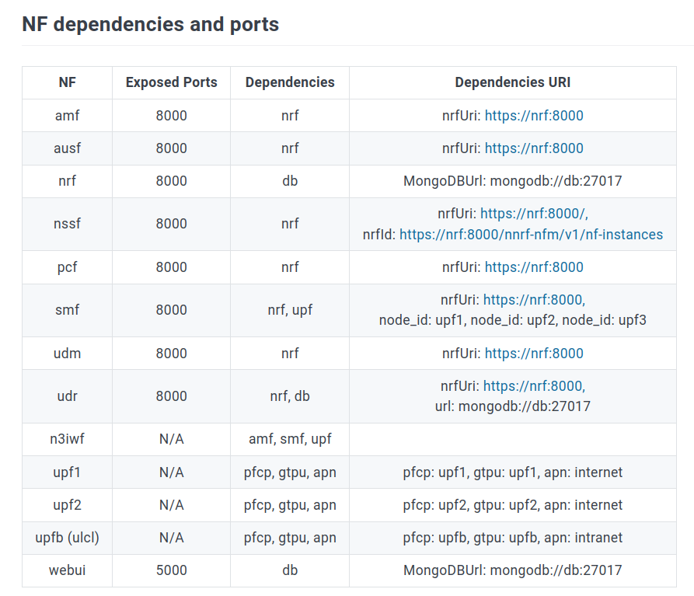
  - nrf, MongodB, upf, amf, smf,
  - nrf → upf → amf → smf → udr → pcf → udm → nssf → ausf →
- After building all docker images, we have: use command sudo docker build -t amf:1.0.0 . To build amf image
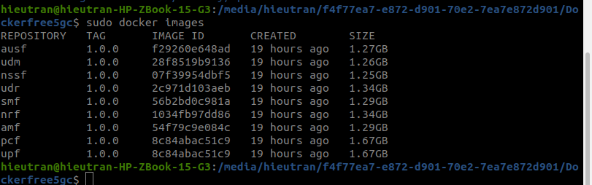
- How to run each NF seperately:
- Check step 7 in https://github.com/free5gc/free5gc-stage-3
- Go into the container to run: sudo docker run -it amf:1.0.0 sh
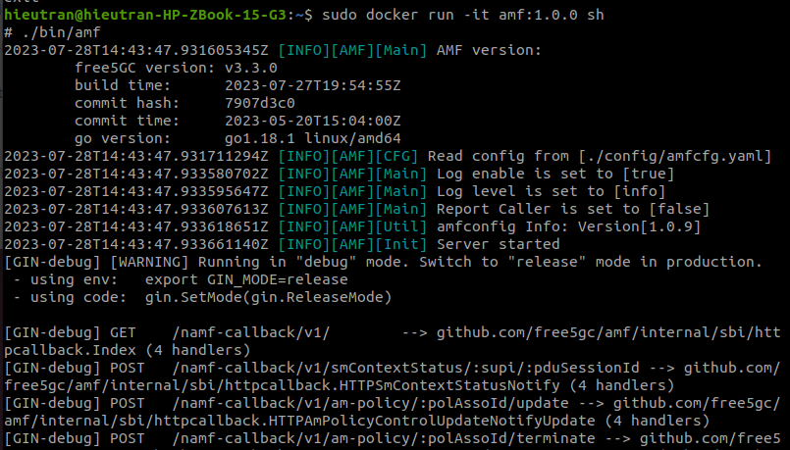
- Run upf error:
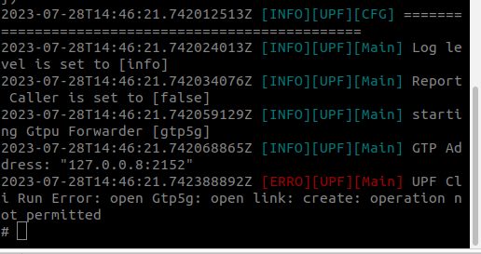
- https://github.com/free5gc/free5gc-stage-3
- https://github.com/free5gc/gtp5g
- https://stackoverflow.com/questions/62455239/making-building-a-kernel-module-inside-a-docker-container
- Error with make install
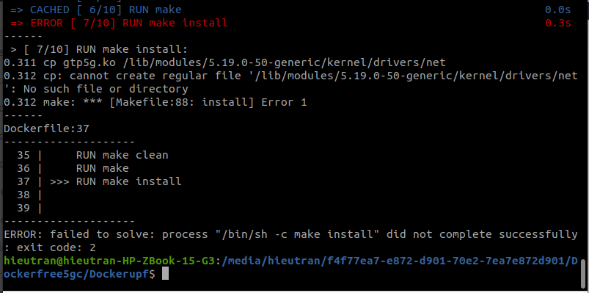
- ChatGPT recommends to remove make install
- https://github.com/abousselmi/docker-free5gc/tree/master/upf
- https://github.com/free5gc/upf
- MongodB:
- We can install gtp5g in host and Mongodb run directly: sudo docker run -d --name mongodb -p 27017:27017 mongo:latest
- sudo ps aux | grep mongo: Finding any Mongodb Run by host machine
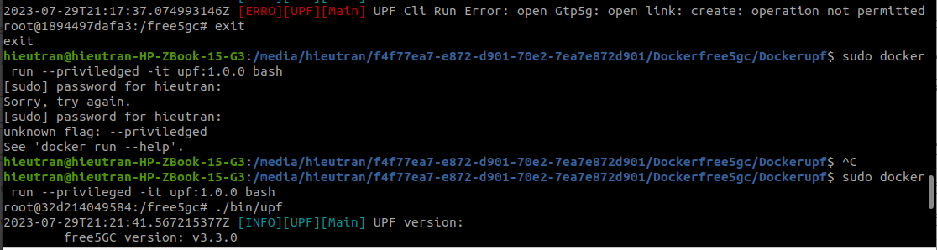
- sudo docker run --privileged -it upf:1.0.0 bash
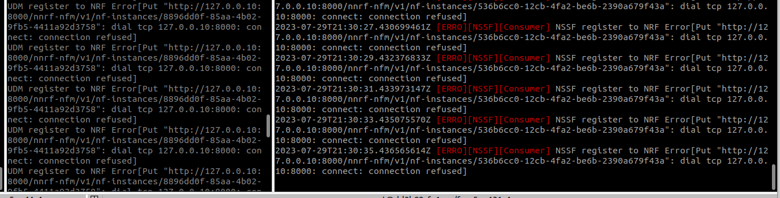
- sudo docker run -p 8000:8000 -it nrf:1.0.0 bash It still error when connecting to other Nfs. Check IP address of host
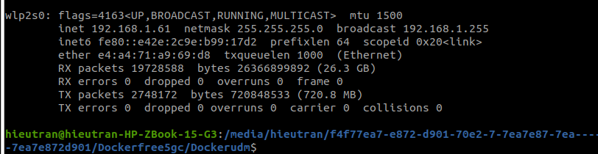
- sudo docker run -p 8000:8000 -it nrf:1.0.0 bash
- Include vim, net-tools, into each Dockerfile
- 172.17.0.3
- telnet 192.168.1.61 8000
- NRF:
- sudo docker build -t upf:1.0.0 .
- sudo docker run -p 8000:8000 -it nrf:1.0.0 bash
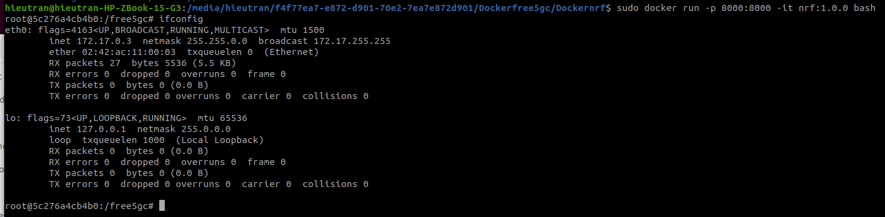
- Update configure file of NRF using host IP 172.17.0.3
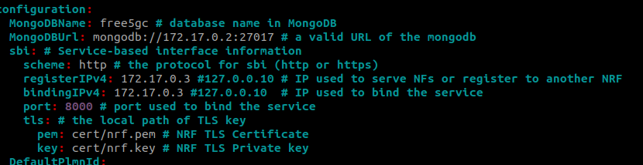
- ./bin/nrf
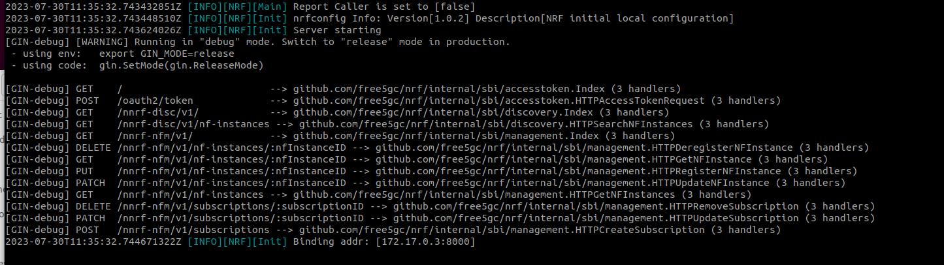
- AMF:
- sudo docker run -it amf:1.0.0 bash
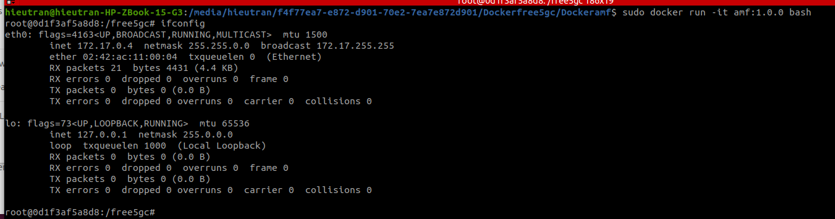
- Update configure file of AMF using host IP 172.17.0.4
update nrfuri: 172.17.0.3, /ngapIplist/registerIPv4/bindingIPv4: 172.17.0.4
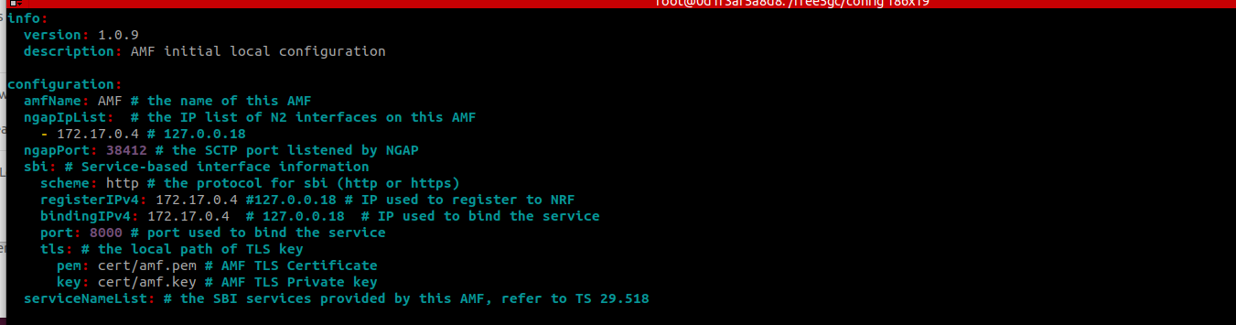
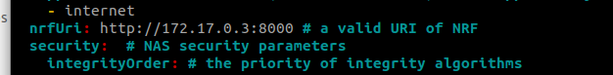
- ./bin/amf
- nrfuri: In the 5G core network architecture, "nrfuri" refers to the Uniform Resource Identifier (URI) used to access the NF Repository (NRF). The NRF is a key component in the 5G core network that acts as a repository for network functions (NFs) information. It helps other network functions discover and interact with the available NF instances and services within the 5G network. The "nrfuri" is a unique identifier used to locate the NRF in the network.
- After running amf, nrf creates a new instances
- 2023-07-30T20:38:42.142809100Z [ERRO][AMF][Gmm][amf_ue_ngap_id:RU:1,AU:1(3GPP)][supi:SUPI:imsi-208930000000003] Select SMF failed: NSSelection Get Error[NSSF No Response]
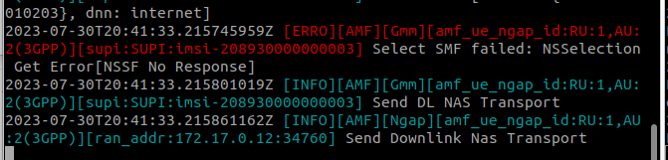
- https://forum.free5gc.org/t/on-version-3-0-6-facing-error-select-smf-failed-dnn-internet-is-not-supported-or-not-subscribed-in-the-slice-while-establishing-session-with-ueransim/1197
- Check smfcfg.yaml and uerouting.yaml
  - Check uerouting: imsi or SUPI is different with configuration
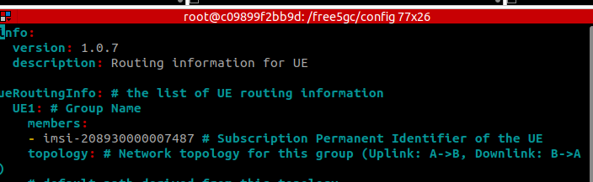
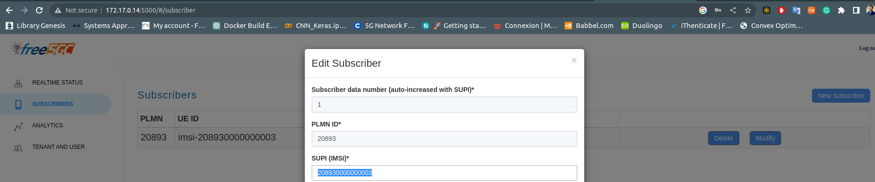
- UPF:
- sudo docker build -t upf:1.0.0 .
- sudo docker run -it upf:1.0.0 bash
- Ifconfig OP 172.17.0.5
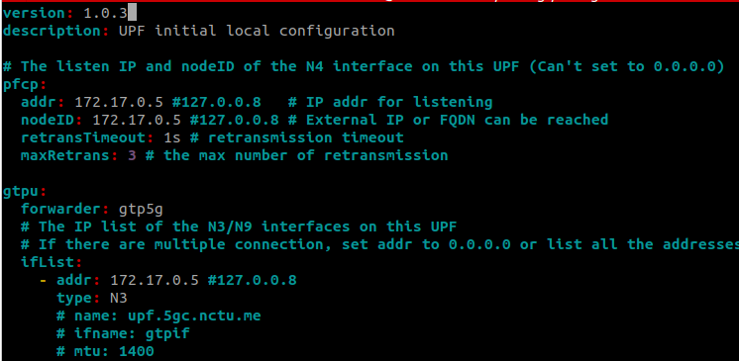
- Sin UPF needs to use the GTP kernel of host, thus we need to run sudo docker run --privileged -it upf:1.0.0 bash
- ./bin/upf
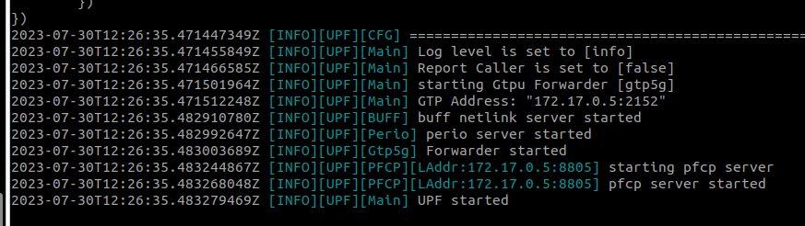
- SMF:
- ifconfig , we have 172.17.0.6
- cd config
- Update all IP in configure file
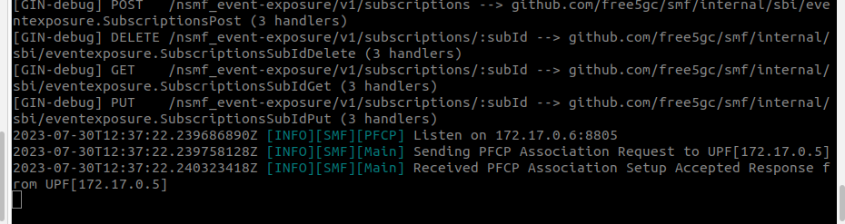
- AUSF:
ifconfig , we have 172.17.0.7
cd config
Update all IP in configure file
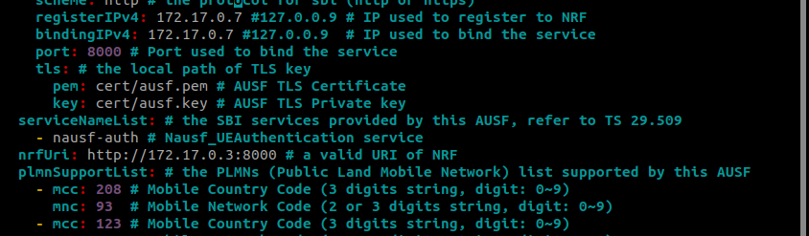
- NSSF: Didnot change localhost IP address checked IP 172.17.0.15
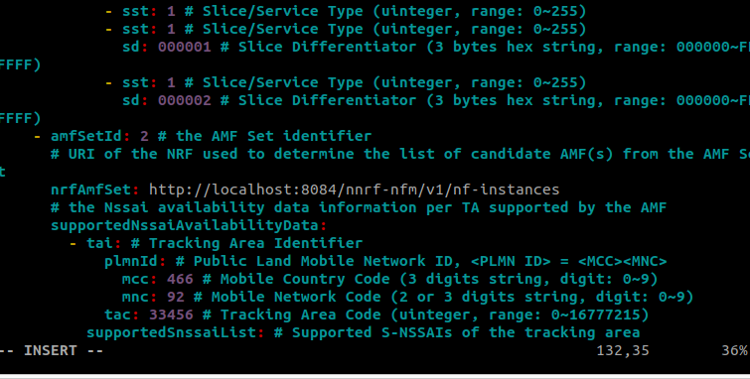
- localhost:8084: how to replace localhost by IP address of NRF 172.17.0.3 is still error at AMF. Try with 127.0.0.1:
- PCF: IP 172.17.0.9
- UDM: IP 172.17.0.10
- UDR: IP 172.17.0.11

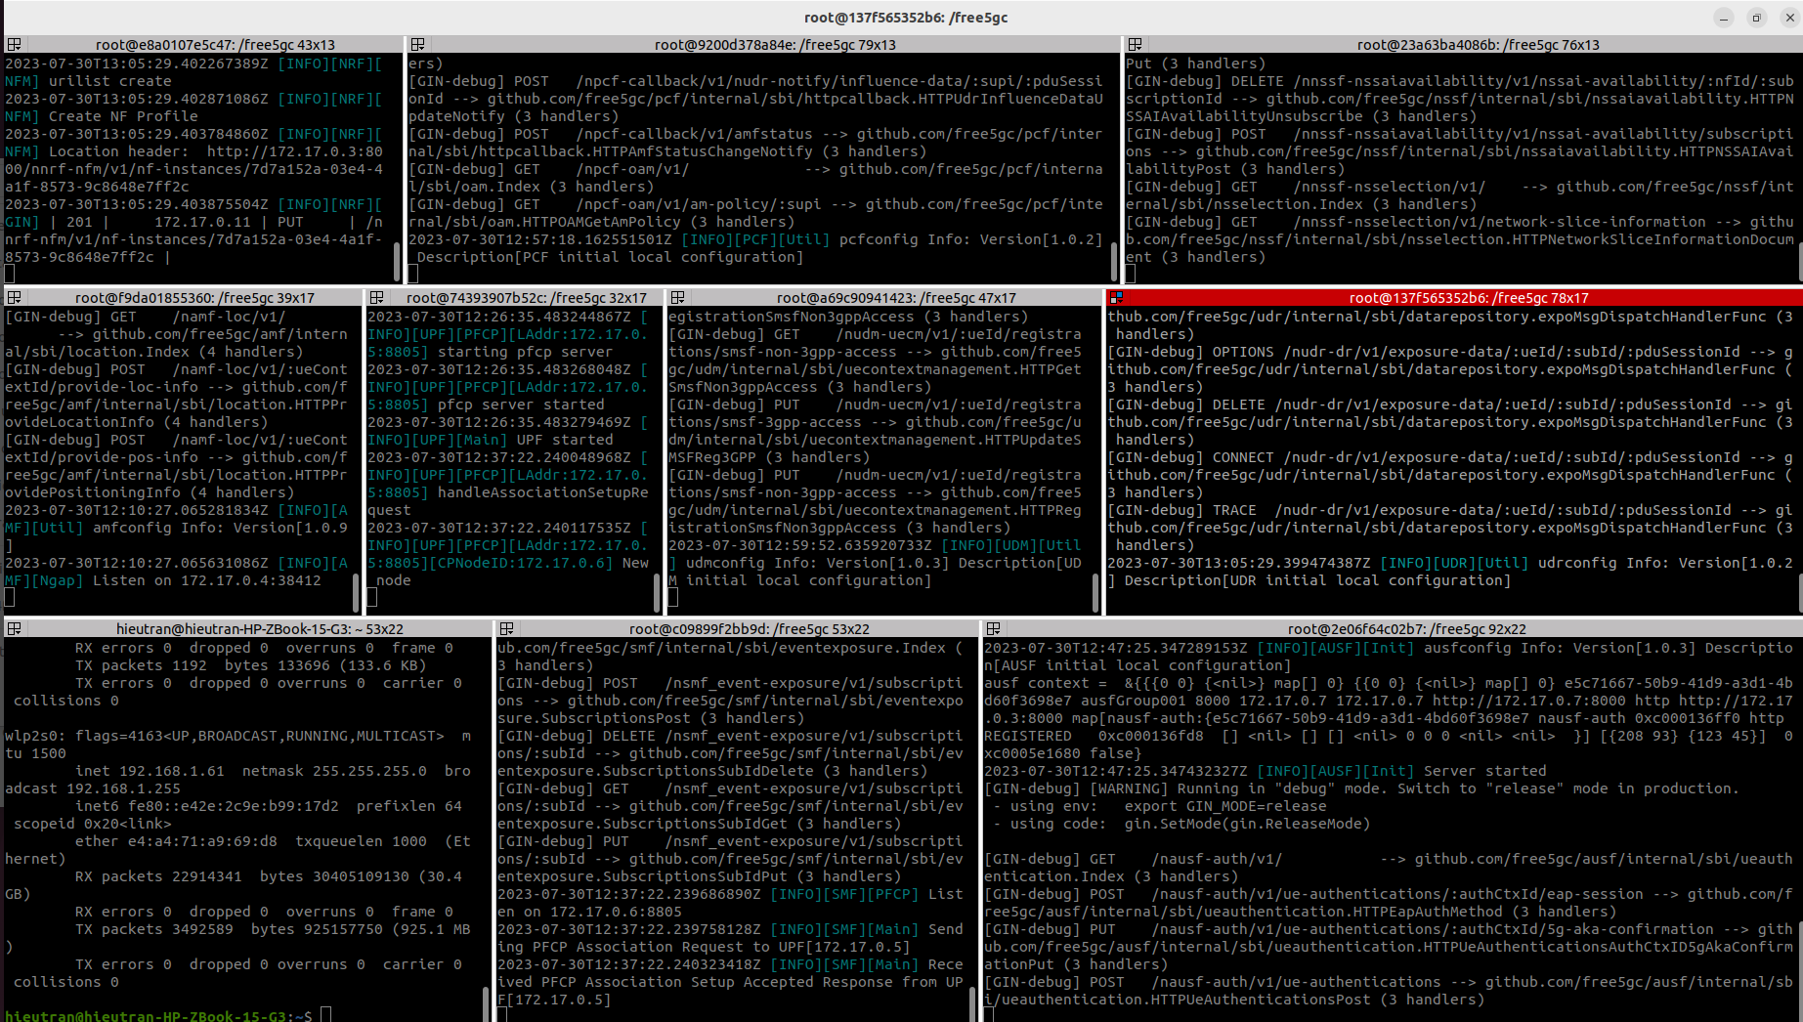
- UERANSIM:
- gnb: IP: 172.17.0.12
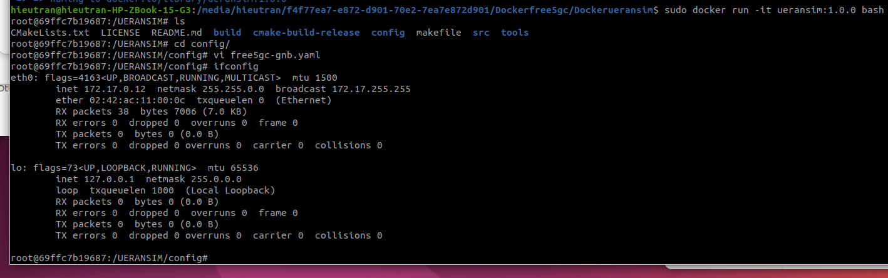
- ue: 172.17.0.13
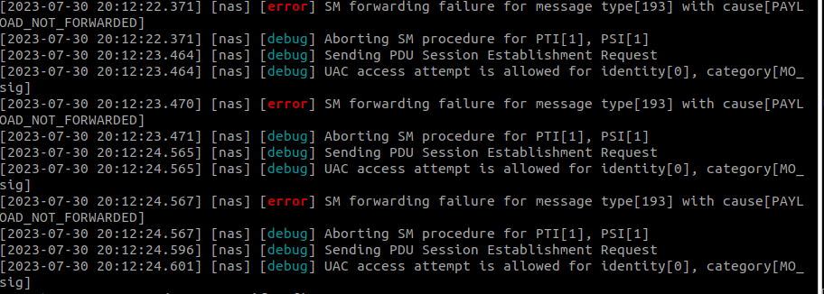
- Check amfcfg.yaml and nssfcfg.yaml file:
- https://docs.oracle.com/communications/F29627_01/docs.10/Network%20Slice%20Selection%20Function%20(NSSF)%20User_s%20Guide/GUID-DC11F46A-A4F6-4C56-9E8A-A16B57B7BA9C.htm#Network-Slice-Selection-Service
  - mcc and mnc are different. Check all information in the configuration file, it should be the same as the registered information in webconsole.
  - After checking all information between amfcfg and nssfcfg such as mcc, ncc, imsi, snssai. The above error is fixed.
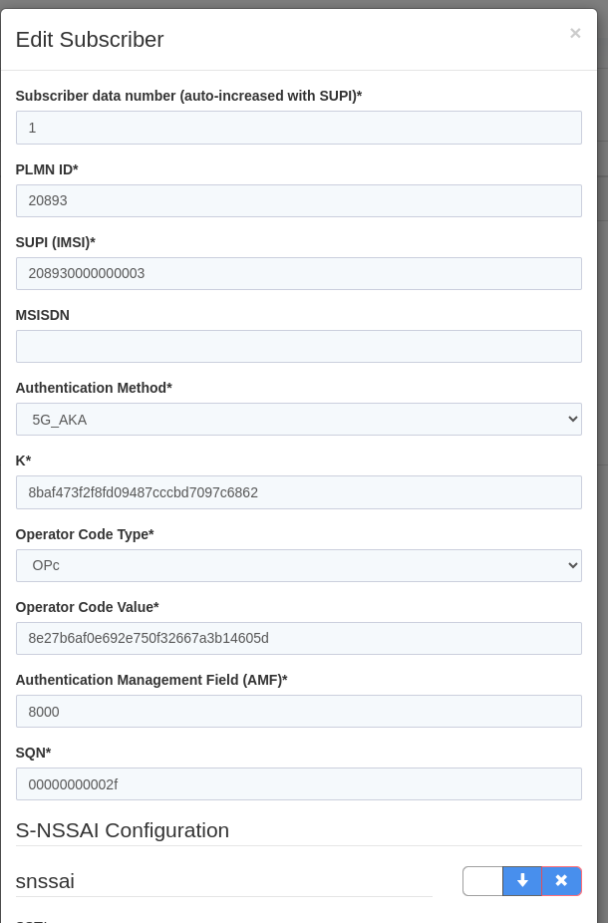
- New error: at the UE we have new error, i.e., TUN allocation failure.
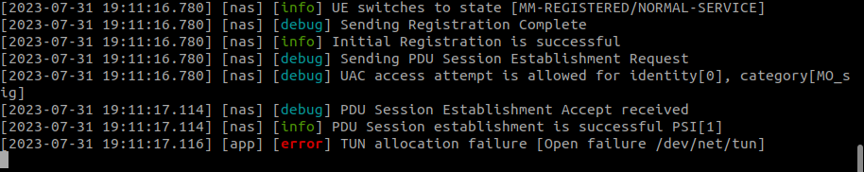
  - https://github.com/aligungr/UERANSIM/issues/377
  - Read https://mail.sharetechnote.com/html/5G/5G_PDUSessionEstablishment.html to understand how PDU session establishment.
  - Check SMFcfg file
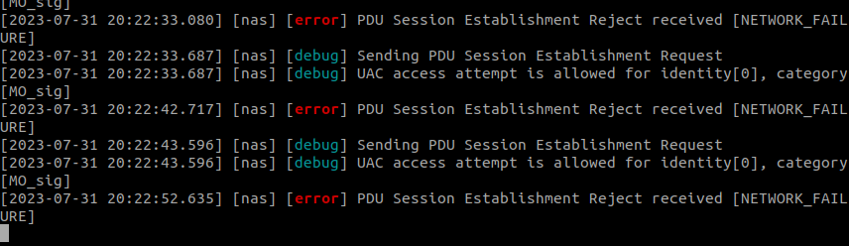
- Read TS 24.501 section 6.4.1: UE-requested PDU session establishment procedure
- Fixed: sudo docker run --privileged --it ue:1.0.0 bash sudo docker run --privileged --it upf:1.0.0 bash
- ok%20to%20have%20multiple,defined%20networks%20and%20shared%20volumes.
- uerasim cannot ping to google from a running container: https://forum.free5gc.org/t/stage-3-free5gc-compose-with-ueransim-ue-cannot-connect-to-the-internet/782
- Read: https://github.com/aligungr/UERANSIM/wiki/Usage
- ssh into a container: sudo docker exec -t <container_name or id> bin/bash
- route -t, tcpdump
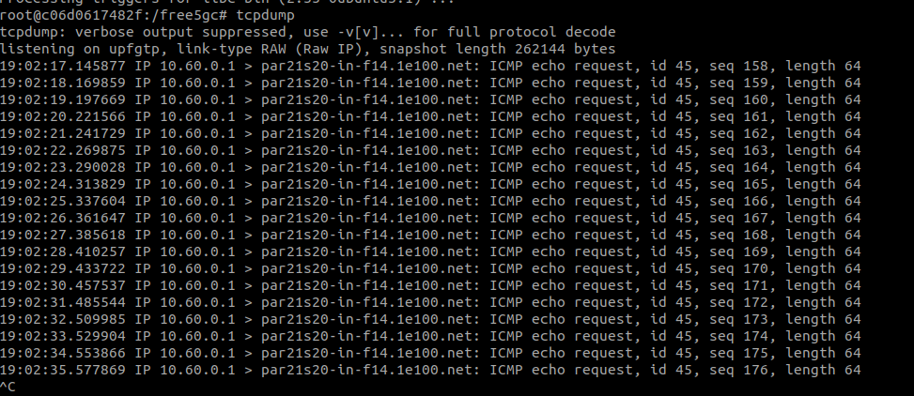
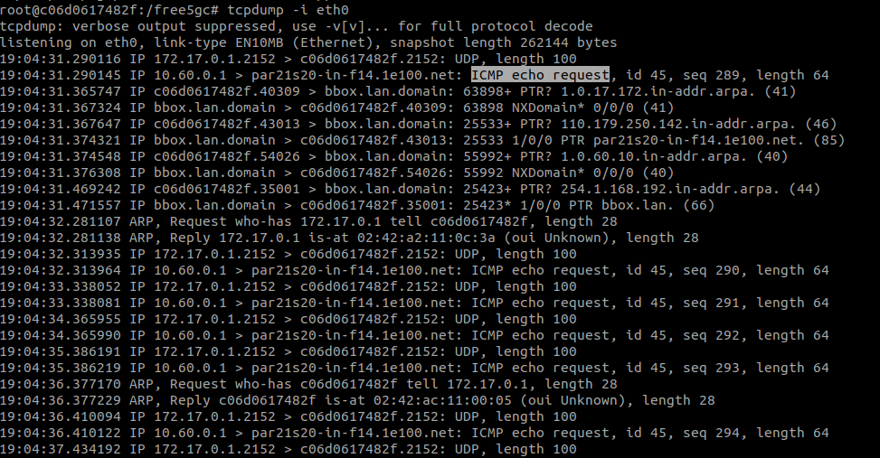
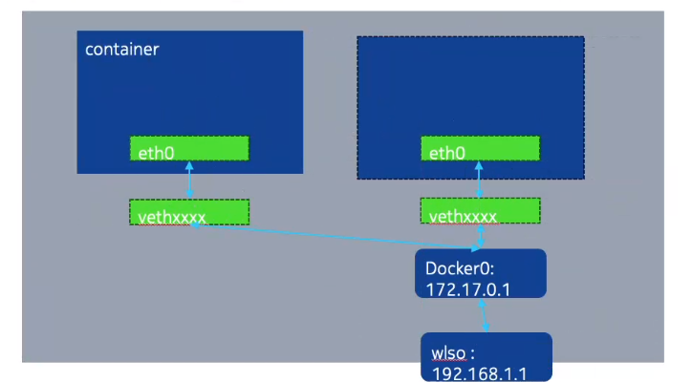

- Veth: virtual ethernet which is virtual interface.
- The error because of missing: root@c06d0617482f:/free5gc# iptables -t nat -A POSTROUTING -o eth0 -j MASQUERADE at UPF
- Before add nat, we have
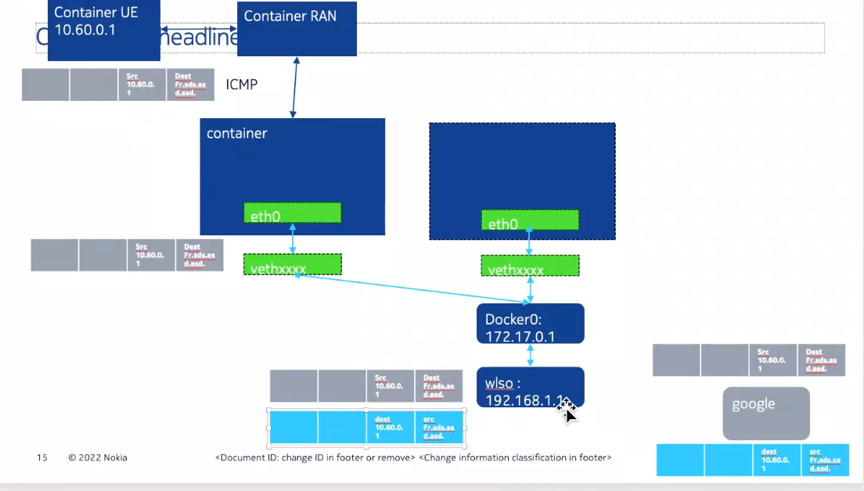
- Host don’t know where is dest 10.60.0.1 since it is the private IP of container UE.
- After add nat:
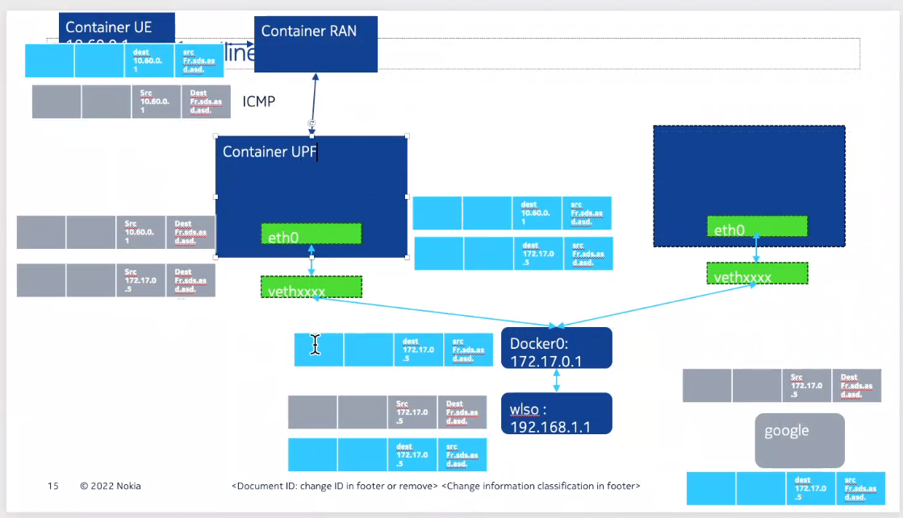
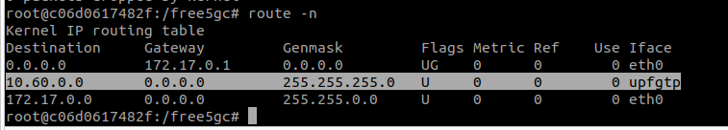
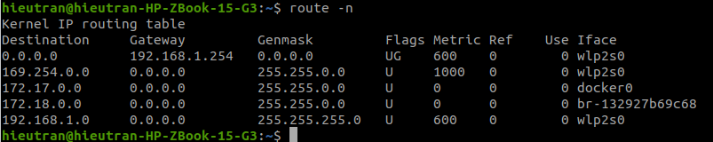
- tcpdump: check routing of a packet, e.g., ping to google.
- WebConsole:
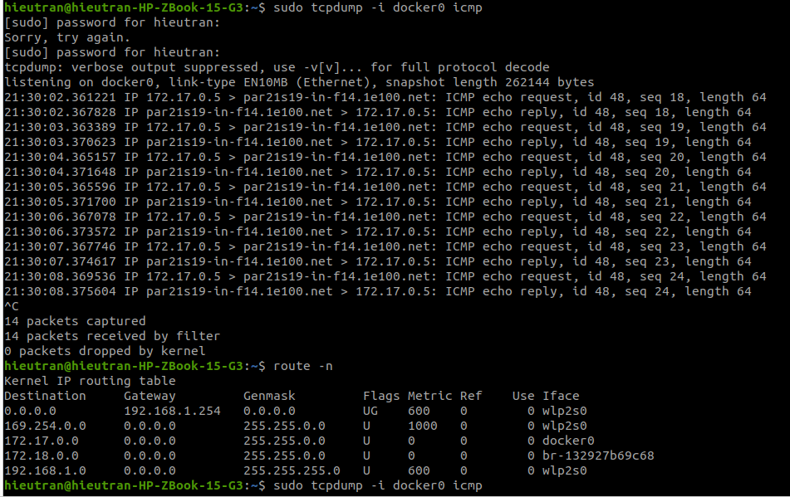
- IP 172.17.0.14
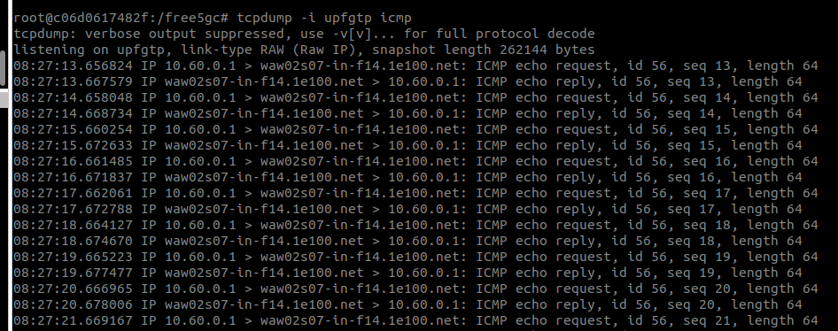
- Change webconsole/config file IP: localhost:27017 → 172.17.0.2:27017

