Using Qt5 Designer to create GUI for ROS

Install PyQt5, QtSql and Qt5 Desinger.
- Open the terminal and paste command:
+ sudo apt-get install python3-pyqt5 install PyQt5.
+ sudo apt-get install python3-pyqt5.qtsql install QtSql.
+ sudo apt-get install qttools5-dev-tools install Qt5 Designer.
+ sudo apt install pyqt4-dev-tools.

- To open the Qt5 Desinger, use the command:
+ /usr/lib/x86_64-linux-gnu/qt5/bin/designer
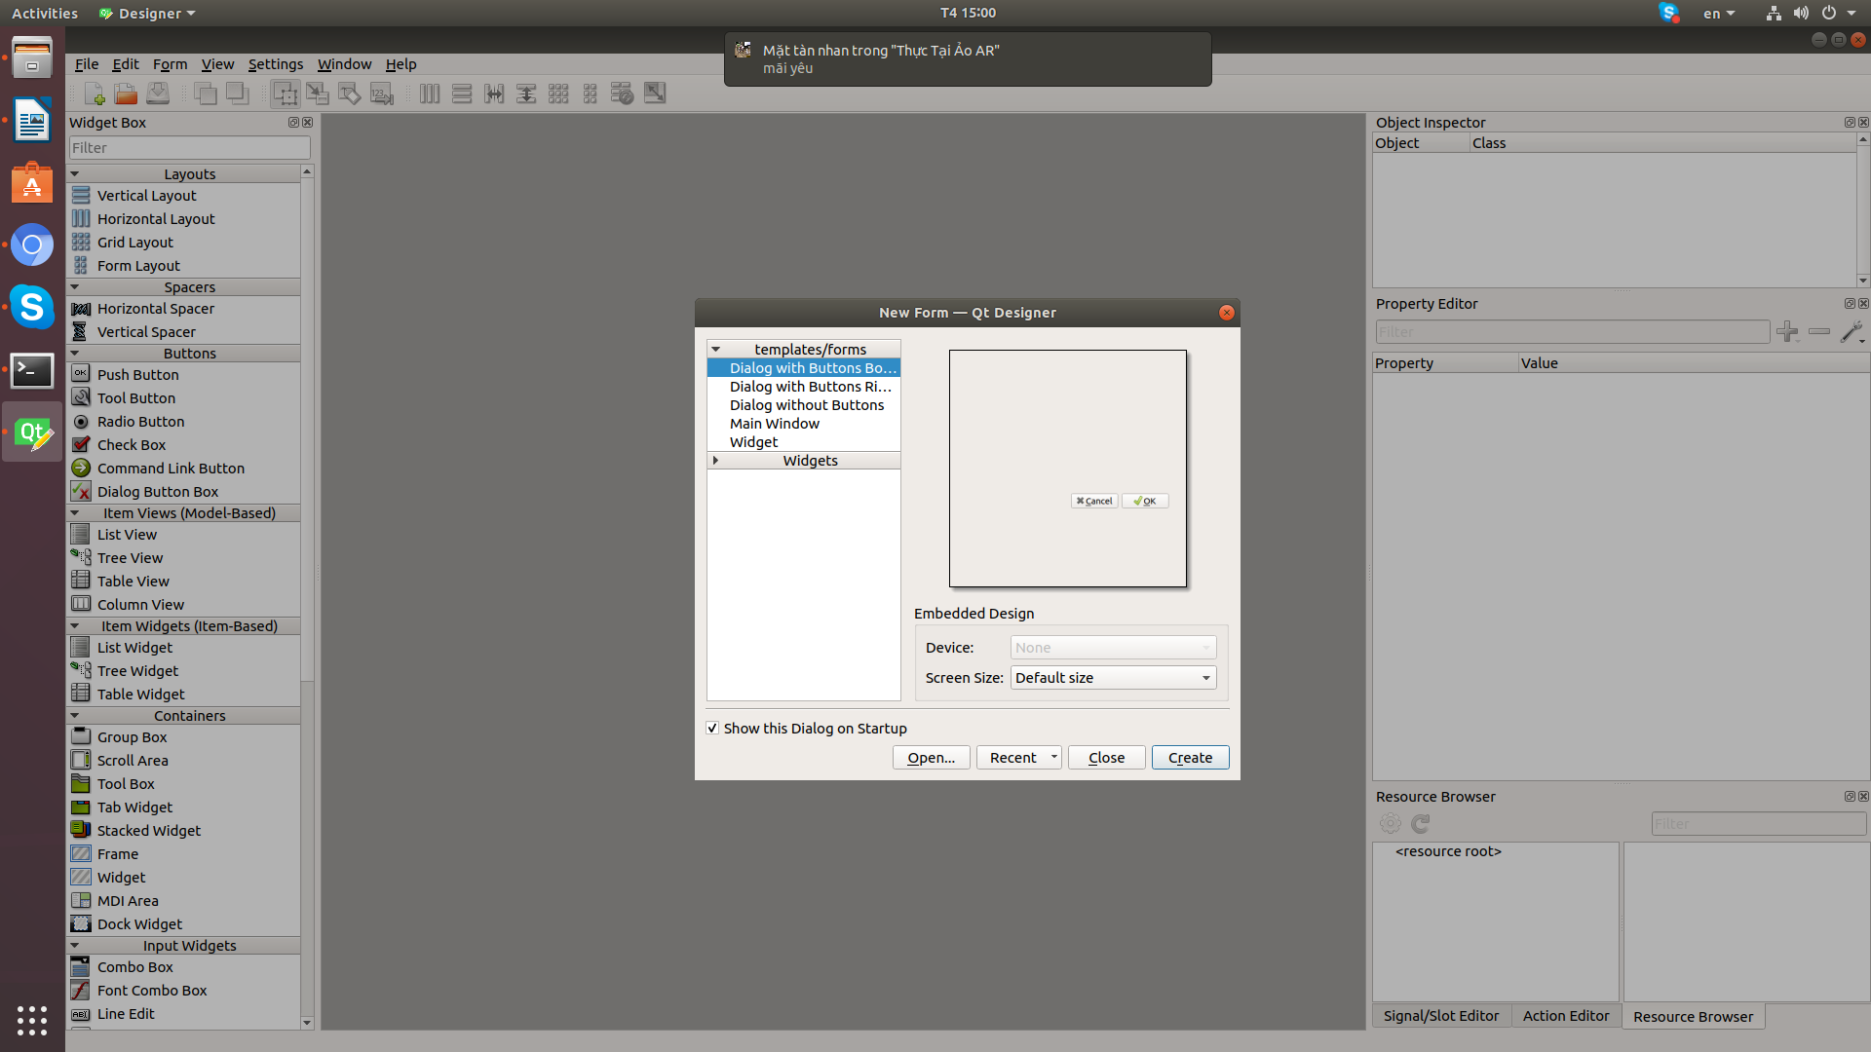

- To compile the ui file to python file, use the command:
+ pyuic4 -x namefile.ui -o namefile.py

sudo apt install python-tk to install tkinter (creating a splash screen)

