David Tran

8-31-2015

Homework 1

C#

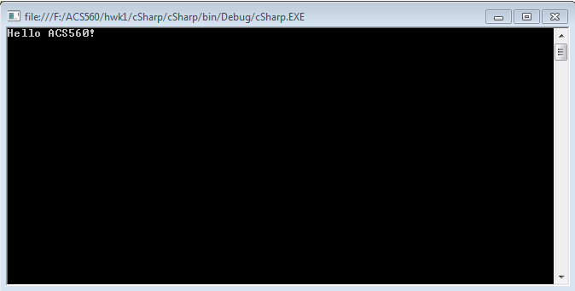

C++

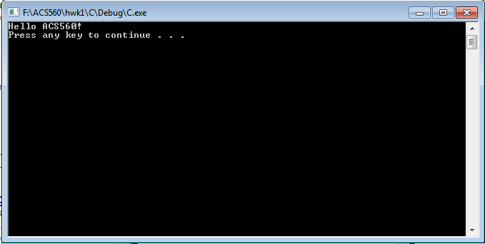

HTML

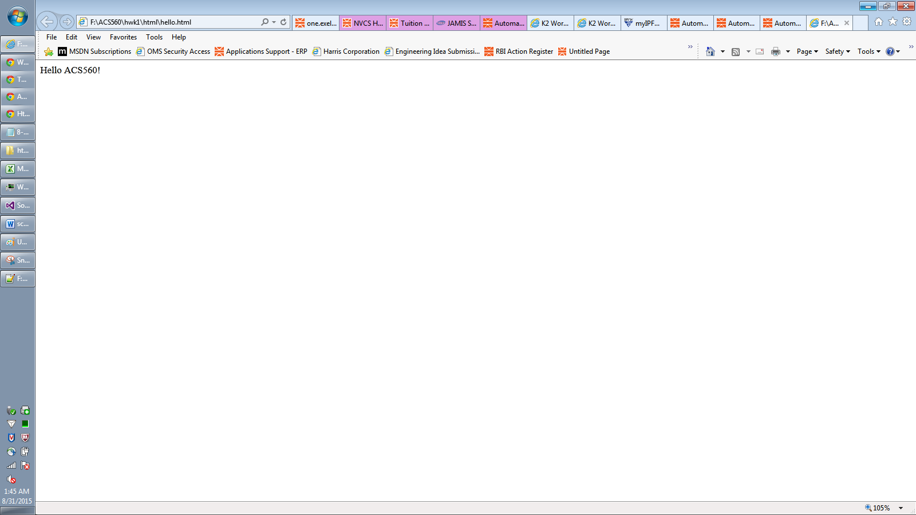

Javascript

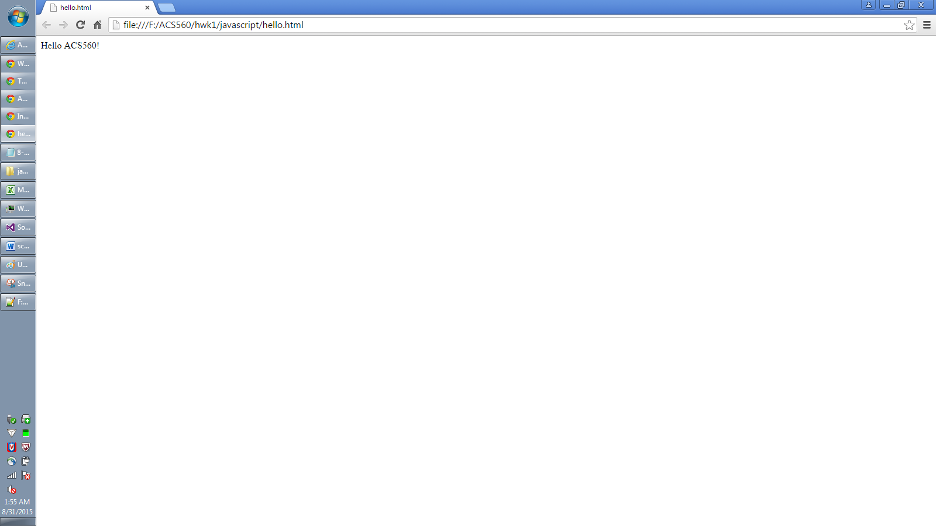

Python

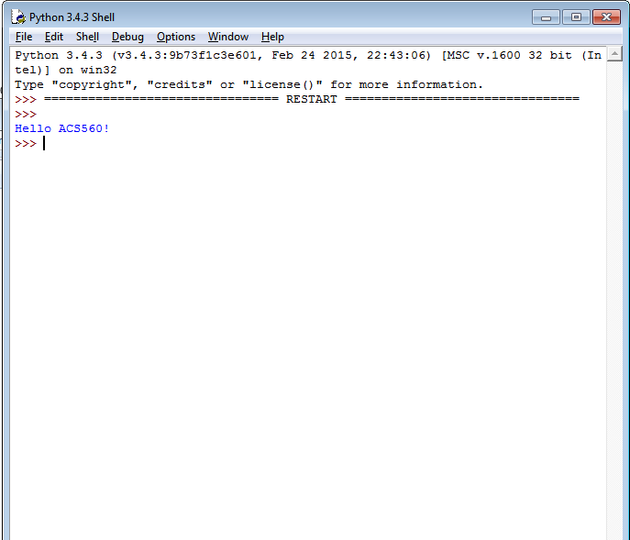

Shell script

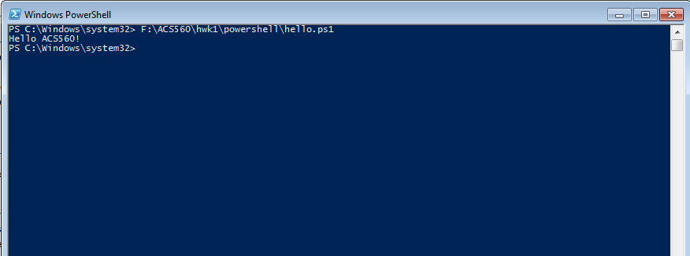

**Go**

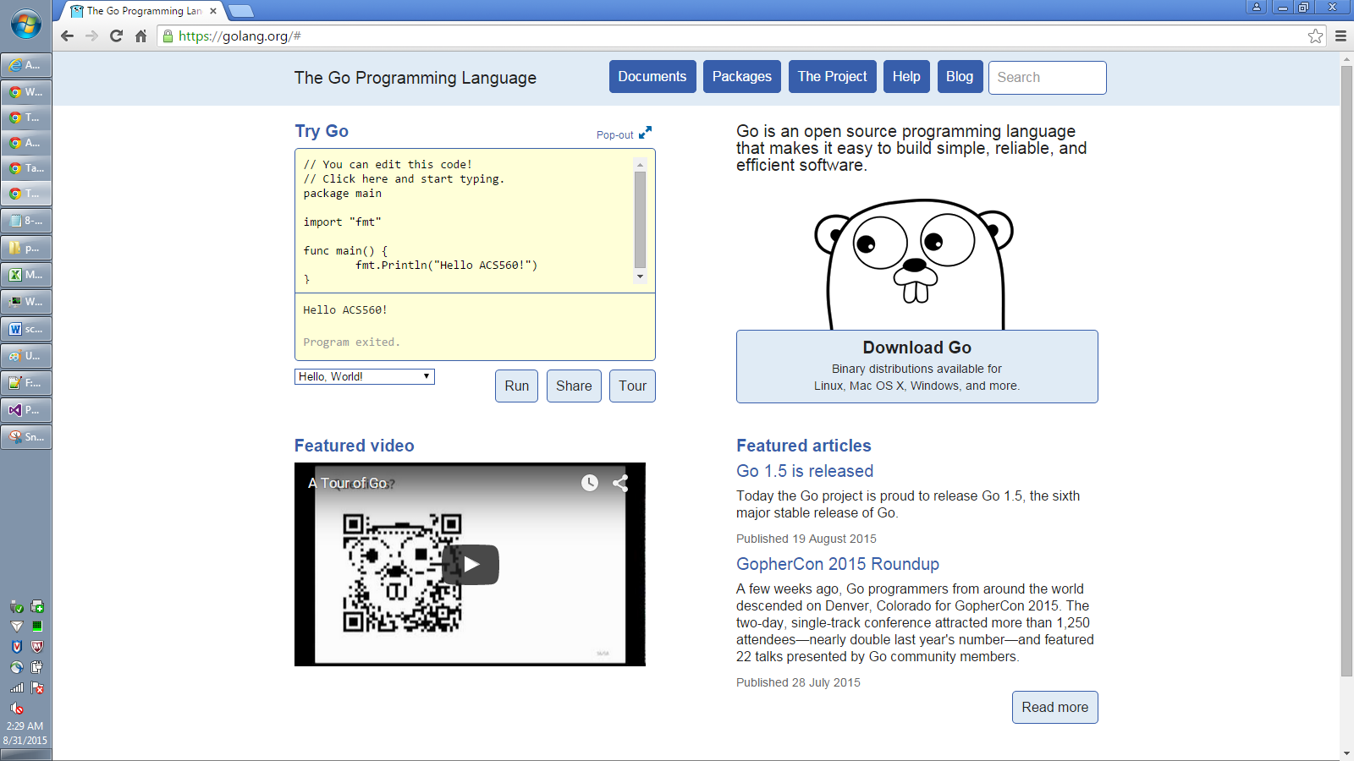

**Java(eclipse)**

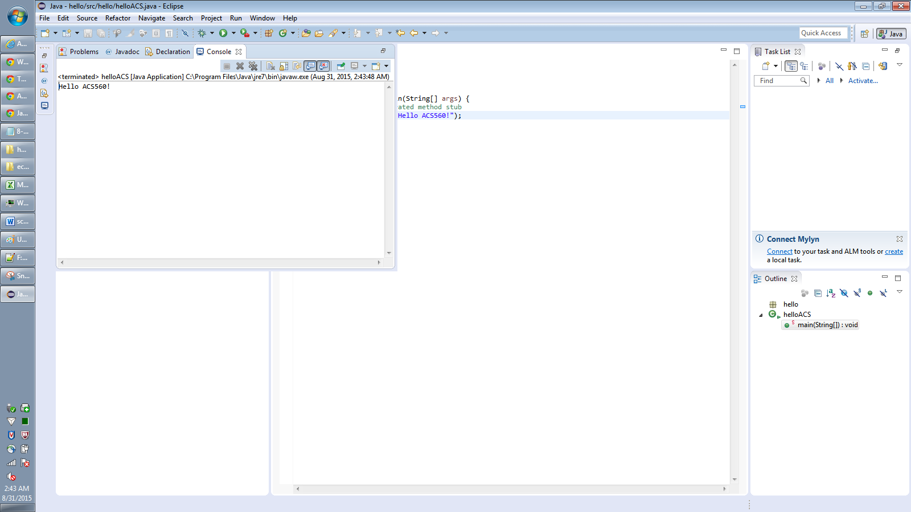

**GO resources**

* **Search: google go**
  + [**https://golang.org/doc/**](https://golang.org/doc/)
* **Search: google go example**
  + [**https://gobyexample.com/**](https://gobyexample.com/)
* **Search: go language**
  + [**https://www.golang-book.com/guides/bootcamp**](https://www.golang-book.com/guides/bootcamp)