1. How to check a variable’s type?

*Python has a function called type which can tell you what class a value falls into*

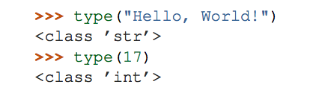

2. In what cases, you will get ***SyntaxError*** from the compiler telling you that some of your variables have **invalid names**? Can you give 3 different examples of **invalid names**?

*If you give a variable an illegal name, you get a syntax error*

*Examples for syntax error:*

* *76trombones = "big parade"   # the variable cannot begins with a letter*
* *more$ = 1000000   # the variable cannot contain illegal character, the dollar sign*
* *class = "Computer Science 101"   # the variable cannot as the same as Python keywords*

