1. **What is Boolean? Write down 3 different expression that results a Boolean type (i.e. 5 == 6)**

* In general, boolean value is either true or false. And in Python, the two Boolean values are **True** and **False**.
* 3 different expressions:
  + 1 <= 8
  + 4 == (5 + 4)
  + “hi” != “hello”

1. **What is a flow chart? Draw flow chart for the following code snippet: (you can draw on a paper, take a picture of it)**

* A flowchart is a type of diagram that represents an algorithm, workflow or process, showing the steps as boxes of various kinds, and their order by connecting them with arrows
* ***Draw*:**

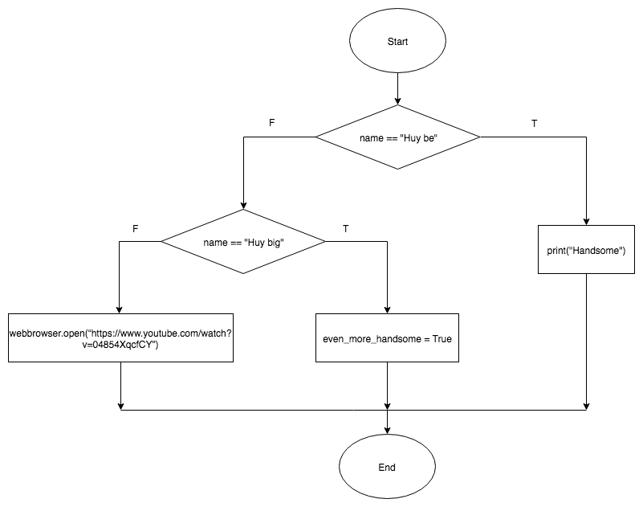

1. **What is nested conditionals? Write a piece of code that uses nested conditionals**

* Nested conditional is a conditional inside a branch of another conditional.
* ***Example*:**

num = int(input(“Enter a number: “)

if num % 5 == 0:

print(“a is divisible by 3”)

else:

if num % 2 == 0:

print(“a is not divisible by 3, but a is still an even number”)

else:

print(“a is an odd number, not divisible by 3”)