# **USER REQUIREMENT**

## **List of students**

1. Trần Duy Đạt – HE140517
2. Nguyễn Tuấn Dũng – HE140329
3. Nguyễn Tiến Đạt – HE140524
4. Trần Huy Vũ – HE140495

## **Problems**

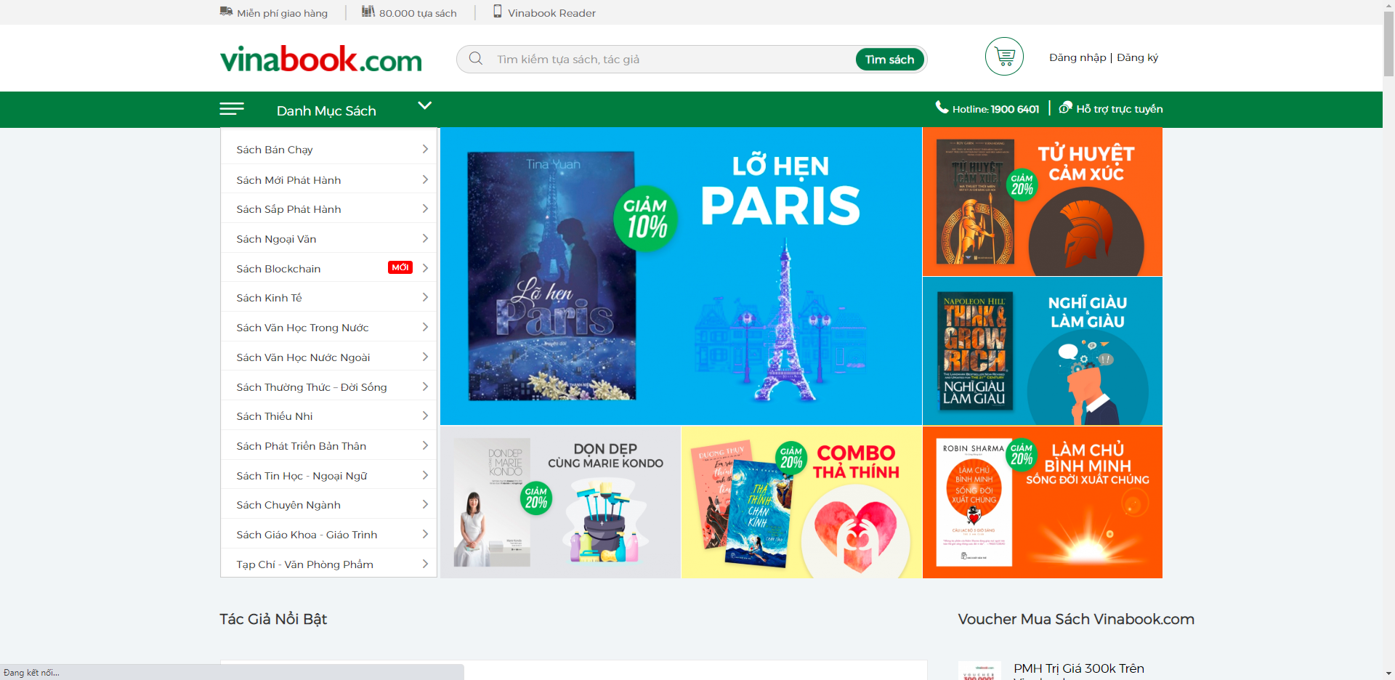

Figure Vinabook’s Homepage

1. Design and develop a database system for a bookstore online name Vinabook.com
2. Store user accounts (accounts, passwords, remember passwords, login)
3. Archive books (book id, title, author, ...)
4. The bookstore shall accept orders over the Internet.
5. The author section of the book should have 1 attributes about the author and need (id, address, phone number, number of transactions with the website such as)
6. A book-selling website requires an administrator: an account is required to log in to the system
7. And transactions between sale and customers will be stored through invoices and book storage to manage (here should have the Customers, Employees, Order, Order details table)
8. Invoices on sale (off and online sales) (need customer id, loan time and deadline, customer phone number ... ..) and purchase (customer id, date purchased, book price, title ... .)
9. The bookstore shall provide electronic links between the Web and database and the shipping fulfillment system.
10. Store products about books, stationery. Can add, edit, delete the products you want.
11. List everything you need to store
12. Store product information (Product name, price, description, ...)
13. Store quantity of goods in stock
14. User account hosting
15. Store transaction history when choosing an article or book you are currently choosing to read
16. Archive sales invoices for customers (Off + Online)
17. Store customer feedback, product reviews, leave comments or questions about the product, or feel about the delivery service.
18. Create a forum for exchanging information between customers and online support channel about products and purchasing methods.

## **List of required data objects with these attributes**

1. **Authors** (Author_ID, Author_Thumbnail, Author_Name, Biography, Author_Slug, Is_Translator)
2. **Cart_Items** (Item_ID, Cart_ID, Product_ID, Quantity, Price, Discount_Applied, Date_Added, Date_Modified)
3. **Carts** (Cart_ID, User_ID, Address_ID)
4. **Categories** (Category_ID, Category_Name, Category_Description, Slug, Parent_ID, Number_Of_Products, Sort_Order, Date_Added, Date_Modified
5. **Discounts** (Discount_ID, Discount_Desc, Type, Valid_From, Valid_To, Amount_Percent)
6. **Logistic_Companies** (Logistic_Com_ID, Company_Name, Contact_Name, Contact_Title, Work_Phone, Fax, Address)
7. **Order_Details** (Order_ID, Product_ID, OrderLine_Number, Quantity_Ordered, Price_Each, Discount_Applied, Shipper_ID, Supplier_ID)
8. **Orders** (Order_ID, Order_Date, Shipped_Date, Required_Date, Status, Note, User_ID)
9. **Page_Meta** (PMeta_ID, Page_ID, PMeta_Key, PMeta_Value)
10. **Pages** (Page_ID, Page_Name, Page_Excerpt, Content, Author_ID, Page_Slug , Status, Publish_Date, Last_Modified)
11. **Payment_Meta** (Pay_Meta_ID, Payment_ID, Pay_Meta_Key, Pay_Meta_Value)
12. **Payments** (Payment_ID, User_ID)
13. **Products** (Product_ID, Product_Name, Product_Thumbnail, Category_ID, Author_ID, Publisher_ID, Description, Format, Size, Weight, Page_Number, Quantity_In_Stock, Regular_Price, Sale_Price, Date_Published, Date_Modified)
14. **Publishers** (Publisher_ID, Publisher_Thumbnail, Publisher_Name, Publisher_Description, Slug)
15. **Reviews** (Review_ID, User_ID, Product_ID, Rating, Title, Comment, Is_Approved, Date_Added, Date_Approved)
16. **Roles** (Role_ID, Role_Name)
17. **Shippers** (Shipper_ID, Logistic_Com_ID, Shipper_Name, Shipper_Phone)
18. **Site_Options** (Option_Key, Option_Value)
19. **Suppliers** (Supplier_ID, Supplier_Name, Sup_Contact_Name, Sup_Contact_Title, Sup_Work_Phone, Sup_Fax)
20. **User_Addresses** (Address_ID, User_ID, Full_Name, Phone, Country, Province, Distinct, Building_Name, Apartment_Number, Street)
21. **User_Meta** (Umeta_ID, User_ID, Umeta_Key, Umeta_Value)
22. **User_Roles** (Role_ID, User_ID)
23. **Users** (User_ID, User_Password, User_Email, Gender, Date_Of_Birth, Newsletter, Address_ID, Payment_ID)
24. **Wishlists** (Wishlist_ID, User_ID, Product_ID, Date_Added, Status)

## **List of required transactions**

### **For Admins**

* Add/Edit/Remove/Analyze Products, Pages, User Roles, Users etc.
* Select and get the list of best sellers product in a range of time
* Censor user’s review
* Set priviliges for lower level users
* Login into their dashboard to manage site
* Etc.

### **For Customers**

* Add/Remove/Edit/Buy products
* Add/Remove products into their Wishlist
* Edit their address, profile
* Add/Edit their review for each products
* Add/Edit their payment info
* Register/Login into personal page
* View their bills