

**E-iceblue Co., Ltd.** is a vendor of .NET, Silverlight and WPF development components. The goal of e-iceblue is always to offer high-quality components for reading and writing different formats of office files.

The key developers of e-iceblue have over 10 years of combined experience developing high-performance, high-quality .NET, Silverlight and WPF component technology.

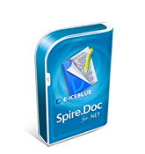

**Spire.Doc for .NET** is a professional Word .NET library specifically designed for developers to create, read, write, convert and print Word document files from any .NET platform with fast and high quality performance.

As an independent Word .NET API, Spire.Doc for .NET doesn't need Microsoft Word to be installed on neither the development nor target systems. However, it can incorporate Microsoft Word document creation capabilities into any developers' .NET applications.